|  |  |
| --- | --- |
|  | Common Financial System Reporting and Data Warehouse (CFSRDW)  Scope Document |

Last Revised: 5/25/2010

DRAFT

REVISION CONTROL

**Document Title:** Common Financial System (CFSRDW) Reporting and Data Warehouse Scope

**Author:** Enterprise Reporting and Data Warehouse Services (ERDWS)

**File Reference:**

Revision History

| Revision Date | Revised By | Summary of Revisions | Section(s) Revised |
| --- | --- | --- | --- |
| 07/16/2009 | Cheryl Kwiatkowski | Document Creation | All |
| 11/12/09 | ERDWS | Additional updates in progress to support CFS project phase updates | All |
| 12/14/2009 | Cheryl Kwiatkowski | Revised Scope based on modified approach | All |
| 01/14/2010 | Cheryl Kwiatkowski | Rewrote the Work Approach Section to include more content  Added training and deployment Milestones for all 4 Waves | 6.0  2.3 |
| 05/20/2010 | Cheryl Kwiatkowski | Clarified scope | All |

Review / Approval History

| Review Date | Reviewed By | Action (Reviewed, Recommended or Approved) |
| --- | --- | --- |
| March 2010 | CFS Project Office | Reviewed per initial posting of draft scope |
|  |  |  |

Table of Contents Page

1.0 Introduction 4

1.1 Project Stakeholders 4

1.2 Project Goals 5

1.3 Project Objectives 5

2.0 Project Scope 6

2.1 In Scope 6

2.2 Out of Scope 6

2.3 Milestone Timeline 7

3.0 Reporting and Data Warehouse Deliverables 7

4.0 Project Assumptions and Risks 8

4.1 Assumptions 8

4.2 Risks/Challenges 9

5.0 Technical Environment 9

5.1 Enterprise Reporting and Data Warehouse Services (ERDWS) Demo/Development/Testing Environments 9

DataStage ETL Server Requirements 9

OBIEE Server Requirements 9

5.2 Development Environment 10

DataStage ETL Development Environment 10

OBIEE Development Environment 10

5.3 Production Environment 11

6.0 Work Approach 12

6.1 Overall Approach 12

6.2 Dashboards & Reports 14

6.3 Training Approach 16

7.0 Project Organization 16

7.1 Project Roles and Responsibilities 16

# Introduction

This document establishes the approach and scope for the Common Financial System Reporting and Data Warehouse (CFSRDW) project. Scope, in this context refers to the work and output that will be necessary to accomplish the project’s objectives as well as any areas that are determined to be outside of the project’s purview. The purpose of having a clearly defined, detailed scope document is to provide a reference point for the activities that are expected to be performed and to identify deliverables that will be produced over the duration of the project.

The CSU currently relies on several different mechanisms to deliver financial reporting in support of System-wide, Campus Operational, and Campus End-User business requirements. The implementation of the Consolidated Financial System (CFS) in July 2010 will introduce several changes to how these reporting requirements will be met. The Common Financial System Reporting and Data Warehouse effort is one part of that overall strategy. The **CFS Reporting Strategy** document located on the CFS Project Management website <http://cms.calstate.edu/04_Applications/04B_Finance/CFS90/CFSProjectManagement.asp> outlines the overall approach and associated impact of the changes.

Background

The California State University (CSU) has completed a system-wide implementation of Oracle’s PeopleSoft finance, human resources, and student administration applications at its 23 campuses and the Chancellor’s Office (CO). This effort is called the Common Management System (CMS) project. Implementation of CMS began in 1999 and completed in 2008. All 23 campuses and the CO are operational on one or more of these applications.

CMS currently supports individual campus and CO production databases. This model may not be sustainable in its current state.  The goals established for CMS for 2008 were to achieve best business practices, reduce costs, and improve performance.  To this end, the CMS Executive Committee proposed the Common Financial System (CFS) initiative and the CFS Advisory Group was established to research the feasibility of adopting a common financial system.  One of the primary drivers identified was to enable the adoption of a corporate financial model and provide the CSU with a comprehensive reporting system through the delivery of a common financial reporting environment. The common finance reporting system will provide the campuses and the CO with a centrally developed and maintained data warehouse which will establish the foundation for incorporating future, added reporting functionality.

## Project Stakeholders

The success of any project requires the participation and commitment of project stakeholders. Within this document, stakeholders consist of, but not limited to, the following constituents:

* Executive Council
* Technology Steering Committee
* CABO
* CFS Steering Committee
* FOA
* CMS Executive Committee
* CMS Management
* CMS Central Team
* CMS User Groups (FUG, HUG, SAUG, and TUG)
* Operations and Support Services (OSS)
* Information Technology Advisory Committee (ITAC)
* Information Security Officers (ISO)
* Technology Infrastructure Services (TIS)
* Campus constituents and Project Directors

## Project Goals

The primary goal of the Common Financial System Reporting and Data Warehouse (CFSRDW) Implementation project is to deliver reporting and analytic capabilities via a centrally maintained, enterprise-wide financial reporting environment and data warehouse which enables campuses to maintain their flexibility through financial reporting and achieves a corporate financial reporting system for the Chancellor’s Office.

## Project Objectives

The primary business objective of the CFSRDW project is to deliver a centrally-managed, robust, enterprise financial reporting environment for all campuses and the Chancellor’s Office.

Additional objectives are as follows:

1. To deliver a central common financial reporting environment in support of General Ledger Campus, State and GAAP reporting in July 2010
2. To deliver the functionality required to support additional financial reporting by July 2011
3. To establish the foundation and scalable architecture to include additional financial reporting that leverages delivered Oracle EPM Finance data models thus reducing the need for labor intensive “home grown” design efforts
4. To reduce the need for all campuses and the Chancellor’s Office to fund and invest resources on the development and maintenance of local finance data warehouses and reporting environments
5. To leverage where possible the Finance 9.0 GL reporting solution (RSOL), as a starting point for designing (modeling) the General Ledger data marts
6. To establish the common financial reporting environment as the primary source for campus and CO reporting and analysis
7. To enable future strategies to archive and/or purge finance application data in accordance with systemwide retention/disposition policies
8. To identify, define, and develop the common set of core reporting capabilities required by campuses and the Chancellor’s Office
9. To implement a process to assist in the identification, definition, and prioritization of ongoing reporting capabilities and data warehouse functionality required by campuses and the Chancellor’s Office
10. To develop and foster a business intelligence (BI) report and dashboard resource pool comprised of functional and technical campus and Chancellor’s Office staff assigned to assist in the ongoing development of common financial reports and dashboards
11. To establish a common set of standards, guidelines and processes to be used in the development of financial reports and dashboards
12. To provide the campuses an environment, (DWS instance) which replicates daily the CFS production data from which they can source their local data warehouses using local campus ETL processes. The “data warehouse source” Data Guard (DWS) instance will be used for this purpose. Campuses will be given a database (DB) account to allow them to download their campus data. Campuses will not be allowed to download sensitive data such as credit card information and SSNs.

# Project Scope

## In Scope

The CFSRDW Implementation project extends through July 2011. The July 2010 deliverables focus on General Ledger data and reporting. During the July 2010 through July 2011 period, additional data and reporting capabilities will be rolled out quarterly. The CFS governance structure will prioritize the additional data to be included in the Common Financial Reporting Environment.

The following main categories of work effort are within scope of this project.

1. Design and development of a centrally maintained enterprise financial data warehouse which:
   1. Sources data from a nightly replication of the CFS consolidated data base for the CSU campuses and the Chancellor’s Office
   2. Is updated nightly providing data current as of COB the night before
   3. Is dimensionally modeled and designed for ease of reporting
2. January 2009 to July 2010 - Design and development of ten (10) general ledger (GL) data marts based on the priorities identified by the CFS Design Team. A data mart is a subset of the organization's/campus’ data, focused on a specific subject area or business area. The data marts are designed for ease of reporting. The July 2010 data marts are:
   1. Campus - Actuals, Budgets, Encumbrances, Pre-Encumbrances, and Summary (5 data marts)
   2. FIRMS/Legal - Actuals, Budgets, Encumbrances, Summary (4 data marts)
   3. GAAP (1 data mart)
3. July 2010 to July 2011 - Based on established priorities, design, develop, and deliver new data marts and reporting capabilities on a quarterly basis for the areas *such as*:
   1. Purchase Orders
   2. Requisitions
   3. Vendor Analysis
   4. Accounts Payable
   5. Account Receivables
   6. Grants & Contracts
   7. Asset Management
   8. Labor Cost Distribution
4. Design and development of a centralized reporting infrastructure using Oracle Business Intelligence (OBIEE) which includes:
   1. A role-based, user-friendly Web interface
   2. Subject-oriented, interactive “Dashboards” containing the common set of core reporting capabilities required by campuses and the Chancellor’s Office (a Dashboard is a user interface that organizes and presents information in a way that is easy to read)
   3. A security framework which controls authentication and provisioning of appropriate data access for campus and Chancellor’s Office end-users
5. Provision of a standard interface to allow campuses to extract and load their campus data from the centrally maintained data warehouse into their local data warehouse. Campuses will be provided with a data base (DB) link for access to their data. Data model diagrams and source-to-target mappings will be available to assist the campuses.
6. Provision of a training and development plan to support the needs of campus and Chancellor’s Office end-users of the common financial reporting environment
7. Development of Campus and CO reporting Team (CAT TEAM) to assist in the ongoing identification, definition, prioritization, and development of common financial dashboards and reporting and analytic capabilities
8. Development of a centrally managed plan for ongoing support, development, and maintenance of the common financial reporting environment

## Out of Scope

The following items are out of scope for and will not be addressed within scope of the Common Financial Reporting and Data Warehouse project:

1. Campus pre-consolidated data will not be loaded in the data warehouse
2. Campus unique data fields

## Milestone Timeline

|  | Milestone | Planned Start Date | Planned End Date |
| --- | --- | --- | --- |
| GL Data and Reporting | Define data/Information requirements | 1/5/2009 | 10/30/2009 |
| Design data models | 1/5/2009 | 10/30/2009 |
| ETL development | 3/9/2009 | 2/26/2010 |
| Campus data profiling | 6/1/2009 | 2/26/2010 |
| Develop core reporting capabilities | 9/1/2009 | 12/15/2010 |
| Create reporting CAT Team | 2/1/2010 | 2/26/2010 |
| Wave One campus Train-the-Trainer | 4/19/2010 | 06/30/2010 |
| Wave One pre-production campus training | 4/26/2010 | 7/30/2010 |
| Wave One Campus validation | 7/19/2010 | 08/06/2010 |
| Wave One Campus production | 8/09/2010 |  |
| Wave Two campus Train-the-Trainer | 10/04/2010 | 12/17/2010 |
| Wave Two pre-production campus training | 10/04/2010 | 12/17/2010 |
| Wave Two Campus validation | 1/14/2001 | 02/07/2011 |
| Wave Two move to production | 2/10/2010 |  |
| Wave Three campus Train-the-Trainer | 2/7/2011 | 2/11/2011 |
| Wave Three pre-production campus training r | 2/14/2011 | 4/29/2011 |
| Wave Three validation | 4/15/2011 | 5/09/2011 |
| Wave Three move to production | 5/11/2011 |  |
| Wave Four campus Train-the-Trainer | 4/18/2011 | 4/22/2011 |
| Wave Four pre-production campus training | 4/25/2011 | 6/30/2011 |
| Wave Four move to production | 7/15/2011 | 8/01/2011 |
| Wave Four move to production | 8/08/2011 |  |
|  | | | |
| July 2010 - July 2011 additional functionality  (TARGETS) | Develop and prioritize the rollout plan for P2 data marts and reporting capabilities | 5/1/2010 | 6/30/2010 |
| P2 Data Marts design and development | 7/1/2010 | 6/30/2011 |
| Rollout first release P2 data marts and reporting capabilities marts additional | October 2010 | |
| Rollout second release P2 data marts and reporting capabilities marts additional | January 2011 | |
| Rollout third release P2 data marts and reporting capabilities marts additional | April 2011 | |
| Rollout fourth release P2 data marts and reporting capabilities marts additional | July 2011 | |
|  |  |  |  |

# Reporting and Data Warehouse Deliverables

The global CFS Implementation Scope document contains detail and summary information on deliverables related to all areas of the project. Reporting and Data Warehouse deliverables are listed or summarized where appropriate in the global scope document. This scope document is specific to the CFSRDW subproject. Reporting and data warehouse deliverables are outlined by category in the following section.

| # | Deliverables | Description |
| --- | --- | --- |
| 1 | Scope Document | Document that establishes the approach and scope for the CFSRDW project |
| 2 | Project Plan | Campus tasks and activities and timelines integrated into the global CFS project plan |
| 3 | Business Intelligence (BI) Advisory Structure/Process -  (Reporting Action Team) CAT Team | Establishment of an Campus & CO Reporting Action Team to assist ERDWS in the   1. Planning for and defining ongoing data requirements 2. Planning for and defining ongoing reporting requirements 3. Definition of data quality standards 4. Establishment of DW business rules and data definitions |
| 4 | Logical Data Models | One logical data model per data mart. The data models document the Facts and Dimensions to be delivered for each of the data marts |
| 5 | Source to Target Mappings | Details the specific fields where data is to be pulled, and possibly transformed, to populate the target database columns. |
| 6 | Data Marts | Actual data marts delivered into production environment |
| 7 | Dashboards | Subject-Oriented Dashboards model that house the reporting capabilities and queries |
| 8 | Reports | Common set of core reporting capabilities required by campuses and the Chancellor’s Office |
| 9 | Campus Test Plan Approach | Test cases / scenarios for each category of testing |
| 10 | Training workshops | Delivers train-the trainer workshops to campus and CO on the common Dashboards and queries |
| 11 | User Guides | OBIEE Dashboards and reporting capabilities reference guide |
| 12 | CFSRDW Security Approach | Overall infrastructure security approach.  Application business security requirements. Includes access level based on roles. |

# Project Assumptions and Risks

## Assumptions

The following assumptions have been identified for the CFSRDW project.

1. Adequate funding and staffing with appropriate skill levels will be available to support the needs of the project.
2. Due to the significant resources required, a collaboration of Chancellor’s Office and campus personnel will be established in support of various project efforts including end-user training, identification of new reporting requirements, and ongoing report queries and dashboard development.
3. Campuses will identify ongoing local resources responsible for the direct support of their end-users.
4. Any and all necessary data edits, data clean-up/modification or data conversion of campus source data will take place in the CFS application and not in the data warehouse.
5. Since the data for the warehouse will be sourced from the campus operational applications, it is assumed that the campus end-users of the common financial reporting environment will already understand the meaning of the data. Campus training on interpreting and understanding data housed in the data warehouse will be continued to be provided by the campuses.

.

## Risks/Challenges

A risk is a potential problem or situation that, if it materializes, may adversely affect the project. All projects have risks that can occur at any point during the project and once materialized, are no longer risks, but are issues. Risk is continually assessed throughout the project beginning in the planning phase and mitigation strategies and action plans are implemented as required. The following risks have been identified for the CFSRDW project.

Challenges and risks associated with this project include:

1. The timely availability of appropriate campus resources to assist in testing, training and campus-wide end-user deployment

# Technical Environment

This represents the projected hardware requirements for the CFSRDW project components of the common financial reporting solution. Long term vision is that all of the subject areas of HR, Finance, and Campus Solutions will be modeled into the same logical database. The solution environment will need to grow and be designed to accommodate the additional content and user base.

## Enterprise Reporting and Data Warehouse Services (ERDWS) Demo/Development/Testing Environments

DataStage ETL Server Requirements

Hardware

Sun Fire V890, 8 ways @ 2.1 GHz CPU  
32 GB RAM

Note: This is the existing infrastructure.

Software

DataStage: v8.1 Enterprise Edition  
EPM – 9.0  
PeopleTools -- 8.49   
Operating System – Solaris 10  
DBMS Server – Oracle 10gR2  
Application Server – BEA Tuxedo 8.1

Note: This is the existing infrastructure.

OBIEE Server Requirements

Hardware

Windows Platform: 2, 2.33GHz CPUs; 4 GB RAM

Note: This is the existing infrastructure. Two (2) BI Servers are utilized for each environment: Test and Dev. OBIEE does not have a Demo environment.

Software

OBIEE: v10.1.3.3.4  
Operating System – Windows Server 2003  
DBMS Client – Oracle 10g  
SUN JDK 1.5 or greater  
Identity Access Management – Shibboleth (TBD)

Note: This is the existing infrastructure..

## Development Environment

DataStage ETL Development Environment

Hardware

1 GHz Pentium or equivalent processor  
1 GB Disk Space  
2 GB of RAM or higher

Software

Windows XP Professional or Windows Vista  
DataStage Client  
Browsers: Microsoft Internet Explorer 6.x, or 7.0, or Mozilla Firefox Version 2  
Adobe Acrobat Reader

OBIEE Development Environment

Hardware

1 GHz Pentium or equivalent processor  
1GB Disk Space  
1 GB of RAM or higher

Software

Windows XP Professional or Windows Server 2003  
Oracle Client 10g  
Sun JDK 1.5 or greater  
Microsoft Office 2003 or 2007  
Adobe Acrobat PDF Reader

## Production Environment

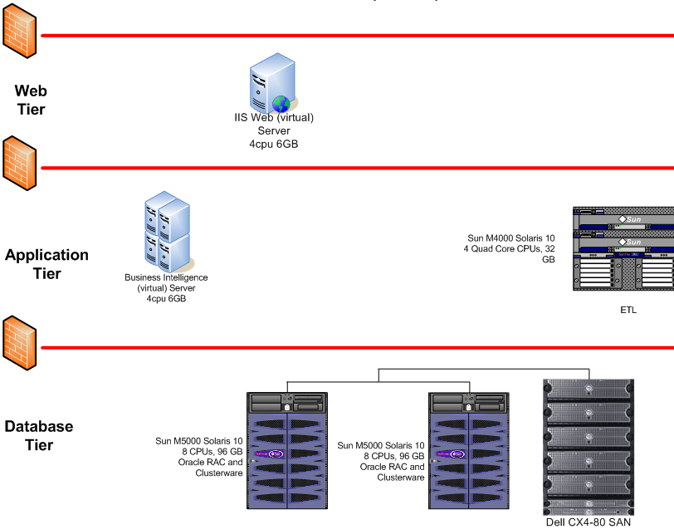

# Work Approach

The goal of the CFSDW project is to provide a reporting and data warehouse solution that supports the transition of campus users from a distributed Oracle Finance implementation with varied reporting solutions to a centralized Oracle implementation with a centralized reporting structure.

## Overall Approach

The Finance data warehouse will extract and load campus and CO data from a nightly replication of the CFS consolidated data base. It will be updated nightly providing data current as of close of business (COB) the night before. Individual campus data will be loaded into the data warehouse upon their migration to CFS.

In July 2010, the data warehouse will include 10 General Ledger Data Marts. A data mart is a subset of the organization's/campus’ data, focused on a specific subject area or business area. The data marts are designed for ease of reporting. Data Marts are comprised of Fact and Dimension tables. The fact tables consist of the measurements, metrics or [facts](http://en.wikipedia.org/wiki/Facts) of a specific [business process](http://en.wikipedia.org/wiki/Business_process). The dimension tables contain attributes which provide descriptions about the facts including who, what, when, where, and how. Typical finance dimensions are Fiscal Year, Period, Department, Account category…

The GL data marts contain, by campus, all ledger (summary) data, and the corresponding detailed transactions.

The Fact Tables are:

* Campus (5 data marts)
  + Actual Transactions
  + Budget Transactions
  + Encumbrance Transactions
  + Pre-Encumbrance Transactions
  + Summary Level data
* FIRMS/Legal (4 data marts)
  + Actual Transactions
  + Budget Transactions
  + Encumbrance Transactions
  + Summary Level data
* GAAP Summary (1 data mart)

The Dimension tables are:

* Document Source
* Day
* Period
* Program
* Department
* Ledger
* Account
* Fund
* Project
* Business unit
* Budget Scenario
* Vendor

End-users will access the data warehouse through a centralized reporting infrastructure using Oracle Business Intelligence (OBIEE) which includes:

* A role-based, user-friendly Web interface
* Subject-oriented, interactive “Dashboards” containing the common set of core reporting capabilities required by campuses and the Chancellor’s Office (a Dashboard is a user interface that organizes and presents information in a way that is easy to read)
* A security framework which controls authentication and provisioning of appropriate data access for campus and Chancellor’s Office end-users

Major objectives of the overall work approach is to:

* Integrate project plan priorities with the Common Financial System implementation plan
* Develop centralized dimensional data marts based on the business requirements as defined by the CFS Design Team (July 2010), and the CFS Governance Structure working closely with FOA and the reporting CAT Team (July 2010 – July 2011)
* Provide centralized reporting based on common campus reporting requirements
* Develop a user friendly web based reporting solution using the Oracle OBIEE reporting solution.
* Implement a train-the-trainer program
* Continue to extend data warehouse functionality by following an iterative development methodology that incorporates data warehouse best practices
* Develop and foster a collaboration of Chancellor’s Office and campus personnel to provide ongoing support in the following areas:
  + Ongoing Data and Reporting Requirements Management
  + Report/Query Development
  + Dashboard Design
  + Testing
  + Training and Documentation
  + End User Support

## Dashboards & Reports

The first developed set of dashboards and reporting capabilities will be designed to match the requirements as defined by the CFS Design Team which are based on the CSU SLO Calpoly data warehouse reporting model and the CAT Team. This first set of deliverables report against the five “Campus” GL data marts and will provide campuses with the Budget to Actual detail currently supplied via a combination of their campus PS/Query and nVision reports. The next step for release 2 includes development of reports in support of FIRMS/Legal and GAAP requirements as well as other reports as defined and prioritized by the campus user community through a Campus Action Team (CAT) for reporting team.

In March 2010, a Campus Action Team (CAT) for reporting will begin meeting to review the first developed set of dashboards and reporting capabilities. The purpose of this CAT Team is to gain familiarity with the currently developed Oracle Business Intelligence (OBIEE) interactive dashboards and reports, experience the flexibility that is available with the full range of report criteria options, and provide feedback to the report designers. Participants will also beasked to validate that the dashboards/reports meet their reporting requirements. If more reports are needed to satisfy user reporting requirements, this group will be asked to identify, and define additional needs. It is expected that a reporting CAT team will continue to meet on a routine basis. The goal is to create a community of campus and CO resources to assist in the ongoing identification, definition, prioritization and development of core reporting and analytic capabilities.

**One Dashboards & Reporting Capabilities Deliverables**

A dashboard is a user interface that organizes and presents information in a way that is easy to read. Each dashboard is comprised of pages with each page providing a unique set of reporting capabilities.

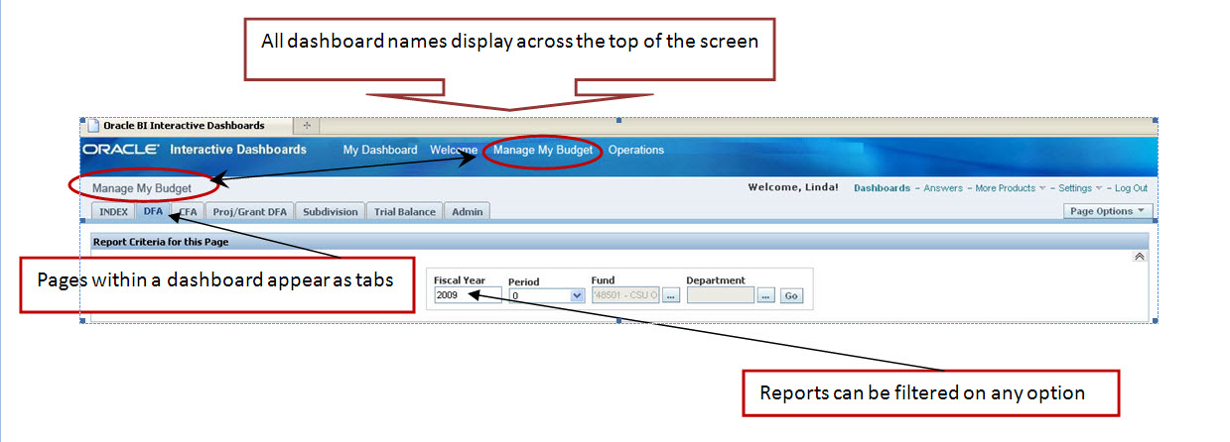

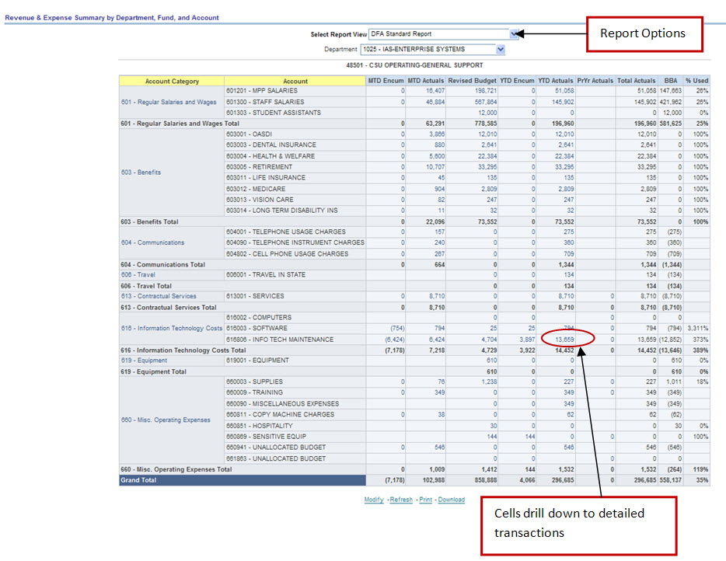

**Release One Dashboards and Reports**

The Common Financial Reporting environment will be accessed through a web link provided in the CSU Portal. This link will direct end users to a set of interactive dashboards containing the first set of common, core reporting capabilities required by campuses and the Chancellor’s Office.

Initial development includes two dashboards and related pages geared for:

* Finance Operations - Power users **(Operations)**
* Department end users **(Manage My Budget)**

## Training Approach

The planned approach is to deliver a web based, train-the-trainer program which will empower campuses by developing internal training resources. Each campus will be asked to identify 6 to 8 individuals to participate in the training as well as a campus contact who will act as the training coordinator for their campus. The training schedule will be coordinated to align with the rollout of each Wave. Campus participants will be trained up to 3 months in advance of their first month close in the CFS Consolidated environment the initial training will focus on the use of the OBIEE reporting toolset and the first set of delivered dashboards and associated reporting and analytic capabilities.

Teleconferences will be set up to provide a support for campus and CO trainers and power users in the use of the OBIEE and the common financial reporting environment. It is expected that a subset of these individuals will become a members of the Campus Action Team (CAT) for reporting and contribute in the identification, definition, and development of common core reporting and analytic capabilities for the CSU.

# Project Organization

Working in close collaboration with the Design Team, the Enterprise Reporting and Data Warehouse Services (ERDWS) Team is responsible for performing the design, development, and operational duties of the reporting and data warehouse lifecycle as defined the detailed project plan. The ERDWS Team staffing includes:

* Cheryl Kwiatkowski, Director, Enterprise Reporting and Data Warehouse Services
* Viet Hoang
* Linda Horan
* Minh Pham
* Kevin Chi

## Project Roles and Responsibilities

| Role | Responsibility | Primary Resource |
| --- | --- | --- |
| Data Warehouse Project Manager /Team Lead | The Data Warehouse Project Manager has overall responsibility for a project’s successful implementation. The project manager defines, plans, schedules, monitors, and coordinates the activities of the team, and reviews their deliverables. | Director, ERDWS |
| Business/Data Analyst(s) | The role of the business analyst is to perform research and possess knowledge of finance business reporting and analysis needs, and will assist in the development of the common financial reporting solution business requirements definition. | Design Team  CAT Team  ERDWS |
| Data Architect | The Data Architect responsibilities encompass definition of overall data warehouse architectures and standards, definition of data models for the data warehouse and all data marts. | ERDWS |
| ETL Developer | The ETL Developer develops various functional components of the data warehouse applications including extract programs on source systems, ETL applications, data cleansing functions, system management functions including load automation, data acquisition functions and others. | ERDWS |
| System Administrator | The System Administrator is responsible for maintaining hardware reliability, system level security, system level performance monitoring and tuning, and automation of production activities including extract and load functions, repetitively produced queries/reports, etc. The system administrator is also responsible for ensuring that appropriate disaster recovery functions such as system level backups are performed correctly and on an accepted schedule. | CO Data Center Services |
| Database Administrator | The Database Administrator is involved in database design, especially the physical design used to implement the data warehouse or data marts. The DBA monitors and tunes DBMS performance, administers end-user access and security at the DBMS level, ensures that DW data is appropriately protected via database backup and related strategies, assists with load process automation, and evaluates and selects infrastructure components. | CMS |
| Business Intelligence (BI) Developer | The Business Intelligence (BI) Developer develops data access queries/programs using OBIEE and assists end users with development of complex ad hoc queries and analyses. This role may be a power user trained in the use of the query/reporting/analysis tool. | ERDWS  Campuses |
| Business Intelligence (BI) Tool Trainer | The Business Intelligence (BI) Tool Trainer is responsible for training end users to use data query/analysis/ reporting tools, assisting end users in development of queries and reports, and assisting in development of production queries/reports. | ERDWS  Campuses |
| Security Administrator | The duties of the Security Administrator include the setup of user IDs and system access roles for each person or group which is given access to the data warehouse or data mart. | Campuses |
| Help Desk | The role of the Help Desk is to maintain a central point of contact for all campus and CO for all data warehouse related matters. | Campuses – Level 1  CO Service Center – Level 2  ERDWS- Level 3 |