**Financial Market Reaction to Standard and Poor’s U.S. Credit Outlook**

**Background:** At approximately 13:09GMT on Monday, April 18, 2011, or 9:09am Eastern Standard Time (in New York), Standard and Poor’s released a statement that it was cutting its long-term outlook for U.S. sovereign debt from stable to negative. The New York Stock Exchange opened approximately 20 minutes later (at 9:30am). The Bloomberg.com article and charts which follow trace the impact of that announcement on financial markets.

***Bloomberg.com April 18, 2011***

U.S. stocks sank the most in a month, and gold rose to a record after Standard & Poor’s cut the American credit outlook to negative and concern about Europe’s debt crisis worsened. S&P cut its long-term outlook for the U.S. to negative from stable, while affirming its ‘AAA’ long-term and ‘A-1+’ short-term ratings. Greek two-year bond yields surged to 20 percent for the first time since at least 1998. Gold prices in New York climbed as much as 0.9 percent to $1,498.60.

**‘Material Risk’**

S&P assigned a one-in-three chance it will lower the U.S. rating in the next two years, saying the credit crisis and recession that began in 2008 worsened a deterioration in public finances. Budget differences among Democrats and Republicans remain wide and it may take until after the 2012 elections to get a proposal that addresses the concern, S&P said.

S&P said in the statement that it believes there is a “material risk” that U.S. officials may not reach an agreement on how to address budgetary challenges by 2013. “It’s truly a shot across the bow and a message to Washington, which has been clowning around on this and playing politics when they should toss ideology aside and focus on achievement,” said [David Ader](http://search.bloomberg.com/search?q=David%20Ader&site=wnews&client=wnews&proxystylesheet=wnews&output=xml_no_dtd&ie=UTF-8&oe=UTF-8&filter=p&getfields=wnnis&sort=date:D:S:d1&partialfields=-wnnis:NOAVSYND&lr=-lang_ja), head of government bond strategy at Stamford, Connecticut-based CRT Capital Group LLC. “It’s a big deal. They’ve put us on notice.”

Treasury Assistant Secretary [Mary Miller](http://search.bloomberg.com/search?q=Mary%20Miller&site=wnews&client=wnews&proxystylesheet=wnews&output=xml_no_dtd&ie=UTF-8&oe=UTF-8&filter=p&getfields=wnnis&sort=date:D:S:d1&partialfields=-wnnis:NOAVSYND&lr=-lang_ja) said today that S&P’s outlook on the U.S. credit rating “underestimates” the nation’s leadership. “We believe S&P’s negative outlook underestimates the ability of America’s leaders to come together to address the difficult fiscal challenges facing the nation,” Miller said in a statement.

**Market Reaction**

The S&P 500 tumbled 1.6 percent to 1,298.09 at 1:13 p.m. in New York and the [Stoxx Europe 600 Index](http://www.bloomberg.com/apps/quote?ticker=SXXP:IND) slid 1.7 percent. Ten- year Treasury yields lost three basis points to 3.38 percent as concern about Europe’s finances overshadowed S&P’s move. The euro lost 1.4 percent to $1.4227, while [Portuguese](http://www.bloomberg.com/apps/quote?ticker=CPGB1U5:IND) debt- insurance costs rose to a record.

The MSCI All-Country World Index of shares in 45 countries tumbled 1.8 percent. Global stocks also slid after China increased banks’ reserve requirements to lock up cash and cool inflation, and central bank Governor [Zhou Xiaochuan](http://search.bloomberg.com/search?q=Zhou%20Xiaochuan&site=wnews&client=wnews&proxystylesheet=wnews&output=xml_no_dtd&ie=UTF-8&oe=UTF-8&filter=p&getfields=wnnis&sort=date:D:S:d1&partialfields=-wnnis:NOAVSYND&lr=-lang_ja) said monetary tightening will continue for “some time.”

Thirty-year Treasury yields climbed less than one basis point to 4.48 percent. Two-year yields slipped four basis points to 0.66 percent. The dollar slid 0.9 percent to 82.42 yen, the lowest level of the month, while still strengthening against 14 of 16 major peers.

The cost to protect U.S. corporate bonds from default rose to the highest level this month. The Markit CDX North America Investment Grade Index, which investors use to hedge against losses on corporate debt or to speculate on creditworthiness, added 1.9 basis point to a mid-price of 95.9 basis points, according to index administrator Markit Group Ltd.

About 18 stocks declined for every one that gained in the [Stoxx Europe 600](http://www.bloomberg.com/apps/quote?ticker=SXXP:IND). Commerzbank AG, Spain’s biggest lender, and France’s Societe Generale SA fell at least 3.9 percent. [Smith & Nephew Plc](http://www.bloomberg.com/apps/quote?ticker=SN%2F:LN), which had been identified as a bid target for Johnson & Johnson by analysts at Sanford C. Bernstein & Co., Morgan Stanley and Investec Securities, declined 3 percent after Synthes Inc. said it’s in talks about a possible takeover by J&J.

The euro depreciated against 13 of its 16 major counterparts, losing 2.2 percent versus the yen. Portugal’s 10- year yield climbed to a record 584 basis points above [benchmark](http://www.bloomberg.com/apps/quote?ticker=.PTGERSP:IND) German bunds while the [Greek spread](http://www.bloomberg.com/apps/quote?ticker=.GRGER10:IND) reached 1,132 basis points, the most since Bloomberg began collecting the data in 1998.

Credit-default swaps insuring [Greek](http://www.bloomberg.com/apps/quote?ticker=CGGB1U5:IND) bonds jumped 66 basis points to 1,221, signaling a 64.5 percent chance of a default within five years, while those for Portugal climbed 18.5 basis points to 616.5, according to CMA.

Greece isn’t discussing restructuring its debt, Finance Minister [George Papaconstantinou](http://search.bloomberg.com/search?q=George%20Papaconstantinou&site=wnews&client=wnews&proxystylesheet=wnews&output=xml_no_dtd&ie=UTF-8&oe=UTF-8&filter=p&getfields=wnnis&sort=date:D:S:d1&partialfields=-wnnis:NOAVSYND&lr=-lang_ja) said April 16 in Washington. European Central Bank Governing Council members signaled over the weekend they will keep tightening monetary policy this year to curb inflation.

“The European story has a lot of risks to it as Germany is very strong but peripheral Europe is clearly quite weak, so the last thing they need is higher interest rates,” [Adrian Mowat](http://search.bloomberg.com/search?q=Adrian%20Mowat&site=wnews&client=wnews&proxystylesheet=wnews&output=xml_no_dtd&ie=UTF-8&oe=UTF-8&filter=p&getfields=wnnis&sort=date:D:S:d1&partialfields=-wnnis:NOAVSYND&lr=-lang_ja), JPMorgan Chase & Co.’s Hong Kong-based chief Asia and emerging- markets strategist, said in a Bloomberg Television interview.

The yield on Germany’s 10-year bund declined 13 basis points to 3.25 percent. The 10-year gilt yield slipped four basis points to 3.56 percent. The pound fell 0.5 percent versus the dollar after Ernst & Young LLP’s Item Club cut its economic outlook for the U.K.

**Summary**

Of the 17 countries rated triple-A by Standard & Poor’s, the United States now has the distinction of being the only sovereign to see its rating outlook cut to negative by S&P. But as Alan Ruskin, global head of G-10 FX strategy at Deutsche Bank, noted, the deficit/debt concerns behind S&P’s decision shouldn’t come as a surprise “to any market professional with a pulse.”

Also worth noting that a negative outlook is quite different from being placed on negative review and doesn’t always lead to an automatic rating downgrade.

**Charts Relating to S&P Announcement and Europe’s Debt Crisis**

The following pages present charts of various financial markets showing how these markets reacted to the S&P announcement as well as the ongoing debt crisis in Europe.

**Chart 1: German Stock Market**

As noted below, the DAX index fell immediately after the release of the S&P statement (around 3:09pm in Germany).

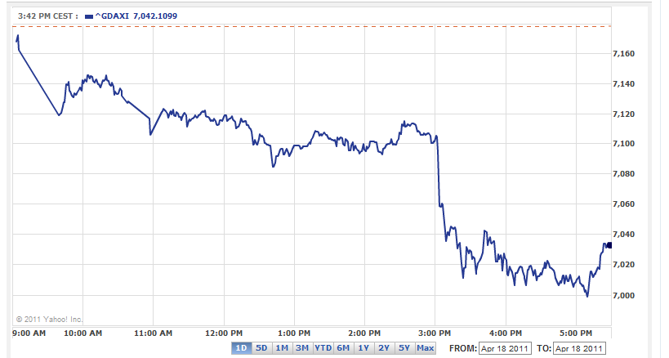

**Chart 2: London Stock Exchange**

As noted below, the London Stock Exchange (FTSE 100) fell immediately after the release of the S&P statement (around 2:09pm in London)

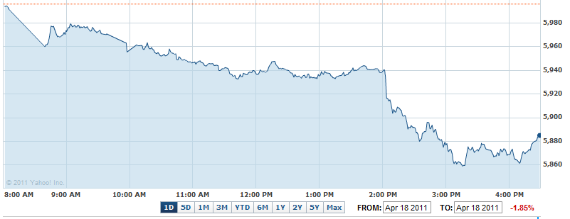

**Chart 2: Dow Jones Industrial Average**

Note that the stock market opened approximately 20 minutes after the S&P announcement. The DJIA opened at 12,158.15 down 180.55 points from Friday’s close (12,338.70). The DJIA reached a low of 12,099.04 at 11:09am. The DJIA closed the day at 12,200.91.

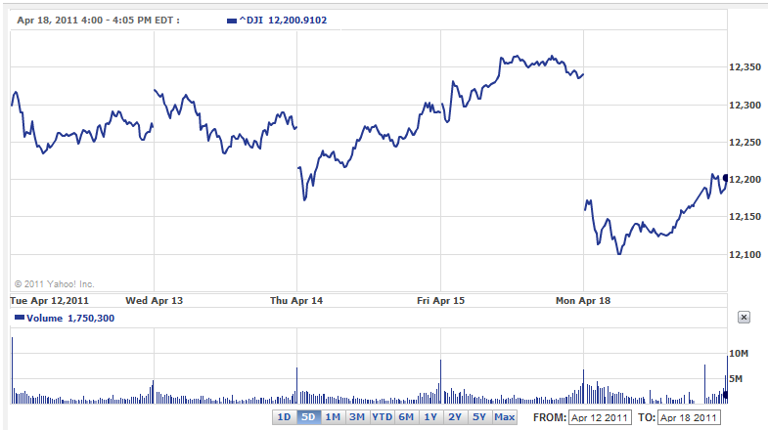

**Chart 3: Euro U.S. dollar Exchange Rate**

As noted, the euro continued to weaken against the U.S. dollar

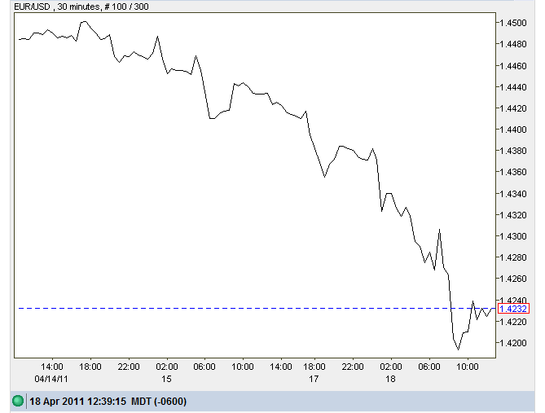

**Chart 4: Yen U.S. dollar Exchange Rate**

As noted, the Yen strengthened against the U.S. dollar reflecting its safe haven status. Note that the time scale on this chart is GMT.

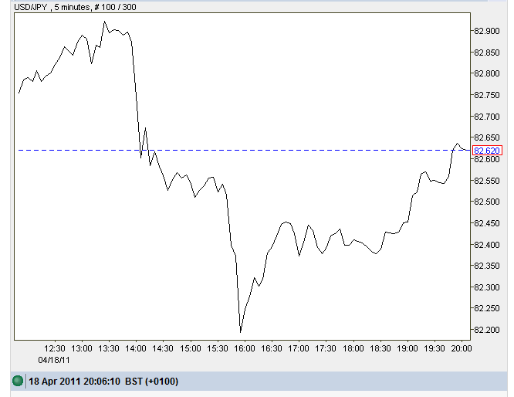

**Chart 5: Spot Gold Prices in New York**

Note the jump in spot gold prices immediately after the S&P announcement (9:09 EST). Bid refers to the price at which gold dealers are offering to buy gold for immediate delivery (i.e., spot).

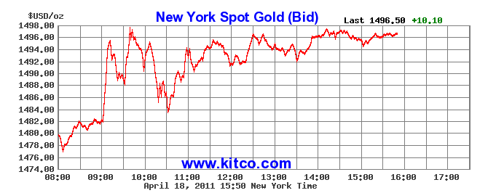

**Chart 6: U.S. Treasury Yields and Prices (and the Yield Curve). April 18, 2011**

Note from 2 years out to 30 year maturities, the prices of U.S. Treasuries actually rose and accordingly their yields fell (look at Price/Yield Change Column).

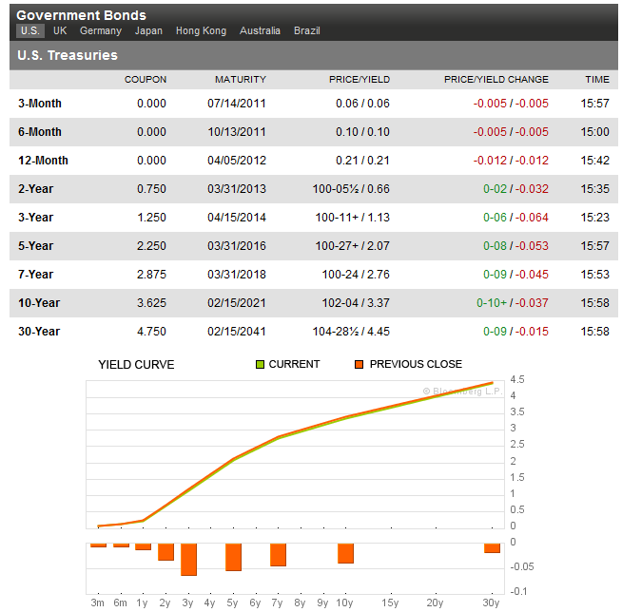

**Chart 7: Greek Government CDS (Quotes through April 15th)**

