
Introduction to Bike Repair:

Cranks & Bottom Brackets

Types of bottom brackets
Most bottom bracket shells are 68mm wide. The inside diameter is typically 33.6-33.9mm with ashtabula cranks using an inside diameter of 51.3mm. The threads are typically 24 threads per inch.
- Loose Bearing: This type of bottom bracket works with a 3 piece crankset. The bearings are held inside the bottom bracket shell with a cup and cone, in the same fashion as a wheel hub.
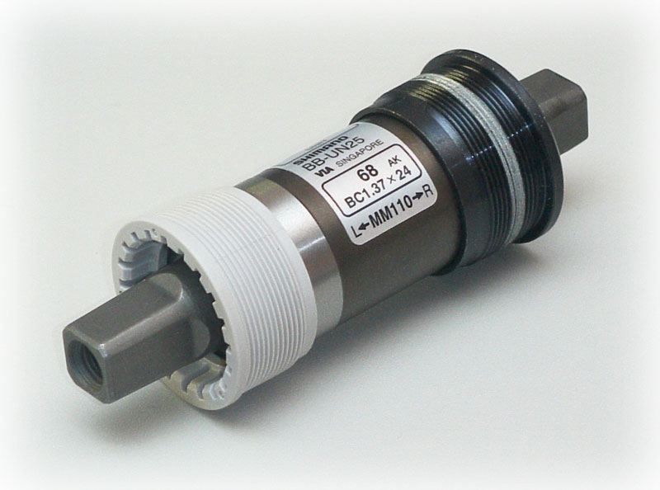Cartridge Style Bottom Bracket[e]
- Cartridge: This type of bottom bracket is completely self-contained. It comes as two parts – the integrated spindle and bearings, and a support cup to keep the spindle in place. This type of bottom bracket is not serviceable and must be replaced when it is damaged or worn out. Removal consists of unscrewing the support cup and pulling out the spindle assembly.
- One-piece (ashtabula): This type of bottom bracket has integrated crank arms that are a single piece and a pressed in cone to hold the bearings.
- External Bearing: this type of bottom bracket is a new development. They have many similarities to the cartridge style bottom bracket, with the exception that the bearings are housed on either side of the bottom bracket shell.
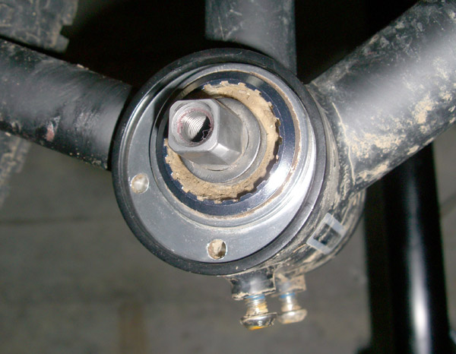An eccentric bottom bracket with plug [f]
- Eccentric: An Eccentric bottom bracket is an oversized bottom bracket shell that has been fitted with a plug that may be rotated. A standard bottom bracket fits into one side of the plug. The plug is rotated to adjust the length of the chain line. These are typically found on tandems.

One piece crank (Ashtabula) removal and installation
The one-piece crank is the simplest type of crank. It is often found on older bikes and bmx bikes as it is heavy and not prone to failure. One-Piece cranks are only found on threadless bottom brackets.
- Remove the left pedal (reverse threaded)
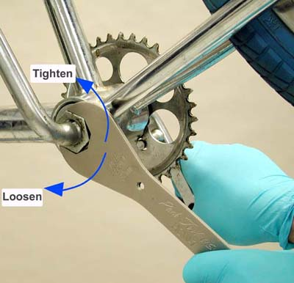One-Piece Crank Removal [d]
- Using a large wrench remove the locknut on the left side of the bottom bracket (reverse threaded)
- Remove the keyed washer
- Using a pin spanner or a screwdriver remove the left side cone (reversed threaded).
- Remove both the bearing retainers making sure to remember orientation and which side it came off of.
- The right side cone is pressed into the frame, it should only be removed if it needs to be replaced. Use a hammer and punch to remove it.
- Clean and dry all parts. Make sure that the bearings and cups are not pitted. If there is pitting then replace the defective parts
- Lubricate the bearings with heavy grease.
- Installation is the reverse of removal.
- Adjust the bearing tension so that the cup is as loose as possible, but without play, by tightening and loosening the left side cone. Tighten the lockring down when the appropriate tension is achieved.

Cranks
The cranks are the part of your bike that connect the pedals to the chain-rings and bottom bracket. There are severals different types of cranks in common use:
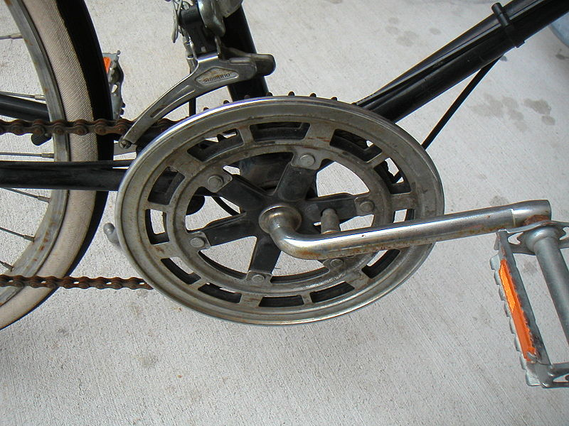One-Piece Crank [a]
- One-Piece - This type of crank is a single piece of metal from one pedal, through the bottom-bracket shell and onto the other pedal.
- 3-Piece Cottered - This type of crank consists of 2 "pedal arms" and a bottom bracket. The arms connect to the bottom bracket with a pin that runs parallel to the bottom bracket at their base. This pin is called a cotter.
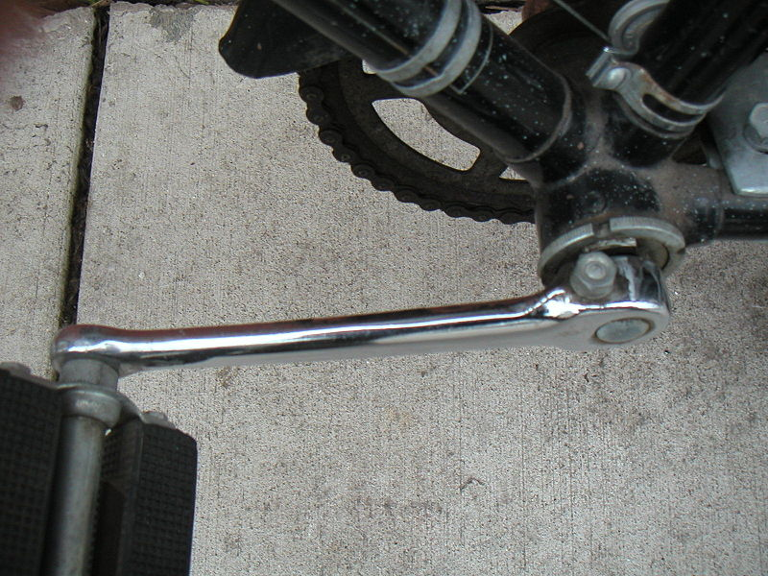Cottered Crank [b]
- 3-Piece Cotterless - This type of crank is the same a cottered crank, with the exception that the arms connect to the bottom bracket with a bolt that runs into the end of the bottom bracket.
- 2-Piece - This type of crank has the bottom bracket assembly permanantly attached to one arm of the crank

Cotterless Crank Arm Installation and Removal
If a crank arm is bent, the bottom bracket needs to be accessed, the chain-rings need to be removed, or the pedal threads are stripped then removing the crank arms is often useful. Removal is simple:
- Remove the dust cap (if present) from the end of the arm.
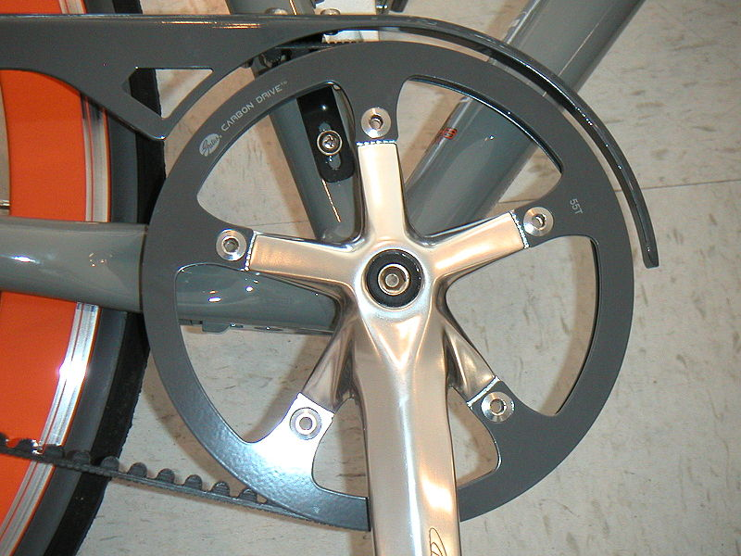Cotterless Crank [c]
- Using a socket wrench remove the bolt that holds the arm onto the bottom bracket
- Rotate the crank-extractor with respect to the head so that the larger, outer piece, is as far from the handle as possible.
- Thread the larger threads of the crank-extractor into the threads of the hole that the bolt came out of.
- Rotate the handle of the crank-extractor to push the smaller 'foot' of the extractor to push against the bottom bracket. This should cause the crank arm to be pulled off.
- Re-install the arm by pushing it onto the bottom bracket post and tightening the bolt.

Credits
[a] http://en.wikipedia.org/wiki/File:One-piece_crank.JPG
[b] http://en.wikipedia.org/wiki/File:Cottered_crank.JPG
[c] http://en.wikipedia.org/wiki/File:Belt-drive_crankset.JPG
[d] http://www.parktool.com/images_inc/repair_help/bb302.jpg
[e] http://en.wikipedia.org/wiki/File:Shimano-UN25-68x110-ST.jpg
[f] http://www.pvdwiki.com/images/6/63/Bbshim3.jpg

