**10 Tips for Effective Financial Presentations**

[[Hide All](javascript:AlterAllDivs('none');)Hide All](javascript:AlterAllDivs('none');)

When you present financial information to team members, investors, or other parties, it's essential that you not only communicate the basic information, but that you help the audience analyze and actually understand it. To do this, you can create a Microsoft Office PowerPoint® presentation to help make your points in a way that would be impossible with just a verbal presentation and handouts.

**The PowerPoint paradox**

PowerPoint is a powerful tool with almost limitless design and production possibilities — and therein lies the danger. With so much to choose from in PowerPoint, it's possible to overwhelm your content with your dazzling presentation. And it's so easy to create slides, that you can quickly make more than you'll ever have time to show.

**It's all about the story**

Financial presentations tell a story. You're not just showing a collection of profit-and-loss statements and balance sheets — you're telling a story that your audience needs to hear. It may be a story of a new company with promising growth. Or, maybe it's a story about meeting market challenges. Whatever your story is, stick to it: Toss everything that doesn't help you tell it in a compelling, easy-to-follow way. Tell your story with simplicity and clarity.

Many studies have been done on the best ways to present financial data. Communication experts, including David Brooks, 1990 Toastmasters World Champion of Public Speaking, agree on basic principles of effective presentations. These 10 tips can help you focus on your story and present financial information more effectively.

1. **Limit the amount of information on each slide.**Most people can easily see five or six words per line and five or six lines per slide. The guidelines apply to financial reports — so instead of showing full reports, focus on just the main points, with no more than four to six columns and six to eight rows.

For example, this simplified profit-and-loss statement is easy to read on paper, but on a slide it's more like an eye exam.

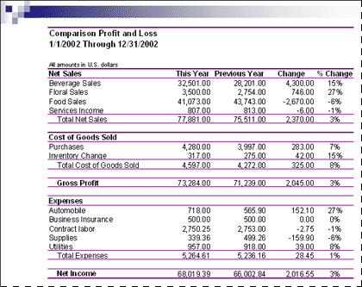

People cannot read or retain this much complex information on slides. It's too small to read, and it's too much information to retain. Use your slides to make or illustrate your point, and save the detailed financial statements for the handouts.

1. **Use charts.**Your audience would have a difficult time analyzing 12 months' worth of data in a report, but they can instantly visualize 12 months of sales and net profit in a chart. Continuing with the preceding example, you can use a chart to show how sales from different areas are changing.

Depending on the point you want to make, you could use pie charts to show how your overall product mix is changing. Or, you could play up the fact that although service sales are down, beverage sales more than made up for it and total sales and net income are up.

Unless you are comparing results, for example on two pie charts, use only one chart per slide. Make the charts as large as possible on the slide.

Bar chart



Line chart



1. **Use a readable font and font size.**Some experts recommend a font designed specifically for online viewing, such as Tahoma® or Verdana®, but others would choose readable classic fonts, such as Goudy. Remember that ornate or very blocky fonts are difficult to read in slide shows, and try to keep the font size at 32 or greater.

[WordArt (WordArt: Text objects you create with ready-made effects to which you can apply additional formatting options.)](javascript:AppendPopup(this,'ppdefWordart_1_1')) has its place, but less is generally more in a financial presentation. Mr. Brooks considers runaway WordArt to be "the mark of a pure amateur." He points out that typography is an art; fonts are carefully created by professionals. And then, "words are squeezed, twisted, or worse yet animated. It's comparable to listening to music at a different speed, totally destroying the artist's work."

1. **Go easy on the transitions.**Venetian blinds and wagonwheel transitions are fun, but they can be distracting in a financial presentation. And checkerboard transitions can actually be difficult to look at when they come between slides that display mostly numbers.

Mr. Brooks prefers the left-to-right wipe, but he says, "the important thing is to pick one transition and stick to it." Some experts recommend a different transition between major topics. In most cases, it's best to err on the side of simplicity. Let the audience notice slide content — not slide transitions.

Remember, if something doesn't add to your presentation's story, it probably detracts — and nothing distracts like a big transition fanfare to celebrate the pressing of the **Next** button.

1. **Choose high-contrast backgrounds and colors.** According to Mr. Brooks, you can't go wrong with a black or dark blue background and white or light yellow text. Some people prefer black text on a white background; although the white background is somewhat harsher, it is easier to see in a room with more light. Bonus: When you use black text on a white background, you don't have to dim the lights so low that you lose half your audience to a quick nap.

If you add background designs, keep them simple and make sure they don't overlap and obscure your information. And consider the quality of the projection system you will be using. Beautiful backgrounds and colors may not look the same on the large screen as they do on your computer — another reason to keep your backgrounds simple.

1. **Use blank or black screens between illustrated points.**When the action is not on the screen, don't hesitate to insert a blank screen, or temporarily black out the screen. The focus will then be on you and your message — not on the previous topic or the one coming up next.
2. **Check for unintended color combinations or symbols.**It should go without saying that unless you're presenting financial statements for a doll company, avoid pink and purple. If it's not a Christmas boutique, stay away from green and red combinations. Likewise, look for incongruous background shapes, like shapes that look like stops signs on an otherwise positive financial presentation.

Unintended color combinations and symbols

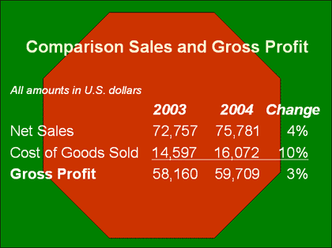

Same report with black text on a white background

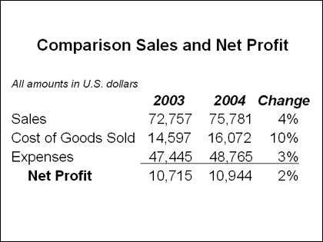

1. **Provide useful handouts.**A good PowerPoint presentation seldom makes a useful handout without some adjustments. If you've kept your PowerPoint slides concise — five or six words to a line and five to six lines per slide — printing your slides one to a page would take reams of paper and have text so large it would strain the eyes. One solution is to print more than one slide per page.

[[Show](javascript:ToggleDiv('divExpCollAsst_1'))How?](javascript:ToggleDiv('divExpCollAsst_1'))

* 1. Hide any slides you do not want to print.

[[Show](javascript:ToggleDiv('divExpCollAsst_2'))How?](javascript:ToggleDiv('divExpCollAsst_2'))

* + 1. On the **Slides** tab in normal view, do one of the following:
       - To select nonadjacent slides, click one slide, and then hold down CTRL and click each additional slide.
       - To select adjacent slides, click the first slide in the sequence, hold down SHIFT, and then click the last slide.
    2. On the **Slide Show** menu, click **Hide Slide**. The hidden slide icon Hidden slide iconappears with the slide number inside, next to the slide you have hidden.

**Note**  The slide remains in your file, even though it is hidden when you run the presentation.

* 1. On the **File** menu, click **Print Preview**.
  2. To set headers and footers, click the arrow on the **Options** button, and then click **Header and Footer** Button image.
  3. On the **Print Preview** toolbar, in the **Print What** box, click the **Handout** layout option you want.

Two to four slides per page generally works well.

* 1. To choose the page orientation, click **Portrait** Button imageor **Landscape** Button imageon the [toolbar (toolbar: A bar with buttons and options that you use to carry out commands. To display a toolbar, press ALT and then SHIFT+F10.)](javascript:AppendPopup(this,'IDH_oftipToolbar_2_2')).

Handout with four slides on a page

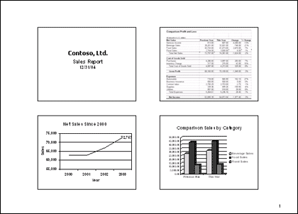

* 1. On the **Print Preview** toolbar, click **Print**Button image.

**Note**  After you print, don't forget to unhide any slides that you need for your presentation.

Handouts are also the place for all the reference material, detailed charts, and any other information that is too difficult for viewers to see in a slide presentation, or that they need to take away with them.

Avoid passing out more than a sheet or two of paper at the beginning of the presentation. Some viewers won't be able to resist looking ahead — distracting themselves and the people around them.

1. **Arrive early.**Allow yourself plenty of time to make sure that you have everything and that it all works. You don't want to be searching for power cords and connections as your audience arrives.
2. **Get to the point.**Remember that your audience is busy and intelligent. Make your points — then know when to quit and let them read the handouts themselves.

**Summary**

By following these tips from the professionals, you can give more effective financial presentations. And when you see that your audience really understands the financial story you have to tell, you'll know that your presentation is a success.