Rachel Trudeau

**Name**______________________________  **Date**_______________ Page 1

I think I got________ points. Total Points_________/16

**Tell Me The Time!**

This test will show me that you understand how clocks measure time and how to tell time.

Circle

1. the tool used to tell time.

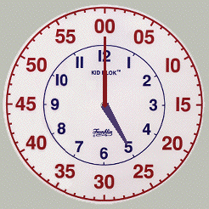 C:\Program Files (x86)\Microsoft Office\MEDIA\CAGCAT10\j0300840.wmf 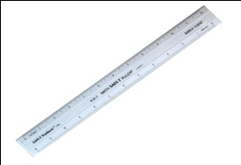 1 point

+____ /1

Page 2

2. 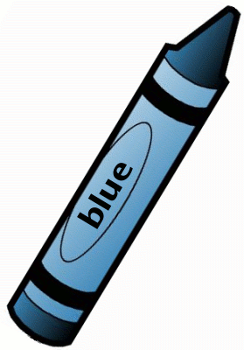Color the hour hand **blue**. 1 point

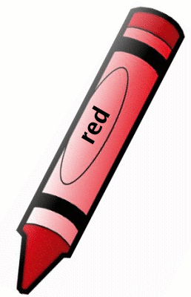 Color the minute hand **red**. 1 point

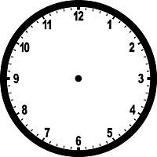

Write the time ______ o’clock. 1 point 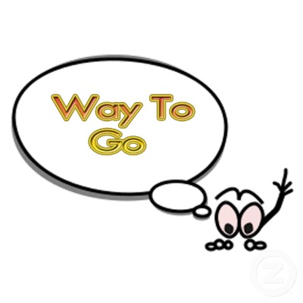 +____ /3 Page 3

**Use your kid klok !** 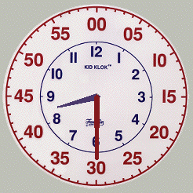

 Box when done!

3. Build your bed time 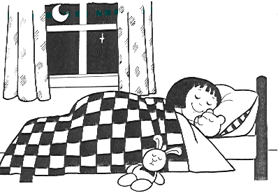 .

Draw your bed time  . 1 point

 Color hour hand **blue.** 1 point

Trace minute hand **red**. 1 point

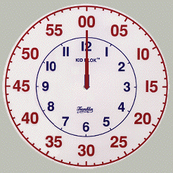

Write the time.

______ o’clock. 1 point

+____/4

Page 4

  You are so bright!

**Use your kid klok! **

** Box when done!**

4. Build the time **2 o’clock**. 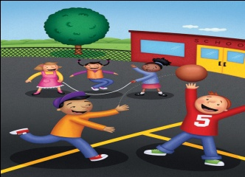

 Color hour hand **blue.** 2 points

Trace minute hand **red**. 1 point



Write the time. _____ O ‘clock 1 point

+____/4

Page 5

 Draw a picture of what you are doing at 2 o’clock.

2 points

 Write what are you doing at 2 o’clock? ___________________________ ----------------------------------------- ___________________________ -----------------------------------------___________________________

2 points

 Super Job! All Done! +____/4

Rachel Trudeau

Math Assessment

**Telling Time!**

This math assessment was created for Kindergarten students. During the school year students are introduced to the tool that measures time and landmark times to the nearest hour. The GLCES that I incorporated are:

**M.TE.00.02** Identify tools that measure time (clocks measure hours and minutes).

**M.UN.00.03** Identify daily landmark times to the nearest hour (lunchtime is 12 o’clock;

bed time is 8 o’clock).

When designing my assessment I knew I would need to incorporate the tool used to measure time and daily events to the hour, which students could relate to. I divided the test into three sections. In the first section, students circle the picture that correctly identifies the tool used to tell time. Students then use a red and blue crayon to color the hour and minute hand on the clock provided. The words o’clock will be given, a term that would be discussed in a prior lesson. Students will have to write the number that displays the time on the clock. For the second portion of the assessment, students will build their bedtime using their Kid Klok, draw the time on the clock provided and color the hour hand blue and minute hand red. Students will write the number of the time on the blank line provided, o’clock will already be present. Finally, in the last section of the assessment students will build the time 2 o’clock using their kid klok. Students will draw the time on the clock provided, and color the hour hand blue and minute hand red. Students will write the number of the time, o’clock is provided. Finally, students will explain what they are doing at the landmark time 2 o’clock. The more difficult sections of the assessment were at the end and the easier questions at the beginning, so Bloom’s synthesis is apparent. My initial thinking was it would take Kindergartners about 15 -20 minutes to complete since it took me about 5 minutes to finish the assessment. My mid- term partners Stephanie Brigolin and Desiree Wortkins both completed the test in 4 minutes, and my final partner Kara Hellinski completed it in 5 minutes. After averaging the scores I concluded an appropriate time frame would be about 12-15 minutes. For Kindergartners, the time gets tripled and based on the time it took me and my peers to complete the assessment I feel this time frame is practical.

When creating this assessment my objectives were for students to understand the tool used for telling time is a clock and clocks measure hours and minutes. Students would be able to recognize the difference between the hour and minute hand. Students would also be able to identify landmark times to the nearest hour such as lunchtime 12 o’clock and bedtime 8 o ‘clock. Students would be able to identify the correct placements of the minute and hour hand to show a specific hour and write the digital hour with o’clock already provided for them. I believe it is imperative for students to build times on a clock, before drawing the time on the assessment. Students need to physically see it displayed in front of them before writing it.

**Literature Connections**

I found various literature connections to help prepare my lessons and assessments on time. All the books address the specific GLCES and complement the lesson ideas well. The books have great illustrations and show students how the hour and minute hands measure time. The books include landmark times and address the important things that happen at the hour. These books are great references for students to look through to help with any difficulties they may be having. Students can read the books at centers and share prior knowledge or experiences about time with each other.

I found a video that allows students to pretend they are detectives and through an investigation must solve a mystery about time.

Tick! Tock! Jungle Clock: Turn the Hands to Tell the Time!

By Thomas Taylor

Illustrated by Thomas Taylor

It's About Time, Jesse Bear

By Nancy White Carlstrom

Illustrated by Bruce Degen

# It's About Time!

### By Stuart J. Murphy

### Illustrated by John Speirs

Me counting Time

From Seconds to Centuries

Written by Joan Sweeney  
Illustrated by Annette Cable

Series Fun to Learn: All about Telling Time Video

**Lesson Ideas for Time Unit**

1. **›** [Visit Amazon's Thomas Taylor Page](http://www.amazon.com/Thomas-Taylor/e/B001HCX7XW/ref=ntt_athr_dp_pel_pop_1)

Find all the books, read about the author, and more.

See [search results](http://www.amazon.com/s/ref=ntt_athr_dp_sr_pop_1?_encoding=UTF8&sort=relevancerank&search-alias=books&field-author=Thomas%20Taylor) for this author

Are you an author? [Learn about Author Central](http://authorcentral.amazon.com/gp/landing/ref=ntt_atc_dp_pel_1)

It’s important to begin the time unit by introducing a large Kids Klok for students to observe and interact with. A class discussion should occur about what they observed. Topics included should consist of the different size and color of the hands on the clock. Students need to recognize the minute hand is red and longer and the hour hand is blue and shorter. Draw student's attention to the clock in the classroom. Ask how many big numbers are on the clock? Have students point to the hour hand. Tell them that when the hour hand moves from one number to the next, one hour has passed. Have students point to the minute hand. Tell them that when the minute hand moves from one tick mark to the next, one minute has passed. Students should note the importance of clocks in our daily lives. Students are then ready to make clocks of their own. These clocks will be made from paper plates and students will label the hours on the clock. Including the minutes is a great idea for implementing higher thinking skills. This will help students learn to count by 5’s and assist them in learning the hour.

In some circumstances students have pre- made clocks with the hours and minutes already sketched on them or individual Kid Kloks. A set of Kid Kloks for every student can be relatively expensive, therefore using paper plates that have 60 ridges works great. Allowing students to build draw and explain their own Kid Klok would be beneficial to their learning process.

1. As a whole group or in small groups students can play "Time Tic-Tac-Toe." Prepare blank tic-tac-toe grids and duplicate these for the students. Print Grid and have students write in times on the hour. (The degree of difficulty can be adapted as the student’s progress.) Display a clock showing a time. If the student has that time written on his/her game board, he/she may cover it with a marker. The first person to complete a row horizontally, vertically or diagonally wins.
2. Write times to the hour from 1 o'clock to 12 o’clock on index cards. Then number from 1 to 12 on a tag board squares. Put the numbers from 1-12 in a large circle to figure a clock face. Children sit around the clock. Give 12 children each a time card to keep facedown. Choose two volunteers, one taller than the other, stand in the center of the clock.

Ask the other students:   
Who should be the minute hand? Why? (the taller child because the minute hand is the long hand.)   
Where should the taller child point to show 2 o’clock? (to 12)   
Where should the shorter child point? (to 2)   
Children should take turns holding up their index cards. Students tell where the children representing the hands should point to show that time. Repeat the activity until all children have a turn to show the time.

1. Construct a partner matching game that allows students to match digital clock cards, analog clock cards and cards with daily landmark picture times. For example, students will match 12 o’clock digital with face clock that displays 12 o ‘clock, with a card that has a picture of lunch. Together students will group all like times and pictures together.

Students need to be aware of the important events that occur during the day. Instead of saying its “12 o’clock time for lunch,” have students refer to the clock and figure out together what time it is. This will make the students more attentive of the clock in the classroom and when to expect specific times in the day.