## Guidance Notes for staff and students on using the New Smart Card system

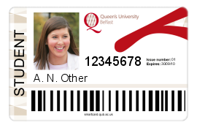

**Contents**

[Introduction 2](#_Toc271635636)

[Managing your card through “My Smart Card” 3](#_Toc271635637)

[Adding funds to your New Smart Card 7](#_Toc271635638)

[Checking the balances on your New Smart Card 10](#_Toc271635639)

[Printing and photocopying with your the New Smart Card 11](#_Toc271635640)

[Building/door access using your the New Smart Card 14](#_Toc271635641)

[Purchasing in catering outlets using your the New Smart Card 16](#_Toc271635642)

[Using your New Smart Card for your Student Experience Bursary 17](#_Toc271635643)

[Taking care of your New Smart Card 18](#_Toc271635644)

[Damaged, Lost or Stolen Cards 19](#_Toc271635645)

[Getting help / contacting us 20](#_Toc271635646)

[Appendix 1: Detailed Instructions - Printing 21](#_Toc271635647)

[Appendix 2: Detailed Instructions - Photocopying 22](#_Toc271635648)

Introduction

The University is implementing a new Smart Card system during summer 2010, offering a range of additional and improved services over the previous system. New cards were issued to all staff and returning students in August and new students will receive their new card as part of Enrolment and Registration in September.

If you are a returning student and have not received your new card, don’t worry. If required, a new card will be issued to you once you complete Enrolment and Registration.

You can use your new smart card for a range of services, including:

* Printing and photocopying in libraries, Student Computing Areas and some other locations
* The new smart card is already in use for access to the McClay Library and for borrowing books in all libraries
* Building/door access, including the International and Postgraduate Student Centre and the PEC
* Car park access (where appropriate)
* Catering purchases, in a number of University outlets
* Purchases in the Students’ Union Shop
* Spending the Student Experience Bursary

Please also note that your smart card is your staff/student ID and should be carried at all times when on campus.

Printing and photocopying will “go live” with the new smart card on **10 September 2010**. Please make sure you carry your new card from that date. Please also note that your old card will still be required to access some services (e.g. the PEC, the Student Experience Bursary) for a short period after that date.

The purpose of this document is to give you more information on the transition to the new card and on using your new smart card to access services. The sections below cover:

* Managing your card through “My Smart Card”
* Adding funds to your card
* Printing and photocopying
* Door access (including the libraries and PEC)
* Catering / Students’ Union Shop
* Student Experience Bursary
* Taking care of your smart card
* Damaged, lost or stolen cards
* Getting help / contacting us

You might also find it useful to visit the [Frequently Asked Questions](http://smartcard.qub.ac.uk/FAQ/) section of the webpage at <http://smartcard.qub.ac.uk/>.

Managing your card through “My Smart Card”

*You will be able to use the “My Smart Card” application from 10 September 2010*

The “My Smart Card” application is accessed by logging in to Queen’s Online and following the “My Smart Card” link.

It allows you to manage your smart card. You can use it to:

* Add funds to the various *purses* on your card, using a credit/debit card (a purse is simply an electronic means of storing monetary values on your smart card)
* View your transaction history and card balances
* Hotlist (i.e. disable) your card should you lose it

In addition, if you are a staff member or returning student, “My Smart Card” will show you any balances and/or print credits on your old card and enable you to transfer these to your new card. You will only see this option if you have a balance to transfer.

“My Smart Card” is an intuitive application, designed for ease of use. Some screen shots are included below.

**Homepage**

The home page within “My Smart Card” shows the options available to you (students will have an additional icon for their Student Experience Bursary Purse). It also displays the balance you have in each purse and the most recent transactions against that purse.

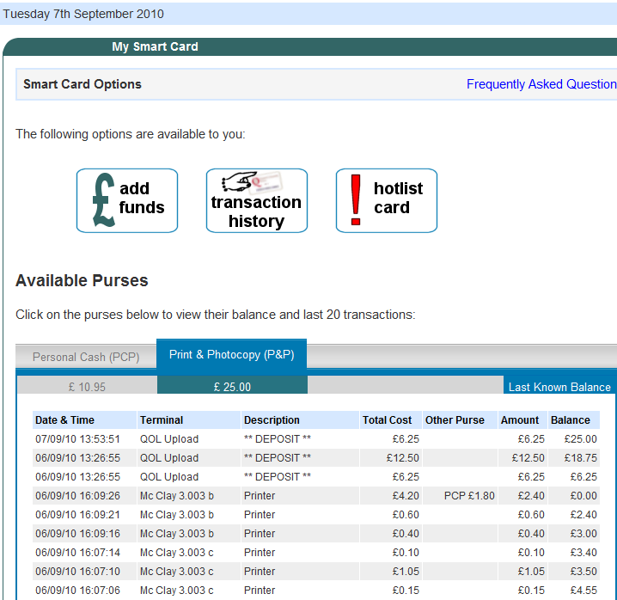

Please note that transactions are held at the cash upload machines and at the card readers and are transferred at regular intervals (every 30 minutes approximately) to the smart card database. As “My Smart Card” draws its information from the smart card database, very recent transactions will not display immediately on your transaction history.

The following points are worth noting when viewing your recent transactions for a purse in “My Smart Card”:

* The “Terminal” and “Description” columns tell you the type of the transaction and where it occurred.
* The “Total Cost” column tells you how much was involved e.g. if it was print job, how much it cost.
* The “Other Purse” column tells you whether funds from any other purse were used to complete the transaction. For example, when you print or photocopy, the system will first try to deduct the money from the Print and Photocopy Purse on your card. If there are insufficient funds in this purse but enough in a combination of the Print and Photocopy Purse and Personal Cash Purse, then the system will take what is in the Print and Photocopy Purse and the remainder from the Personal Cash Purse.
* The “Amount” column tells you the amount that was taken from the purse you are looking at. The total of the “Amount” value and the “Other Purse” value (if any) will be the same as the “Total Cost” value.
* The “Balance” column shows you the balance on the purse following the transaction.

**Transferring balances**

This one-off screen allows you to transfer any balances from your old card to your new card. You should transfer any existing balances before adding new funds to your smart card.

**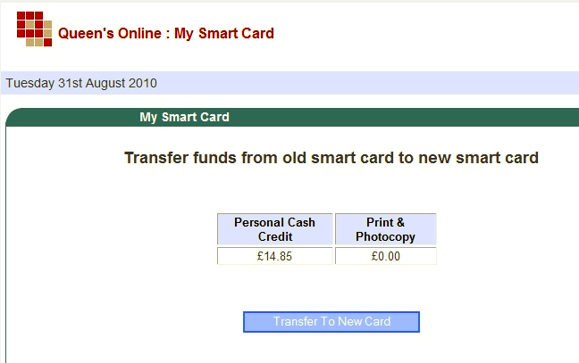**

**Adding Funds**

This screen allows you to select a purse and an amount to upload, using your credit/debit card. Please note that purses have an upper limit (this is a requirement of the Financial Services Authority) and you cannot add funds that would take you above the limit for the purse. More information on purses can be found in the section “Adding funds to your New Smart Card” (below). Please note that if you add funds using a credit or debit card, the balance on your card will be increased the next time you insert the card into any card reader.

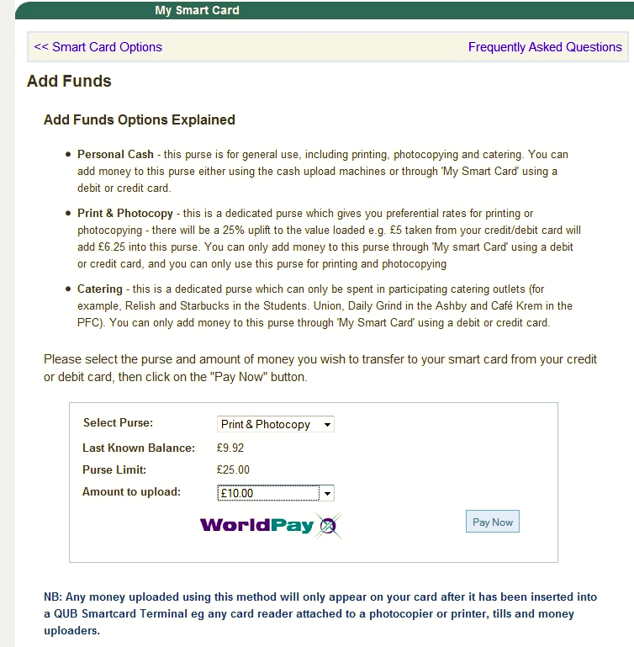

**Transaction History**

This allows you to view your transaction history for a given purse over a specified period.

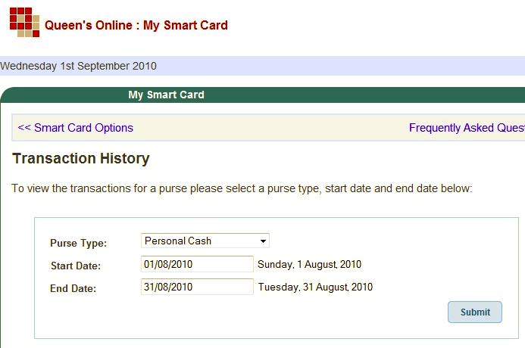

Please note that transactions are held at the cash upload machines and at the card readers and transferred at regular intervals (every 30 minutes approximately) to the smart card database. As “My Smart Card” draws its information from the smart card database, very recent transactions will not display immediately on your transaction history.

**Hotlist a card**

If you think you have lost your card or had it stolen, you should use this option to disable it immediately.

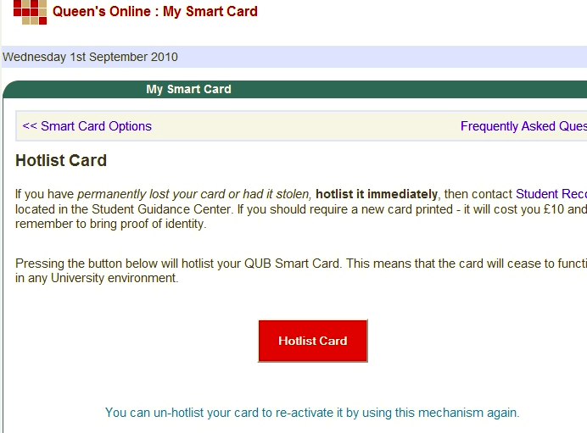

Adding funds to your New Smart Card

*You will be able to add funds to your new smart card from 10 September 2010*

The Smart Card operates by having money stored directly on electronic purses on the card (this also means that the card can be used even where there is no network connectivity). Your smart card has a number of purses:

* **Personal Cash Purse** – this purse is for general use, including printing, photocopying, catering and bursary outlets. You can add money to this purse either using the cash upload machines or through “My Smart Card” using a debit or credit card. The limit on this purse is £25.
* **Print and Photocopy Purse** – this is a dedicated purse which gives you preferential rates for printing or photocopying – there will be a 25% uplift to the value loaded e.g. £5 taken from your credit/debit card will add £6.25 into this purse. You can only add money to this purse through “My Smart Card” using a debit or credit card, and you can only use this purse for printing and photocopying. The limit on this purse is £80.
* **Catering Purse** - this is a dedicated purse which can only be spent in participating catering outlets (for example, Relish and Starbucks in the Students’ Union, Daily Grind in the Ashby and Café Krem in the PFC. Other sites may be added later). You can only add money to this purse through “My Smart Card” using a debit or credit card. The limit on this purse is £100.
* **Student Experience Bursary** - this purse is updated automatically if the University receives confirmation from the Student Loans Company that you are entitled to a bursary. It can be used for payments in the PEC, University Bookshop, QFT, Festival, Language Centre and Careers in the Student Guidance Centre.

Please note that purses have an upper limit as set out above (this is a requirement of the Financial Services Authority) and you cannot add funds that would take your balance above the limit for the purse. There are two methods of adding funds to your smart card:

1. Through the “My Smart Card” application within Queen’s Online (QOL), you can add funds to your Personal Cash Purse, Print and Photocopy Purse or Catering Purse using a credit or debit card.
2. Through the cash upload machines in the libraries, you can use cash to add funds to the Personal Cash Purse only.

**Using a credit/debit card**

To add funds using a credit/debit card, log into Queen’s Online and launch the “My Smart Card” application. “My Smart Card” enables you to select a purse and the amount to be added, and to pay for that using your credit/debit card. This transaction takes place over a secure network connection.

Please note that if you add funds using a credit/debit card, the balance on the card will be increased the next time you insert the card into any card reader. The next time you insert your card into a reader the message “Card Being Updated” will briefly display as the new funds are added to the card.

**Using a cash upload machine**

Cash upload machines are located near the print/photocopying facilities in the libraries. The machines take both notes and coins and allow you to add funds to the Personal Cash Purse only.

There are two types of machine:

* The machines in the Short Loan area and the upper floors of the McClay Library allow you to add funds to your staff/student card. The steps to adding funds are: insert your card; insert your money (notes or coins); and remove your card when finished.
* The machines in the Extended Hours Reading Room (ground floor) of the McClay Library, in the Medical Library and in the Biomedical Library also allow you to add funds to your staff/student card, but in addition allow visitor cards to be printed. The steps to adding funds to your staff/student card are the same as above, but you must press Stop or Eject to return your card when finished.

Visitor cards cost £2 of which 75p is available for printing or photocopying.

In all cases, instructions are printed on the machines. Please follow these instructions carefully and make sure that you do not remove your card until it has been updated.

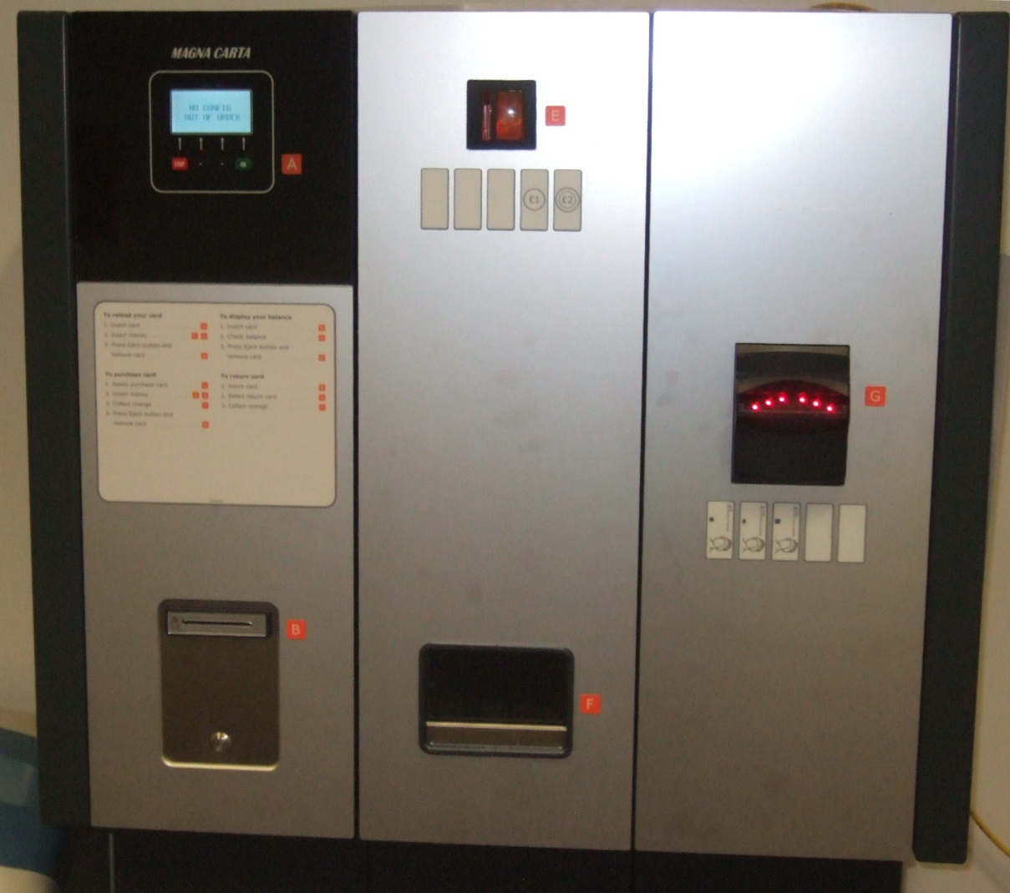

Cash upload machine (with visitor card dispenser)

**Transfer of existing balances**

Many returning students will have balances on their old smart card (i.e. the card used during 2009-10) and/or a number of print credits. These balances will be transferred to the new card as follows:

* From 10 September 2010 any existing card balances that you have will be displayed within the “My Smart Card” application and you will be able to transfer them to the new card.
* If you have an outstanding balance on your Student Experience Bursary, it will be automatically transferred (later in September) to the Student Experience Bursary purse on your new card.

Checking the balances on your New Smart Card

**“My Smart Card”**

The simplest way to check the balances on your smart card is to use “My Smart Card” within Queen’s Online. “My Smart Card” displays the last known balance you have in each purse and the most recent transactions against that purse.

The money for each purse is physically held on the smart card and the transaction history is held on the smart card database. Transactions recorded at the card readers and cash upload machines are regularly uploaded to the database (every 30 minutes approximately). This allows the system to continue to function should the network not be available.

As “My Smart Card” draws its information from the smart card database, very recent transactions will not be reflected immediately in your balances and will not display on your transaction history – you may need to wait up to 30 minutes for this to happen.

**Cash upload machines**

When you insert your smart card into one of the cash upload machines, it displays the balance in your Personal Cash Purse only.

**Photocopiers**

When you insert your smart card into a card reader attached to a photocopier, it displays any balance you have in your Print and Photocopy Purse. If you do not have any funds in your Print and Photocopy Purse, then it displays any balance in your Personal Cash Purse. You can also press the “?” key on the reader to toggle between the display of your Print and Photocopy Purse balance and your Personal Cash Purse balance.

Printing and photocopying with your the New Smart Card

*NB – printing and photocopying with the new smart card will “go live” in the McClay Library on 10 September 2010, followed immediately by the remaining libraries and Student Computing Areas. Once that changeover happens you will need your new card in order to print or photocopy in these locations.*

When you pay for services using your smart card, the money is taken from one or more purses on your card. For printing and photocopying, two purses can potentially be used:

* **Print and Photocopy Purse** – this is a dedicated purse for printing and photocopying only. You can only add money to this purse through the “My Smart Card” application in Queen’s Online (QOL) using a debit or credit card.
* **Personal Cash Purse** – this is for general use, including printing, photocopying and catering. You can add money to this purse either using the cash upload machines or through “My Smart Card” with a debit or credit card.

Because the Print and Photocopy Purse does not involve cash handling, we will give you a 25% uplift to all money loaded into this purse e.g. £5 taken from your credit/debit card will add £6.25 into this purse. This uplift only applies to the Print and Photocopy Purse, not the Personal Cash Purse. Therefore you should try wherever possible to use the Print and Photocopy Purse rather than the Personal Cash Purse.

When you print or photocopy, the system will first try to deduct the money from the Print and Photocopy Purse on your card. If there are insufficient funds in this purse but enough in a combination of the Print and Photocopy Purse and Personal Cash Purse, then the system will take what is in the Print and Photocopy Purse and the remainder from the Personal Cash Purse. If there is nothing in the Print and Photocopy Purse and enough in the Personal Cash Purse the system will take the money from the Personal Cash Purse.

Information on how to add money to the purses on your card can be found in the *Managing your card through “My Smart Card”* section above.

**Printing**

Printing with the new smart card is very different to the old system. You no longer need to purchase special ‘print credits’ as the cost of printing is charged directly to your Print and Photocopy Purse or Personal Cash Purse.

With the new system, when you print a document from a PC in the libraries or Student Computing Areas (SCAs), it does not print immediately. Instead, it is sent to the print queue where it waits until you release it. When you wish to release the job for printing you should go to the printer of your choice, insert your card into the card reader attached to the printer and follow the instructions displayed on the card reader. You do not have to release your job at the printer nearest to you, you can go to any printer in the building and insert your card in the reader attached to that printer and print your jobs – this is known as ‘follow me’ printing.

Detailed instructions on releasing your print jobs using your smart card can be found at Appendix 1 of this document. There are a few additional points worth noting:

* When you send a job to the print queue, it will stay in the queue for 3 hours. If you do not release it within that time it is automatically deleted from the queue.
* If you send a job to the print queue but then decide that you don’t actually want it to print, just leave it in the queue without releasing it and it will disappear after 3 hours.
* If you send the same document, with the same document name, to the queue more than once, then all instances of that document will sit in the queue (not just the most recent). For example, if you send “assignment1.doc” to the queue, then make some changes to it and send it again, then you will have two jobs in the queue, both with the same name. The jobs arrive in the queue in chronological order, so if you only wanted to print the second version in this example you would skip the first job in the queue and release the second.
* If you go to the printer to release your print job(s) and find you do not have sufficient funds on your card, you can add the necessary funds to your card (using “My Smart Card” or the cash upload machines) and then return to the printer to release your job(s).

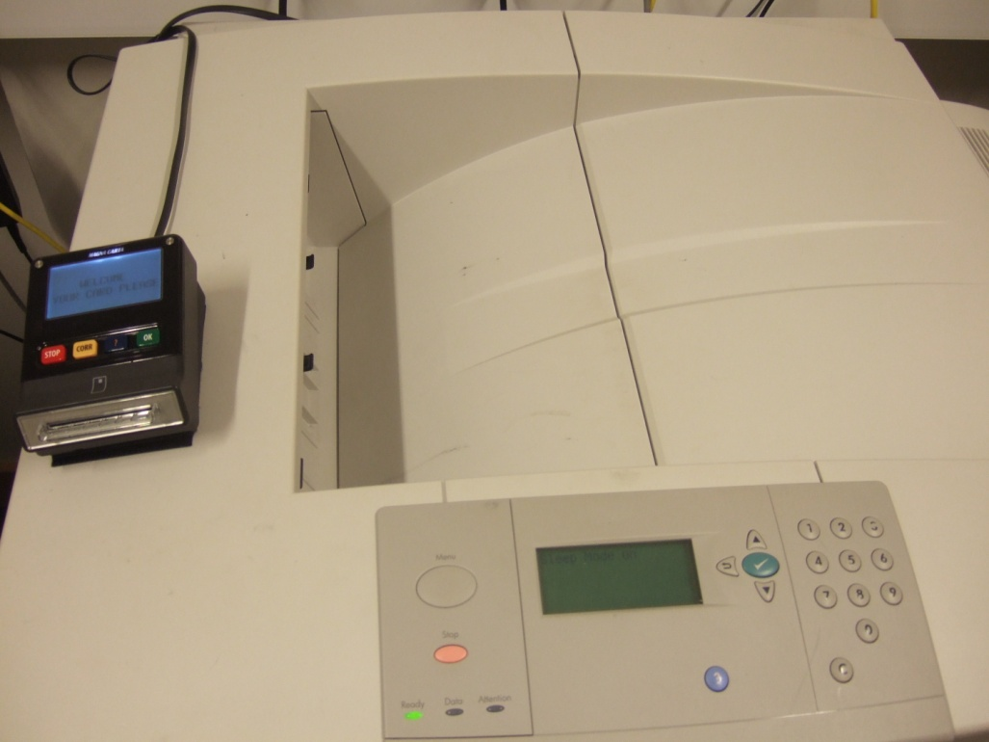

Printer with card reader attached

**Photocopying**

Unlike the previous system, you no longer need a PIN code for photocopying. Simply insert your smart card into the card reader attached to the photocopier and follow the instructions displayed on the card reader.

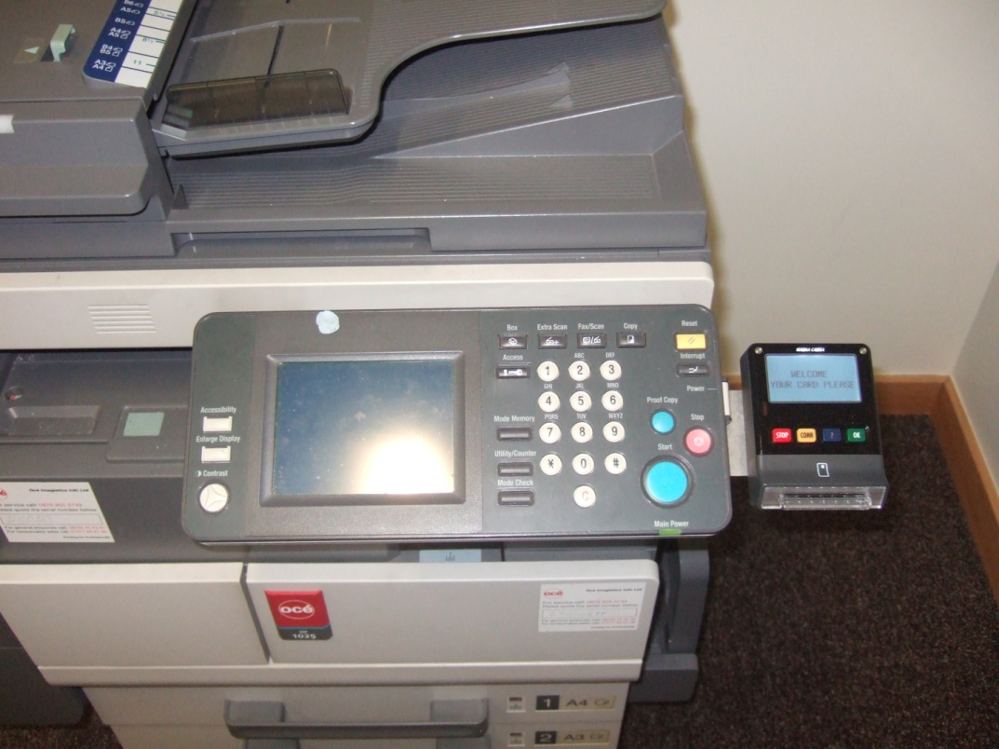Detailed instructions on photocopying using your smart card can be found at Appendix 2 of this document.

Photocopier with card reader attached

Building/door access using your the New Smart Card

The University access control system is currently being upgraded to allow access to buildings using the new smart card (see <http://www.qub.ac.uk/sites/NewSmartCard/BuildingDoorAccess/Programmeofworkforthechangetothenewaccesscontrolsystem/> for details of the upgrade programme). The main change is that if you previously used a PIN code to gain access, you may now be able to use your smart card instead.

As before, most University buildings will be open during the “normal” working/academic day and you do not need your card or any other device to gain access. The main locations where you do need to use your smart card for access are:

* The McClay Library – the turnstiles in the McClay Library are now working with the new smart card.
* International & Postgraduate Student Centre – door access in the new Centre is controlled using the new smart card.
* PEC – the door access system in the PEC has not yet been changed over to work with the new smart card. This change will happen in mid-September so you should retain your old card for access to the PEC until then.

**Students**

With the exception of the locations above, students will not typically use their smart card for door access. However, some Schools do allow students controlled access to their buildings – for example in the evenings. Schools have already supplied Estates with the details of students who require their card to be enabled for building/door access. If you think you should have controlled access to a building/door you should contact your School.

If you have been given a PIN code or a door access card by your School then you may be able to use your smart card instead, depending on the type of door reader (see below).

**Staff**

If you have previously used a PIN code to gain access to any building, then you may be able to use your smart card instead, depending on the type of door reader (see below).

**Using your smart card instead of a PIN**

There are two main types of door access readers in the University: older ‘scramble’ pads and newer proximity readers. For proximity readers, you can either enter your PIN code or hold your new smart card within 2cm of the reader. For scramble pads, you must continue to enter your PIN.

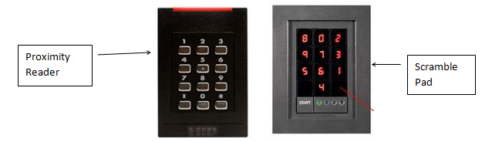

Purchasing in catering outlets using your the New Smart Card

*Use of the new smart card for purchasing in catering outlets will not be enabled until mid to late September 2010. Further information will be made available in due course.*

When you pay for services using your smart card, the money is taken from one or more *purses* on your card. For purchasing in catering outlets, two purses can potentially be used:

* **Catering Purse** – this is a dedicated purse which can only be spent in participating catering outlets (for example, Relish and Starbucks in the Students’ Union, Daily Grind in the Ashby and Café Krem in the PFC. Other sites may be added later). You can only add money to this purse through the “My Smart Card” application in Queen’s Online (QOL) using a debit or credit card.
* **Personal Cash Purse** – this is for general use, including printing, photocopying and catering. You can add money to this purse either using the cash upload machines or through “My Smart Card” with a debit or credit card.

One advantage of the Catering Purse is it allows you to “ring fence” money that can only be spent in the participating catering outlets. This might also be attractive to parents and guardians of students.

When you make a purchase using your card in one of the catering outlets, the system will first try to deduct the money from the Catering Purse on your card. If there are insufficient funds in this purse but enough in a combination of the Catering Purse and Personal Cash Purse, then the system will take what is in the Catering Purse and the remainder from the Personal Cash Purse. If there is nothing in the Catering Purse and enough in the Personal Cash Purse the system will take the money from the Personal Cash Purse.

Information on how to add money to the purses on your card can be found in the *Managing your card through “My Smart Card”* section above.

Using your New Smart Card for your Student Experience Bursary

*NB: Returning students will continue to use their old student card to spend against their existing Student Experience Bursary until mid-September. Further information will be provided when we are ready to switch the Student Experience Bursary over to the new card.*

Queen’s University pays a non-repayable £110 Student Experience Bursary to all full-time UK undergraduate and PGCE students paying tuition fees of £3,290 from households with an income of up to £34,203. If you are a full-time undergraduate student on a foundation course (paying tuition fees of £2,193) with a household income of up to £34,203, you will be entitled to a Student Experience Bursary of £73. Further details on the Student Experience Bursary, and your potential entitlement, can be found at <http://www.qub.ac.uk/home/TuitionFeesandStudentSupportArrangements201011/UndergraduateTuitionFees201011/StudentSupport/>

The University uses the information submitted in your PN1/PR1 application to the Education and Library Board (ELB) for fee loan and other financial support, so please make sure you complete all relevant sections.

If you are eligible to receive it, the Student Experience Bursary will be added automatically to your smart card – there is a special purse on the card for this Bursary. Eligible students are notified by email when the Bursary has been transferred to their student card.

The Student Experience Bursary can be spent in the Bookshop at Queen's, the Physical Education Centre, Queen's Film Theatre, Ulster Bank Belfast Festival at Queen's and a range of innovative activities from the Degree Plus Programme, including the Language Centre.

You can use the “My Smart Card” application within Queen’s Online to check the status of your Student Experience Bursary purse and view any transactions. If you want to spend from your Bursary purse, then you should present your card at the locations/services above where the Bursary can be spent.

Any unspent money on your Bursary will remain on your card for use in the next academic year. For students that will not be returning, any unspent money on the Bursary is transferred to the Student Hardship Fund.

**Transfer of existing balances**

Some returning students will have an outstanding Bursary amount on their old smart card (i.e. the card used during 2009-10). If you have an outstanding balance on your Student Experience Bursary, it will be automatically transferred to the Student Experience Bursary purse on your new card (in mid-September).

Taking care of your New Smart Card

Your smart card is expected to last for the full duration of your stay at Queen’s. If the card is lost or rendered unusable at any stage then there will be a £10 charge to provide a replacement.

To ensure the durability and validity of the card:

* Keep the card in a safe carrying case – e.g. a credit card wallet
* Keep the card away from magnets to avoid magnetic damage
* Do not punch holes in the card
* Do not tamper with the card
* Keep the surface clean and free from marks or scratches
* Do not bend the card
* Avoid exposing the card to excessive heat
* Do not wash the card or use it for any purpose for which it was not designed

Damaged, Lost or Stolen Cards

It is important to deactivate and report a lost or stolen card as soon as possible.

* To disable the card, go to the “My Smart Card” application within Queen’s Online and select the option to Hotlist A Card.
* Lost or stolen cards should be reported to the Information Desk in the Student Guidance Centre (email: [sgc@qub.ac.uk](mailto:sgc@qub.ac.uk) / telephone: 028 9097 2727).
* There will be a £10 charge for replacement cards.
* The system records all transactions for a given card. If a new card has to be issued it will contain the balances that were on the previous card at the point that it was reported lost.
* For more information please visit <http://smartcard.qub.ac.uk>

Getting help / contacting us

If you need help, please refer first to the smart card web page at <http://smartcard.qub.ac.uk/> and to the Frequently Asked Questions section at <http://smartcard.qub.ac.uk/FAQ/>, as the information you need may already be available there (see below for a list of FAQs already covered on the website). If you cannot get the help you need from the website, then the following is advised:

* If your problem relates to a specific service (e.g. using your card for printing in the Student Computing Areas or borrowing books in the libraries), then you should seek help from the staff who support that service locally e.g. Computer Assistants or the Borrower Services Desk.
* If you are a student and your problem has to do with your card (e.g. you have not received your card, your card has incorrect information or is not working) then you should contact the Student Guidance Centre (the Information Desk is on the first floor or email [sgc@qub.ac.uk](mailto:sgc@qub.ac.uk)).
* For other enquiries or assistance, please email [studentcard@qub.ac.uk](https://owa.qub.ac.uk/owa/redir.aspx?C=930c70feea444201b588b8c0416efec8&URL=mailto%3astudentcard%40qub.ac.uk) (for students) or [staffcard@qub.ac.uk](mailto:staffcard@qub.ac.uk) (for staff) with the details and we will answer your question.  Please quote your student or staff number in any email.

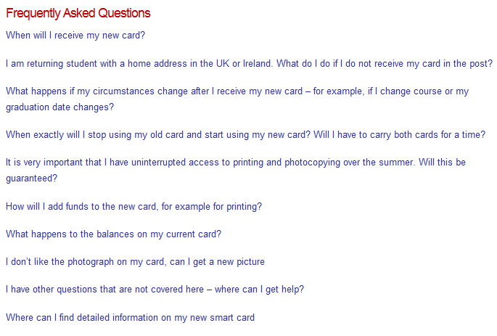

Appendix 1: Detailed Instructions - Printing

|  |  |  |  |  |  |
| --- | --- | --- | --- | --- | --- |
| 1. **Default Display**   When not in use the reader alternates between the following screens:   |  |  | | --- | --- | | welcome.jpg | time.jpg | | | | |
| 1. **Insert Your Card**   When you insert your card the reader briefly displays the screen below:   |  | | --- | | (When you add funds to your card using a credit/debit card, the next time you insert your card in a reader the message “Card Being Updated” will briefly display on the reader as the new funds are added to the cardmoment.jpg)moment.jpg | | |  |
| 1. **Printing**   If you have no jobs to print, the screen will display as below:  no print jobs.jpg | If you have jobs to print, the screen will display your queued print jobs one at a time:   |  |  | | --- | --- | | job1of3.jpg |  |   Press  to print the current job or  to go on to the next job without printing the currently displayed job. Repeat the process for each job in the queue. | | |
| 1. **Finish**   When you have finished printing, remove your card. | | | |

Appendix 2: Detailed Instructions - Photocopying

|  |  |  |  |  |
| --- | --- | --- | --- | --- |
| 1. **Default Display**  |  |  | | --- | --- | | When not in use the reader alternates between these screens: | time.jpgwelcome.jpg | | | |
| **moment.jpg**   1. **Insert Your Card**   When you insert your card the reader briefly displays this screen:  (When you add funds to your card using a credit/debit card, the next time you insert your card in a reader the message “Card Being Updated” will briefly display on the reader as the new funds are added to the card) | |
| 1. **Photocopying**   As you photocopy, the reader display alternates between the two screens to the right:   |  | | --- | |  |   During the session the balances will be updated after every sheet is copied. | |  |  | | --- | --- | | stop_finished.jpg | copied subsidy.jpg | | | |
| 1. **Finish**   When you have finished copying press the  key. The screen to the right is displayed:  Wait until you see the screen display “PLEASE TAKE CARD” before removing your card.   |  | | --- | |  | | ready take.jpg  ready signal.jpg | |
| 1. **Don’t Lose Money!**   If you remove your card too early you will hear a bleeping noise and the screen to the right will display. If you do not re-insert your card in time you will lose 5p.   |  | | --- | |  | | **lose.jpg** | |