**Age of Imperialism**

**(1800 – 1912) Imperialism – The policy of building an empire**

**3 Main Causes of Imperialism**

1. **Nationalism or pride in ones country. Feeling that your country is superior, led nations to look outside their own borders to acquire more land abroad to strengthen their prestige and wealth. This breeds competition amongst Great Britain, France, Belgium, Germany, Italy, Holland, Spain, Portugal and Russia. This fuels political rivalries.**
2. **The Industrial Revolution creates the need for raw materials like iron ore, coal, lumber, and oil.**
3. **Religion. European countries and the religious institutions like the Catholic Church thought it was important to spread Christianity around the globe to the indigenous people that were conquered.**

**Rudyard Kipling’s White Man’s Burden**

**Take up the White Man's burden--Send forth the best ye breed--  
Go bind your sons to exile  
To serve your captives' need;  
To wait in heavy harness,  
On fluttered folk and wild--  
Your new-caught, sullen peoples,  
Half-devil and half-child.  
  
Take up the White Man's burden--In patience to abide,  
To veil the threat of terror  
And check the show of pride;  
By open speech and simple,  
An hundred times made plain  
To seek another's profit,  
And work another's gain.  
  
Take up the White Man's burden--The savage wars of peace--  
Fill full the mouth of Famine  
And bid the sickness cease;  
And when your goal is nearest  
The end for others sought,  
Watch sloth and heathen Folly  
Bring all your hopes to nought.  
  
Take up the White Man's burden--No tawdry rule of kings,  
But toil of serf and sweeper--  
The tale of common things.  
The ports ye shall not enter,  
The roads ye shall not tread,  
Go mark them with your living,  
And mark them with your dead.  
  
Take up the White Man's burden--And reap his old reward:  
The blame of those ye better,  
The hate of those ye guard--  
The cry of hosts ye humour  
(Ah, slowly!) toward the light:--  
"Why brought he us from bondage,  
Our loved Egyptian night?"**

**Take up the White Man's burden--Ye dare not stoop to less--  
Nor call too loud on Freedom  
To cloke your weariness;  
By all ye cry or whisper,  
By all ye leave or do,  
The silent, sullen peoples  
Shall weigh your gods and you.  
  
Take up the White Man's burden--Have done with childish days--  
The lightly proferred laurel,  
The easy, ungrudged praise.  
Comes now, to search your manhood  
Through all the thankless years  
Cold, edged with dear-bought wisdom, The judgment of your peers!**

**Born in British India in 1865, Rudyard Kipling was educated in England before returning to India in 1882, where his father was a museum director and authority on Indian arts and crafts. Thus Kipling was thoroughly immersed in Indian culture: by 1890 he had published in English about 80 stories and ballads previously unknown outside India. As a result of financial misfortune, from 1892-96 he and his wife, the daughter of an American publisher, lived in Vermont, where he wrote the two Jungle Books. After returning to England, he published "The White Man's Burden" in 1899, an appeal to the United States to assume the task of developing the Philippines, recently won in the Spanish-American War. As a writer, Kipling perhaps lived too long: by the time of his death in 1936, he had come to be reviled as the poet of British imperialism, though being regarded as a beloved children's book author. Today he might yet gain appreciation as a transmitter of Indian culture to the West.What is it today's reader finds so repugnant about Kipling's poem? If you were a citizen of a colonized territory, how would you respond to Kipling?**

**Source - This is an excerpt from Reading About the World, Volume 2, edited by Paul Brians, Mary Gallwey, Douglas Hughes, Azfar Hussain, Richard Law, Michael Myers, Michael Neville, Roger Schlesinger, Alice Spitzer, and Susan Swan and published by Harcourt Brace Custom Books.**

**Age of Imperialism**

**The advertisement to the left was for Pears’ Soap. The British soap company used Kipling’s Poem to sell their soap abroad. The ad says the Pears’ Soap *“is a potent factor in lightening the dark corners of the earth as civilization advances.”* What would you think of such a company if you were one of the regions that were being colonized by the European country?**

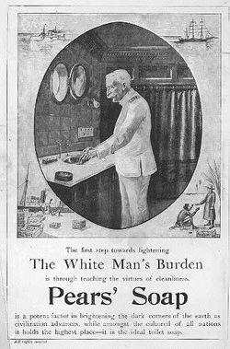

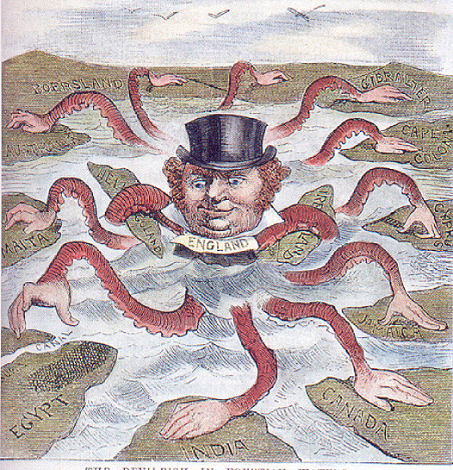

## “The Sun Never Set’s on the British Empire”

## Industrial Revolution’s effect on the expansion of Colonies

**Raw materials were needed to feed the factories:**

**- Rubber, copper, gold came from Africa,**

**- Cotton and Jute came from India,**

**- Tin came from Southeast Asia.**

**- Bananas, oranges, melons and other fruit from the Caribbean**

**- Colonial tea from Asia**

**- Coffee and cocoa from South America and Africa**

**Levels of Control in Imperialism**

**These are in order of decreasing control**

**Definition of Colony: Imperialist power rules directly over its Colony**

**Most control over people**

**Definition of Protectorate: A protectorate has own government but policies and political affairs are guided by mother country**

**Definition of Sphere of Influence: Region of a country where another country has exclusive trading rights.**

**Least control over the people**

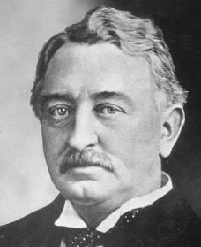

**Cecil Rhodes (1853 –1902) Rhodes was an English entrepreneur who emerged as one of the world’s richest men through investment in diamond mines in South Africa. His economic influence eventually helps lead Britain to extend their political influence within the continent of Africa. To the left is a political cartoon of the day. What message do you think the author is trying to demonstrate through the cartoon? Rhodes would use his finances to set up the Rhode Scholarship in Oxford, England to provide free graduate education to individuals who show promise in helping their fellow man.**

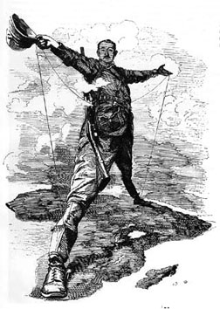

**Age of Imperialism – Africa**

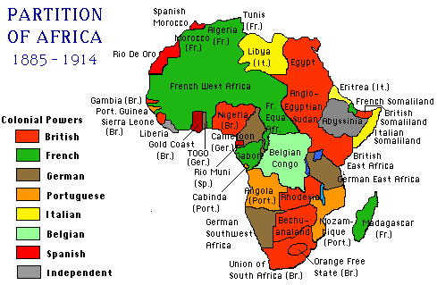

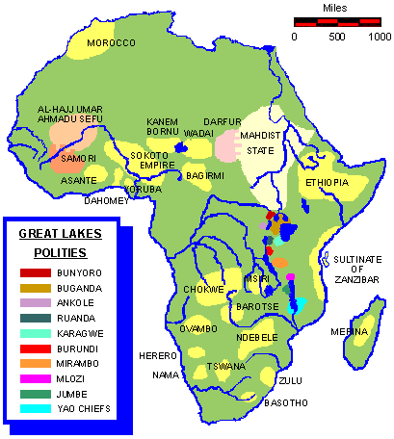

**The maps on the left and right represent the change Africa went through during the late 1800’s and early 1900’s. The tribes of Africa (the indigenous population) were largely ignored in Europe’s quest for wealth. Cotton, copper, gold, diamonds, and rubber were all available in Africa, and needed for industrial growth in Europe. Like a giant cake, European countries divided up Africa in the Berlin Conference in 1884. Called for by Portugal and organized by Otto Von Bismarck, the conference became known as the “Scramble for Africa” and decided which European powers will have what territory. Africans had no real say at the conference.**

Northern Africa

**The French take Algeria, Tunisia and Morocco. There is some local resistance to domination by Abd Al-Qadir in Algeria. In 1869, Ferdinand de Lesseps (FR) built the Suez Canal. The Egyptian government and their president, Muhammad Ali exhibit financial mismanagement and increased debt cause the Egyptian government to seek financial help from Great Britain. The company sells shares to the government of Britain. To protect her investment, the British invade Egypt and later Sudan. The British launch attacks against the Sudanese in the Battle of Omdurman and against the French at Fashoda. The Italians invade Tripoli and Libya.**

**Sub-Saharan Africa**

**Due to the fact that there is a lack of political unity on the part of the Africans; the Portuguese, Dutch, British and French set up trading posts beginning in the 1500 and 1600’s as part of the Triangle of Trade. By the 1800’s slave trade is illegal in many areas but trade for goods with Europeans and the seemingly endless desire on the part of Europeans continues the growth of expansion. Beginning in 1870, Europeans began to push inland, up the rivers and away from the coast. Most countries in Africa fall under European control. One of the few free countries is Liberia, which was founded by American slaves in 1847.**

East and Central Africa

**King Leopold II of Belgium controlled the Congo from 1878 as the Congo Free State giving her freedom in 1908. Ethiopia is one of the free countries ruled by Menelik II.**

Southern Africa

**In the mid-1600’s, the colony of Capetown was founded by the Dutch who were known as Afrikaners. The British seize control in the early 1800’s. They stop slavery while the Dutch feel slavery is OK. The Dutch move inland, the journey is known as the “Great Trek”. They end up fighting with the local tribe known the Zulu. The British fight with the Dutch in 1902 in the Boer War. The British win this conflict.**

**Age of Imperialism – Asia**

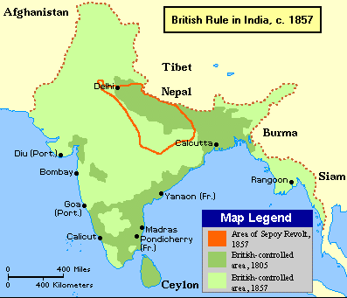

**INDIA**

**1600 The British East India Company begins trading in India. The French challenge the British for control of the trade are defeated leaving the British with a sphere of influence.**

**1857 The East India Company controls the trade within most of India. The Sepoy Rebellion, started through a misunderstanding between the Sepoy, a group of guards within the Company, sparks a move toward additional control of the Indians to protect the investment by the East India Company.**

**1858 Parliament dissolves the East India Company and sends a Viceroy to India to govern. They build an infrastructure including paved roads, a railroad system, telegraph lines, irrigation systems and schools and universities. However, the Indians continued to be discriminated against.**

**1885 The Indian National Congress is formed to address Indian concerns but there are few reforms, with the British dominating the government.**

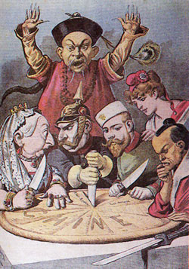

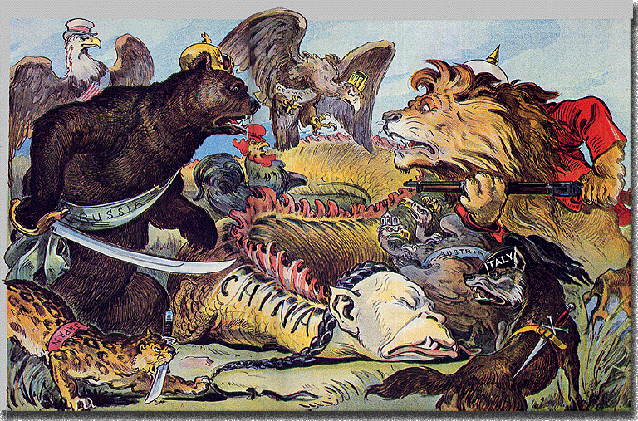

**CHINA**

**There is limited western interaction. The British effectively force trade for tea, silk, porcelain-using Opium that they imported from Turkey and India.**

**OPIUM WARS (1839-1842)**

**In 1839 the Chinese government resists interaction with the British the Opium from the British. By 1842 the British win the war and sign a treaty with the Chinese that the Chinese call the “Unequal Treaties”. These trade treaties weaken the Qing Dynasty and ultimately the Taiping Rebellion results from 1851-1864. China becomes a sphere of influence for Great Britain, France, Germany, Russia and Japan. By 1899, the US gets in the game with the Open Door policy in 1899 in which all will be able to trade, none exclusively.**

**1900 The Empress of China Ci Xi (Tsu See) oversees the Society of Righteous and Harmonious Fists (Boxers). In June 1900 these Boxers attack foreigners in what is known as the Boxer Rebellion. Several hundred foreigners are killed. The Europeans send 25,000 troops to extract their nationals.**

**1911 The Revolution of 1911 occurs and Ci Xi allowed foreign troops to stay making changes in society. To keep her control, she makes small changes and they are too late for her to keep control.**

**1905 Sun Yat Sen is elected as the head of the United League or the Kuomintang (Nationalist Party)**

**1908 Ci Xi dies and Pu Ye becomes emperor**

**1911 Troops of the Emperor rose against the Emperor and Sun Yat-sen becomes the president of the Republic of China.**

**Age of Imperialism – Asia**

**JAPAN**

**Emperors come to Japan in the 1500’s and Shoguns follow them during the Tokugawa Shogunate. Due to perceived foreign involvement as bad for the country, the Japanese cut off trade with the West in the early 1600’s in a series of laws called Exclusion Laws. This remains the case until 1853 when Commodore Perry enters Japan to deliver a letter requesting a change in the existing situation and movement toward a treaty between the two countries. The result of this venture is the Treaty of Kanagawa, which changes not only the relationship of Japan to outside world but also the relationship of the Japanese government to itself. The treaty causes the advisors of the Shogun to lose political power and ultimately the Shogun to lose power leading to the Meiji Emperor taking control and vowing to modernize the country. Japan, with her efficient government and industrial base was in need of raw materials and in this way acted like a European power taking parts of surrounding countries for supplies. This included the country of Korea that she won over the efforts of Russia in the Russo – Japanese War in 1903**.

[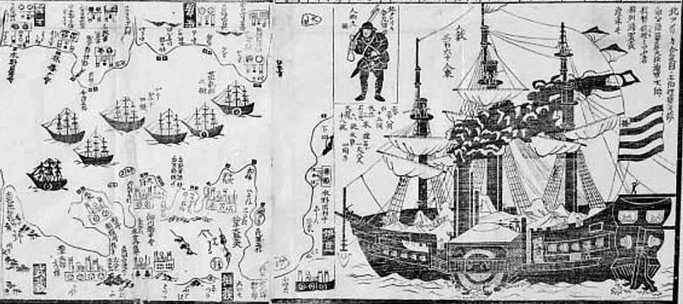](http://upload.wikimedia.org/wikipedia/commons/c/ce/Japanese_1854_print_Commodore_Perry.jpg)

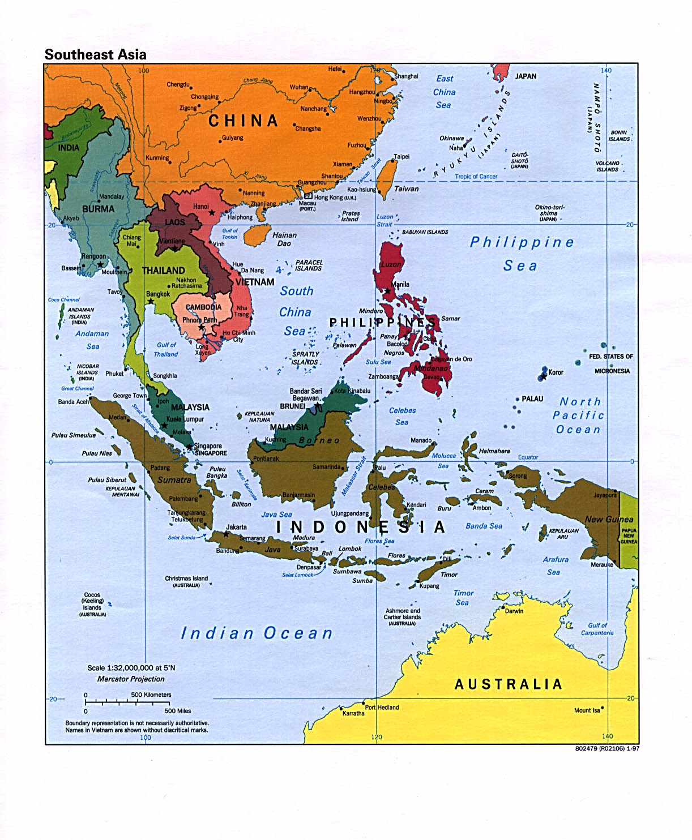

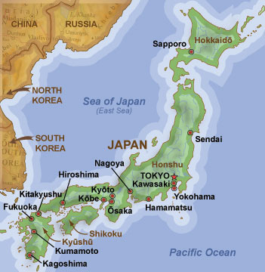

**SOUTHEAST ASIA**

**The area is divided up into two main groups of islands: Indonesia and the Philippines and Mainland Southeast Asia that occupy the Indochinese and Malay peninsulas. The European powers came, saw and conquered this area beginning in the 1500’s. The Europeans included the Dutch (Indonesia), the Spanish (Philippines), the British (Malaysia) and the French (Vietnam).**

**The islands of Southeast Asia are rich in natural resources and attracted foreign domination. The Dutch were the first to take control of the East Indies using a system of forced labor called the Culture System to gather the raw materials.**

**Prince Diponegoro from Java began a revolt against the Dutch in 1825 and failed. Nationalist forces would change the history of Indonesia after the turn of the century.**

**The Philippines were control by the Spanish. However, after the Americans declared war on Spain and liberated the country from Spain the Americans tried to control it until Emilio Aguinaldo led a revolt against the Americans.**

**Mainland Southeast Asia was a place where Britain and France struggled for domination. The British dominated India and the western parts of Southeast Asia while the French controlled Indochina. The land between these two blocks was called Siam and stood independent for some time despite the European domination that surrounded it.**

**Age of Imperialism – America**

## Monroe Doctrine

**President Monroe in 1823 issued the following warning to European Nations:**

**1. American continents are not to be considered for colonization by any European power.**

**2. Any attempt on the part of the European Nations will be considered to be a move from peace and safety.**

**In 1800 the only free country in the Western Hemisphere was the United States. By 1895 many countries were independent. First Haiti then Paraguay, Chile, Colombia, Mexico, Peru broke from Spain. Brazil from under the rule of Portugal, Bolivia, Uruguay, Ecuador, and Venezuela were independent.**

## Spanish American War

**Cubans revolted against Spain in 1895 and Spain intervened militarily. The United States citing the Monroe Doctrine sent the USS Maine in January of 1898. It exploded, unifying American desire to enter the fray in the Spanish-American War. Declaring war in April 1898, America soon won and gained possession of Cuba, Puerto Rico, the Philippines and several Pacific Islands. Because of the Platt Amendment, the United States agreed not to take control of Cuba but the countries of the Western Hemisphere were protected from the controlling powers of the European colonists but not from the United States.**

## Roosevelt Corollary

**Beginning in a debt repayment problem between Venezuela and the European nations of Great Britain, Germany and Italy, the United States offered to act as a impartial third party in disputes between Europeans and Western Hemisphere dwellers. This further extends the responsibilities of the United States from the Monroe Doctrine’s disallowing of colonization to the United States acting as the Hemisphere’s policemen.**

## The Panama Canal

**In the 1880’s, a Frenchman named Ferdinand de Lesseps, builder of the Suez Canal attempted to build a canal and failed. In 1903, the United States led by Teddy Roosevelt took over the cause. Panama was deemed to be the best site. When the Colombians who owned the Panama refused America’s deal for the land, America hatched a plan. On November 3rd, 1903 the American military prevented the Colombians from putting down a Panamanian uprising and Panama became independent. After 10 years of labor, the canal opened in 1914.**

## Intervention in Mexico

**After Victoriano Huerta overthrew Porfirio Diaz in 1910, the United States was looking for a way to become involved in Mexican politics. Woodrow Wilson disliked Huerta and when several soldiers were arrested he sent the Marines to close the port of Vera Cruz. This angered the Mexicans who did not want American meddling in their affairs. Huerta was soon taken from power and Wilson had to choose among the leaders who struggled for power. He chose Carranza and his opponent, Pancho Villa responded by killing several American travelers in Mexico and crossing the border into New Mexico and killing several more. Wilson responded by sending troops to look for Villa who was never found and the U.S. troops were withdrawn due to American involvement in W.W.I.**