LEGISLATIVE APPROACHES TO

RIGHT-SIZING MUNICIPAL SERVICES

January 30, 2009

(Revised June 18, 2009)

Joseph P. McLaughlin, Jr., PhD, Director

Michelle J. Atherton, MA, Assistant Director

Katrina Morrison, Candidate for the MA Degree in Criminal Justice

Institute for Public Affairs

Temple University

Contents Page

I Executive Summary 1

II Overview of the Problem and Discussion of Options 4

Matrix of Options 12

III Right-Sizing Options Explained 16

Appendix A Selected Pennsylvania Programs 27

Appendix B Pennsylvania Reform Initiatives Present and Past 31

Appendix C Programs and Initiatives in Other States 41

Appendix D Public Opinion on “Right-Sizing” Issues 50

Appendix E Potential Economies of Scale in PA Municipalities 52

Appendix F Costs of Regional Versus Local Police Services 66

Appendix G Individuals Interviewed 93

Bibliography 95

**Part I: Executive Summary**

Pennsylvania has perhaps the most fragmented system of local government in the United States, with 2,563 municipalities, 2,289 volunteer fire companies, and more than 3,100 municipal pension systems, or 25 percent of all such plans in the nation. Although some social scientists argue that multiple local governments lead to more efficient tax and service levels because consumers can shop for the package that best fits their needs, even proponents of that view would agree that government policies can distort the market for efficient tax-service packages. There is reason to believe that Pennsylvania has distorted that market.

Perhaps alone among the states, the Commonwealth does not require municipalities to provide police protection, fire protection, or to take care of thousands of miles of essentially local roads. Nearly half of municipal pension plans are funded through Act 205 pension distributions, paying the full cost of the employer contributions without exercising any oversight of benefit levels. The number of municipal pension plans exploded subsequent to enactment of that state subsidy in 1984. Tens of thousands, if not millions, of local taxpayers are almost certainly not paying the full cost of the local services they receive. Although some of these policies can perhaps be justified on the grounds that they remedy unequal capacity to provide adequate services, there is evidence to suggest that they also subsidize inefficiency, impede economic growth, and therefore reduce the public resources available to address inequality in other, and perhaps more effective, ways. The graphs showing per capita costs for virtually all municipal functions in Appendix E and comparing the per capita costs of regional versus local police forces in Appendix F, for example, suggest that savings could be realized by “right-sizing” services. Right-sizing in this report includes the facilitation of boundary changes (difficult to achieve) and of cost-sharing through the formation of regional services forces or inter-municipal agreements.

Because of state subsidies and a variety of other factors, including cultural preferences, citizens -- and the local officials they elect - tend to favor the status quo and have resisted many previous efforts to induce, or require, cost-sharing or consolidation.

The 2009-10 legislative session seems likely to be dominated by economic, fiscal, and financial crises, which have been described by one expert we interviewed as “a perfect storm.” State and local tax revenues are falling, service demands rising, pension portfolios plummeting, and deficits looming.

Studies suggest that opportunities for more than incremental change often occur (“policy windows” open) when problems, policies, and politics converge (Kingdon 1984; Baumgartner and Jones 1993). We may be in such an environment now. The crises are huge. State agencies and advocacy groups have been laying the groundwork for proposed policies for the last several years. The Senate held hearings on municipal distress and on the looming municipal pension problem last year. As the campaigns run by both presidential candidates suggest, the public is ready for change. The public also wants to see bipartisan cooperation, which seems possible on these issues and which is essential in a divided government such as Pennsylvania now has. In addition, the coalition of business and civic leaders who supported the streamlining of the state’s antiquated tax collection structure appears ready to be reactivated on the pension issue.

Two issue areas where these conditions seem most clearly present are the right-sizing of police services and the consolidation of municipal pension plans. A third general approach respects the complexity and intractability of the problem by recommending new policies and structures to focus on these opportunities and on a number of other more incremental measures, including the enhancement of Pennsylvania’s current programs to encourage right-sizing, which compare favorably with those in other states.

Although we did not interview the interest groups most directly affected by right-sizing issues, our research, including interviews with state officials, suggests that even public employee groups, such as the Fraternal Order of Police and the firefighters, recognize the gravity of current adverse trends are more amenable to consolidation than they have been in the past. Of particular concern are a desire for more uniform pensions and the viability of volunteer fire companies facing manpower as well as resource shortages.

Our first recommendation is that the House and Senate establish, either as a matter of policy or through rules, a moratorium on legislation that either adds to municipal burdens (such as public employee union proposals to increase benefits not won at the bargaining table) or that relieves fiscal pressures on local governments without corresponding progress on “right-sizing” services. In addition, we believe three broad approaches are worthy of special focus:

1. the right-sizing of police services;
2. the consolidation of municipal pension plans; and
3. the re-evaluation and enhancement of Pennsylvania’s current programs to encourage right-sizing, which appear to compare favorably with those in other states, including a greater effort to educate the public about the costs of municipal proliferation and the options for right-sizing services.

As indicated in our proposal, this study identifies -- but cannot fully evaluate -- options for pursuing the right-sizing of municipal services. Given the complexity and broad scope of the issues in this field, it might be useful to assign further work in pursuit of right-sizing opportunities to a body with the time, staffing, and resources to negotiate with affected interests and develop legislation. This mission could be given to a new, statutory agency, as has been done in a number of other states, or to an existing agency, like a reinvigorated State Planning Board or the Local Government Commission. Alternatively, the House and Senate could establish a special committee to deal with these issues or could assign that mission to standing committees with additional resources and expertise. The Senate and House also could direct their Appropriations Committees to focus on right-sizing issues during their hearings and work on the budget. Any of these steps would signal the affected interests that municipal right-sizing is a priority for the General Assembly and might bring them to the table.

Part II of this report defines the problem and discusses these approaches in somewhat greater detail. It concludes with a matrix of 16 more specific options that underlie the broad approaches. The matrix includes a rough assessment of relative difficulty of implementing each initiative and the cost to the state of doing so. Part III discusses the 16 options in more detail. The report also includes the following appendices:

Appendix A summarizes current Pennsylvania programs to reduce municipal proliferation, some of which could be adjusted or enhanced to incentivize more progress.

Appendix B summarizes initiatives likely to emerge from state agencies or private organizations, like the State Planning Board, the Public Employees Retirement Commission (PERC), or the Institute of Politics at the University of Pittsburgh. Appendix B also cites recent Senate testimony on these issues and previous studies authorized by the House or Senate that might be useful to legislators or staffers taking a fresh look at right-sizing issues.

Appendix C summarizes right-sizing programs and initiatives in other states.

Appendix D discusses public opinion toward right-sizing issues. In a nutshell, the public appears to favor right-sizing as a general proposition but frequently votes against specific proposals that affect their jurisdictions. Consistent with our thesis that the state subsidies disguise the costs of municipal proliferation, focus groups suggest that voters are satisfied with their local governments but don’t know much about how services are financed.

Appendix E provides per capita municipal expenditures in Pennsylvania and for specific services organized by size of municipality.

Appendix F compares the cost of regional versus strictly local police forces serving populations of similar size.

Appendix G lists individuals interviewed for this report and is followed by a bibliography.

**II. Overview of the Problem and Discussion of Options**

**The Problem Briefly Defined**

Pennsylvania has perhaps the most fragmented system of local government in the United States. The Commonwealth ranks third in number of sub-county general local governments (2,563 municipalities), has the largest number of volunteer fire companies (2,289), and has roughly 25 percent of all the municipal pension plans in the nation (more than 3,100). The state also has 2,079 authorities and 1,793 planning commissions. Although there is a school of thought in social science that argues that multiple local governments lead to more efficient tax and service levels because consumers can shop for the package that best fits their needs, even proponents of that view would agree that government policies can distort the market for efficient tax-service packages. There is reason to believe that Pennsylvania has distorted that market.

Perhaps alone among the states, the Commonwealth does not require municipalities to provide police protection, fire protection, or arguably to bear the full cost of local road maintenance.[1] For nearly half of municipal pension plans eligible for Act 205 pension distributions, it also pays the full cost of the employer contributions without exercising any oversight of benefit levels. The number of municipal pension plans exploded subsequent to enactment of that state subsidy in 1984. Tens of thousands, if not millions, of local taxpayers are almost certainly not paying the full cost of the local services they receive. Not surprisingly, they, and the local officials they elect, tend to favor the status quo and have resisted most previous efforts to induce, or require, cost-sharing or consolidation. Indeed, the legislature did not adopt these policies out of the goodness of its heart; local officials undoubtedly lobbied the legislature vigorously on each of these issues to secure the arrangements they favored.

State government policies are not the only reason for the proliferation of local governments or for their resistance to change, of course;[2] we have singled them out because even conservative thinkers who favor market solutions -- and hence transparent pricing -- might recognize these policies as problematic. There is ample historical evidence that Pennsylvanians simply prefer smaller communities (and to the extent that residents are willing to pay higher taxes for what they regard as higher quality services with more local responsiveness and accountability, that is arguably sound public policy). Liberals concerned about urban poverty and fiscal stress also criticize local government proliferation on the grounds that it fosters inequality in tax and service provision, particularly with respect to school districts. Some research from both conservative and liberal analysts suggests that local government proliferation is an impediment to economic growth, and particularly in Pennsylvania (Hamilton, Miller, and Paytas 2004). Business support for Act 32 of 2008, vastly reducing the number of local tax collectors in Pennsylvania, appears to buttress that view.

Pennsylvania is not alone in facing municipal proliferation problems or in finding them relatively intractable. The Commonwealth is one of 20 states -- largely in the Northeast and Midwest -- with “wall-to-wall” local government, which means that every square inch of Pennsylvania is incorporated as part of a city, township, borough, or town. David Rusk, a former New Mexico legislator and mayor of Albuquerque and now an analyst at The Brookings Institution, contrasts these 20 “little box” states with the 30 “big box” states largely in the South and West that facilitate municipal growth by a variety of means, including city annexation of unincorporated territory, or that constrain municipal proliferation by simply abolishing small, inefficient towns, as Georgia did in the 1990s. Nationally and in Pennsylvania, the number of municipalities has remained relatively constant for decades, despite strenuous efforts by business, civic, and political leaders to encourage consolidation.[3]

It should be noted that some (though uneven) progress is being made in right-sizing local government services in Pennsylvania, and because such progress is driven by trends and pressures that are likely to continue, the simplest of all options is laissez-faire, or leave the market alone. At the other end of the spectrum would be dramatic, and very controversial (and in Pennsylvania likely unsuccessful), efforts to impose drastic reforms on a system that has evolved over decades, if not centuries. This report assumes that a more reasonable and achievable goal lies between those extremes and would consist of new or strengthened incentives that begin, in varying degrees, to rebalance the market. The incentives would be aimed at inducing local taxpayers and officials to accelerate to some degree what may be inevitable, but uncertain and often halting, trends toward more rational and efficient tax and service provision. The approaches suggested in this report are different means to that common end, not ends themselves.

**Conceptual Issues: Focus on Efficiency**

Advocates often argue that municipal consolidation or cost-sharing will improve both equality and efficiency, although some economists view the relationship between these two principles as a tradeoff, with gains in one offset by losses in the other. Pennsylvania policies subsidizing inefficient municipal governments could be justified as remedying an unequal capacity to provide adequate services, particularly in rural areas. This undoubtedly was an argument for the Commonwealth to take over local roads during the Depression, and it is an argument for the provision of state police coverage for many small communities today. This report focuses on the goal of improving efficiency rather than addressing inequality on the assumption that a more effective use of public and private resources is part of the answer to problems of inequality.

Municipal proliferation may undermine two forms of efficiency. Economic (sometimes called “allocative”) efficiency has to do with supply and demand and is measured by consumer (or in this case, citizen) satisfaction with available goods and services, often as measured in the public sector by surveys, citizen complaints, or decisions to move. (Surveys suggest most citizens are satisfied with their local governments, but may not understand how services actually are financed and delivered. See Appendix D.) Budget (sometimes called “technical”) efficiency has to do with the relationship between inputs and outputs and can be measured more directly as relative prices, providing differences in quality are controlled.

Economic inefficiency results when government boundaries and policies distort markets, encouraging local jurisdictions to capture revenues for themselves and export problems (such as overcrowded roads and schools resulting from subsidized new development) to their neighbors. Complex and widely varying local taxes or inadequate services, such as poor schools, also discourage business investment. Budget inefficiency results when multiple municipalities provide services at unnecessarily high costs because they cannot individually achieve economies of scale, duplicate functions that could be consolidated, or over-invest in capital facilities. Ultimately, the two forms of inefficiency are related; costly and inadequate government services and unnecessarily high tax rates discourage private investment and economic growth. One study has found a relationship between Pennsylvania’s high ranking on metropolitan fragmentation and the low ranking of its metro areas on economic growth (Hamilton, Miller, and Paytas 2004).

Economic inefficiency seems best addressed by institutional reform, which means boundary changes. Boundary changes, or the consolidation or merger of governments, are difficult in “little box” states like Pennsylvania, which have wall-to-wall governments and constitutional provisions that arguably require such changes to be approved by a majority of voters in each affected jurisdiction. Although this report includes options for encouraging and streamlining mergers and consolidations, most of the options cited aim at what might be called functional reform, or reducing budget inefficiency by encouraging municipal cost-sharing arrangements. Both institutional and functional reform can be described as efforts to achieve the “right-sizing” of government services. Experience in Pennsylvania and in other states suggests that municipal cost-sharing might lead in some cases to eventual consolidations or mergers by governments that have learned to trust and work with one another.

Another conceptual difference worth noting has to do with public acceptance of right-sizing issues. Research generally shows that the public is more willing to support consolidation of “system-maintaining” services, such as water supply and mass transit, than “life-style” services, such as local schools and police. This is significant because the municipal service most amenable to right-sizing progress appears to be police services for reasons cited below.

**How Inefficient Are We?**

Calculation of even the rough costs of economic and budget inefficiency are well beyond the scope of this report and perhaps of any single study. In a sense, only the citizens of Pennsylvania can answer this question, which amounts to deciding how much local government they want and are willing to pay for. We took a very rough cut at identifying potential economies of scale by analyzing the expenditures of all municipalities except Philadelphia.[4] Although our analysis is far from conclusive, we found that the 339 smallest municipalities (below 500 in population) have higher per capita costs than larger jurisdictions (Appendix E), suggesting that savings could be achieved if they were to form or join larger service units or share costs. For some services, economies of scale also seem to apply to municipalities below 1,000 in population. It should be noted that these expenditures include contributions to municipal pension funds (they are included in the category “Average Other Expenditures”) but not the payment of benefits from these funds.

Our analysis is subject to important caveats: the expenditure data (1) cannot measure differences in quality of services; (2) do not take account of different needs, such as relative crime rates; (3) include non-recurring capital, as well as operating, costs; (4) do not take account of density, scarcity, or other geographic differences; (5) except for the within-county analyses, do not account for regional cost-of-living differences, and (6) do not account for differences in tax capacity and state or federal grants.

The Pennsylvania Economy League’s Central Division expects to publish this spring a two-part study that is similar to, but probably deeper than, ours. In addition to analyzing all municipal expenditures, perhaps using the similar methodology, PEL is studying the audited budget statements of six local jurisdictions to determine their capacity to support basic services and, by implication, the potential benefits of achieving greater economies of scale. This study involves DCED’s Center for Local Government Services and 10,000 Friends of Pennsylvania and is Part II of PEL’s *Structuring Healthy Communities Report*. PEL also may undertake a separate analysis in selected counties where municipal right-sizing has occurred to assess whether shared services legislation that requires new taxing authority could be justified on a cost-benefit basis.

In addition to the caveats listed above, not all studies have concluded that bigger is cheaper. Based on work so far, Gerald Cross, who is conducting the PEL study cited above, believes regionalization might in many cases increase costs, because the service quality in the weaker jurisdictions probably has to be raised to match quality in the more affluent jurisdiction. Cross believes that local governments are running out of tricks to maintain services with inadequate tax bases (such as paying for operating costs with borrowed funds) and are now balancing their budgets by letting services deteriorate.[5] Similarly, although a Rutgers University review of 65 U.S. and international studies concluded that municipalities between 25,000 and 250,000 are more efficient than smaller and larger municipalities, the relationship does not hold for all services. Some studies have found labor intensive services such as police are more efficient in smaller municipalities. The review also notes many of the limitations of efficiency measures in this field (Holzer 2009).

As the Rutgers researchers behind the March 2009 report issued by the Local Unit Alignment, Reorganization, and Consolidation Commission (LUARCC) in New Jersey put it:

The most significant lesson from the literature is that consolidation is beneficial in some situations but not in others; there are no general parameters given to make this determination. Rather, a case-by-case analysis is necessary, evaluating the goals of the consolidation against the realistic possibility of how those goals would be furthered by a merger…The literature does indicate that consolidation is more successful if implemented voluntarily…

As noted earlier, some public choice theorists argue that multiple small governments are more efficient than larger units more prone to monopoly pricing and rent-seeking interests. Studies for a legislative task force studying police reorganization in 1999 concluded that county-level police departments would not be more efficient than municipal forces, and the Governor’s Center for Rural Pennsylvania concluded that larger school districts were not necessarily more efficient.

**Opportunity Defined: Problems, Policies, and Politics Converge**

The 2009-10 legislative session seems likely to be dominated by three inter-related crises, which have been described by one expert we interviewed as “a perfect storm” First, the national recession is throwing Pennsylvanians out of work, reducing state and local tax revenues and increasing demand for social services and therefore state and local spending. Second, these same forces will confront state and local governments with substantial operating deficits, or a fiscal crisis, that may drive more municipalities to cut services, raise taxes, or seek Act 47 status. Third, the simultaneous collapse of financial and real estate markets has undoubtedly damaged state and local government pension portfolios, making it all but certain that municipal officials will seek legislative relief, probably in the form of longer amortization schedules, so as to forestall huge increases in their required contributions. Although higher contributions to compensate for last year’s losses will not be required until 2011, municipalities are likely to seek legislative relief before the end of 2009.

Studies suggest that opportunities for more than incremental change often occur (“policy windows” open) when problems, policies, and politics converge (Kingdon 1984; Baumgartner and Jones 1993). We may be in such an environment now. The crises are huge and widely understood. State agencies and advocacy groups have been laying the groundwork for proposed policies for the last several years. The Senate held hearings on municipal distress and on the looming municipal pension problem last year. As the campaigns run by both presidential candidates suggest, the public is ready for change. The public also wants to see bipartisan cooperation, which seems possible on these issues and which is essential in a divided government such as Pennsylvania now has. In addition, the coalition of business and civic leaders who supported the streamlining of the state’s antiquated tax collection structure appears ready to be reactivated on the pension issue.

Two issue areas where these conditions seem most clearly relevant are the right-sizing of police services and the consolidation of municipal pension plans. A third general approach respects the complexity and intractability of the problem by recommending new policies and structures to focus on these opportunities and on a number of other more incremental measures, including the enhancement of Pennsylvania’s current programs to encourage right-sizing, which compare favorably with those in other states.

**Right-Sizing Police Services**

As shown in the first table in Appendix E, we found that police and roads consumed the largest part of municipal budgets (roughly 15 percent each) suggesting that cost-sharing in these areas might produce the largest benefits. Because the Governor’s Center for Local Government Services, the General Assembly, the Local Government Commission, and other organizations, including the Fraternal Order of Police, have given a great deal of thought in recent years to right-sizing police services, we took a closer look at this function. We compared the relative cost of regional versus strictly local police services for populations of roughly the same size and in the same counties (Appendix F). We found almost invariably that regional police services, which are formed when municipalities join to form a new force under joint control, had lower per capita costs. Once again, these data are subject to the same caveats as indentified earlier for the comprehensive municipal data in Appendix E, and they are therefore suggestive rather than conclusive with respect to potential economies of scale. They are in line, however, with a previous state analysis that took a different approach and compared the cost of police services for the same populations after regional forces were formed. The analysis found that after initially higher expenses during the transition period, the cost of regional police services was as much as 24 percent lower than for the individual jurisdictions that formed the regional force after five years.[6] It also should be noted that the analysis of police costs in both Appendices E and F omits from statewide averages municipalities that have no expenditures because the state police provide full-time coverage.

The Center for Local Government Services supports the Regional Police Services program with technical assistance and provides roughly $125,000 in grants. Once local police forces have entered the program, a police chief from a municipality outside the region is recruited as a peer counselor to help the cooperating departments complete the process. The Senate and House might want to explore with DCED options to accelerate the formation of regional forces.

Providing portability in police pensions and health care benefits would be a major boost to efforts to speed the formation of regional police forces and would appeal strongly to the FOP, for whom portability is a major goal.

**The Municipal Pension Problem**

According to the Public Employee Retirement Commission (PERC), Pennsylvania has 3,160 local government pension plans, or more than 25 percent of all public employee pension plans in the United States and more than four times the number of plans as any other state. The breakdown is as follows:

Government Police Fire Non-uniformed Total

County 0 0 72 72

City 58 45 64 167

Borough 485 20 558 1,063

Township (1st Class) 88 7 102 197

Township (2nd Class) 302 7 800 1,109

Authority 0 0 491 491

Council of Govt. 32 0 29 61

Total 965 79 2,116 3,160

PERC estimates that the 4,600 local government units in Pennsylvania could establish more than 7,000 pension plans. The number of plans has increased by 31 percent since 2005, and only 6 of the additional plans have 10 or more members. PERC reports that although two thirds of local government pension plans have 10 or fewer members and 29 percent have three or fewer members, the total active membership of local government pension plans exceeds the active membership of the Pennsylvania State Employees’ Retirement System. According to a pension reform task force at the University of Pittsburgh’s Institute of Politics (IOP), even before the financial markets collapsed last year, 200 municipal pension plans were severely underfunded, including at least one in every Senate district except Senator Pat Vance’s 31st. Assuming pension portfolios have suffered the 30 to 40 percent declines in other investment funds, municipal pension underfunding is significantly worse today.

Although municipal pension plan consolidation would have to be phased in slowly (one plan calls for a 12-year time frame),[7] the potential savings are quite large. One expert interviewed for this report estimates eventual administrative savings at $14 million and eventual gains from pooled investments at $70 million.

Aggregate administrative costs reported by the 2,462 municipal pension plans that reported such expenses were $36.1 million, or $509 per member. Per-member administrative expenses are proportionately higher among smaller pension plans. PERC estimates that if the administrative costs of pension plans with more than 500 members ($302.74) were applied to the municipal pension plans that reported administrative costs to the commission, the annual savings to the 2,462 municipalities would total more than $14.6 million, a potential 40.5 percent reduction. According to PERC, “the continuing escalation of the administrative expenses for municipalities…may be partially attributable to state aid, which in many cases fully covers the administrative expenses and thus reduces the incentive for municipalities to contain costs. Administrative expenses for authorities, which have never received state aid, are less than half of the municipal costs.

Act 205 distributions, which total almost $200 million, cover not just administrative benefits but the full cost of employer contributions for almost half of the municipalities eligible for such reimbursement. The subsidy reduces incentives to control retirement benefits. According to PERC, “This degree of subsidization has fundamentally changed the municipal pension plan environment in the Commonwealth.”

Part III outlines in somewhat more detail several fairly bold approaches to municipal pension plan consolidation now under development in Pennsylvania. Senator Jane Orie, who in previous sessions has introduced legislation calling for establishing a uniform, statewide system for law enforcement personnel, co-chairs with Representative Dan Frankel the IOP pension task force at the University of Pittsburgh. An impressive array of business, civic, academic, and labor leaders (including from public employee unions) have been involved in the IOP project.

**Foster Incremental Change and Do No Harm**

This report recommends a variety of structural or procedural options, such as establishing commissions or endowing standing or special legislative committees with additional resources and expertise, not just to wrestle with the complex issues discussed above but to investigate other approaches, both incremental and longer range, on a continuing basis.

In the course of this study, we have not found any single authoritative clearinghouse for policymakers interested in pursuing right-sizing initiatives. David Y. Miller, an associate professor at the University of Pittsburgh’s Graduate School of Public and International Affairs, is constructing such a website. We have described briefly in Appendix C relevant initiatives we found in other states. The good news is that Pennsylvania’s incremental programs appear to compare well with the other “little-box” states that are struggling with this issue. A number of these states point to our programs as models. Senate and House standing committees or the Appropriations Committees could be asked to assess the possibility of meaningful enhancements to our existing programs or borrowing programs or features from programs from other states.

Finally, if one accepts the view that state government legislation sometimes raises municipal costs and/or subsidizes municipal inefficiency, an important option -- and one that can be implemented at almost no cost -- is the first in the matrix that follows: Do no harm! This can be accomplished by simply imposing a moratorium on such legislation or by requiring fiscal notes to identify such potential costs before they are brought to a vote.

**Matrix of Options for Right-Sizing Municipal Services**

|  |  |  |
| --- | --- | --- |
| **Reform/change** | **Route to change and ROUGH FEASIBILITY ESTIMATE** | **Comments and ROUGH COST ESTIMATE TO STATE** |
| **Do no harm.** | Senate and House Policies or Rules  EASY | Impose a moratorium on legislation that increases municipal costs or subsidizes municipal proliferation. Alternatively, adopt policies or procedures that subject legislation to analyses for such effects. Over many decades, the Commonwealth has subsidized municipal proliferation in unrecognized ways. NO COST. |
| **Streamline procedures for municipal mergers or consolidations.** | Legislation  EASY TO MODERATELY DIFFICULT | Advocates and experts argue that the process for pursuing consolidations and mergers is unnecessarily complex, cumbersome, and lengthy, with the result that municipal officials and citizens are discouraged from undertaking such initiatives or abandon them before completion. The State Planning Board is developing legislation to streamline the process. NO COST. |
| **Condition state aid or new local revenue options on progress in right-sizing services** | Legislation and/or budget language  DIFFICULT | It is all but certain that municipalities will seek a variety of fiscal relief measures, particularly with regard to their pension funds (see below). Lehigh Valley officials and business interests are expected to seek a sales tax to support regional assets, municipal revenue sharing, and municipal property tax reductions. The legislature should consider conditioning responses to such requests on meaningful steps toward right-sizing services. The legislature could also require the administration to identify all state grants that currently require, or could require, applicants to address the potential for right-sizing services supported by the grant. NO COST. |
| **Create a statewide commission to recommend and enforce right-sizing measures** | Legislation  EASY TO MODERATELY DIFFICULT | Municipal right-sizing issues are both politically and substantively complex and require concentrated resources and enormous amounts of time to resolve. Other states have established commissions to deal with such issues. Such a step also signals municipal officials and unions that the legislature is intent on making progress on the right-sizing problem, and it creates a forum for negotiations with the goal of reaching consensus. The State Planning Board is developing legislation to create a Boundary Change Commission. MODEST COST. |
| **Establish special legislative committees to recommend and approve right-sizing legislation** | Senate and House Rules or Joint House and Senate Committees  EASY | This approach has some of the same advantages of a statutory commission but is easier to implement. MODEST COST IF COMMITTEES ARE PROVIDED WITH ENHANCED RESOURCES AND EXPERTISE. |
| **Require counties and municipalities to develop coordinated service delivery strategies.** | Legislation  VERY DIFFICULT | The State Planning Board is developing legislation to require counties with “non-viable” municipalities (as determined by the DCED secretary) to convene municipal officials and explore possible mergers or consolidations to assure adequate service provision to residents of the non-viable community. If no agreement is reached, the State Boundary Commission could recommend to the legislature a mandatory consolidation or merger. Georgia required each county and all municipalities within each county to develop service delivery strategies. According to Georgia officials, the process has led to some consolidations and cost-sharing agreements. MODEST COST. |
| **Strengthen municipal planning, as proposed in House Bill 1525 of 2007-08.** | Legislation  DIFFICULT IF IT REQUIRES STRICTER CONFORMANCE WITH COMPREHENSIVE PLANS | The State Planning Board may recommend reintroduction of House Bill 1525, which attempted to strengthen the effectiveness of comprehensive municipal planning, including the integration of sewage facilities and storm water management, economic development, capital projects, transportation, and land use and to encourage multi-municipal planning and/or consistency with neighboring municipal plans and county plans. New version may delete the section in the current code that provides that no action of a governing body is subject to challenge or appeal on the ground that it is inconsistent with a comprehensive plan. The bill passed the House 198-0 after PSATS succeeded in preserving that section; it died in the Senate Local Government Committee. |
| **Require, or incentivize, consolidation of municipal pension plans.** | Legislation  DIFFICULT TO VERY DIFFICULT | This seems to be the policy area most ripe for change and most susceptible to legislative leverage. Faced with plummeting pension portfolios and declining tax revenues, municipalities almost certainly will seek longer amortization periods in 2009 to escape dramatically higher contributions to their plans in 2010 and beyond. The legislature could require, as a condition of such relief, that all pension plans (with the possible exception of Philadelphia) join the Pennsylvania Municipal Retirement System (PMRS) or join a new statewide system established for troubled plans. Much of the policy development groundwork has been done in this area, and the business coalition that supported the consolidation of tax collection activities appears to be organizing to push for pension fund consolidation during the current session. Further, the Fraternal Order of Police may be willing to support consolidation if it also includes portability for its members. MODEST COST. |
| **Provide new funds or revenue sources to communities establishing regional police forces or sharing police costs.** | Legislation and Appropriations  DIFFICULT TO FIND FUNDS | As indicated in Appendices D and E, police services are among the largest municipal expenses and appear to be susceptible to realizing savings through economies of scale. Governor Ridge’s proposal to charge large municipalities for state police coverage provoked a thorough examination of the organization of local police forces by a bipartisan and bicameral legislative task force, including the identification of potential new revenue sources, such as surcharges on criminal violations. Few of the recommendations were implemented, but municipalities face more severe fiscal problems today. The Senate and House could designate this area as a priority during the current session. SIGNIFICANT COSTS IF DRAMATIC PROGRESS IS EXPECTED. |
| **Enhance existing Pennsylvania programs to support municipal consolidation and cost-sharing efforts**. | Legislation or budget appropriations and language.  EASY | Pennsylvania’s current programs (many of which are summarized in Appendix A) appear to be as good as any we could find. The Senate and House Appropriations Committees could explore options for enhancement during budget hearings, particularly with respect to programs in the Center for Local Government Services in the Department of Community and Economic Development. MODEST COSTS IF INCREMENTAL PROGRESS IS EXPECTED. |
| **Educate officials and the public about potential savings from right-sizing services.** | Administrative action and appropriations.  EASY | Ask appropriate committees to hold a series of public hearings around the state, provide more data on the cost of municipal government and options for savings on state websites; explore the feasibility of building an online municipal consolidation and cost-sharing analysis tool, as has been done for school districts. LITTLE TO NO COST. |
| **Provide property tax credits to municipalities that consolidate, merge, or join in cost-sharing agreements.** | Legislation  VERY DIFFICULT | Municipal officials might be willing to consider consolidations, mergers, or right-sizing measures to secure property tax relief. Citizens can now force municipalities to consider consolidations and mergers through the initiative process in the state constitution, but it has been rarely used. The prospect of property tax cuts might motivate citizens to pursue ballot questions or to pressure local officials to consider consolidation or right-sizing partnerships. In the current fiscal climate, this option may not be feasible. New Jersey enacted such a program and then let it expire, apparently because of fiscal stress. If this option is selected, the New Jersey experience should be more fully explored. SIGNIFICANT COST IF DRAMATIC PROGRESS IS EXPECTED. |
| **Employ negative incentives to encourage or require municipalities to consolidate, merge, or to join cost-sharing agreements.** | Legislation  VERY DIFFICULT | One such example already mentioned above would be to require municipal plans to pay some portion of their local pension costs. As noted, for almost half of the plans in the state, Act 205 contributions cover all costs. Another obvious negative incentive would be to charge municipalities above a certain size for state police protection, as Governor Ridge proposed doing for municipalities above 9,000 in population. Currently, 1,322 local governments receive full-time state police coverage, and 397 local governments receive part-time state police coverage. Although many of these municipalities are small and in rural areas, some are large and fairly affluent.  COULD REQUIRE STATE TRANSITION SUBSIDIES. |
| **Enact legislation to coordinate fire services, encourage fire company consolidation, and define responsibilities of municipalities.** | Legislation  DIFFICULT | This option was recommended by the Legislative Budget and Finance Committee’s *Report on the Feasibility of Regionalizing Pennsylvania’s Volunteer Fire Companies* (June 2005).  COULD REQUIRE STATE TRANSITION SUBSIDIES. |
| **Enact legislation to place all local government uniformed and non-uniformed employees into a statewide system for health care benefits.** | Legislation  VERY DIFFICULT | Senator Jane Orie and 20 colleagues introduced in 2007 Senate Resolution 46, calling on the LBFC to investigate and make recommendations for the establishment of a voluntary, opt-in statewide system for health care and other employee benefits for uniformed and non-uniformed local government employees. The resolution was not reported from committee. This initiative may have been inspired by a similar LBFC study for school employees, which in 2004 estimated savings at $585 million with no significant change in benefits. Because the state participates in paying for school retirement and health care benefits, savings could also accrue to the state.  This initiative would probably be far more difficult to implement for municipalities. |

**III. Right-Sizing Options Explained**

Current Pennsylvania programs to support municipal consolidations, mergers, or cost-sharing agreements are identified in Appendix A; proposed Pennsylvania initiatives are more fully explained in Appendix B, and programs and initiatives in other states are more fully explained in Appendix C.

1. **Invoking the Hippocratic Oath, do no harm.**

The House and Senate, individually or together, could adopt rules, procedures, or policies that deliberately and effectively impose a moratorium on legislation that would further subsidize or in other ways aggravate the municipal fragmentation problem. Alternatively, the House and Senate could require an analysis of the potential for such effects before bringing bills to a vote. Analyses could be required or requested from the Appropriations Committees, Legislative Budget and Finance Committee, Local Government Commission, or other appropriate body, such as the Public Employees Retirement Commission for pension bills. Legislation that increases pension, health care, or disability benefits for municipal workers and retirees is a classic example of the kind of legislation that should be subjected to a moratorium or to such analyses. The goal would be to guard against future legislation that perhaps unintentionally subsidizes inefficiency, such as the 1984 Act 205 distribution formula, which fully funds pension costs for almost half of the municipal plans in the state. This funding eliminates or greatly reduces pressures to contain administrative costs and benefits and to consider right-sizing measures or joining the statewide retirement system.

1. **Streamline procedures for municipalities considering mergers or consolidations.**

The State Planning Board is likely to recommend legislation that would streamline the merger and consolidation process by municipalities that now find the process daunting in its complexity, length, and potential political and financial costs. Among other problems, voter approval of mergers and consolidations often takes four election cycles to complete. The board’s amendments would provide more flexibility and tighter timelines for approving and implementing mergers and consolidations, including allowing voters to consider approval of a home rule charter or optional plan at the same time they consider approval of a consolidation or merger initiative and the election of a study commission. This legislation is based on studies conducted over the last several years by 10,000 Friends of Pennsylvania and The Brookings Institution.

1. **Require defined and measurable progress toward the right-sizing of municipal services as a condition of responses to municipal requests for new state aid, taxing authority, or other forms of fiscal relief or to applications for existing state grants.**

Associations representing local elected officials, study groups like the Pennsylvania Economy League, and state agencies like the Department of Community and Economic Development have been arguing for some time that many Pennsylvania municipalities are under increasing fiscal stress and need additional resources to maintain adequate public services and avoid, or escape, Act 47 status. The national economic crisis has surely aggravated municipal distress and will undoubtedly lead to new pleas for state assistance during the 2009-10 session. For example, the legislature could require right-sizing progress in response to the expected requests of municipalities for extended amortization periods to meet pension contribution obligations in the wake of the severe declines in their investment portfolios and the business-supported effort by Lehigh Valley counties to obtain a regional asset sales tax. More specific variants of this general strategy are discussed below. State grants could be systematically surveyed, perhaps through Senate and House committee hearings, to determine whether existing regional impact requirements are being honored or whether grants without such requirements should be amended to add language similar to the following criterion under the PennVest program:

*Whether the project encourages consolidation of*

*water or sewer systems, where such consolidation would enable*

*the customers of the systems to be more effectively and*

*efficiently served.*

1. **Create a statewide commission to study, recommend, and possibly even enforce steps to incentivize municipal consolidations, mergers, and cost-sharing agreements.**

Many of the options for incentivizing right-sizing are both substantively and politically complex and might be best dealt with by a statewide commission or legislative committees or study groups that have the expertise, time, and mission of developing legislation or other policies. The State Planning Board is developing such legislation for Pennsylvania. It would

-Establish a Pennsylvania Boundary Review Commission consisting of 11 members, 5 to be appointed by the governor representing each class of municipality and 6 to be appointed by the governor representing other interests and competencies in municipal issues, all to be confirmed by the Senate.

-Describe the commission’s purposes as encouraging sound economic growth, discouraging sprawl, preserving open space and farm land, providing for efficient and effective local services, and encouraging the orderly organization and development of municipalities.

-Authorize the commission to conduct studies (including cost-benefit analyses) and make recommendations to the General Assembly regarding consolidation, merger, annexation, shared services and functions, boundary changes, and establishment of area governments in accordance with Articles 6, 7, and 8 of the Constitution.

-Authorize the commission to act on petitions for studies from local governments or from at least five percent of registered voters in a municipality or upon notification by the DCED secretary that voluntary efforts for a non-viable or fiscally distressed municipality have failed.

-Upon a finding by the DCED secretary that a municipality was no longer operationally viable (this would require amending Act 47 to define operational distress), the secretary would appoint a commission of officials from the county and surrounding municipalities to develop a plan for consolidation or merger of the non-viable municipality with one of its neighbors. If no such action can be agreed to, the secretary, the county, any local government, or citizens by petition could ask the state boundary commission to recommend to the legislature a boundary change or other action to insure that the municipality has an adequate service and tax base.

Among states that have taken the commission approach are New York, New Jersey, Ohio, Indiana, Wisconsin, Georgia, and Minnesota. In some cases, commissions were established after more direct efforts to force consolidation or right-sizing measures failed. These commissions, which vary in statutory power, are described in Appendix B. The commission could be charged with assessing or implementing a number of the specific measures listed below.

1. **As an alternative (or in addition) to a statutorily created commission, the House and Senate could establish by resolution a joint special committee (or the Senate and House could establish a special committee) or direct standing committees to oversee the development of recommendations and legislation.**

Creating a special committee would focus expertise, resources, and time to attacking the issue of right-sizing municipal services and would signal the interest groups that often instinctively oppose change that they should be prepared to participate in a serious examination of these issues. As with the statewide commission above, special committees could be asked to look more deeply into the options identified in this report. Alternatively, standing committees could be provided with additional resources and expertise to grapple with the more complex issues, such as pension reform.

1. **Mandate procedures that force or incentivize counties and municipalities to develop coordinated service delivery strategies or to consider alternative forms of organization and/or service delivery, either with or without financial incentives.**

The procedures could range from holding public hearings on a required set of alternatives to requiring all counties and municipalities to develop service delivery strategies (see Georgia’s approach below) to holding referenda on specific options, the last being a much more controversial and expensive step. It is important to note that the procedures are mandated but new organizational arrangements are left to voluntary adoption by municipalities, local voters, or in the case of the state boundary change legislation discussed above, the legislature acting on the recommendations of a commission. The alternatives could range from consolidation with neighbors to the formation of regional service delivery organizations to cost-sharing for specific functions through intergovernmental cooperation agreements.

Legislation under development by 10,000 Friends of Pennsylvania would provide ways for municipal services to be organized on a shared basis in county-wide, sub-county, or multi-county regions and would authorize new county-level taxes to provide property tax relief and support the new service agreements. This legislation, which may draw the support of the State Planning Board, would authorize the establishment of a Shared Municipal Services Commission upon petition of county commissioners, a group of municipalities, or voters. Elected officials would constitute a majority of the 11 to 21 commission members. The commission’s recommended changes in service districts, delivery systems, and taxes would have to be approved by governing bodies in 50 percent of the counties or municipalities representing 50 percent of the population of the proposed new service district. Counties would be authorized to levy one of the following: a personal income tax of up to one percent, sales tax of up to one percent, municipal liquor tax of up to 10 percent, or realty transfer tax of up to one percent. Funds from the new tax would be distributed as follows: 25 percent to a shared services fund, 25 percent to reduce county property taxes, 25 percent to reduce municipal property taxes, and 25 percent to the county general fund. The state would be asked to provide study grants (estimated at $4.5 million a year for 30 grants at $150,000 each).

Pursuant to work by the Georgia Future Communities Commission, the Georgia General Assembly during the 1997-98 session enacted House Bill 489 requiring each county and its local governments to adopt service delivery strategies. The purpose of the law was for local governments to look at service delivery and identify gaps or overlap. The law also requires local governments to look at their land use plans and to minimize conflicts between local governments and counties. Each strategy must include:

-- An identification of all services presently provided in the county by cities, counties and authorities.

-- An assignment of which local government will be responsible for providing which service in what area of the county.

-- A description of how all services will be funded.

-- An identification of intergovernmental contracts, ordinances, resolutions, etc. to be used in implementing the strategy, including existing contracts.

Additionally, all services provided primarily for unincorporated areas must be funded by revenues derived exclusively from the unincorporated areas. Failure to adopt a strategy results in the loss of eligibility by the county or city for all state and federal funding and permits granted by the State (Georgia Municipal Association). It appears that the state did not provide grants to counties or municipalities to support this process.

Though not explicitly mandated, the Service Delivery Strategy Act has led to consolidation as municipalities and counties discover the benefits of cooperation, prime examples being Athens-Clarke, Columbus-Muscogee, and Augusta-Richmond counties, according to one state official (see Appendix C).

1. **Amend the Municipal Planning Code to strengthen municipal planning, as proposed in House Bill 1525 of 2007-08.**

The State Planning Board may recommend reintroduction of House Bill 1525 of 2007-08, which attempted to strengthen the effectiveness of comprehensive municipal planning, including the integration of sewage facilities and storm water management, economic development, capital projects, transportation, and land use and to encourage multi-municipal planning and/or consistency with neighboring municipal plans and county plans. Sponsored by Representative David Steil, now retired, the bill was passed by the House, 198-0, and died in the Senate Local Government Committee. The board may support the inclusion in this legislation of language deleting section 303(c) in the current code, which provides that no action of a governing body is subject to challenge or appeal on the ground that it is inconsistent with a comprehensive plan. Steil agreed to remove the deletion of this section to overcome objections of the Pennsylvania State Association of Township Supervisors (PSATS).

**8. Require, or incentivize, consolidation of municipal pension plans.**

There seems to be broad agreement among key actors that municipal retirement plans should be consolidated and that the “perfect storm” of falling tax revenues and plummeting investment returns may make it possible to achieve significant progress on this front during the current session. There is less agreement on specific approaches to the consolidation. Among supporters of consolidation as a proposition are the Public Employees Retirement System (PERC), the Pennsylvania Municipal Retirement System (PMRS), the Pennsylvania League of Cities and Municipalities, the Pennsylvania Economy League of Southwestern Pennsylvania, the Allegheny Policy Institute, and the Institute of Politics (IOP) at the University of Pittsburgh.

Several important efforts are underway to consolidate municipal pension systems and could emerge in legislative form during the 2009-10 session:

-The Pennsylvania Employee Retirement Commission (PERC) is developing amendments to Act 205 to establish two new systems for financially distressed municipal pension plans. New employees in municipalities with moderately distressed pension plans (with funding ratios between 60 and 70 percent) would be required to join a new Municipal Employees Retirement System (MERS) with state determined benefits (not set through collective bargaining), contributions, and administration. Employees could move to higher benefit levels as the plan’s funding ratio improved. All employees in severely distressed plans (with funding ratios below 60 percent) would be required to join a new Severely Distressed Municipal Pension Recovery Plan (SDMPRP) with separate plan accounting, no benefit changes, and aggregation of plans for administration and investment purposes.

-An alternative would be to require municipal pension plans seeking relief during 2009 from current amortization schedules to join the Pennsylvania Municipal Retirement System (PMRS), which traditionally has opposed mandating membership in its system but might support incentives structured in this fashion. PMRS provides central administration but not plan consolidation, so savings would be primarily in administrative costs. A benefit of this approach is that members of the PMRS system are guaranteed portability. Although dramatically lower portfolio values will not affect required municipal contributions until 2011, history and logic suggest municipalities will seek relief during 2009, which would mirror the timetable followed in the previous recession. The Institute of Politics at the University of Pittsburgh (IOP), which has been studying the public pension problem for two years with the involvement of a wide range of business, civic, and labor leaders, as well as pension experts, has called for phasing all plans into the PMRS system over a 12 year period, beginning with the smallest plans. Senator Jane Orie and Representative Dan Frankel are co-chairs of the IOP task force, and Senator Patrick Browne is identified as a task force member. The IOP task force also recommends that the legislature revise the Act 205 aid to require all municipalities to pay a portion of pension costs, freeze unit cost reimbursement at current levels, and distribute savings to municipalities on a merit basis (such as responsible management practices) or to aid distressed plans. The IOP also recommends that the legislature impose a moratorium on state legislation expanding municipal pension benefits and prohibit municipalities with underfunded plans from expanding benefits through local action. The task force recommends that the legislature enact fiduciary responsibility legislation calling for higher standards, more consistency in actuarial assumptions, and more detailed and frequent reporting by plans. It also recommends mounting a campaign to educate state and local officials, private sector leaders, and the public about the gravity of the municipal pension crisis.

--A third alternative would be to establish a new statewide system for all police and law enforcement personnel along lines envisioned in Senate Bill 596, introduced in the last session by Senator Jane Orie. This legislation, which was developed by PERC, also provided portability and was supported by the Fraternal Order of Police (FOP). Groups recommending the establishment of a uniform statewide system for police pensions include the House Resolution 167 (of 1997-98) Task Force on Improving Policing and the Senate Republican Policy Development and Research Office. The FOP advocates establishment of a consolidated system as one way to achieve portability and perhaps also to upgrade benefits for many current officers in small plans.

The legislature could simply require consolidation outright or, as suggested above, condition relief from current amortization schedules, which municipalities seem sure to request during the current session, on joining the state system. PERC estimates potential savings in administrative costs at $14 million if all plans could achieve the per capita costs of large plans. One knowledgeable state official also foresees substantial gains from pooling investment funds and believes that net benefits of consolidation (administrative savings plus investment gains) could reach $70 million. Leveling benefits across all plans might require additional state aid, so the net costs of the entire program might even be greater initially, but in the long run, consolidation seems likely to result in significant savings.

Legislation to require or incentivize plan consolidation would necessarily be complex and require extended negotiations with the affected parties, including not just the various classes of municipalities but unions representing their workers and retirees. Enacting such legislation also would require a significant bipartisan effort, probably equal to, if not greater than, the effort required to pass Act 32 of 2008, consolidating tax collection. This task could be assigned to standing committees in the legislature, to new special committees or a joint special committee, to a new, statutorily based commission such as the one recommended above, or to an existing entity like the Local Government Commission. The House Resolution 167 Task Force recommended establishing a special legislative committee with pension expertise to explore portability and a possible uniform statewide system for municipal police.

1. **Provide additional funds or new dedicated revenue sources to communities establishing regional police forces or contracting with other municipalities to share police services.**

Authorizing such municipalities to enact new dedicated real estate tax millage was recommended by the House Resolution 167 Task Force on Improving Policing in 1999 and by the Pennsylvania State Association of Township Supervisors (PSATS). Surcharges on convictions for misdemeanors of the 3rd degree and lesser offenses have been recommended in the past by a variety of groups, including the Senate Republican Policy Development and Research Office (SRPDRO) during the work of the House Resolution 167 Task Force. The SRPDRO also recommended offering businesses tax credits similar to those in the Neighborhood Assistance Program for contributions to efforts to regional police forces, but this recommendation was not endorsed by the House task force.

Some task force participants recommended creating county police forces under either the sheriff or the commissioners. The task force rejected this suggestion after receiving a report by an Indiana University of Pennsylvania professor that concluded that county level police forces would not be more efficient.

One financial incentive that would not require new appropriations or local revenue measures would be to change the distribution of existing Act 205 funds. Adopting an option identified by the IOP, the legislature could require all plans to pay a minimum portion of their pension costs (say, 20 percent) and/or could simply freeze existing distributions and reserve growth in the insurance premium tax for incentives. The savings could be used to enhance distributions to municipalities that consolidate, merge, form regional service agencies, or join cost-sharing agreements. Additional Act 205 funding for regional police forces was recommended by the House aRepublican Policy Development and Research Office but rejected by the House Resolution 167 Task Force on the grounds that it would create losers as well as winners.

1. **Enhance existing Pennsylvania programs to incentivize and support municipal consolidation and cost-sharing efforts**.

Pennsylvania’s programs,which are described in Appendix A, appear to compare favorably with those in other states, a number of which point to our programs as models. Most of Pennsylvania’s programs are in the Governor’s Center for Local Government Services in the Department of Community and Economic Development (DCED). Enhancement could take the form of an increase in appropriations and staffing (perhaps difficult in a tight budget year for the state), a reduction in any local government matches required (probably meaningful in a tight budget year for municipalities), and an increase in the compensation for peer counselors (police chiefs) in the shared municipal policing program (now $25 an hour). Among ways to explore this option further are the House and Senate Appropriations Committees’ hearings on the DCED budget.

The most common municipal service-sharing incentive program used in other states already exists in Pennsylvania. For Fiscal Year 2009, the Shared Municipal Services Program (SMSP) was budgeted at $2.36 million (reduced by the governor’s freeze to $2.15 million) to incentivize local government efficiency through grant making. Since 2003, more than $8.6 million has been distributed through the program. There are no minimum or maximum grants, though there is a 50 percent match required. DCED officials are concerned that fewer municipalities may pursue this course due to the match requirement.

Michigan’s Centers for Regional Excellence also offers grants to municipalities to cooperate, though only 8 grants are available at $25,000 each. Minnesota’s Government Innovation and Cooperation Board issued competitive grants from 1993 to 2000 at approximately $4.6 million, though its funding was revoked and ceased to exist in 2002. New York’s AIM program provides financial incentives to cooperate through a 25 percent increase in the combined municipalities’ aid amount.

Also in New York, the Shared Municipal Incentives Program (SMSI) as of 2007-2008 had $25 million available for cooperation efforts, which included $10 million for Consolidation Incentive Aid operated through the Division of Budget and $13.7 million for grants administered by the Department of State. The award limit was $200,000 per municipality. Grants are made to plans or studies toward consolidations, mergers, and similar efficiency measures.

One option is to provide grants or tax incentives for feasibility studies of such cooperative efforts, such as those made in New York. In addition, New Jersey’s SHARE program offers grants to municipalities and COUNT grants to counties to encourage cooperation in functional operations. These include implementation grants and feasibility studies.

PennDOT has two programs that aim to achieve greater efficiency in local road maintenance. Under the Agility Program, the department and municipalities swap maintenance responsibilities to achieve greater efficiencies in the deployment of their resources. Under the Highway Transfer (better known as Turnback) Program, the department negotiates agreements to turn responsibility for stretches of roads or bridges over to the local governments after providing funds to improve their condition and committing to provide $4,000 per mile for ongoing maintenance. Since the inception of the program in 1981, 4,628 miles of state highways and bridges have been transferred to local governments, but the rate of turnback decreased substantially in 2008, due to the high cost of materials. Because this program is supported by the Motor License Fund, additional resources, such as raising mileage reimbursement, would arguably detract from funds available for state highway maintenance, but enhancement options could be explored during Senate Appropriations Committee hearings on PennDOT’s budget.

1. **Take steps to educate municipal officials and the public about the costs of municipal proliferation and the potential savings from right-sizing services.**

The Governor’s Center for Local Government Services in DCED already provides not only technical assistance and grants but much helpful information to local officials and other advocates interested in consolidation or some form of right-sizing arrangements. Information on developments in other states is hard to come by; the National Conference on State Legislatures, for example, does not monitor local consolidation and cost sharing efforts in the various states. David Y. Miller, an associate professor at the University of Pittsburgh’s Graduate School of Public and International Affairs, is building an Internet accessible database that will provide information on Innovations in Regional Government (http://www.innovate.gspia.pitt.edu/Research/Database/). (Miller, a former local government official who serves on the board of the Southwest Planning Commission and Institute of Politics, has authored influential books and articles on the economic costs of fragmented government.) Other states that have such information online include New York, New Jersey, and Michigan, all of which cite Pennsylvania’s programs with implicit approval.

It may be feasible for the Center for Local Government Services to build and put online a model that allows municipalities to compare themselves, with a few mouse clicks, to other municipalities on a variety of dimensions, such as geographic proximity, per capita costs for various services, per capita municipal debt, tax base and rates, pension fund size, structure (number of plans) and funding ratio, pension fund administrative costs and benefit levels, etc. The idea would be to stimulate, and facilitate, thinking by municipal officials of potential consolidations and cost-sharing partnerships. The Rendell administration will be putting online a school district consolidation model designed to stimulate similar activity on the part of school officials. The school model was built for the administration by Public Financial Management and is worth viewing on its own merits. Whether the school model will stimulate meaningful consolidations, mergers, or cost-sharing partnerships remains to be seen. It also is not clear whether such a tool would work as well for municipalities, which vary more in the service packages they offer than do school districts. In New Jersey, the State League of Municipalities has formed an Interlocal Advisory Center to provide information for service sharing across municipalities. Their website includes a “Shared Services Board” to function as a want ad for those seeking to share services and also examples of collaboration efforts around the state.

Noting that pension issues are understood largely by a relative small number of actors with direct responsibility or expertise, the IOP task force calls for a substantial effort to educate state and local officials, private sector decision makers, and the public about the gravity of the municipal pension crisis and its potential impact on public services and tax rates.

1. **Provide residential property tax credits to municipalities that consolidate, merge, or join in cost-sharing agreements, as has been tried in New Jersey’s Regional Efficiency Assistance Program (REAP), enacted in 1999.**

This program, which was open to counties and school districts as well as municipalities, apparently tried to incentivize taxpayers to pressure local officials to consider consolidation or cost-sharing arrangements. A similar, well-funded property tax reduction program in Pennsylvania might activate citizens to use the initiative process in the Constitution to require municipal consolidation referenda on the ballot, although Pennsylvania’s fiscal distress probably precludes such an effort at this time. Further, the history in New Jersey is not promising. The legislature initially funded the program at $35 million but, faced with state financial distress, cut the program to $8 million in Fiscal 2008, and eliminated it in Fiscal 2009. At this point, it appears to be a failed experiment.

1. **Employ negative incentives to encourage or require municipalities to consolidate, merge, or to join cost-sharing agreements.**

An inventory of approaches tried previously in Pennsylvania or being tried in other states would not be complete without including negative incentives, however unlikely their adoption may be. Even if such proposals are not adopted, putting them on the table may cause local officials to propose alternatives that they otherwise might resist.

One such example already mentioned above would be to require municipal plans to pay some portion of their local pension costs. As noted, for almost half of the plans in the state, Act 205 contributions cover all costs.

Another obvious negative incentive would be to charge municipalities above a certain size for state police protection, as Governor Ridge proposed doing for municipalities above 9,000 in population. Currently, 1,322 local governments receive full-time state police coverage, and 397 local governments receive part-time state police coverage. Although many of these municipalities are small and in rural areas, some are large and fairly affluent.

According to officials in the Governor’s Center for Local Government Services, the availability of free state police protection has halted some joint municipal initiatives to engage in cost-sharing or form regional departments. Although the legislature did not follow the governor’s recommendation, his proposal generated the adoption of House Resolution 167 of the 1997-98 session, which led to a bicameral legislative task force staffed by the Local Government Commission that conducted a thorough legislative review of the organization of local police and law enforcement resources in Pennsylvania. The municipalities that would have been charged formed a coalition to argue for different formulae for assessing charges (Appendix A), indicating that they took seriously the possibility that this policy would be adopted.

Governor Mitch Daniels, Republican of Indiana, and Jon Corzine, Democrat of New Jersey, have proposed very dramatic negative incentives in recent years. In a sweeping proposal akin to the death penalty, Daniels has called on the legislature to abolish the three elected county commissioners and row offices and replace them with a single elected county executive. He also has called the legislature to abolish townships, shift their functions to counties, and force a consolidation of school districts. It seems unlikely that the legislature will enact these measures, but it also remains to be seen whether other forms of right-sizing result from the governor’s pressure. Corzine initially called for a 50 percent cut in state aid to municipalities with fewer than 10,000 residents and also was rebuffed by the legislature. However, these smaller municipalities did suffer a 10 percent cut in aid. Whether fewer resources and gubernatorial pressure will result in more consolidation or cost-sharing activity remains to be seen.

Although remedies as severe as those proposed by Daniels and Corzine seem unlikely to win legislative approval, such bold steps have succeeded on occasion. In 1995, Georgia abolished 186 towns on the grounds that they were not meeting a defined minimal threshold of public services.

1. **Enact legislation to coordinate the Commonwealth’s fire service system, emphasizing the consolidation of existing fire companies or the formation of regional partnerships and the responsibilities of municipalities to assure adequate fire and emergency medical services.**

This option was recommended by the Legislative Budget and Finance Committee’s *Report on the Feasibility of Regionalizing Pennsylvania’s Volunteer Fire Companies* (June 2005), which is summarized in Appendix B. Pennsylvania does not require municipalities to provide or support fire services (and most municipalities do not contribute to such services) but does provide state support through programs listed in Appendix A. One state official interviewed for this report recommends fire companies should be organized by school district, which would pressure companies to rationalize service within 500 fire service districts. Legislation in this area also might need to address the growing manpower shortage faced by volunteer companies.

1. **Enact legislation to place all local government uniformed and non-uniformed employees into a statewide health system along lines recommended for school employees by the Legislative Budget and Finance Committee in 2004**.

Senator Jane Orie and 20 colleagues introduced in 2007 Senate Resolution 46, calling on the LBFC to investigate and make recommendations for the establishment of a voluntary, opt-in statewide system for health care and other employee benefits for uniformed and non-uniformed local government employees, but the resolution was not reported from committee. Representative Joseph Markosek introduced in 2009 House Resolution 18, calling on LBFC to make recommendations for the establishment of a statewide system providing health care and pension benefits for all transit agency employees.

This initiative may have been inspired by a similar effort with respect to school employees. The LBFC conducted a study of the feasibility and cost effectiveness of merging public school employees and state employees under one health benefits plan. Many of the study findings are based on an August 2003 survey sent to all 647 local education agencies (LEAs). LEAs include school districts, intermediate units, and certain other educational entities. The report estimated savings from putting school employees under a statewide plan similar to the Commonwealth’s plan at $585 million. It found these savings could be achieved without any significant change in health care coverage.

**APPENDIX A- Selected Pennsylvania Programs**

**Pennsylvania Department of Community and Economic Development**

**Governor’s Center for Local Government Services**

Provides financial and technical support to municipalities and local government officials in the areas of general government administration, finance, management, or community planning and community and economic development.

**Act 47 – Municipalities Financial Recovery Act**

Provides loan and grant funds and technical assistance to local governments experiencing severe fiscal difficulty to develop and implement financial recovery plans that will alleviate the distressed conditions. Appropriated at $1,480,000.

**Shared Municipal Services Program**

Provides matching grants to promote cooperation between two or more municipal functions that together can be provided more efficiently and effectively. Appropriated at $2,369,000 and cut to $2,150,000.

**Regional Police Assistance Grant Program**

Provides grants for a period of up to three years for start-up of consolidated police departments. Typically funded at about $125,000 year.

**Community Revitalization Program**

Supports local initiatives that improve the stability of communities and enhance local economic conditions. Appropriated at $40,200,000 and cut to $36,500,000.

**Early Intervention Program (EIP)**

Provides matching funds to assist municipalities experiencing fiscal difficulties to develop comprehensive multi-year financial plans and establish short and long term financial objectives. The grantee usually provides 50 percent of funds, although waivers may be granted due to fiscal stress. Appropriated at $740,000.

**Infrastructure Development Program**

Provides grants and low interest loan financing for public and private infrastructure improvements necessary for business growth, expansion or new location. Appropriated at $22,500,000 and cut to $21,000,000.

**Land Use Planning and Technical Assistance Program (LUPTAP)**

Provides grant funds for the preparation of community comprehensive plans and the ordinances to implement them. Promotes cooperation between municipalities in making sound land use decisions that follow or adhere to the Governor’s Executive Order on Land Use. Appropriated at $4,173,000 and cut to $3,747,000.

**Infrastructure and Facilities Improvement Program**

Provides grants to certain issuers of debt to assist with the payment of debt service associated with financing for manufacturing facilities, hospitals, convention centers, industrial facilities and large retail centers. Appropriated at $27,000,000 and cut to $25,500,000.

**Local Economic Revitalization Tax Assistance Act (LERTA)**

Center for Local Government Services provides technical assistance to municipalities, school districts, and counties offering tax abatements on property improvements for up to 10 years.

**Local Government Capital Projects Loan Program**

Provides low interest loans for equipment and facility needs of small governments with populations under 12,000. This program is not used very often.

**Local Government Resources and Development Program**

Provides grants that promote community and/or economic development; improve the stability of the community; and enhance the delivery of local government services through inter-municipal approaches to service delivery. Appropriated at $10,000,000 and cut to $9,000,000.

**Office of Community Revitalization and Local Government Support**

Helps to coordinate economic development activities by creating effective partnerships with local municipalities, municipal associations, and economic and industrial development associations. Regional local government liaisons serve as ombudsmen for local government officials, associations, and economic development agencies.

**Pennsylvania Department of Conservation and Natural Resources**

**Volunteer Fire Assistance Grants**

Supplies needed equipment and training to skilled volunteer firefighters serving rural areas and communities with populations under 10,000.

**Rural Cooperative Development Grants**

Help to establish and operate centers for rural cooperative development to improve economic conditions in rural areas.

**Rural Economic Development Loans and Grants**

Loans and grants to electric or telephone cooperatives to finance economic development and job creation projects in rural areas.

**Grants for Public Works and Economic Development**

Promote long term economic development and assist in the construction of public works and development facilities needed to initiate and support the creation or retention of permanent jobs in the private sector in areas experiencing substantial distress.

**Economic Development Initiative**

Grants to local governments to enhance both the security of loans guaranteed through the Section 108 Loan program and the feasibility of the economic development and revitalization projects they finance.

**Act 32- Earned Income Tax Collection Initiative**

Enacted in July 2008, this act amends the Local Tax Enabling Act (Act 511) of 1965. Before the act, 560 taxing authorities collected approximately $1.9 billion in annual revenue from over 2,900 local taxing jurisdictions. Under Act 32, one tax collector is provided for each county except for Philadelphia, creating 69 tax collecting districts. Allegheny County has four tax collecting districts. Act 32 is an example of consolidated earned income tax collection and may be a model for other consolidation efforts in PA.

**Assistance to Firefighters Grant (AFG) Program**

Through the Federal Fire Protection and Control Act of 1974, one year grants are awarded directly to fire departments to enhance their ability to protect the health and safety of the public as well as that of firefighting personnel facing fire and fire related hazards.

**Act 33 of 1996**

Established procedures and structures for regional police pension plans.

**Pennsylvania Department of Education**

**Consolidation Incentives and Shared Services**

Appropriated at $987,000 and cut to $487,000.

**Pennsylvania Department of Environmental Protection**

**Sewage Facilities Planning Assistance Act 537**

Supports major or significant municipal sewage facilities planning, including Act 537 update revisions and special studies. Appropriated at $1,925,000 and cut to $1,843,000.

**Storm Water Management**

Provides technical, administrative and financial assistance to counties preparing storm water management plans and pays for 75% of the costs counties incur in preparing plans and enacting, administering and implementing stormwater ordinances. Appropriated at $2,171,000 and cut to $2,079,000.

**Pennsylvania Department of General Services**

**COSTARS**

**COSTARS** is a new approach to the Cooperative Purchasing Program. **COSTARS** encourages the formulation of an interactive partnership between Local Public Procurement Units and the Commonwealth. There are approximately 6,000 Local Public Procurement Units taking advantage of existing Commonwealth contracts. The goal is to provide better contracts with competitive pricing, while increasing participation of eligible participants.

The Department of General Services (DGS) requires Local Public Procurement Units and State Affiliated Entities to register as COSTARS Members, and only those entities registered with DGS may purchase from the contract. Several thousand potential Purchasers are already registered with DGS as COSTARS Members. **The contractor agrees to sell items or services under this contract to DGS-registered costars members.  The contractor is not permitted to use this contract to sell to non-costars members.**

**Pennsylvania Infrastructure Investment Authority (Penn Vest)**

**Drinking Water, Waste Water and Storm Water Loans**

Low interest loans for design and construction of system improvements for private or municipality-owned water and/or sewer facilities or publicly-owned storm water systems.

**Pennsylvania Department of Transportation**

**Liquid Fuel Tax Distributions**

20% of 11.5 cents is given to municipalities.

100% of 0.5 cents is given to counties.

**Agility Agreements**

Under these agreements, PennDOT and municipalities share road maintenance duties in order to improve the efficiency of service delivery across jurisdictional boundaries. In fiscal year 2006-2007, there were 804. By 2007-2008, there were 697. Currently, there are 685 agility agreements.

**Highway Transfer Program**

Better known as the Turnback Program, this initiative was created by the General Assembly in 1981 to transfer ownership of state highways that function as local roadways to municipalities.  After the transfer, the local government is in a better position to maintain the roadway therefore providing higher levels of maintenance to the users of the roadway.  In turn, the transfer allows the department to concentrate limited resources on the state highways that serve a more regional function.  As part of the transfer process, the department provides the funding to upgrade the roadway or bridge to acceptable standards.  Additionally, the municipalities that agree to a turnback annually receive $4,000 per mile to help maintain the roadway or bridge.  Since the inception of the program, 4,628 miles of state highways and bridges have been transferred to local governments. Turnback activity during 2008 decreased to only 9.4 miles and one bridge mainly due to the unusually high cost of asphalt paving and construction materials.  Because the program is voluntary, municipalities became hesitant to accept a turnback because of the escalating and volatile cost of construction and increased long term maintenance costs.

**Pennsylvania State Police**

**Local Police Coverage**

Numerous jurisdictions do not have local police service; instead, these jurisdictions opt for full-time coverage from Pennsylvania State Police. Currently, 1,322 local governments receive full-time state police coverage, and 397 local governments receive part-time state police coverage.

**Municipal Police Training**

Appropriated at $4,932,000 and cut to $4,582,000.

**Volunteer Emergency Responder Assistance**

**Municipal Planning Code (MPC) - Article XI- Intergovernmental Cooperative Planning and Implementation Agreements**

This provision states that:

The governing bodies of municipalities (including counties) may enter into intergovernmental cooperative agreements in accord with PA law to develop, adopt, and implement a comprehensive plan . A plan can cover a county, areas within a county, or areas with municipalities in more than one county. Agreements may also involve authorities and special districts providing water, sewer, transportation, or other services within the area of the plan.

**APPENDIX B- Present and Past Pennsylvania Reform Initiatives**

**State Planning Board**

The following initiatives have been developed by the State Planning Board. It is not yet known whether they will be endorsed by the governor.

**Merger and Consolidation Act Amendments.**

--Enable consolidation or merger using a joint agreement and ordinance of affected municipalities to become effective upon approval by the electorate of the joint agreement.

- Allow municipalities to consolidate or merge where one or more uses a joint agreement and one or more uses initiative and referendum on petition of voters.

- Allow voters to consider approval of a home rule charter or optional plan at the same time they consider approval of a consolidation or merger initiative and election of a study commission.

- Establish or tighten deadlines to at various stages to shorten the process for approving or rejecting consolidations and set a deadline for full implementation of the merger or consolidation within four years after voter approval.

**Municipal Financial Recovery Act Amendments (Act 47)**

The board, working with DCED, believes that approximately 100 small Pennsylvania municipalities cannot provide adequate services and should be merged or consolidated with neighboring municipalities. This legislation would:

- Add to DCED’s authority to declare municipalities fiscally distressed authority to declare municipalities operationally distressed and non-viable (which may or may not include fiscal distress).

-Define a non-viable government as “a municipality…determined to be unable to provide adequately for the health, safety and welfare of its citizens without consolidation or merger with one or more adjacent municipalities.” The board estimates that about 100 municipalities are non-viable.

- Upon DCED finding of non-viability, require a county to appoint a commission of representatives from the county and surrounding municipalities to develop plan for consolidation or merger. If no consolidation or merger can be agreed to, the DCED secretary, county, or any municipality or citizen could petition a proposed new State Boundary Commission (see below) to recommend to the legislature a boundary change or other actions to provide residents and businesses with adequate services and an adequate tax base.

**Municipal Planning Code Amendments (House Bill 1525 of 2007-08)**

-Reintroduce House Bill 1525, which attempts to strengthen the effectiveness of comprehensive municipal planning, including the integration of sewage facilities and storm water management, economic development, capital projects, transportation, and land use and to encourage multi-municipal planning and/or consistency with neighboring municipal plans and county plans.

-Support the inclusion in this legislation the deletion of section 303(c) in the current code, which provides that no action of a governing body is subject to challenge or appeal on the ground that it is inconsistent with a comprehensive plan. Rep. David Steil agreed to remove the deletion of this section to overcome objections of the Pennsylvania State Association of Township Supervisors. The House then passed the bill, 198-0; it died in the Senate Local Government Committee.

**New Boundary Change Legislation**

-Establish a Pennsylvania Boundary review Commission consisting of 11 members, 5 to be appointed by the governor representing each class of municipality and 6 to be appointed by the governor representing other interests and competencies in municipal issues, all to be confirmed by the Senate.

-Describe commission’s purposes as encouraging sound economic growth, discouraging sprawl, preserving open space and farm land, providing for efficient and effective local services, and encouraging the orderly organization and development of municipalities.

-Authorize the commission to conduct studies (including cost-benefit analyses) and make recommendations to the General Assembly regarding consolidation, merger, annexation, shared services and functions, boundary changes, and establishment of area governments in accordance with Articles 6, 7, and 8 of the Constitution.

-Authorize the commission to act on petitions for studies from local governments or from at least five percent of registered voters in a municipality or upon notification by DCED secretary that voluntary efforts for a non-viable or fiscally distressed municipality have failed.

-Upon a finding by the DCED secretary that a municipality was no longer operationally viable, the secretary would appoint a commission of officials from the county and surrounding municipalities to develop a plan for consolidation or merger of the non-viable municipality with one of its neighbors. If no such action can be agreed to, the secretary, the county, any local government, or citizens by petition could ask the state boundary commission to recommend to the legislature a boundary change or other action to insure that the municipality has an adequate service and tax base.

**Shared Services Legislation**

--Upon completion of supporting cost benefit analyses by DCED and the Pennsylvania Economy League (expected this spring), introduce legislation drafted by 10,000 Friends of Pennsylvania is to provide ways for traditional municipal services (including police, fire, EMS, public works, recreation, health, recycling, tax collection, land use planning, infrastructure [roads, bridges, water and sewer], transit, and economic development) to be organized on a shared basis in countrywide, sub-county, or multi-county regions.

-Authorize in the legislation establishment of Shared Municipal Services Commission upon petition of county commissioners, a group of municipalities, or voters by petition. Commission would consist of 11 to 21 members, with elected officials constituting a majority.

--Authorize commission to study effectiveness of current and proposed municipal delivery systems at the municipal, multi-municipal, county, or multi-county level.

- Authorize commission to recommend in a report changes in service districts, delivery systems, and taxes.

-Provide that implementation of recommendations requires approval by governing bodies in 50 percent of the counties or municipalities representing 50 percent of the population of the proposed service district.

-Upon approval of commission recommendations, authorize counties to levy a personal income tax up to 1 percent, earned income tax up to 1 percent, local option sales tax up to1 percent, local municipal liquor tax up to 10 percent, or realty transfer tax up to 1 percent.

-Distribute new revenues as follows: 25 percent to shared services fund; 25 percent to reduce county property tax; 25 percent to participating municipalities for property tax relief; and 25 percent to county’s general fund.

-Provide state support in the form of study grants (estimated at $4.5 million a year for 30 grants at $150,000 each), transition costs ($3.5 million for 14 at $250,000 a year), and authorizing participating municipalities to opt into statewide health and pension plans.

**Governor’s Office**

The governor’s office could formally endorse all, some, or none of the initiatives under discussion in the State Planning Board.

**Commonwealth of Pennsylvania School District Consolidation Model**

This tool, which was developed by Public Financial Management at the direction of the governor’s policy secretary, will be available online at some point in the near future and will enable school districts to quickly assess other districts for possible consolidation or shared services agreements. The tool allows users, with a few mouse clicks, to compare any school district in the state with all other districts or a select group of districts on a wide variety of key variables, such as instructional expenses, average teacher salaries, test scores, enrollment, average daily membership, aid ratios, transportation spending, special education spending, debt as a percentage of the budget, ratio of 12th graders to kindergarten students (a measure of growth or decline in enrollments), real estate tax rates, and distance between compared districts. The tool allows users to set tolerance limits for each variable (e.g., all school districts within 15 miles of district A with test scores within plus or minus 10 percent, teacher salaries within 12 percent, and aid ratios within 5 percent). The tool produces a list of legislators who represent teach district and a statewide map showing the location of the districts. Whether the availability of the tool will increase school consolidation efforts is unknown. Although it might be difficult or even impossible to create a similar tool for municipalities, whose service packages vary more than that of schools, the possibility seems worth investigating.

**10,000 Friends of Pennsylvania**

***Renewing Pennsylvania Local Government: Legislative Changes Needed to Promote Greater Cooperation and Innovation.* (September 20, 2004).**

This study by Alan Kugler, former director of the Pennsylvania Economy League’s Northwest Division and now a consultant to local governments on consolidation and right-sizing issues, lays out in some detail the steps needed to facilitate consolidation and cost-sharing among municipalities. It is one of the studies that underlies the work of the State Planning Board.

**The Brookings Institution**

***“Little Boxes”- Limited Horizons A Study of Fragmented Local Governance in Pennsylvania: Its Scope, Consequences, and Reforms*. (December 2003).**

This study by David Rusk, a former New Mexico state legislator and mayor of Albuquerque and now a senior Brookings analyst, argues strongly for institutional (boundary change), which can reduce economic and service inefficiency or address concerns about equality, as opposed to functional reforms, which he also supports but argues can only reduce service inefficiency. Rusk’s function reforms are listed in the next section.

-Allow citizen initiative petitions to include a home rule charter for single-vote approval for consolidation.

-Allow parts of municipalities to merge, leaving, for example, rural sections of townships intact.

-In proposals involving three or more municipalities, allow merger to proceed even if a majority of one of the municipalities votes against merger.

-Allow “single-box” voting if initiated by a defined percent of combined jurisdictions and approved by a majority of voters in the combined jurisdictions rather than by a majority of each jurisdiction.

-Following Georgia, define essential municipal services and require the dissolution of municipalities not providing a threshold number of those services.

-Empower counties to designate groups of municipalities as “communities of interest)” and develop shared-services compacts (using the Constitution’s Intergovernmental Cooperation clause) for 20 to 25 years or to transfer functions (such as land use, infrastructure, tax abatements, etc.) to counties.

-Require municipal zoning and land-use decisions to conform to plans approved under the Municipal Planning Code by removing Section 303 (c).

-Require state agencies to conform their grants for infrastructure such as highways and water and sewer lines to conform the local plans.

-Adopt Oregon’s growth boundaries law, Maryland’s moderately priced housing law, and Minnesota’s tax-base sharing law.

**Legislative Budget and Finance Committee**

***Report on the Feasibility of Regionalizing Pennsylvania’s Volunteer Fire Companies* (June 2005).**

In addition to recommending that the State Fire Commissioner systematically promote regional partnerships and cooperative agreements among the state’s 2,354 fire companies, this report recommended that the General Assembly:

-Develop and enact a comprehensive statute to plan, guide, and coordinate the Commonwealth’s fire service system, as was done in 1985 for the state’s emergency medical services system.

--Consolidate in the comprehensive statute existing fire-related states and provisions. The various municipal codes do not clearly specify the responsibility of local municipal governing bodies for assuring the provision of fire and emergency medical services responses.

--Define and clarify municipal fire protection responsibilities and require municipalities and fire service providers to certify expected standards of services.

--Provide for a range of service delivery models, with the preferred option involving some form of regional partnership or cooperative service arrangement, wherever possible.

--Require the development and maintenance of a statewide inventory of fire services equipment and resources and authorize the fire commissioner to assess needs in making grants and loans so as not to subsidize proliferation of equipment.

--Incorporate into existing state grant and loan programs and expand purposes to include defined “eligible costs” related to regionalization projects.

--Establish “fire services regions” that mirror the nine-region structure established in 2002 for the Regional Counter-Terrorism Task Forces and create “regional fire services coordinators” to assist and promote voluntary regionalization efforts.

***Report on the Feasibility of Placing Public School Employees Under the Commonwealth’s Jurisdiction for the Purpose of Providing Health Care Benefits (2004*).**

House Resolution 159 called on the LBFC to conduct a study of the feasibility and cost effectiveness of merging public school employees and Commonwealth employees under one health benefits plan. LBFC contracted with the Hay Group to conduct this study. Many of the study findings are based on an August 2003 survey Hay sent to all 647 local education agencies (LEAs). LEAs include school districts, intermediate units, and certain other educational entities. The report estimated savings from putting school employees under a statewide plan similar to the Commonwealth’s plan at $585 million. It found these savings could be achieved without any significant change in health care coverage. The report recommended:

-Creating a Public School Employee Trust, ideally comprised of equal labor and management representation, to develop a limited number of health plan options

-Using the PA Employee Benefit Trust Fund to administer the plan

-Pro rata cost sharing between state and LEA funds

-Providing a subsidy so no LEA would pay more than under their current plan

-Including retirees in the statewide plan

-Implementing the plan by July 2005

Senator Jane Orie and 20 colleagues introduced in 2007 Senate Resolution 46, calling on the LBFC to investigate and make recommendations for the establishment of a voluntary, opt-in statewide system for health care and other employee benefits for uniformed and nonuniformed local government employees, but the resolution was not reported from committee. Representative Joseph Markosek introduced in 2009 House Resolution 18, calling on LBFC to study and make recommendations for the establishment of a statewide system providing health care and pension benefits for all transit agency employees.

***Report of the House Resolution 167 Task Force Recommendations on Improving Policing* (September 1999).**

After Governor Ridge proposed that municipalities with more than 9,000 residents that did not provide or contract for police services be billed for state police protection, the House adopted House Resolution 167 of 1997-98, creating this task force, which recommended:

-Upgrading core training for municipal police and other law enforcement personnel and provide additional state financial support to reimburse municipalities for lost service days due to training.

-Designate the Governor’s Center for Local Government Services in DCED as advocate for municipal police departments and provide the center with additional staff and appropriations to act as clearinghouse, conduct studies, and provide consulting services to municipalities considering joining a regional force or contracting with other municipalities for police services.

-Authorize municipalities to enact a dedicated tax of up to 10 mills to support police services provided either directly or through regional forces or contracts with other municipalities.

-Make greater use of DCED’s Shared Municipal Services Program by providing additional resources and funding to promote consolidation, regionalization, or cost sharing among police departments.

-Establish a special committee with pension expertise to explore portability and a possible uniform statewide system for municipal police.

-Enact a $25 surcharge on convictions of third degree misdemeanors and above to provide start-up funds and seed money for municipalities considering starting a police department, joining a regional force, or contracting with another municipality for police services. The surcharge was estimated to produce about $2.7 million in 1999.

These recommendations emerged from recommendations submitted by a task force subcommittee charged with exploring alternative methods for improving police services proposed by other executive, legislative, government, or private agencies. The subcommittee’s report is of interest because it identifies sources of alternatives that were accepted or rejected for one reason or another. They include:

Communities Organized for Fair Treatment of Municipalities (COFFTOM), representing municipalities that would be charged for state police services under the governor’s proposal, submitted three recommendations, all of which were endorsed for task force consideration.

-Charged all municipalities (not just above a certain population) on a fair basis. The task force rejected this recommendation on the grounds that there was no consensus on fair charges.

-Increase state funding to support police services.

-expand the powers of the county sheriff to provide police service at the county level or establish a county or regional police option. The task force rejected this recommendation because expert studies were inconclusive as to whether county services were more efficient.

Representative Thomas A. Tangretti, task force member, submitted five recommendations, all of which were endorsed for task force consideration.

-Establish a dedicated funding source for purchase of capital projects, equipment, and vehicles by municipal police departments.

-Apply a $25 fee to all criminal convictions, exclusive of traffic violations and third degree misdemeanors, to establish a fund, 70 percent of which would support municipal police departments and 30 percent of which would be used for regional police forces.

-Establish a single state agency to advocate for municipal police forces and other law enforcement agencies.

-Establish a joint committee or standing committees within the General Assembly to deal with legislation concerning law enforcement and municipal police services.

-Establish a statewide pension system for all law enforcement personnel, similar to the Public School Employees Retirement System.

The Pennsylvania State Association of Township Supervisors submitted four recommendations, three of which were endorsed for task force consideration.

--Amend Act 111 of 1968 to provide that the cost of the third arbitrator be shared by the municipality and the union. The subcommittee rejected this proposal as divisive.

-Create a dedicated municipal tax, similar to the fire tax, to support police services or provide funds to municipalities from higher fines for criminal violations.

--Establish a state loan program similar to that provided in the Volunteer Fire Company, Ambulance Service, and Rescue Squad Assistance Act (Act 208) of 1976 to allow municipal police departments to obtain low-interest loans to purchase equipment and facilities.

The Senate Republican Policy Development and Research Office submitted five recommendations, all of which were endorsed for task force consideration.

-Establish a statewide municipal pension system.

--Provide state business tax credits similar to the Neighborhood Assistance Program for contributions to the establishment of regional police forces. The task force unanimously rejected this recommendation on the grounds that there were better sources of funding than tax credits.

-Establish a dedicated funding source for municipal police forces funded by an increase in fines for criminal convictions exclusive of traffic violation and third degree misdemeanors.

-Amend Act 205 of 1984, the Municipal Pension Plan Funding Standard and Recovery Act, to allocate more funds from the insurance premiums tax to regional police departments. The task force rejected this recommendation on the grounds that it would create losers, as well as winners.

-Increase reimbursements for regional police departments for officer training under the Municipal Police and Training Law.

*A Study of the Statutory Cap on the Pennsylvania State Police Complement* (1996), by the Legislative Budget and Finance Committee recommended that the General Assembly increase funding for the Shared Services program authorized by Act 78 of 1970, which the subcommittee endorsed for task force consideration.

The County Commissioners Association of Pennsylvania (CCAP) submitted two recommendations, both of which were endorsed for task force consideration.

-Authorize county commissioners to establish county-wide police departments. As noted above, the task force rejected this on the basis that expert studies were inconclusive as to the effectiveness of county departments. It is worth noting that CCAP strongly opposed county departments under control of the sheriff.

-Provide additional mechanisms for inter-municipal cooperation.

**Pennsylvania Economy League**

***Structuring Healthy Communities Part I: Revenue Generation and Fiscal Health* (March 2007).**

After documenting declining fiscal health among many municipalities, this report calls for future legislation to encourage and assist communities to pursue shared services agreements, including shared tax base agreements, to better align resources with the needs of an entire region. The report states that it “is not a call for municipal consolidation or border change,” concluding that “experience has shown that combining local governments is an expensive and time-consuming process…generally inconsistent with power forces like local culture, pride, and ‘the way things have always been done.’” The report recommends that the General Assembly:

-Encourage, and even provide *appropriated* (emphasis added) incentives for, regional police forces, streamlining volunteer fire company structure, multi-municipal parks, regional land use planning, shared tax base and/or revenue sharing, community development by regions or corridors, economic development by country or economic corridors, regional mass transit, extended or merged water and sewer systems, and consolidation of local tax collections (accomplished in Act 32 of 2008).

-Allow communities to decide locally how and how much to tax based primarily on the need to provide services. Eliminate ineffective and expensive-to-collect taxes such as per capita and flat occupational taxes.

-Overhaul the Act 47 program to emphasize prevention and timely recovery. Emphasize early intervention but with a name change and other steps to remove political stigma.

-To the greatest extent possible, enhance existing revenue generating options. Consider authorizing municipalities to share revenue with existing state or county tax systems (sales or income, for example) and to enter into voluntary sharing of a regional tax base.

-To prevent future fiscal distress, provide, as soon as possible, a wide menu of revenue (not just taxes) generating tools to communities (not just municipalities but service districts).

-Provide shared expertise for very complex issues.

-Keep and enhance current DCED programs.

-Conduct further study of local government costs, particularly to determine whether municipal pension systems and health care benefits would benefit from consolidation.

--Maintain a database of municipal fiscal health.

***Structuring Healthy Communities Part II* (forthcoming).**

This study, expected to be completed later this spring, will consist of two sections: (1) six in-depth case studies of municipalities representing each class of local governments to determine whether their revenue systems are adequate to support basic public services, and (2) a statistical analysis of expenditure patterns and the per capita costs of delivering basic services in all 2,563 municipalities which apparently will be similar to the analysis presented in appendices to this report. PEL’s research so far indicates that the cost of basic public services outstrips tax revenues in all of the case-study municipalities and that in some cases, debt and other one-time mechanisms are being used to support ongoing operations.

**Lehigh Valley Officials and Business Leaders**

County and municipal officials and business leaders in Lehigh and Northampton Counties are developing a version of the Allegheny County Regional Asset District legislation. The bill would authorize the two counties to levy a one percent sales tax expected to raise about $50 million a year. The tax would be collected by the state and remitted as follows:

40 percent for revenue sharing with municipalities;

40 percent for county and municipal residential property tax relief;

20 percent to support projects overseen by the regional asset district.

**Municipal Pension Reform**

**Public Employee Retirement Commission. *Status Report on Local Government Pension Plans* (December 2008).**

In a cover letter to the governor and members of the General Assembly, A. Carville Foster, the chairman of the commission, states: “More than two decades have passed since the first status report was issued pursuant to the Municipal Pension Plan Funding Standard and Recovery Act (Act 205 of 1984), and the Commission believes it is time for the Commonwealth to move beyond that landmark municipal pension reform statute.” The Commission asks the legislature to:

-Update and expand Act 205 to reflect the passage of time and to accommodate new circumstances, such as the proliferation of small plans (67 percent have 10 or fewer members) and the lack of portability;

--Enact legislation to begin the consolidation of municipal pension plans and thereby reduce administrative costs; and

--Extend to counties the reporting standards applicable to municipalities and authorities.

In support of the second recommendation, the report contends:

Aggregate administrative costs reported by the 2,462 municipal pension plans that reported such expenses were $36.1 million, or $509 per member. Per-member administrative expenses are proportionately higher among smaller pension plans. PERC estimates that if the administrative costs of pension plans with more than 500 members ($302.74) were applied to the municipal pension plans that reported administrative costs to the commission, the annual savings to the 2,462 municipalities would total more than $14.6 million, a potential 40.5 percent reduction. According to PERC, “the continuing escalation of the administrative expenses for municipalities…may be partially attributable to state aid, which in many cases fully covers the administrative expenses and thus reduces the incentive for municipalities to contain costs. Administrative expenses for authorities, which have never received state aid, are less than half of the municipal costs.”

Senate Bill 596, Printer’s No. 1759 , introduced by Senators Jane Orie, Lisa Boscola, and 17 others, and amended in the Senate Finance Committee by Senator Patrick Browne on February 11, 2008. This legislation, which was not reported from committee, created a unified and mandatory local government police retirement system. It was drafted with the help of the PERC. The bill‘s short title is as follows:

Amending Titles 24 (Education) and 71 (State Government) of the Pennsylvania Consolidated Statutes, adding and amending certain definitions; prohibiting creation of local government police employee retirement systems; providing for mandatory membership of local government police employees; revising general municipal pension system State aid; and providing for supplemental local government police benefit accumulation plans and for local government contributions and guarantees.

**Testimony Before the Senate Urban Affairs and Senate Housing and Senate Finance Committees (September 2008).**

-City of Pittsburgh recommended revising the Act 205 allocation formula to cap the percentage reimbursed by the state, targeting future increases to underfunded plans, uncapping Pittsburgh’s allocation under the formula, extending to all municipalities the prohibition in the 3rd class city code against counting overtime in benefit calculations, and authorizing hybrid or defined contribution plans.

-Brian K. Jensen, senior vice president, Pennsylvania Economy League of Southwestern Pennsylvania, recommended statewide consolidation of municipal pension funds, freezing distributions of Act 205 funds and targeting increases in the revenues to underfunded plans, and providing state aid to defray cost increases that typically accompany leveling off benefits.

-Pennsylvania League of Cities and Municipalities recommended statewide consolidation of municipal pensions but with benefit levels determined by state law rather than through Act 111 binding arbitration. The league also asked that the General Assembly refrain for passing laws that increase benefits to municipal employees.

-Allegheny Institute for Public Policy recommended statewide consolidation of municipal pension plans, moving to a defined contribution as opposed to defined benefit system for new hires, and selling assets such as liquor stores to obtain funds to eliminate unfunded liabilities in existing plans.

**Testimony Before the Senate Urban Affairs and Housing Committee on Act 47 (May 2007).**

-Dennis Yablonsky, then secretary of the Department of Community and Economic Development, recommended increasing options for right-sizing municipal services, provide a process to deal with non-viable municipalities, authorize tax-base sharing, address the impact of tax-exempt non-profits, and provide expedited resolution of the collective bargaining and binding arbitration processes.

-Sean Welby, senior counsel for the Fraternal Order of Police, supported consolidation of 1,500 police pension funds as proposed in Senate Bill 596, sponsored by Senator Jane Orie, and also supported Senate Bill 766, sponsored by Senator Rhoades and others (including Senators Scarnati and Erickson), which allows Act 47 administrators to identify overall expenditure goals for distressed municipalities and then allow the parties to negotiate within the overall limit, as was done (according to the witness) in Chester.

-David Eckman, president of the Pennsylvania Professional Firefighters Association, said Act 47 has been used by municipalities to cut employees and employee benefits for unionized positions at the same time management employees were being expanded. The result is a threat to public safety. He complained that cities have ignored his organization’s offer to help identify savings and new revenue sources.

-Richard Drewfus, Commonwealth Foundation, recommended benchmarking public pension and health care benefit plans to private plans.

-Chris Dougherty, mayor of Scranton appearing for the Pennsylvania League of Cities, recommended providing local governments with more tax options and requiring Act 111 arbitrators to consider municipal fiscal capacity in determining awards.

**Institute of Politics, University of Pittsburgh**

-Require each local government to designate an “investment officer” who would receive at least six hours of training a year on investment responsibilities.

-Consolidate local government plans into the Pennsylvania Municipal Retirement System by phasing in all plans with fewer than 10 employees in the first three years, then plans of 10 to 20 employees, until all plans are consolidated over 12 years.

-Revise the Act 205 state aid legislation to require all plans to pay a portion of pension costs, freeze unit cost reimbursement at the current amount, increase the tax rate on out-of-state insurance policies, and empower Office of Auditor General to distribute extra funds generated because of reimbursement freeze based on merit factors, such as investment performance or responsible management practices.

-Enhance fiduciary responsibility by requiring municipal pension plans be bonded, imposing greater consistency on assumptions in valuation reports, requiring plans that are less than 75 percent funded report in greater detail on obligations to retirees, and require contributions on a quarterly basis.

-Prohibit underfunded plans (below 80 percent) from increasing benefits.

-Educate local officials and the public about municipal pension funding issues.

**APPENDIX C- Programs and Initiatives in Other States**

**Reform Programs**

**General Government Administration**

**Georgia**

In 1995, the Georgia General Assembly created the Georgia Future Communities Commission to examine the issues confronting local governments and to determine what changes are needed to improve their structure and operation. By 1996, the Commission concluded that the lack of a “clear legal distinction between cities and counties since 1972 has fostered inefficient service delivery systems and unhealthy conflict.” This led to the initiative for cities and counties to develop a Service Delivery Strategy. By late January 1997, HB 489, the Service Delivery Strategy Act was introduced and passed that same legislative session, requiring each county and the cities within these counties to adopt Service Delivery Strategies. The general purpose of the law was for local governments to look at their service delivery and identify any gaps or overlap. The law also requires local governments to look at their land use plans to minimize conflicts between local and county governments. Each strategy must include:

-- An identification of all services presently provided in the county by cities, counties and authorities.

-- An assignment of which local government will be responsible for providing which service in what area of the county.

-- A description of how all services will be funded.

-- An identification of intergovernmental contracts, ordinances, resolutions, etc. to be used in implementing the Strategy, including existing contracts.

Additionally, all services provided primarily for unincorporated areas must be funded by revenues derived exclusively from the unincorporated areas. Failure to adopt a Strategy results in the loss of eligibility by the county or city for all state and federal funding and permits granted by the State (Georgia Municipal Association).

Though not explicitly mandated, the Service Delivery Strategy Act has led to consolidation as municipalities and counties discover the benefits of cooperation, prime examples being Athens-Clarke, Columbus-Muscogee, and Augusta-Richmond counties (conversation with Randy Hartman, Georgia Department of Community Affairs).

**Michigan**

MiDEAL (Michigan Delivering Extended Agreements Locally) has existed since 1975. Through this program, local units of government benefit from the State’s negotiating and purchasing power by permitting them to purchase from the State’s contracts on the same terms, conditions and prices as State government. Local governments benefit from reduced cost of goods and services, but also from savings related to writing specifications, researching industries, processing invitations to bid, recruiting and making awards. Membership is open to any city, village, county, township, school district, non-profit hospital or community or junior college with the payment of a fee (Michigan MiDEAL).[8]

Since 2007, the Centers for Regional Excellence (CRE) has made grants to encourage local governments to work collaboratively. In 2008, the CRE will provide eight grants of up to $25,000 over two years. Initial funding is provided through existing community development funds from the Michigan State Housing Development Authority (MSHDA). Proposals “focusing on regional economic development which include a greater variety and number of governmental organizations and community stakeholders are given priority.” Proposals are reviewed by a committee of representatives from state government, Michigan universities, Michigan Association of Planning, and city and township organizations. Applicants must submit a statement of support for the specific collaborative project from each participating governmental unit along with statements of support from local community partners, as well as a description of how progress will be measured (Centers for Regional Excellence Program).

**Minnesota**

The Government Innovation and Cooperation Board created in 1993, was established to improve the efficiency and impact the delivery of public services by stimulating productive change in the public sector through streamlining functions across cooperating levels of government. There were seven successful consolidations as of 2000. The Board issued competitive grants that focused on services outcomes without having to adhere to state rules and laws prescribing how those outcomes were to be achieved. As of 2000, the Board awarded $4,649,319 in grants to 80 pilot projects, at an estimated savings of over $14 million. The Board also authorized waivers of administrative rules and procedural laws to remove state-imposed barriers to innovation. Over half of the requests for waivers and exemptions brought before the Board were approved, resulting in new legislation, or were withdrawn. Unfortunately, after being a 2000 finalist in the Harvard Innovations in American Government Award, in 2002 the Michigan legislature repealed the Board’s statutory authority and eliminated its funding, so the program is no longer in existence.

Still, the State continues to work toward encouraging cooperation. For example, the State auditor produced a report of best practices in 2004[9] and provides a clearinghouse published on its website of service sharing efforts around the state[10] (Harvard University Kennedy School of Government; Citizens Research Council of Michigan, 2008).

**New Jersey**

In 2006, a special Joint Legislative Committee on Government Consolidation and Shared Services was convened that produced 18 major recommendations, 11 of which were enacted, including the creation of a new state-level group to study and promote local government consolidation and service sharing (New York State Commission on Local Government Efficiency and Competitiveness, 2008).

The Local Unit Alignment Reorganization and Consolidation Commission (LUARCC) was created in March 2007. One of the recommendations of the Legislative Committee on Government Consolidation was to create a permanent local government reorganization commission. Conceived originally as similar to the federal Base Realignment and Closure Commission, it was to present a statewide plan for specific local government consolidations to the legislature, which would be accepted or rejected. Instead, LUARCC is charged with studying and reporting on the structure and functions of county and municipal government and recommending legislative changes to promote more efficient government. LUARCC is established “in but not of” the New Jersey Department of Community Affairs.

--The Commission has nine members appointed by the Governor and legislature, a staff and executive director who serve at the pleasure of the Commission.

--This group studies local governments, taxing districts and their statutory basis, as well as fiscal relationships between local governments, the state and the appropriate allocation of service delivery responsibilities from an efficiency standpoint (New York State Commission on Local Government Efficiency and Competitiveness, 2008). LUARCC is discussed in further detail under “Reform Initiatives” in this appendix below.

State aid has been tied to local government efficiency, as part of the recommendation of the Joint Legislative Committee. The law requires performance measures for efficient government. Additional aid will be given to municipalities that meet state-established performance measures (New York State Commission on Local Government Efficiency and Competitiveness, 2008). New Jersey has grants and aid available for shared services and consolidations, like the New York local government efficiency program, discussed below in this report.

Overall, state aid to municipalities has declined, with smaller municipalities facing larger deductions. For municipalities under 10,000 (321 out of 566), aid was cut 10 percent.

New Jersey’s SHARE program (Sharing Available Resources Efficiently) provides grants to municipalities to explore and establish shared services (New Jersey Department of Community Affairs). SHARE provides municipalities, counties, and fire and school districts assistance for the study or implementation of any regional service agreement, or for the coordination of programs and services authorized under the Interlocal Services Act, the Municipal Consolidation Act and the Consolidated Municipal Services Act. They also offer COUNT grants to counties and nonprofit organizations that provide regional coordination of shared services.

--Implementation Grants assist local units with the start-up, transition, and implementation costs associated with new or expanded shared services or the consolidation of local units. Grants of up to $200,000 are available and no local match is required.

--Feasibility Study Grants assist local units with planning and developing shared services, with priority given to public safety issues. Grants of up to $20,000 are available with a cash match of 10% of the loan amount.

--COUNT Grants offer State financial assistance to help county governments and non-profit regional organizations study, develop, and implement new shared and regional services, or to facilitate new shared programs among the county’s towns and school districts. COUNT grants are flexible, offering the opportunity to design and establish innovative programs that reflect the unique needs and circumstances of their county and local governments. These grants provide up to $100,000 of assistance annually for up to three years.

In 1999, legislation was passed to encourage interlocal agreements through financial incentives- the Regional Efficiency Aid Program (REAP). It directly reduced the property taxes for residential taxpayers in municipalities that jointly provided services. Funded by the state legislature, REAP distributed permanent property tax credits to residential taxpayers in an amount based upon the type of collaboration. Credit amounts increased if the municipalities decided to collaborate on the delivery of more services.

REAP was an incentive program to local governments, but also school districts and counties. Funding began with the state contributing $35 million to property tax relief, but by 2002 state appropriation froze and was then cut to $8 million in 2008. But, with the state experiencing fiscal distress, this program is set to be cut in the Fiscal 2009 budget (Innovation Clinic Database).

Currently, the New Jersey State League of Municipalities has formed an Interlocal Advisory Center to provide information for service sharing across municipalities. Their website includes a “Shared Services Board” to function as a want ad for those seeking to share services, and also examples of current collaboration efforts around the state (Citizens Research Council of Michigan).[11]

**New York**

The Aid and Incentives to Municipalities (AIM) program provides financial incentive for municipalities to consolidate. The consolidated municipality will receive the combined total aid each municipality received, and as an incentive to consolidate, a 25 percent increase in the combined aid amount. The increase from consolidation is capped at $1 million (Cortes-Vazquez, 2007).

Cooperative municipal agreements have existed in New York since 1959. The General Municipal Law contains a broad authorization for municipalities and districts to enter into agreements for service provision of any function they would normally perform individually. Still, in April 2007, then Governor Spitzer issued an Executive Order establishing the Commission on Local Government Efficiency and Competitiveness to help guide policy. The Secretary of State administers the program representing New York’s effort to provide incentives for cooperation and consolidation among municipalities. The Shared Municipal Services Incentive Program (SMSI) provides “technical assistance and competitive grants to two or more units of local government for the development of projects that will achieve savings and improve municipal efficiency through shared services, cooperative agreements, mergers, consolidations and dissolutions” (Cortes-Vazquez, 2007).

Over its first two years, the Program received 512 applications from municipalities and districts interested in cooperating. In general, cooperation agreements are divided between “joint agreements,” where governments agree to perform a function or construction of a facility, and “service agreements,” where one government contracts with another to provide a service, usually more appropriate when the municipalities involved are significantly different in size. As of 2007-2008, SMSI had $25 million available for cooperation efforts, which included $10 million for Consolidation Incentive Aid operated through the Division of Budget, and $13.7 million for grants administered by the Department of State. Grant awards were available up to $200,000 per municipality, with a 10 percent cash match. Priority is given to applications that plan or study consolidations, mergers, and dissolutions, include municipalities that meet fiscal distress indicators, promote shared services between school districts and other municipalities, implement shared highway service projects, and develop countywide shared service plans (Cortes-Vazquez, 2007).

The SMSI website also provides useful guides on the program itself, guides to consolidation, dissolution and annexation of towns and villages, and a “how-to” on consolidation of fire districts (New York State Department of State).

**Ohio**

In spring 2008, Ohio passed legislation creating the Commission on Local Government Reform and Collaboration. It is designed to develop recommendations on ways to increase the efficiency and effectiveness of local government, to achieve cost savings for taxpayers and to facilitate economic development. The Commission will look at restructuring and streamlining local government offices, special taxing districts and authorities, and service delivery such as local police forces, fire districts, and school districts. The Commission was given two years to prepare a report of its findings and recommendations (Palsgrove, 2008; New York State Commission on Local Government Efficiency and Competitiveness, 2008).

Ohio’s Department of Development (ODOD) recently launched a Local Government Services Consolidation Grant Program. The program is funded at $900,000 and is designed to provide competitive grants to local governments interested in combining the provision of local government services with those of other local governments (Ohio Department of Development; New York State Commission on Local Government Efficiency and Competitiveness, 2008).

--ODOD seeks to identify thoughtful and creative collaboration ideas for feasibility studies.

--Study proposals that demonstrate similar needs in other communities and potential for replication in other local governments may be scored more favorably.

--ODOD may take into account geographic diversity and subject matter variation to encourage broad study of collaboration opportunities.

-- The program is designed to reward collaboration with more participants by increasing that state’s share of the grant.

-- In-kind services will be credited toward the local match up to 25 percent.

**Wisconsin**

In spite of Wisconsin’s recent attempts at service sharing (see below), some progress has been made in an effort toward municipal consolidation, for example, the state’s Department of Administration (DOA), Division of Intergovernmental Relations (DIR) has made it easier to consolidate. The DIR exists to make collaboration and consolidation easier by answering questions and guiding municipalities through the process. In 2010, the Comprehensive Planning Statute will become mandatory (S. 66.1001), one element of which is collaborating with neighboring municipalities. The DOA DIR encourages consolidation, but in the end, it is easier to encourage service-sharing, which they also do, though not with monetary incentives provided by the State. S. 66.0301 allows local governments to contract for almost anything without state review (Interview with DOA DIR administrator, George Hall).

In the beginning of 2003, Wisconsin’s state legislature passed a statute that required all local governments within metropolitan statistical areas of the United States to engage in cooperative efforts. This act was passed after years of statewide advocacy efforts from groups such as the S.A.V.E. Commission, the Sheeny Commission, and the Kettl Commission to promote more collaborative agreements between local governments. According to this legislation, municipalities were required to create an “areas cooperation compact” with at least two other municipalities or counties in their region that would result in the collaborative provision of at least two governmental services such as fire protection, libraries, solid waste collection or law enforcement. However, as of late 2007, the legislation mandating cooperation was rescinded on the grounds of being unenforceable by the state. Two reasons are provided: 1) There was a lack of personnel in the Department of Revenue to oversee the benchmark guidelines required by the act; and 2) There was no financial incentives provided by the state to encourage collaboration (Innovation Clinic Database).

**School Districts**

**Maine**

Maine began massive school restructuring in 2007. School districts were given six months to submit reorganization plans for approval by the Education Commissioner. School districts had to contain at least 2,500 students, unless the surrounding districts would not merge, or if they were high-performing and efficient, or in isolated areas where the student population minimum is 1,000 (Goodman, 2008). The goal is to move from 290 to no more than 80 school districts. Without a reorganization plan, schools face a 50 percent reduction in some aid streams and less favorable consideration for school building aid. All districts are to be reorganized by July 1, 2009 (New York State Commission on Local Government Efficiency and Competitiveness, 2008).

**Tax Collection**

**Indiana**

In November 2008, the Indiana legislature, under the recommendations of the Commission for Local Government Reform, voted to move property assessment from the state’s elected property assessors to county assessors (Goodman, 2008).

**Minnesota**

According the Innovation Clinic Database, in 1971, the Minnesota Legislature passed the Minneapolis Fiscal Disparities Act, also known as the Twin Cities regional tax-base sharing system. This program covers seven counties in the Minneapolis and St. Paul region, including 192 towns, over 200 local governments, 2.5 million people and over $400 million in tax proceeds. The intention of the Act was to reduce the importance of financial incentives with land use decisions. With the help of the Metropolitan Council that administers the program, each municipality contributes 40 percent of the growth of its commercial and industrial property tax base acquired after 1971 to a regional pool. A tax base is then distributed from the pool to each municipality based upon the inverse net commercial tax capacity. Proceeds are redistributed to municipalities on a need-based formula related to per capita property values. Currently, 20 percent of the regional tax base is shared annually. Still, fiscal zoning competition for tax base still continues in the region, though there is some success at abating it (Innovation Clinic Database).

**Water & Sewer**

**Minnesota**

In May 1967 The Minneapolis St. Paul Metropolitan Council was created as the official Metropolitan Planning Organization for the region. Its objectives included planning for the orderly and economical development of the seven-county metro area, and coordinating the delivery of certain services that could not be effectively provided by any one city or county. The Minnesota legislature officially granted the Council statutory authority, which means it can legally develop and enforce compliance of regional plans within local governments in the area. It is therefore independent of constituent representation in the region. In 1994, the Council became responsible for the Metropolitan Sewer Board. In the mid 1980’s, the Council began a 10 year effort to separate combined sewer systems. Currently, the region is served by 8 regional treatment plants and wins national environmental awards while keeping rates 25 percent lower than similarly sized systems (Innovation Clinic Database).

**Reform Initiatives**

**General Government Administration**

**Indiana**

In 2007, the Indiana Commission for Local Government Reform was established, known also as the Kernan-Shepard Commission. The Commission presented its final report in December 2007. The Commission recommended the provision of services at a broader, county level and the alignment of elections to facilitate voter turnout and accountability.

--MySmartgov.org was formed to promote the recommendations of the Commission with the final goal of making local government more fair and efficient. This includes a public education campaign with local forums, videos and a website to encourage citizens to push for changes recommended by the Commission. The coalition heading up MySmartGov.org includes the Indiana Chamber of Commerce, the Indiana Association of Realtors and the Central Indiana Corporate Partnership. It is expected to spend $300,000 to $500,000 to get more government efficiency measures passed in the next legislative session (*News-Sentinel*, 2008).

--The proposal would cut the number of elected officials from more than 11,000 to about 5,100. Governor Daniels proposes eliminating the elected positions of county recorder, treasurer, assessor, surveyor and coroner, while the county executive would appoint these positions, making them more accountable and professional (Indystar.com, 2008).

--The Commission advised reducing small scale services in township, city and town government. Recommendations focused on transferring current duties of township government to the county level including: assessment, welfare, all public safety services (fire, EMS, 911 dispatch, etc.) and cemeteries. This would mean doing away with township governments entirely, each of which has a board and a trustee. All municipal health departments would be moved to the county level.

--All counties are to be led by a single county executive and a stronger city council, minimum professional standards for county administrative functions and consolidating public safety services and emergency dispatch.

--The Commission recommended reorganizing library systems at the county level (to reduce the number to 92 districts) and requiring budgets and bonds of library and other special districts be approved by relevant municipal or county government.[12]

--Indiana also approved such deep cuts in property taxes (about a one-third reduction) that it will force local governments into a different way of doing business (Goodman, 2008; New York State Commission on Local Government Efficiency and Competitiveness, 2008).

**New Jersey**

Governor Corzine proposed a budget this year that would have eliminated aid for small towns, those with fewer than 10,000 residents, indicating a push for them to consolidate (Goodman, 2008). After the small towns protested, Governor Corzine restored some of that funding (Lu, 2008).[13]

The Local Unit Alignment Reorganization and Consolidation Commission (LUARCC) will recommend more efficient operations, including structural and administrative streamlining of county and municipal government functions, the transfer of functions from one level of government to another and the use or establishment of regional delivery entities. LUARCC will work with local officials, employees and citizens. The first report was issued in March 2009, at which point LUARCC reviewed consolidations and shared services (New York State Commission on Local Government Efficiency and Competitiveness, 2008; see also New Jersey Department of Community Affairs’ *Local Unit Alignment, Reorganization and Consolidation Commission March 2009 Report: A Quest for Efficiency in Local Governance* ).

At the request of LUARCC, the Rutgers University School of Public Affairs and Administration conducted and published in May 2009 a comprehensive review of US and international studies on local government optimal size (Holzer 2009). This literature review and others, though only recently available, were the basis upon which the March 2009 report was based. Summarizing the literature, the review said in general municipalities appear to be most efficient between 25,000 and 250,000 population and appear to be less efficient when smaller or larger. However, this U-shaped curve breaks down when specific services are analyzed: capital intensive services (e.g., utilities) are less expensive in larger governments, but some studies suggest that labor intensive services such as police are more efficient in smaller municipalities. Labor intensive services typically consume as much as 80 percent of municipal budgets. The review also noted the many limitations that characterize studies in this field.

Currently, New Jersey is focusing in on consolidating so-called “doughnut holes,” or towns completely or nearly completely surrounded by other towns with fewer than 10,000 residents. By fall, LUARCC expects to notify communities that would benefit from a merger (Hefler, 2009a). As of May 29, 2009, a committee of Wantage and Sussex Borough officials has completed a consolidation study and a merger looks likely. Five municipalities in Camden County: Somerdale, Stratford, Hi-Nella, Magnolia, and Laurel Springs, recently applied for a state grant to study shared services and possible mergers (Hefler, 2009b).

**New York**

Together with Governor David Paterson, Attorney General Andrew Cuomo is working on legislation to reduce government waste created through the confusion of New York’s laws for local government consolidation (Office of the Attorney General of the State of New York, 2008). Some of his proposals include:

-- Making one single law applicable to all local government entities.

-- Creating uniform and simplified consolidation laws, not dependent on type of local government unit.

-- Allowing all government bodies to initiate consolidation.

--Permitting all citizens of all types of government units to initiate consolidation.

-- Creating a uniform signature requirement.

**Ohio**

The Fund for Our Economic Future is a collaboration of philanthropic organizations and individuals in Northeast Ohio established to increase the economic competitiveness of the region. Created in 2004, the Fund works toward implementing regional strategies with greater government efficiency and collaboration among them. Some of the Fund-sponsored initiatives are:

--The execution of a municipal revenue sharing study, with a budget of $390,000, for an examination of the feasibility of tax revenue sharing and other regional collaborations that would increase efficiency, stimulate economic growth and limit sprawl. The Northeast Ohio Mayor and City Managers Association oversees the study and members have contributed $50,000 toward the effort. More information is available at RevenueStudy.org.

-- The Fund contributed $100,000 to pay for a comprehensive examination of the cost of local government in Northeast Ohio (Fund for Our Economic Future).

**Wisconsin**

The Local Government Institute of Wisconsin was formed in October 2007 as a non-profit, non-partisan corporation representing all citizens of Wisconsin at the local level. It was created to “conduct research, enhance collaboration, and educate the public and policymakers on ways to improve local government’s ability to serve the people.” Since 1957, 12 state-appointed task forces or commissions formed to find ways to improve local government services in Wisconsin. The Local Government Institute marks the first time the associations representing local government combine to confront the issue of improved local service delivery. Its founding members include the Wisconsin Counties Association, the League of Wisconsin Municipalities, the Wisconsin Alliance of Cities, and the Wisconsin Towns Association, by whom it is also funded (Local Government Institute of Wisconsin).

**Emergency Dispatch**

**Maine**

Through the Emergency Services Communication Bureau, Maine has worked since 2003 to reduce the number of Public Safety Answering Points (PSAPs) from 48 to between 16 and 24. The proposal made recommendations to communities regarding specific consolidations that should be made. Those communities not individually addressed were recommended to have at least one PSAP in each county and proposed ideal call volume levels for each PSAP that would continue to provide services. Those with low-levels that want to continue to operate will have to do so without state funding (New York State Commission on Local Government Efficiency and Competitiveness, 2008).

**Prisons**

**Maine**

Due to overcrowding in some jails, excessive costs and failing services, the Governor and representatives from Maine’s counties and sheriff’s departments are working on legislation for comprehensive jail consolidation. This would create a unified system where management oversight would fall to the State Department of Corrections. The State Board of Corrections would decide the best use for county facilities, approve budgets and develop a plan for cost savings through bulk purchasing (New York State Commission on Local Government Efficiency and Competitiveness, 2008).

**School Districts**

**Indiana**

The Commission for Local Government Reform has called for school districts to be reorganized so that all will have a minimum student population of 2,000, as well as proposing a process for this reorganization. The process is related to performance standards, creates local plans for reorganization, and its approval must come through the State Board of Education (New York State Commission on Local Government Efficiency and Competitiveness, 2008).

**Appendix D Public Opinion on “Right-Sizing” Issues**

Surveys of Pennsylvanians and the national population generally find that citizens believe they get more value from local government than from the states or the federal government. The recent presidential campaign suggests that citizens want change and the kind of bipartisan cooperation that issues like municipal right sizing would require. The studies below suggest that citizens do not know a great deal about how local services are provided and financed. To some extent, citizen satisfaction with local government may reflect a lack of understanding of the degree to which local services are underwritten or even directly provided by state government. Although citizens appear to support municipal consolidation and cost sharing as general principles, they often vote against specific plans that would affect them more directly.

**Pennsylvania Economy League (PEL) *Structuring Healthy Communities Part I*** (2007)

PEL used focus groups to gain understanding of people’s knowledge of local governments, attachment to local governments, and thoughts and feelings about the role of state and local government. This information is beneficial.

Findings indicated that citizens do not know a lot about local governments and do not spend much time thinking about them. Citizens are able to identify some services and they know that they pay taxes, but they do not know what local governments do and how they can learn more about what they are doing. More education about the functions of local governments is necessary.

None of the discussions revealed much concern about municipal fiscal distress. The perception was that

municipal distress happens in the larger cities, but does not tend to be viewed as vitally important to

smaller, local communities. Residents of some of the larger cities such as Allentown and Pittsburgh,

tended to understand that their areas had some fiscal difficulties, but those living in the suburbs especially

tended to attribute municipal distress to other places.

Each municipality reflects and nurtures the particular character of the local area in a way the state could

not, citizens frequently said. Local government knows what is happening locally, is always nearby, and

doesn’t make decisions that are simply “by the book” as perhaps more distant officials might.

There is some sentiment that local governments are wasteful and may indeed be expensive to a degree,

but further discussion suggested that the waste and expense is smaller in scale than at the state level. All

levels of government are wasteful, according to citizens, but the waste increases in scale as the level of

government becomes more removed from the local level.

Citizens acknowledged that change in local government has been difficult, incremental and slow, despite

numerous efforts. The most common reason that makes change difficult is a strong belief that citizens

like things they way they are and don’t want to change local government. However, the offered “proof”

is usually anecdotal and locality-specific.

Based on the comments of the focus group participants, it appears that citizens cannot envision how the

world would work without their local governments. In fact, the groups’ discussions suggested that local

government is the primary form of government; for example, the state functions to support local

Focus groups offered specific ideas: functional consolidation such as tax base sharing, health care and pension administration and shared police services.

Following the broad discussion of local and state government, the focus group discussions moved to

specific ideas for reforming local government, including functional consolidation such as tax base

sharing, health care and pension administration, and shared police services. There were concerns about

certain local governments getting their fair share, but there was general support for the idea of

consolidating functions to improve services and save money.

**Pennsylvanians for Effective Government Education Committee Survey**

Most in Citizen Survey of 2006 (PEG) believe that legislature should encourage municipal consolidation. Most agree it could be done through financial incentives such as additional intergovernmental aid.

The General Assembly was asked "Do you think the legislature could take steps to encourage more municipalities to voluntarily consolidate to form bigger and more efficient units?" They were encouraged to "check all that applied".

**N= 36**

**Should Legislature Encourage Municipal Consolidation?**

**86% (31) 100% (14) Democrats 77% (17) Republicans**

**Yes, provide financial incentives/intergovernmental aid in terms of more grants, etc.**

36% (13) -- ( 0) 59% (13)

Yes, give more autonomy from state mandates

14% ( 5) 7% ( 1) 18% ( 4)

Yes, give wider taxation authority

6% ( 2) 7% ( 1) 5% ( 1)

Yes, but only in cases of fiscal distress

3% ( 1) -- ( 0) 5% ( 1)

No, Legislature should not take action to promote municipal consolidations

3% ( 1) -- ( 0) 5% ( 1) Undecided

**Public Choice Model Study**

In a study conducted by Lyons and Lowery (1989), the researchers set out to test whether five public choice model propositions about regionalization had any support. The five propositions are:

1. Consolidated governments are inherently larger, more remote, and more bureaucratic than those found in highly fragmented systems. Therefore, citizens living under consolidated governments are supposed to be less informed and less knowledgeable about the nature of their local tax-service package than those living in more fragmented areas.
2. Citizens living in consolidated settings are less efficacious about their local government in highly fragmented systems.
3. There is a negative relationship between size of local governments and levels of citizen participation.
4. Citizen dissatisfaction with services is higher in consolidated systems. People in fragmented areas are satisfied because they have the opportunity to find a tax-service package that fits their unique needs and desires.
5. Fragmented systems stimulate competition among local jurisdictions, producing a responsive and efficient public economy.

Survey data from Louisville-Jefferson and Lexington-Fayette Counties in Kentucky showed that there was little support for these propositions. Elsewhere, Lowery finds evidence that citizens in larger, consolidated governments have a better understanding of how services are financed than citizens in smaller governments. This evidence, he suggests, undercuts arguments that multiple smaller governments offer citizens more satisfaction because they can shop for the tax-service package that best suits them. Interpreting Philadelphia surveys, Carolyn Adams and her Temple colleagues also question whether citizens actually shop for local governments in the way the public choice model presumes (Adams, Bartelt, Elesh and Goldstein 2008).

**Appendix E Economies of Scale in Pennsylvania Local Government Costs (Excluding Philadelphia)**

The information included in this study was drawn from the Department of Community and Economic Development 2005 Municipal Statistics data. The graphs and charts in this section are suggestive, not conclusive, with respect to potential savings if local governments form larger service units through consolidation, merger, or cost sharing. Bear in mind that the expenditure data: (1) cannot measure differences in quality of services; (2) do not take account of different needs, such as relative crime rates; (3) include non-recurring capital, as well as operating, costs; (4) do not take account of density, scarcity, or other geographic differences; (5) do not account for regional cost-of-living differences, and (6) do not account for differences in tax capacity and state or federal grants.

The following chart lists the services provided to local governments. Additionally, it lists the total state costs for each service, per capita expenditure for each service and the percentage of total costs for each service. The service cost per capita was calculated by adding up the costs of a service across all municipalities then dividing this sum by the state population. Percentage of total state costs was calculated by dividing the state cost for a service by the state’s total costs. All of these expenditure data, and those on the graphs that follow, exclude Philadelphia.

|  |  |  |  |
| --- | --- | --- | --- |
| Service | Total Cost | Service Cost per capita (across PA) | Share of total state costs |
| **General Administration** | **778,718,392** | 76 | 0.1 |
| **Police** | **1,109,373,130** | 108 | 0.15 |
| **Fire** | **393,465,726** | 38 | 0.05 |
| **Other Public Safety** | **72,755,464** | 7 | 0.01 |
| **Public Health** | **22,161,049** | 2 | 0.003 |
| **Streets And Roads** | **1,154,833,823** | 112 | 0.15 |
| **Sewer Exp** | **579,467,008** | 56 | 0.08 |
| **Water Exp** | **132,857,666** | 13 | 0.02 |
| **Solid Waste Exp** | **248,660,696** | 24 | 0.03 |
| **Other Public Works** | **159,092,282** | 15 | 0.02 |
| **Parks And Recreation** | **319,909,478** | 31 | 0.04 |
| **Libraries** | **59,546,667** | 6 | 0.01 |
| **Planning And Development** | **314,598,690** | 30 | 0.04 |
| **Debt Service** | **899,315,811** | 87 | 0.12 |
| **Other Expenditures** | **1,387,351,719** | 135 | 0.18 |

The graph below shows the average expenditures per capita for Pennsylvania local governments. The charts were created after a number of steps. First, all local governments were sorted by population, smallest to largest. Secondly, local governments were split into population groups as such: 0-499; 500-999; 1,000-1,499; 1,500-1,999; 2,000-2,999; 3,000-3,999; 4,000-4,999; 5,000-9,999; 10,000-19,999; 20,000-49,000; 50,000-99,999; 100,000-199,999; and one municipality of 334,563 (Pittsburgh). Finally, expenditures were averaged for each group of municipalities.



The graphs below show the average expenditures per capita for each service across municipalities. For each chart, only municipalities that had expenditures for the service were included in the analysis. The charts were created from a number of steps. First, all local governments were sorted by population. Then, municipalities that had “0” expenditures for the service of interest were excluded. These would include, for example, municipalities that have no police expenditures because the state police provide coverage. Third, municipalities were split into population groups as such: 0-499; 500-999; 1,000-1,499; 1,500-1,999; 2,000-2,999; 3,000-3,999; 4,000-4,999; 5,000-9,999; 10,000-19,999; 20,000-49,000; 50,000-99,999; 100,000-199,999; and one municipality of 334,563. Finally, the expenditures were averaged for each group of municipalities.

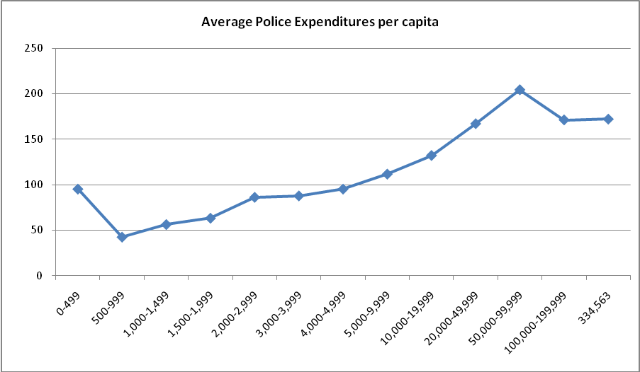

76 45 118 99 180 130 112 247 130 54 9 2 1







110 164 128 103 190 133 86 195 102 49



6 2 1

















196 235 202 165 258 181 140 285 152 59 10 2 1





69 113 124 77 31 103



82 185 109 44 6



113 206 166 131 195 134 96 136





330 393 315 226 324 202 150



The graphs below show the average pension/retirement fund contributions costs for Pennsylvania local governments. The charts were created after a number of steps. First, all local governments were sorted by population, smallest to largest. Second, local governments were split into population groups as such: 0-499; 500-999; 1,000-1,499; 1,500-1,999; 2,000-2,999; 3,000-3,999; 4,000-4,999; 5,000-9,999; 10,000-19,999; 20,000-49,000; 50,000-99,999; 100,000-199,999; and one municipality of 334,563 (Pittsburgh). Finally, expenditures were averaged for each group of municipalities.







Pittsburgh City pop. 334,563 2005 Pension expenditures: 40,055,000

**Appendix F Costs of Regional versus Local Police Services**

The following graphs compare regional police costs to local police costs. Each chart shows regional police agencies expenditures per capita compared to average expenditures per capita of police serving single municipalities. Regionalized agencies were compared to local municipality police services that serve approximately the same number of residents. The caveats in Appendix E also apply to these data.











Note: Berks Lehigh does not include the expenditures of Upper Mucungie Township.















Note: Orangeville Area does not include the expenditures of Orangeville Borough.





































Note: Northeastern Regional does not include the expenditures of Mount Wolf Borough.







The following charts show police expenditures per capita across local governments in counties that have regionalized police agencies. The black bars represent police expenditures per capita for regional police services while the blue bars indicate local police services. It is important to note that police expenditures per capita for regionalized agencies were calculated as if costs are distributed equally among the local governments in the regional agency. Another important note is that only 67 of Allegheny County’s localized police costs are shown in order to make the chart easier to interpret. Finally, 1,719 municipalities receive some form of Pennsylvania State Police (PSP) coverage. Out of all the local governments that use PSP coverage, 1,322 receive full time coverage and 397 receive part time coverage. Local governments that enlist part time PSP service are marked with an asterisk (*). The fact that these municipalities receive part time coverage may explain their lower costs for police service.

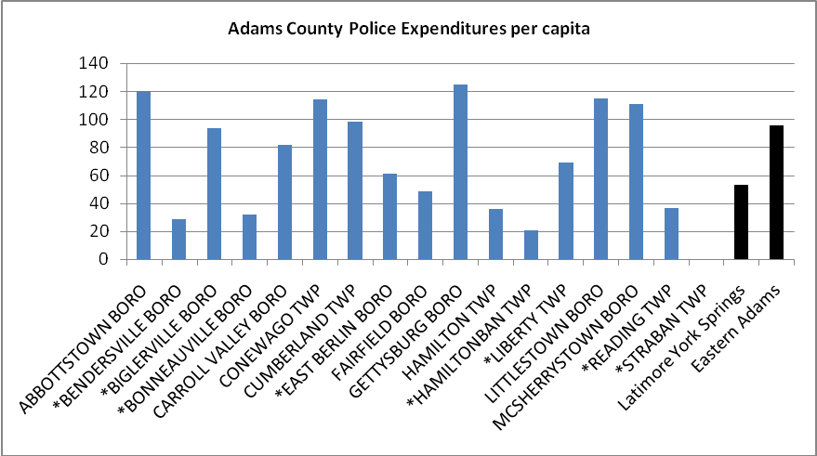

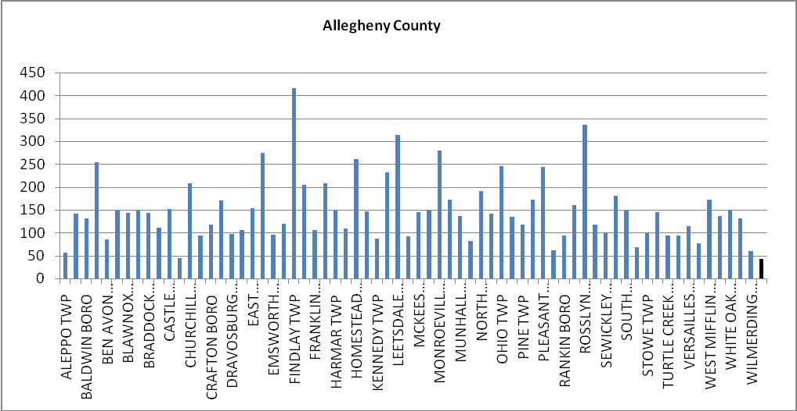

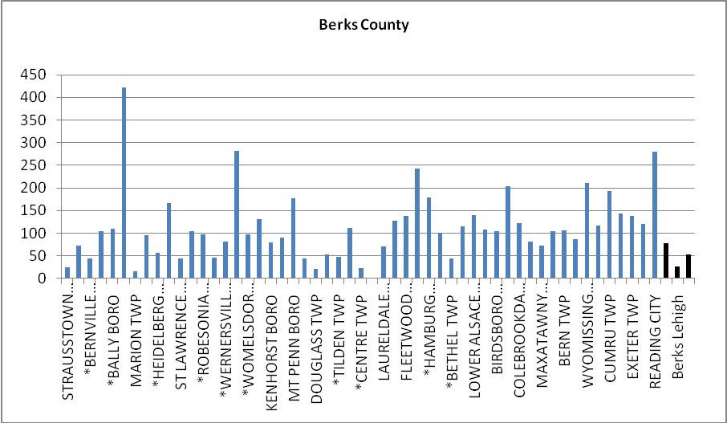

Note: Berks Lehigh does not include the expenditures of Upper Mucungie Township.

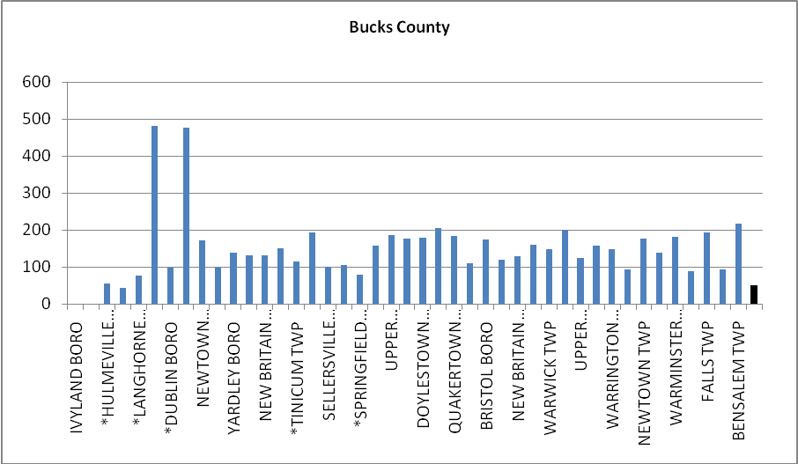

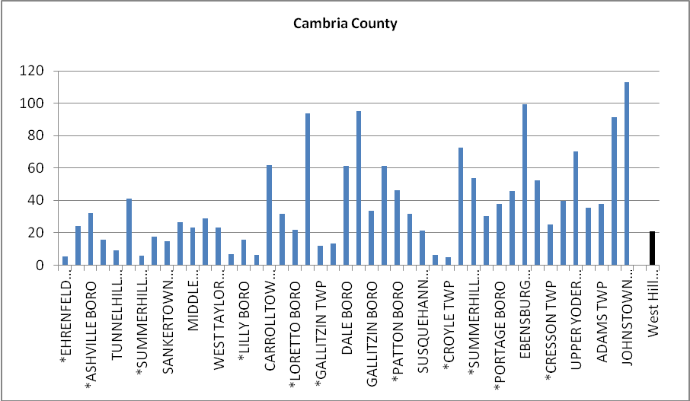

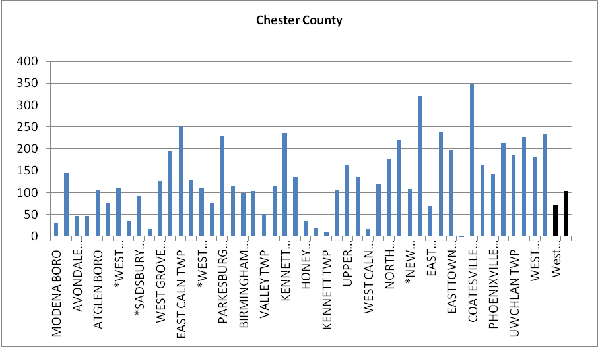

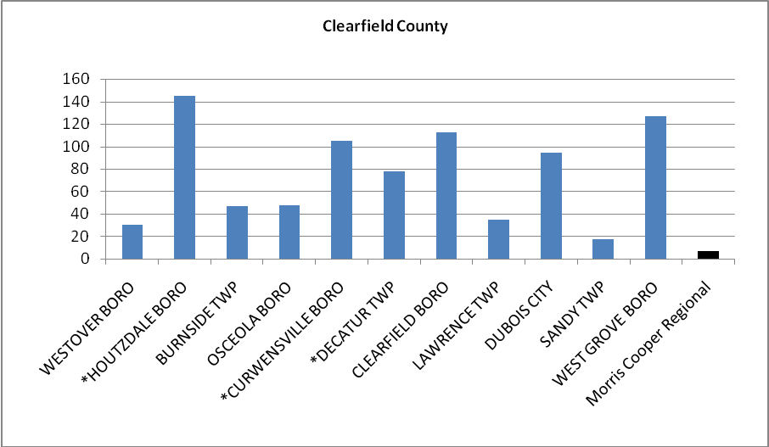

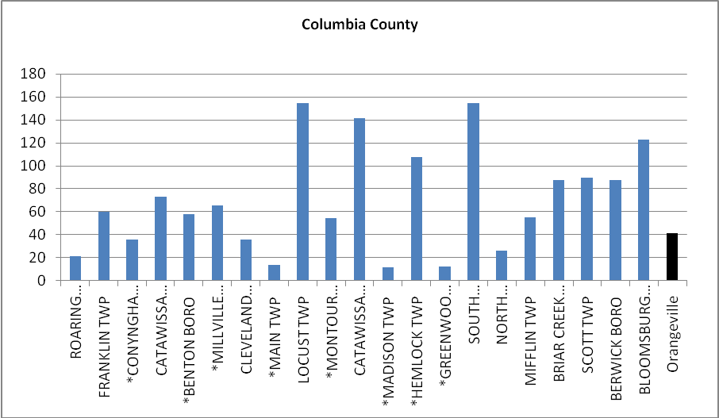

Note: Orangeville Area does not include the expenditures of Orangeville Borough.

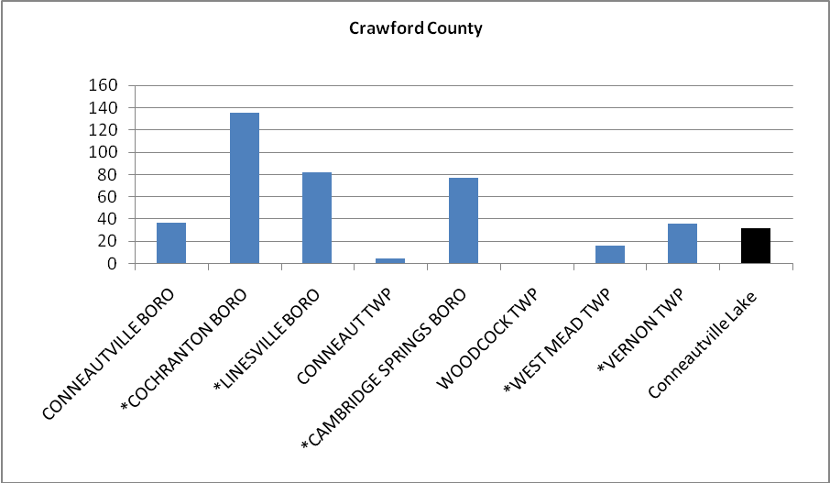

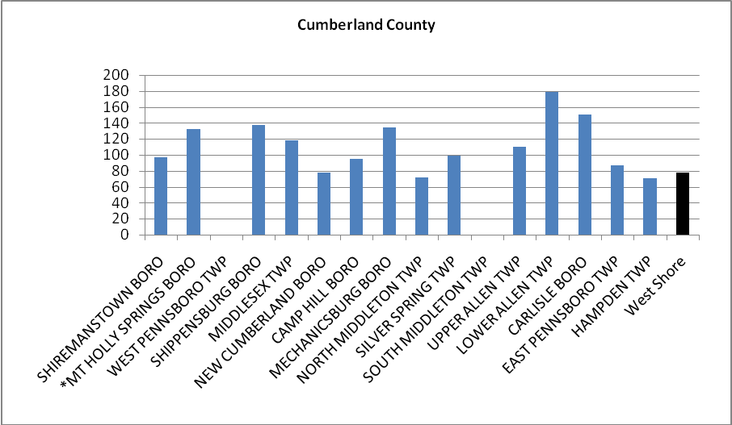

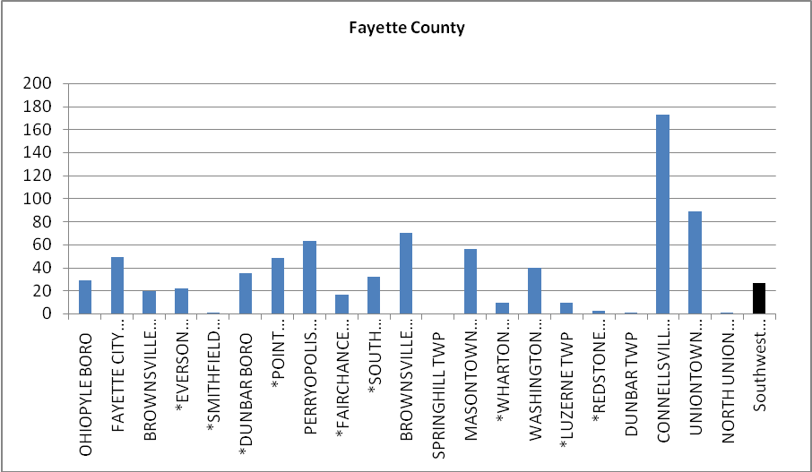

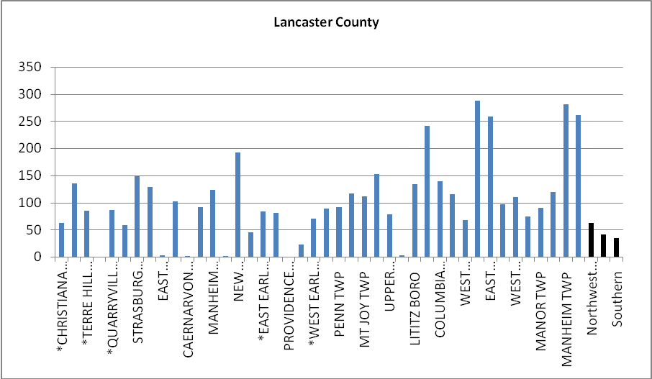

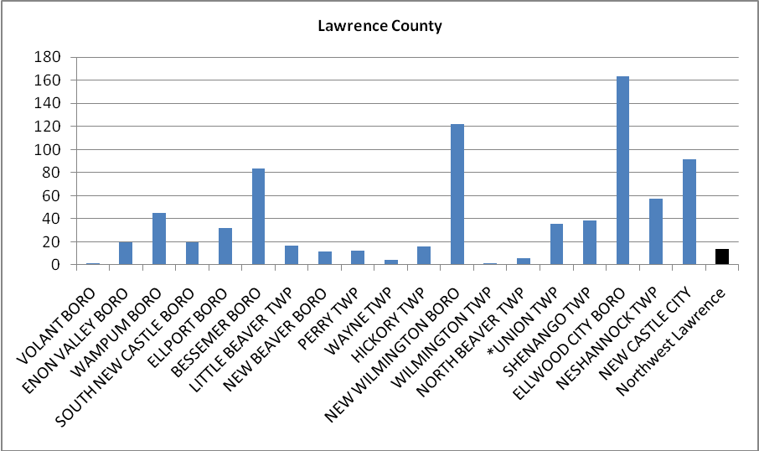

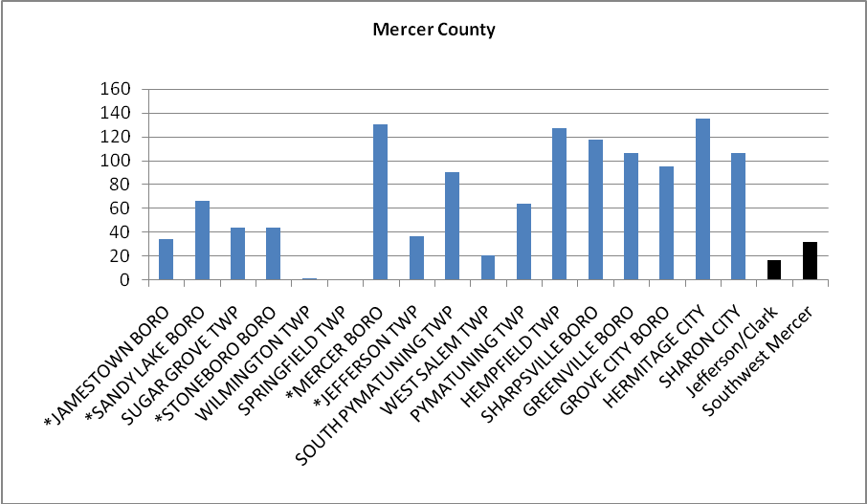

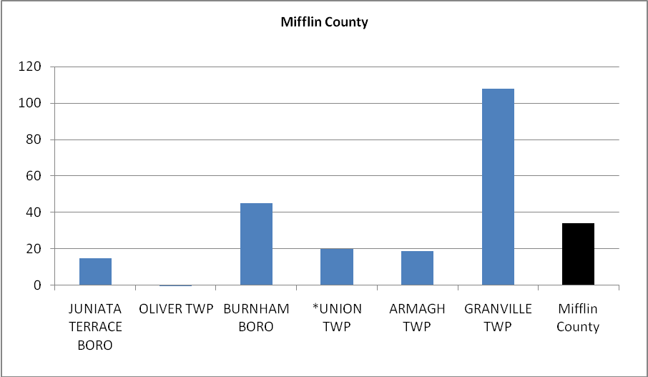

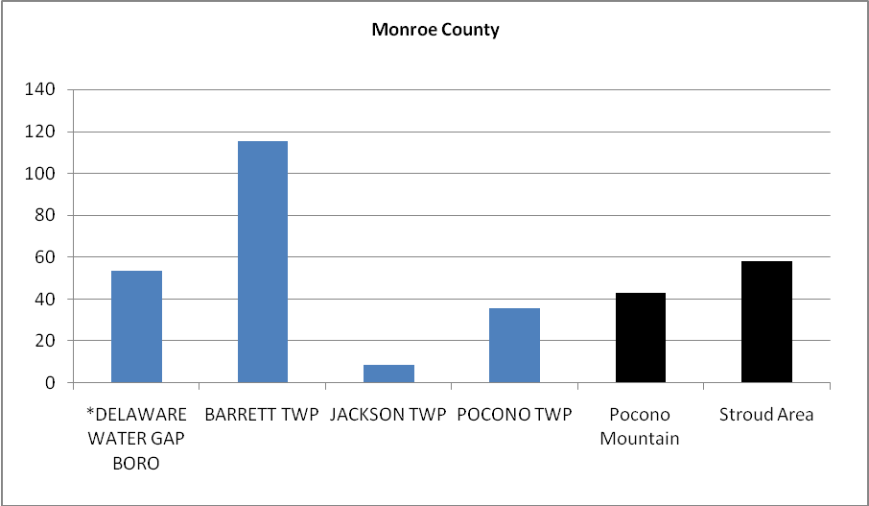

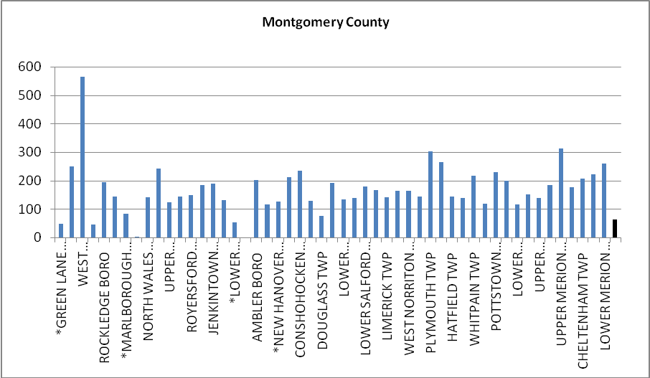

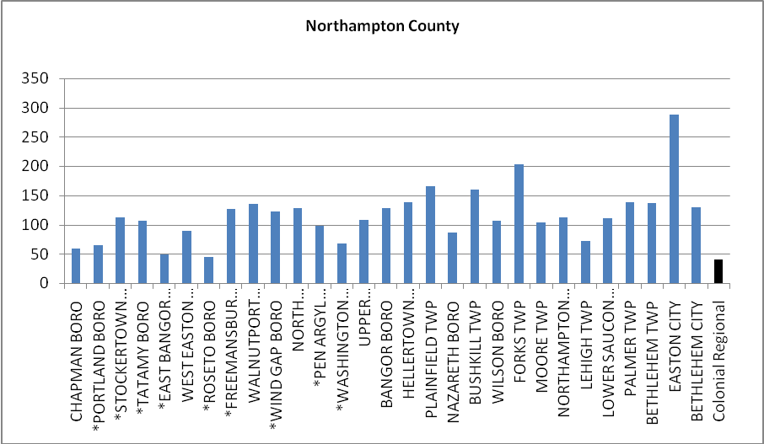

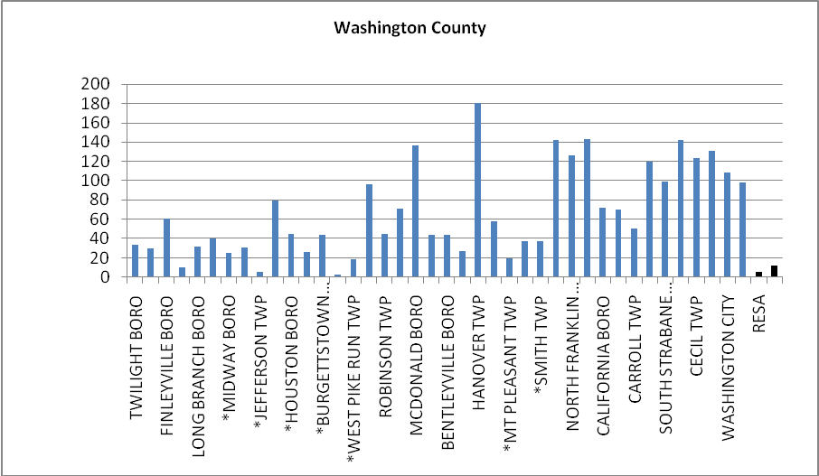

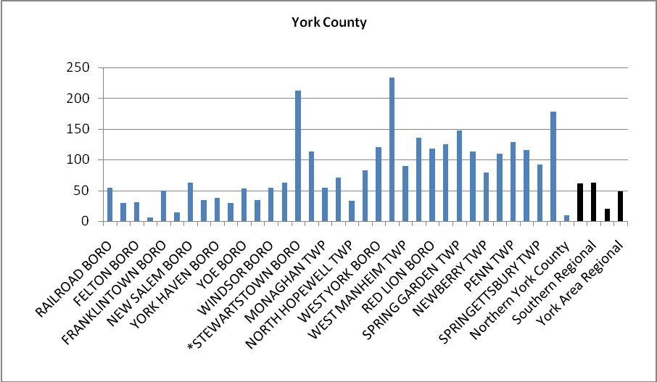

Note: Northeastern Regional does not include the expenditures of Mount Wolf Borough.

*Utilizes Pennsylvania State Police services on a part-time basis.

**APPENDIX G- Individuals Interviewed**

James Allen

Secretary

Pennsylvania Municipal Retirement System

Martin Bergen

Director, Bureau of Municipal Pension Audits

Office of the Auditor General

Bob Boerner

National Conference of State Legislatures

D. Robert Brady

Local Government Policy Specialist

Governor’s Center for Local Government Services

Department of Community and Economic Development

John Cape

Director, State Strategic Consulting

Public Financial Management

Moe Coleman

Executive Director Emeritus

Institute of Politics, University of Pittsburgh

Gerald Cross

Executive Director

Pennsylvania Economy League Central Division

Joanne Denworth

Senior Policy Manager

Governor’s Office

Philip Durgin

Executive Director

Legislative Budget and Finance Committee

Michael Gasbarre

Executive Director

Local Government Commission

Syndi L. Guido

Director, Policy Office

Pennsylvania State Police

George Hall

Administrator

Wisconsin Department of Administration

Division of Intergovernmental Relations

Mary Hanses

Purchasing Operations, MiDEAL

Michigan Department of Management and Budget

Randy Hartman

Director of Environmental Management

Georgia Department of Community Affairs

Mitch Hoffman

Regional Local Government Policy Manager

Governor’s Center for Local Government Services

Department of Community and Economic Development

Brian Jensen

Senior Vice President

Pennsylvania Economy League of Southwestern Pennsylvania

Robert Kassoway

Executive Director

House Finance Committee

Rich Kirkpatrick

Press Secretary

Department of Transportation

Harry Krot, Local Government Policy Manager

Governor’s Center for Local Government Services

Department of Community & Economic Development

Alan Kugler

President

PA Futures

Stephen MacNett

General Counsel

Senate Majority Leader

Donna Malpezzi

Chief Counsel

Senate Majority Leader

James L. McAneny

Executive Director

Public Employee Retirement Commission

David Y. Miller

Associate Professor

Graduate School of International and Public Affairs

University of Pittsburgh

Kerry Moyer

Director of Research (Retired)

Pennsylvania Economy League

Mark Muro

Senior Policy Analyst

Brookings Metropolitan Policy Program

Michael Nadol

Managing Director

Public Financial Management

Frederick Reddig

Executive Director

Governor’s Center for Local Government Services

Department of Community and Economic Development

Judith L. Schwank

President and CEO

Ron Stern

Local Government Policy Specialist

Governor’s Center for Local Government Services

Department of Community and Economic Development

Steve Stetler

Executive Director (Retired)

Pennsylvania Economy League State Office

10,000 Friends of Pennsylvania

**Bibliography**

Adams, Carolyn T., David Bartelt, David Elesh and Ira Goldstein. (2008) *Restructuring the Philadelphia Region: Metropolitan Divisions and Inequality*. Philadelphia: Temple University Press.

Baumgartner, Frank R., and Bryan D. Jones. 1993. *Agendas and Instability in American Politics.* Chicago: University of Chicago Press.

Berman, David R. 2003. *Local Government and the States: Autonomy, Politics, and Policy*. Armonk and London: M. E. Sharpe.

Brookings Institution. 2003. *Little Boxes- Limited Horizons: A Study of Fragmented Local Governance in Pennsylvania: Its Scope, Consequences, and Reforms.* December.

Center for Rural Pennsylvania. 2006. Is Bigger Better: A Comparison of Rural School Districts.

Centers for Regional Excellence Program. http://www.michigan.gov/cre.

Citizens Research Council of Michigan. 2008. *Approaches to Consolidating Local Government Services*. November, Report 354.

Cortes-Vazquez, Lorraine. 2007. *The Framework for Municipal Cooperation and Sharing Services*. *NYSBA Government, Law and Policy Journal,* 9:6-8.

Dowding, Keith, and Thanos Mergojupis. 2003. Fragmentation, Fiscal Mobility, and Efficiency. *The Journal of Politics.*  Vo. 65, No. 4 (November): 1190-1207.

Fund for Our Economic Future. http://www.futurefund.neo.org.

Georgia Municipal Association. 2002. *Charting a Course for Cooperation and Collaboration: An Introduction to the Service Delivery Strategy Act for Local Governments*. http://www.gmanet.com/Assets/PDF/publications/other/dca_sds.pdf.

Governor’s Advisory Council on Rural Affairs. 2008. *The Governor’s Resource Guide to Community and Economic Development. Harrisburg: Governor’s Advisory Council on Rural Affairs*.

Governor’s Center for Local Government Services. 2006. *Regional Police Services in Pennsylvania*.

Goodman, Josh. 2008. Attempted Merger. *Governing* 22: 22-27.

Hamilton, David K., David Y. Miller, and Jerry Paytas.  2004.  Exploring the Horizontal and Vertical Dimensions of the Governing of Metropolitan Regions.  Urban Affairs Review.  Vol. 40, No. 2 (November): 147-81.

Harvard University Kennedy School of Government. http://www.innovations.harvard.edu/awards.html?id=51041.

Hefler, Jan. 2009a.Town-merge study turns to South Jersey. *Philadelphia Inquirer.* May 7.

------. 2009b. N.J. town mergers could start in 18 months. *Philadelphia Inquirer*. May 29.

Holzer, Marc, John Fry, Etienne Charbonneau, Gregg van Ryzin, Tiankai Wang and Eileen Burnash. 2009. *Literature Review and Analysis Related to Optimal Municipal Size and Efficiency* (for the Local Unit Alignment, Reorganization, and Consolidation Commission in New Jersey). May 6. http://nj.gov/dca/affiliates/luarcc/pdf/final_optimal_municipal_size_&_efficiency.pdf.

House Resolution 167 Task Force. 1999. *Report of the House Resolution 167 Task Force Recommendations on Improving Policing.* September.

Indiana Commission on Local Government Reform. 2008. *Indiana Commission on Local Government Reform: 2008 Legislation Addressing Principles and Recommendations*. http://indianalocalgovreform.iu.edu/assets/doc/Legislative%20Update%20with%20LGR%20logo.pdf.

Indiana Commission on Local Government Reform. *Indiana Commission on Local Government Reform: Frequently Asked Questions*. http://indianalocalgovreform.iu.edu/assets/docs/Reform%20FAQ%204-08.pdf.

Innovation Clinic Database at the University of Pittsburgh Graduate School of Public and International Affairs. http://www.innovate.gspia.pitt.edu/Research/Database/.

Kingdon, John W. 1984. *Agendas, Alternatives, and Public Policies.* Boston: Little, Brown.

Kugler, Alan R. 2004. *Renewing Pennsylvania Local Government: Legislative Changes Needed to Promote Greater Cooperation and Innovation*. September 20.

Legislative Budget and Finance Committee. 2005. *The Feasibility of Regionalizing Pennsylvania’s Volunteer Fire Companies*. Harrisburg: Legislative Budget and Finance Committee. June.

------2004. *Report on the Feasibility of Placing Public School Employees Under the Commonwealth’s Jurisdiction for the Purpose of Providing Health Care Benefits (2004*).

------2007. *Study of the Cost Effectiveness of Consolidating Pennsylvania School Districts, Part 1 of 2, Statewide analysis.*

Local Government Commission. 1999. *Report of the House Resolution 167 Task Force Recommendations on Improving Policing*.

Local Government Institute of Wisconsin. http://www.localgovinstitute.org/.

Lu, Adrienne. 2008. Reaction mixed to proposal that shore towns merge. *Philadelphia Inquirer,* December 1.

Lyons, W.E. and D. Lowery. 1989. Governmental Fragmentation versus Consolidation: Five Public Choice Myths about How to Create Informed, Involved, and Happy Citizens. *Public Administration Review*. 49 (6): 533-543.

Melvin, Don. 1995. Who needs a charter? *The* *Atlanta Journal and The Atlanta Constitution,* July 1.

Michigan MiDEAL. http://www.michigan.gov/localgov.

New Jersey Department of Community Affairs. *SHARE PROGRAM!: Sharing Available Resources Efficiently*. http://www.nj.gov/dca/lgs/share.

---. 2009. *Local Unit Alignment, Reorganization and Consolidation Commission March 2009 Report: A Quest for Efficiency in Local Governance*.

New York State Commission on Local Government Efficiency and Competitiveness. 2008. *Local Government Reform Activities in Other States*. New York State Commission on Local Government Efficiency and Competitiveness, October. http://www.nyslocalgov.org/pdf/Reform_Efforts_Other_States.pdf.

New York State Department of State, Division of Local Government Services. http://www.dos.state.ny.us/lgss/smsi/index.html.

*News-Sentinel.* 2008. Ready to lobby for new, smaller government: Proposals to streamline government deserve legislators’ attention. September 4.

Office of the Attorney General of the State of New York. 2008. *Attorney General’s Comprehensive Plan to Enable Reform and Efficiency in Local Government Operations*. December 11. http://www.oag.state.ny.us/bureaus/legislative/government_consolidation/about.html.

Ohio Department of Development. 2008. *Local Government Services and Regional Collaboration Grant Program*. May 20. http://www.development.ohio.gov/Collaboration/.

Palsgrove, Rick. 2008. Commission set to study streamlining local government. *Columbus Messenger,* November 29, Southeast section.

Pennsylvania Department of Community and Economic Development Center for Local Government Services. 2004.  Pennsylvania's Earned Income Tax Collection System An Analysis with Recommendations.

Pennsylvania Economy League. 2007. *Structuring Healthy Communities Part I: Revenue Generation and Fiscal Health.* March.

Pennsylvania Economy League. Forthcoming. *Structuring Healthy Communities Part II.*

Pennsylvania General Assembly. 2006. *Municipal Fiscal Distress and Recovery*. Harrisburg: Pennsylvania Legislator’s Municipal Desk Book, Third Edition.

Pennsylvania Public Employee Retirement Commission. 2008. *Status Report on Local Government Pension Plans.* December.

------. 2009. *Public Employee Retirement Laws for Pennsylvania Local Governments*. January.

Pennsylvanians for Effective Government. 2006. What do people want? Pennsylvanians for Effective Government Education Committee Survey.

Rudolph, Stephanie. 2007. *State May Push Local Governments to Cooperate*. Michigan Land Use Institute, August 27. http://www.mlui.org/print.asp?fileid=17183.

Sleeper, Sally, Henry Willis, Stephen Rattien, and Adrienn Lanczos.  2004.  A Research Agenda for Assessing the Impact of Fragmented Governance on Southwestern Pennsylvania.  Pittsburgh: RAND Corporation.

Smith, Ben III. 1993. House votes to dissolve one-fifth of cities to cut government costs. *The* *Atlanta Journal and The Atlanta Constitution,* February 26.

Stephens, G. Ross, and Nelson Wikstrom. 2000. Metropolitan Government and Governance Theoretical Perspectives, Empirical Analysis, and the Future.  New York: Oxford University Press.

Ruthhart, Bill. 2008. Daniels to push for local government reforms. *Indystar.com,* December 20. http://www.indystar.com/apps/pbcs.d11/article?AID=/20081220/NEWS05/812200395.

University of Minnesota Extension. http://www.extension.umn.edu/distribution/citizenship/components/6541_08.html.

1. State Police will provide police services for any municipalities that decide not to provide such services; currently, 1,322 local governments receive full-time state police coverage, and 397 local governments receive part-time coverage. Municipalities are not obligated to support volunteer fire companies, and most don’t. The Commonwealth, however, does provide financial support to volunteer fire companies. During the Depression, the Commonwealth absorbed roughly 12,000 miles of local roads into the state highway system, which, at roughly 44,000 miles, is sometimes described as larger than that of the New England states, New York, New Jersey, and Maryland combined. New York and Maryland have county road departments. Although Pennsylvania’s takeover decision was made decades ago and is now settled practice, it arguably subsidizes municipal costs that in other states would be paid by local taxpayers.
2. Cultural preferences, patronage concerns, and even personality conflicts play a part. One state official said common reasons municipal right-sizing initiatives fail are political, patronage, and personality conflicts between key officials of the jurisdictions. Another important reason is the recognition by one or more jurisdictions that a tax increase might be necessary to level up the quality of jointly provided services.
3. One of the experts interviewed for this report, John Cape of Public Financial Management, began his career working for New York Governor Nelson Rockefeller (1959-73) on efforts to foster municipal consolidation. Today he is making progress on an ambitious county-driven right-sizing project in highly fragmented Nassau County, New York. From a statewide perspective, however, he reports there has been virtually no significant change in the number of local governments in the intervening years.
4. Philadelphia solved its municipal fragmentation problem in 1854, when the city absorbed 28 surrounding towns, boroughs, and districts and unified city and county borders. The city and county governments themselves were not fully integrated until adoption of the city’s home rule charter in 1951. Nevertheless, in 1930, Paul Studenski, in a classic text on the subject, called Philadelphia the only fully successful example of metropolitan government in the United States. Metropolitan reformers would argue that the Philadelphia solution proved temporary, as the natural economy outgrew the city borders.
5. Interview with Gerald Cross, executive director, Pennsylvania Economy League Central Division.
6. Interview with Ron Stern, Governor’s Center for Local Government Services, Department of Community and Economic Development.
7. In addition to the phase in for administrative functions, benefits for existing retirees could not be changed.
8. Legislation was recently proposed to reduce the cost of membership in order to encourage use of the program (Rudolph, 2007).
9. http://www.osa.state.mn.ud/default.aspx?page=BestPracticesReview.
10. http://www.osa.state.mn.us/BestPractices/.
11. The Shared Services Board is located at http://www.njlm.org/forum1/.
12. These and the full list of recommended reforms, including the 2008 legislation reflecting them, are available on the Commission on Local Government Reform website at http://indianalocalgovreform.iu.edu/assets/doc/Legislative%20Update%20with%20LGR%20logo.pdf.
13. The last municipal merger in New Jersey took place over a decade ago in 1997, when Pahaquarry Township, with a handful of citizens, merged with Hardwick Township. This took years of negotiations and involved special legislation that allowed Pahaquarry to skip a study and two referenda (Lu, 2008).