**The 2010 Texas Time Trials**

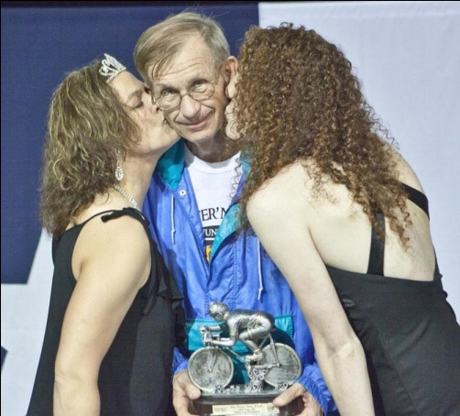

If one word could sum up The 2010 Texas Time Trials, it would be **“Eclectic.”** The people who showed up to race, volunteer and sponsor this year’s race were as different as their personal reasons for being involved with this event. While we enjoyed an extremely diverse group of racers and volunteers, the “Texas Hospitality” that The Texas Time Trials has become known for, remains a mainstay. This year included free spaghetti dinner for all racers, crew, family, friends and volunteers, a new stage, with multi-height podiums, Podium Girls handing out trophies and kisses, and even more TTTT-Volunteers helping out, over

Charlie Fenske gets trophy & kisses

100 of them. TTTT Volunteers manned many of the corners on the 26.5 mile looped course, and at several corners our Corner Marshals set up campers and motor homes to make sure riders were taken care of whether they needed water or a nap. Not a single rider went off course, thanks to volunteer Nelson Ralls, who not only painted arrows with glass beads for every turn, he also painted X’s to alert riders that may have missed a turn and he even added mile markers. As in years past, we believe that although this is a race and there is a winner, every one with the courage to line up at the start deserves a Texas Time Trials Trophy. This year over 200 TTTT Trophies were given out and if you haven’t seen them for yourself, you should take a look! <http://www.tt24tt.com/awards.html>

It means everything to us that so many racers come back from so far away every year and this year Frederic Ricol from France not only returned, but he brought a French friend. Frederic made a TTTT discussion list connection when requesting lodging 5 years ago for his first TTTT. He was introduced to fellow TTTT Racer Dennis Cook and family on his first visit to Texas, then connected again this year, with promises to return the favor at next year’s PBP, when Dennis will be in France. Typically, TTTT draws racers from several different countries and over half of the US States every year and this year was no exception. We love having the diversity of so many racers from out of state mixed with those from our own neck of the woods.

2010 TTTT was made possible by over 100 Volunteers. Many taking time off work and forgoing sleep to help keep the wheels turning, like Tony Gooodnight who volunteered his time to run the TTTT Website. Most TTTT Volunteers were from North Texas Bike Clubs including The Fort Worth Bicycle Association and Lone Star Randonneurs. Uniquely, some volunteers not only volunteer, but also race in the same weekend, while others may race one year then crew or volunteer the next. It is heartwarming to see friends take turns crewing for each other, and to see the same person volunteer to work to keep the race they love alive and give back to the sport and others involved in the sport. We also have some sponsors that volunteer and race.

Time keepers Julie Flickner & Bill Fox

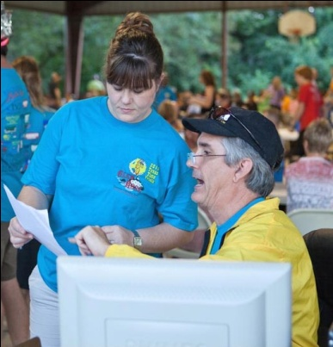

TTTT has some of the very best sponsors a race could ever ask for. Want to know why there is a Starbucks logo on the back of the TTTT T-Shirts? It’s because they bring volunteers 10 gallons of hot coffee two nights in a row, so we can stay up all night to count racers riding through the start/finish chute. Chicken Express fed all volunteers lunch for two days. Trail LED donated a fabulous light for the TTTT raffle. GT Bikes donated a bike for the raffle, Bob Gracey of TSO donated Rudy Project sunglasses and helmets to the raffle, Juliany's made it affordable to feed 300 people at the Awards Dinner and Iron Head Race Productions provided finishers mugs to all racers. Hammer Nutrition has been filling TTTT goodie bags for 8 years as one of TTTT’s major sponsors. Bicycles Inc., Richardson Bike Mart, TSO and Community Bank allow TTTT to give trophies to all our riders.

Glen Rose Courthouse after dark

The City of Glen Rose, Texas has been a perfect home for The Texas Time Trials with hotels, restaurants, bars and shopping within walking distance of The Race. We have all the creature comforts, but also rural roads with low traffic, rolling hills and awe inspiring scenery just pedal strokes away. The 26.5 mile course takes a short jaunt through downtown Glen Rose and right past the County Courthouse. Riders comment in a positive way about the diversity of the route, especially late at night riding through a few blocks of this small town with its “City Lights” really brightens spirits in the wee hours.

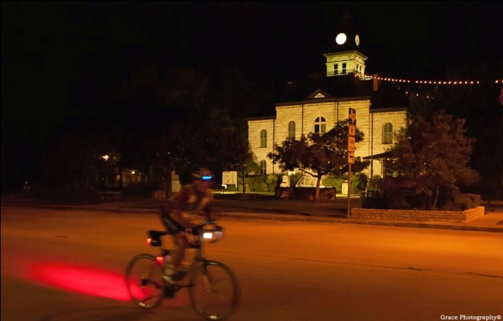

Because The Texas Time Trials is a looped course, many riders enjoy “self-supporting” themselves with just a cooler. The self-supported opportunity allows for a very affordable race weekend forgoing follow vehicles and crew member transportation. It was fun to watch many of the self-supported racers become adopted by a neighboring crew and helped out. In contrast, others bring out the family and friends to add to the ambience. Kirk Gentle brought his oldest son to crew for him, his younger son Sam raced and his wife Meg also raced with their youngest son on the back of her bike in a child seat. It was inspirational to see all the signs that Wayne Dunlap’s family of five snuck out onto the course the night before the race and they were all there to crew for him, making it a family outing instead of “Daddy gone for the weekend with his bike again.” Sandy Earl made friends with some of our local rando riders and negotiated them to crew for her, saving crew transportation expenses. It was fun to see a few racers being crewed by RAAM veterans and other racers with their own aspirations of competing next year.

Although the Tejas 500 and The “Iron-Butt” 24-hour remain predominantly male, the females are gaining ground on the shorter races with 35 females signed up for all races. Not only are these females showing up, but they are kicking some booty, riding further and or faster than many of the men. They call that “chick'd”, but don’t feel bad if you were “chick'd,” some of those gals are truly world-class! With The Tejas 500 and Iron-Butt both being RAAM qualifiers, we had more than 50 racers sign up for a chance to become RAAM qualified. 21 of the Tejas 500 racers did indeed qualify.

This year’s TTTT had its youngest rider ever, 8-year-old Sam Gentle. We also had three riders under 20 years old. Michael Dihigo, 17 years old, averaged almost 22 mph for the 26.5 mile Sprint! Earlier this year, I attended a local “Ride of Silence” and next to me was 12-year-old Hunter Hinton riding with his dad. I asked his dad to bring Hunter out to TTTT and promised we would send him home with a TTTT trophy that just might change Hunter’s life. Hunter showed up and the smile on his face changed the lives of all those around him after he completed the 26.5 mile Sprint and accepted his Trophy. On the other end of the age stage, TTTT drew 5 females and 20 solo males over the age of 60. Three of these managed the Tejas 500, with Virgil Moehsmer of Ellisville, MO placing first in his age group and 4th overall with 34:32. Markus Joswig from Germany was our youngest Tejas 500 racer at 29 years old. Dex Tooke took second place in TTTT’s 24-hour “Iron Butt” at age 60 after competing in RAAM earlier this year. Two of our 12-hour “Tin Butt” Racers were 66 years old. Goes to show that you do have to get older, but you don’t have to grow up, you can ride your bike for a long time.

8-year-old Sam Gentle

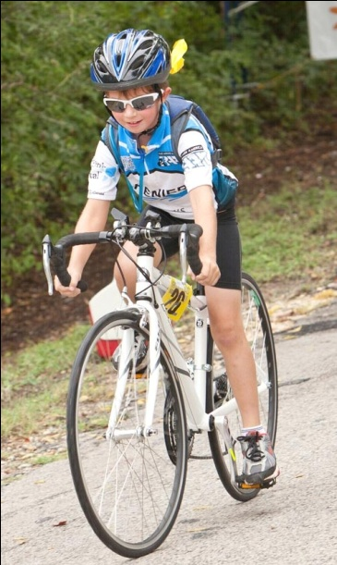

We are pleased to have such a large field of recumbents every year. The ‘bent racers were represented in every race except the 6-hour. This year we had four ‘bent racers in the Tejas 500 with most placing near or at the top of the overall list, including one female, Peggy Petty setting an overall female course record with 35:27. Sandy Earl avenged her previous Tejas 500 DNF with an overall course record on her ‘bent for the 24-hour “Iron-Butt” race with 371 miles. Ray Torrey couldn't get enough racing so after doing his turns for The Tejas 500 4-man “Team Awesome Foursome”, Ray signed up and rode the 26.5 mile Sprint as well. John Scott Freeman set a ‘bent course record of 171.89 miles for The 12-hour “Tin-Butt.” Several teams were a fun mixture of ‘bents and diamond frame bikes.

Peggy Petty Tejas 500 female course record

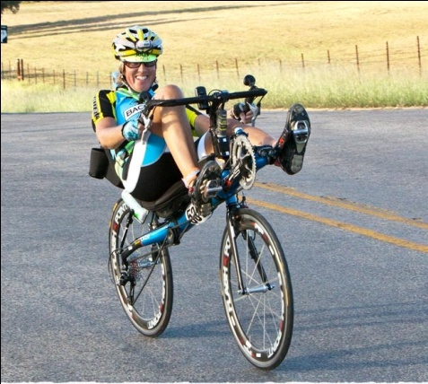

The Tejas 500 is 19 laps and even that basic information sometimes doesn’t translate a language barrier. Our French friend, Thierry Saint Leger who did not speak a word of English, caused concern for one of our time keepers when he noticed that athough he was due to become an official finisher at any minute, Thierry was nowhere to be seen. Did he have a flat? Nope, he thought he was done and went to his hotel room and was sawing logs. Pat, a volunteer, tracked him down, woke him up and got him back on the road. Thierry completed his last lap with plenty of time on the clock. In contrast, Gary Smith, a transplanted Texan down from Washington State, surprised our time keepers when he came through the Start / Finish to complete his 20th Lap. Oops!

Every racer has their own motivation for showing up, for some it is the culmination of a year’s worth of training, for others it is a chance to be a part of something much bigger than a ride with a couple of friends. Some are there to win, some for the reunion, some to enjoy the sunshine, while others are doing the first race of their life. We have a healthy mix of “World-Class Athletes”, “Rookies” and “First Timers”. I love the spontaneous and positive way they interact. For every very serious racer there is a fun one. Pam Wright and Vickie Tyer needing to be the very best they can be at anything they set their mind to, took “fun to a whole new level.” Their 4-person mixed Tejas 500 Team, “Team from Oz,” dressed up as The Wizard of Oz characters. Pam was Dorothy, Vickie the Scarecrow, Pat the Tin Man and Richard the Cowardly Lion. In full costume, they lined up with the other Tejas 500 riders making for a great tension release at the start line, with lots of laughter.

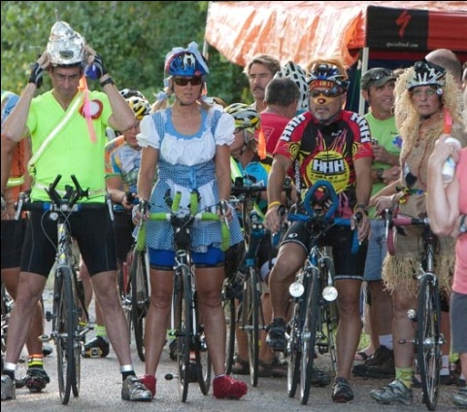

“Team from Oz”

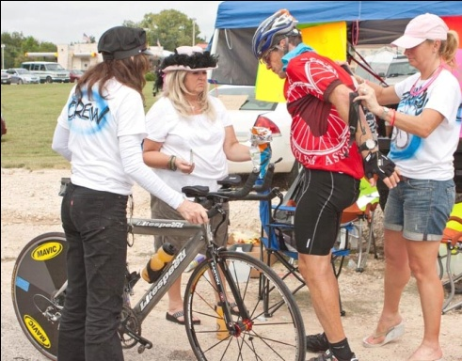

**The Tejas 500** overall win went to local LSR Randonneur Gary Gottlieb with 29:37. It is nice for this honor to come home to roost for a year, as last year’s winner was from Austria and the 2008 winner was from Canada. Second place men’s solo diamond frame went to Wayne Dunlap, Austin’s RBA. Sharon Stevens won the Female Solo Diamond Frame. In the Male Solo ‘Bent Category, Christopher Young earned first place with 32:08 and Steve Petty earned second, with Steve’s wife Peggy setting an overall female course record. Four 4-man teams battled it out with “Team Broken Bulge” coming out on top with a course record of 26:11. “Team from Oz” set a Mixed Team record with 29:44, and proved what I have been saying all along “The 4 person team Tejas 500 can be the most fun race of all”.

Gary Gottlieb & Crew

**The 24-Hour “Iron Butt”** overall course record went to Sandy Earl. Kirk Gentle won the Men’s solo race with 365 miles with Dex Tooke taking second. “Team KO” won the Mixed Team with 265 miles, with team “Old Meta” racing 185 miles.

**The 12-Hour “Tin Butt”** overall course record went to Jeff DeLaVega with 204 miles. John Scott Freeman won the Solo Male ‘Bent with 171 miles, with Rani Freeman winning the Solo Female with 185 miles. There were four 2-person teams with “Team Flat Belly Organics” winning with 238 miles and “Tex-Mex” winning the Mixed Team Division with 106 miles.

**The 6-Hour “Shoot Out”** Scott Simmons shattered the old Solo Men’s record of 106 miles with his 129 mile performance averaging 21.6 mph and setting a new course record. Kathy Wickersham set a new course record for solo females with 97 miles. After Volunteering, Conner/Tudor took first place in the mixed tandem race.

**The 26.5 mile “Sprint”** Solo Male winner was local radio celebrity Craig Miller from The Ticket. The Ticket was a TTTT Sponsor many years ago and it was nice to see Craig back to cycling after a few years away from the sport to do marathon running, Craig averaged 23.98 mph. Greg Gross won the male ‘Bent in 1:13 and Erica Fellers set a course record averaging over 20 mph completing the Female Sprint in 1:18.

For full results including splits of each lap go to <http://www.tt24tt.com/results2010.html>

Photo credits to Linda Middleton <http://www.printroom.com/ViewGallery.asp?userid=lmiddleton&gallery_id=2287655>

CelebratedImages.com

<http://orders.racephotonetwork.com/QPPlus/Images.aspx>

view more photos at <http://www.tt24tt.com/photos-bryan/index-all.html>

Until Next Year, Happy Trails, Dan D. Thanks Pam Wright for making this Race Report readable.