# Creating a Chart

There are many chart types available. The Legacy Dialogs option on the Graphs menu lists some of the more popular types.

## Creating a simple bar chart

1. 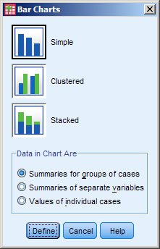Select Bar... from the Legacy Dialogs on the Graphs menu.
2. A dialog box similar to that opposite is displayed. (The more complex charts have more options.)
3. Select the chart sub-type required by clicking on the relevant icon.
4. Select Summaries for groups of cases in the Data in Chart Are option.
5. Click on Define.

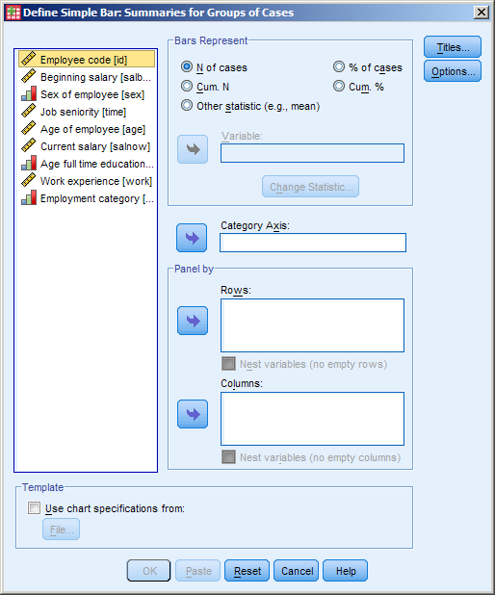

1. In the variable list to the left of the dialog box highlight the variable to chart by.
2. Click on the arrow to add to the category axis. The OK button will then be accessible.

## Creating a pie chart

1. Select Pie... from the Legacy Dialogs on the Graphs menu.
2. Select the Data Type.
3. Click Define
4. Add the variable(s) to the Define Slices by box.
5. Click OK.

## Creating a line chart

1. Select Line... from the Legacy Dialogs on the Graphs menu.
2. Select the line chart type and type of data.
3. Click Define.
4. Add the variable(s) to the Category Axis box.
5. Click OK.

# Modifying a chart

|  |  |
| --- | --- |
| In order to modify a chart you must double click on it in the output window. The chart will then be displayed in the chart editor window. |  |

## Adding Titles and Footnotes

**Titles** - Selecting Title from the Options menu or clicking on the Title button  allows you to enter a title.

**Footnotes** - Appear at the bottom of the chart. Select Footnote from the Options menu or clicking on the Footnote button .

## Changing the size/font/format/alignment of text

1. Select the text to be changed.
2. Use the formatting toolbar to make the necessary changes.

## Show/hide data labels

1. To show data labels, click on the bar Data Label button . Click again to hide them.
2. Select the label position or other options from the Properties box that appears.
3. To show data labels on individual bars, click on the Data Label Mode button  and then on relevant bar or bars. Click on the button again to leave Data Label Mode.

## Swap axes

1. Click on the Transpose Chart Co-ordinate System button .

## Changing the colour of a bar

1. Select the bars by clicking once on one of them. To select a single bar, select all bars, pause and then click once again.
2. 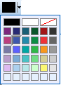Click on the arrowhead to the right of  the Fill Color button.
3. Select the colour required from the palette displayed.

## Exploding slices in a Pie chart

To explode individual slices:

1. Select the slice to explode.
2. Click on the Explode Slice button. 

## Combining Slices in a Pie chart

1. Select the chart and then click on the Properties button  if the Properties window is not visible.
2. Click on the Categories tab.

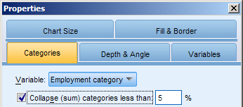

1. Tick the collapse (sum) categories less than… box.
2. Type the percentage below which to combine.

## Adding a point marker to a line chart

1. Select Show Line Markers from the Elements menu or click on the Show Line Markers button. 
2. From the Marker tab in the Properties box that is now displayed, choose the type size and colour required.

## Changing the line connecting data points

1. Double click the line to select it and open the Properties box.
2. If the chart has multiple lines and you only want to change one, select the line.
3. Select the weight/style/colour from the options on the Line tab.
4. On the Interpolation Line tab, select the line type and alignment (if appropriate).

## Adding a Fit Line

1. Double click over the chart in the output window.
2. Select Fit line at Total from the Elements menu or click on the Fit Line button. 

## Adding Gridlines

1. Select Show Grid Lines from the Options menu or clck on the Show Grid Lines button. 
2. Select where to place the grid lines at in the Properties box that appears.
3. Click on the button again to hide the grid lines.

## Changing to a Logarithmic scale

1. Select either axis on the chart by double clicking on it.
2. Select the Scale tab in the Properties box that appears.
3. Change the type to Logarithmic.

# Deleting a Chart

|  |  |
| --- | --- |
|  | Highlight the Graph to be deleted as shown opposite and press the delete key, the graph, its title and notes will be removed from the output window. |

# Printing Charts

To print only the chart:

1. Select the Graph to be printed.
2. Chose Print from the File menu. Click OK

# Modifying the Data

If the data is changed the chart must be recreated to reflect the changes.

# Sigma Plot

SigmaPlot is a specialist scientific graphing software program that can produce publication standard graphs. It has many features such as non-linear curve fitting, confidence intervals, regression lines and automatic error bars.

SigmaPlot graphs can be created using SPSS data and inserted directly into an output file as a SigmaPlot object.