**Supplemental Unit 1. Demand, Supply, and Adjustments to Dynamic Change**

Note: The authors recommend that this feature be read along with Part I, Elements 6, 7, and 11 of *Common Sense Economics*.

*Common Sense Economics* highlights how markets work and their impact on the allocation of resources. This feature will investigate this issue in more detail. It will use graphical analysis to analyze demand, supply, determination of the market price, and how markets adjust to dynamic change.

**Demand**

The law of demand states that there is a negative relationship between the price of a good and the quantity purchased. It is merely a reflection of the basic postulate of economics: when an action becomes more costly, fewer people will choose it. An increase in the price of a product will make it more costly for buyers to purchase it, and therefore less will be purchased at the higher price.

The availability of **substitutes**—goods that perform similar functions—underlies the law of demand. No single good is absolutely essential; everything can be replaced with something else. A chicken sandwich can be substituted for a cheeseburger. Wheat, oats, and rice can be substituted for corn. Going to the movies, playing tennis, watching television, and going to a football game are substitute forms of entertainment. When the price of a good increases, people will turn to substitutes and cut back on their purchases of the more expensive good. This explains why there is a negative relationship between price and the quantity of a good demanded.

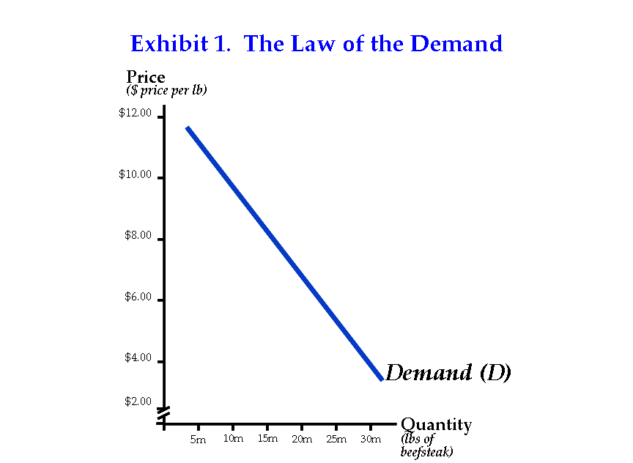**Exhibit 1** provides a graphic illustration of the **law of demand**. Price is measured on the Y-axis and quantity on the X-axis. The demand curve will slope downward to the right, because when the price falls, consumers will purchase a larger quantity.

Correspondingly, an increase in price will cause buyers to reduce the quantity of their purchases. The demand curve isolates the impact of price.

Other factors that might influence the choices of consumers are held constant. For example, factors like consumer income, price of related goods, expectations about the future price, and the preferences of consumers are held constant when the demand curve is constructed. Changes in these factors will 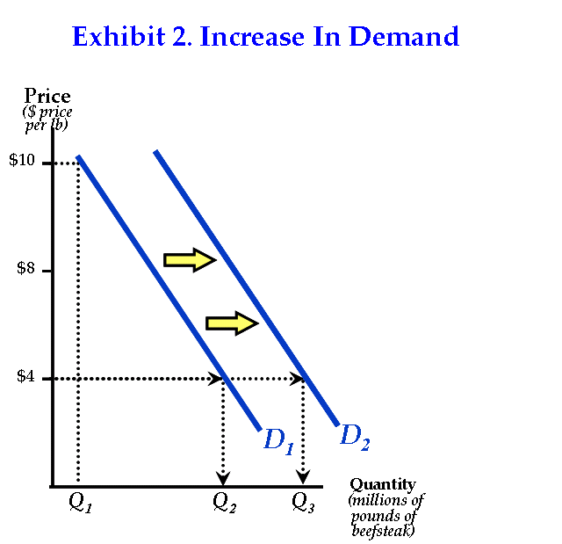shift the entire demand curve.

Using beefsteak as an example, **Exhibit 2** illustrates an increase in demand, a shift in the demand curve to the right. Think how the demand for beefsteak would be affected by an increase in consumer income or an increase in the prices of substitute goods like pork, chicken, or turkey. When consumer income increases or substitute goods become more expensive, consumers will buy more beefsteaks. This will increase the demand for beefsteak, causing the demand curve to shift to the right as shown in **Exhibit 2**. Economists refer to this shift of the entire demand curve to the right as an “increase in demand.” This increase in demand should not be confused with an “increase in quantity demanded,” a movement along the same demand curve in response to a lower price.

Now consider what would happen to the demand for beefsteak if there was a reduction in consumer income or a decrease in the price of the substitute goods. These changes would lead to a decrease in the demand for beef, a shift in the entire curve to the left. As we proceed, we will consider how both increases and decreases in demand affect the market price. But before we can do that, we must consider the supply side of markets.

**Supply**

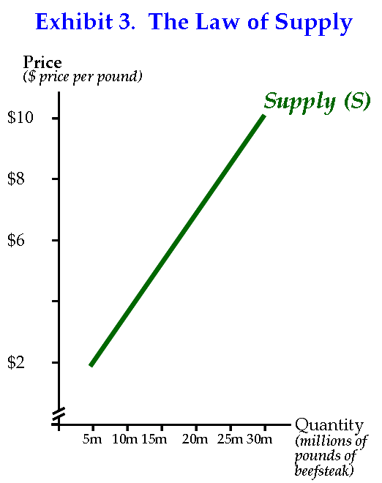The **law of supply** states that there is a positive relationship between the price of a good and the quantity of it that producers will supply. Business firms and other producers purchase resources and combine them into goods and services. The resources have alternative uses so producers will have to pay resource owners a price sufficient to attract them from other potential users. Thus, product suppliers will incur costs as they purchase resources. Producers are in business to make a profit. In order to do so, they will have to supply products that can be sold for a price that is greater than the costs of the resources required for their production. As product prices increase, suppliers will find it profitable to supply more and more units. This accounts for the direct relationship between the price of a product and the quantity supplied by producers.

**Exhibit 3** displays the supply curve. It indicates the quantity of a good that producers are willing to supply at alternative prices. The law of supply states that this relationship is positive – that producers will supply a larger quantity as the price of a good rises. Thus, the supply curve for a good or service, beefsteak for example, will slope upward to the right.

As the price of beefsteak increases, beef producers will find it profitable to produce larger quantities. The upward sloping supply curve reflects the fact that the incentive of producers to supply beef (or any other product) increases as its price rises.

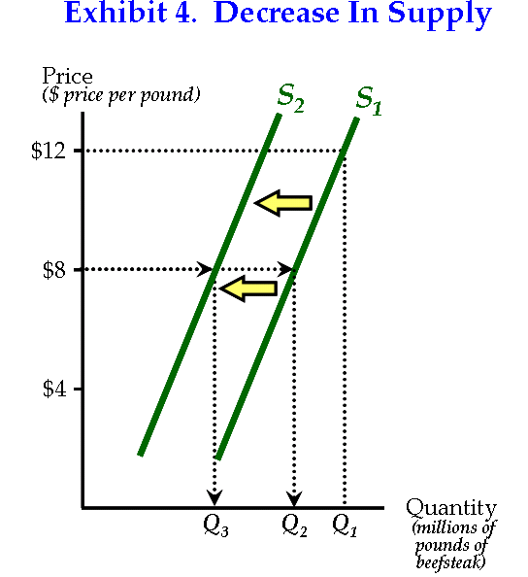 As in the case of demand, other things are held constant when the supply curve is constructed. Put another way, the supply curve isolates the impact of price on the amount supplied. However, changes in factors that influence costs will affect the position of the supply curve. Factors that increase the cost of producing a good will cause the supply curve to shift to the left. For example, an increase in feed grain prices will make it more expensive for farmers to produce cattle.

As **Exhibit 4** shows, the higher costs will “decrease supply,” shift the entire curve to the left. More generally, factors like higher resource prices or taxes that increase the cost of supplying a good will reduce the market supply of a good.

On the other hand, changes that reduce the cost of producing a good will shift the supply curve to the right. For example, an improvement in technology that makes it possible for producers to achieve a lower per unit costs, will increase supply (shift the curve to the right).

**Demand, Supply, and the Determination of the Market Price**

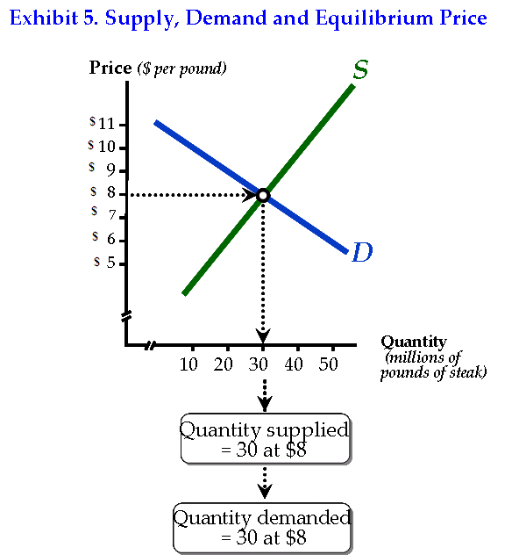The forces of demand and supply combine to determine the market price. As **Exhibit 5** shows, there will be a tendency for price to move toward a level like $8 per pound, which will bring the quantity demanded by consumers into equality with the quantity supplied by producers. This price, where the demand and supply curves intersect, is often referred to as the “**equilibrium**” or “market clearing” price.

Consider the equilibrium price $8 per pound in **Exhibit 5**. What would happen if the price was higher than $8 per pound? At prices higher than the market clearing price, producers will want to supply a larger quantity than consumers are willing to purchase. This would lead to an excess supply and place downward pressure on price. Thus, above equilibrium prices will not be sustainable.

On the other hand, if the price was less than $8 per pound, there would be an excess demand in the market. At prices lower than the market clearing price, consumers would want to purchase a larger quantity than producers were willing to supply. But this will not be possible; goods cannot be consumed if they are not produced. If price was less than the equilibrium, the excess demand would place upward pressure on price, causing it to move back toward $8 per pound.

Market forces will tend to generate prices for products that will bring the quantity demanded by consumers into equality with the quantity supplied by producers. At this equilibrium price, the actions of the consumer-buyers and producer-sellers will be in harmony. Both will be able to realize their choices simultaneously.

eBay illustrates the operation of demand and supply in a setting that will be familiar to many students. On eBay, sellers enter their reserve prices—the minimum prices they will accept for goods; buyers enter their maximum bids—the maximum prices they are willing to pay. The auction management system will bid on the buyers behalf in pre-determined monetary increments. Bidding ensues until the trading period expires or a person agrees to pay the stated Buy-It-Now price. Exchange occurs only when buyers bid a price greater than the seller’s minimum asking price. But when this happens, an exchange will occur and both the buyer and seller will gain.

Though somewhat less visible than the eBay electronic market, the forces of demand and supply in other markets work similarly. The height of the demand curve indicates the maximum amount the consumer is willing to pay, while the height of the supply curve shows the minimum price at which producers are willing to supply various units of the good. As long as the price is between the maximum the consumer is willing to pay and the minimum offer price of a seller, potential gains from trade are present. Note, when the market equilibrium is present, all potential gains from exchange are realized.

**Market Adjustments to Changes in Demand**

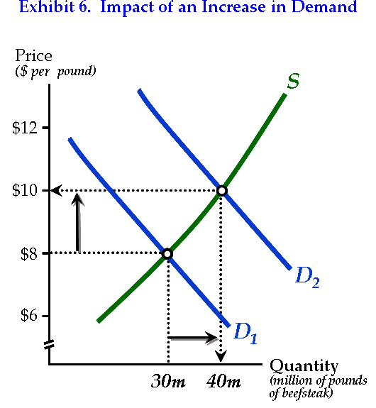While equilibrium is nice, we live in a world of dynamic change. New products and technologies are constantly being discovered and developed. Income, prices of related goods, resource prices, and information change over time. Factors like these will effect demand and supply, and thereby disrupt equilibrium in various markets. Let’s consider how markets will adjust to various changes that alter demand and supply. We will begin by focusing on changes in demand.

Suppose that consumer income increases. How will this affect the market for steak? At the higher level of income, many consumers will increase their purchases of many products, including beefsteak. As **Exhibit 6** shows, this will increase the demand for beefsteak, shifting the demand curve to the right. The stronger demand will increase the price from $8 per pound to $10 per pound. Beef producers will expand their output in response to the higher beef prices. A new equilibrium will occur at a higher price and larger quantity supplied.

Consider another example. What would happen if the price of chicken (a substitute for beef) rose? Like an increase in consumer income, higher prices for chicken would increase the demand for beefsteak. As **Exhibit 6** illustrates, the increase in demand would lead to a higher price and a larger quantity supplied at the new equilibrium.

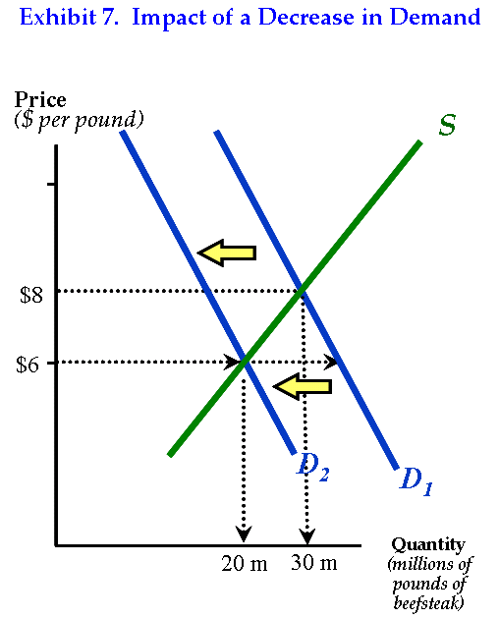 ***In a market economy, when the demand for a good increases, its price will rise, which will (1) motivate consumers to search for substitutes and cut back on additional purchases of the good and (2) motivate producers to supply more of the good. These two forces will eventually bring the quantity demanded and quantity supplied back into balance.***

Now consider how the market for beefsteak would be affected by a reduction in consumer income or a decline in the price of chicken, a substitute product for beef. Each of these factors would lead to a decrease in demand for beefsteak, a shift of the demand curve to the left. As **Exhibit 7** shows, the decline in demand would reduce the market price. In turn, producers will reduce the quantity of beef supplied at the lower price. A new equilibrium will occur at a lower price ($6) and smaller output (20 million pounds of steak).

**Adjustments to Changes in Supply**

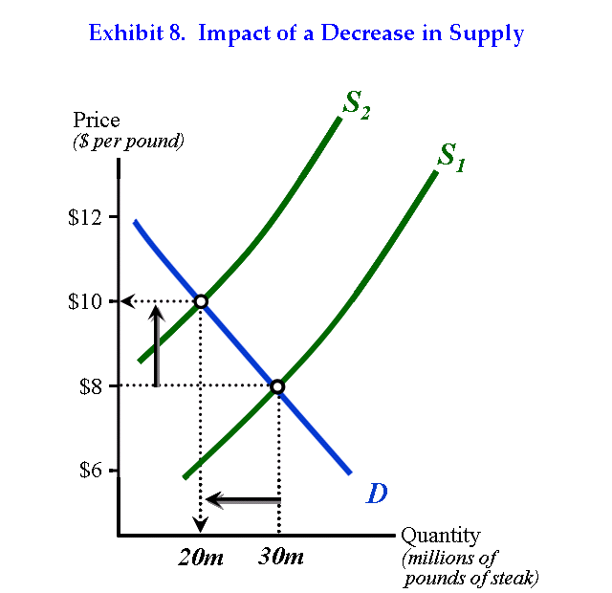Remember, the supply curve reflects the cost of producing a good or service. A product will not be supplied if the producers are unable to cover the cost of producing it. Factors such as higher resource prices or taxes that increase the cost of producing the product will shift the supply curve for the good to the left. On the other hand, lower resource prices, improvements in technology, or other factors that reduce cost will shift the supply curve for the product to the right.

**Exhibit 8** illustrates the impact of a reduction in supply. During 2007-2008, the prices of corn and other feed grains increased sharply. As these resource prices rose, the costs of beef producers increased, reducing the market supply of beef. As is shown in **Exhibit 8**, the reduction in the supply of beef pushed the prices of steak upward. The new equilibrium occurred at a higher price and smaller output for beef steak. The higher prices provided consumers with an incentive to substitute other food products for beef. They also encouraged producers to minimize their reduction in output. These forces kept the quantity demanded in balance with the quantity supplied.

Suppose lower costs of production increased the supply of a product. What impact would this increase in supply have on the equilibrium price and output? Use a pencil and paper to illustrate your answer graphically. If you have done it correctly, the new intersection of the demand and supply curves will occur at a lower price and larger output.

**Demand, Supply, and the Operation of Markets**

Demand and supply analysis provides a powerful tool that helps us better understand how markets work and the role of prices in the allocation of goods and services. The actions of both consumers and producers are directed by prices. Producers bid labor services, materials, and other resources away from their alternative uses and transform them into goods and services like shoes, food products, television sets, medical services, and automobiles for sale to consumers. Producers have a strong incentive to produce efficiently and keep costs low, because lower costs will mean higher profit (or smaller loss). Consumers will not purchase items that are valued less than price. Correspondingly, producers will not supply, at least not for long, products that cannot be sold at prices high enough to cover their production costs.

When property rights are well defined and enforced, and competition is present, market prices will direct producers to supply only those goods and services that consumers value more highly than the resources required for their production. This is a highly important point. The creation of wealth and higher living standards are about the use of resources to produce goods and services that are worth more than their production costs. Supply and demand analysis indicates that prices will tend to channel resources into such wealth-creating activities. This was the message of Adam Smith more than 230 years ago when he noted that markets tended to direct people, as if by an “invisible hand” to undertake activities that promoted the general welfare. Indeed, market prices, reflecting the forces of demand and supply, are the “invisible hand” to which Smith referred.