Math 2 Name ________________________

Unit 2 Test – Review Date ___________ Period ________

**FORMULAS:  **

Simplify each expression. Leave your answer as a simplified radical.

1.  2.  3. 

4. Calculate the midpoint of the line segment that has (4, 2) and (-2, 8) as its end points.

5. Given the midpoint of a line segment is (-2, 1) and its endpoints are (4, 3) and (x, y). Find x and y

6. Calculate the distance between the points (4, 1) and (-3, 6). Leave your answer as a radical.

7. The distance between the points (3, 0) and (6, y) is . What is y?

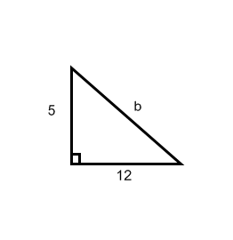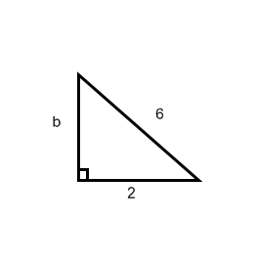

Use the Pythagorean Theorem to find the missing side length of each

triangle. Leave your answer as a simplified radical.

8. 9.

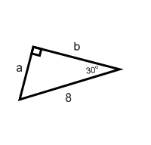

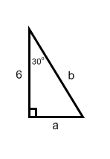Find the unknown side lengths and angles in each triangle. Write your answers as simplified radicals.

10. 11.

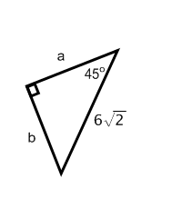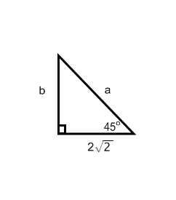

12. 13.

**Use the information given in the figure to answer each question.**





14. What is the measure of ?

15. is congruent to what segment?

16. The following triangles are similar, Solve for x and y.



17. Write the trigonometric ratios for angle F.

sinF= ________

cosF = ________

tanF = ________

**Use you calculator to find the identified trig. funcion for each angle. Round your answer to three decimal places.**

18. tan 760 19. cos 130

**Use your calculator to find the measure of angle A based on the equation given. Round your answer to the nearest whole number.**

20. cos A = .635 21. sin A = .786

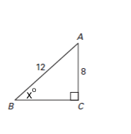**Use trigonometric ratios to find the value of *x*. Show all your work and round your answer to the nearest tenth.**

22. 23.

24. Which trigonometric value is equal to cos 62°?

a. cos 12°

b. sin 28°

c. tan 90°

d. sin 62°

25. Which trig expression is equal to sin (72° - a)?

a. cos 90° - (72° - a)

b. sin 90° - (72° - a)

c. sin 18°

d. cos 18°

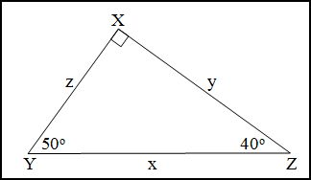26.

Which property can be justified using the ratios in triangle XYZ ?

a. cos Y = $\frac{x}{z}$

b. sin Y = cos (90° – Y)

c. cos Z = $\frac{z}{x}$

d. sin Z = sin (90° – Z)

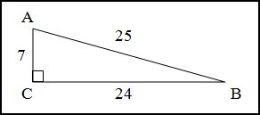

27. In triangle ABC, sin A = $\frac{24}{25}.$ Which other expression has a value of $\frac{24}{25}?$

a. cos C

b. sin B

c. tan A

d. cos B

28. 29.





30.

