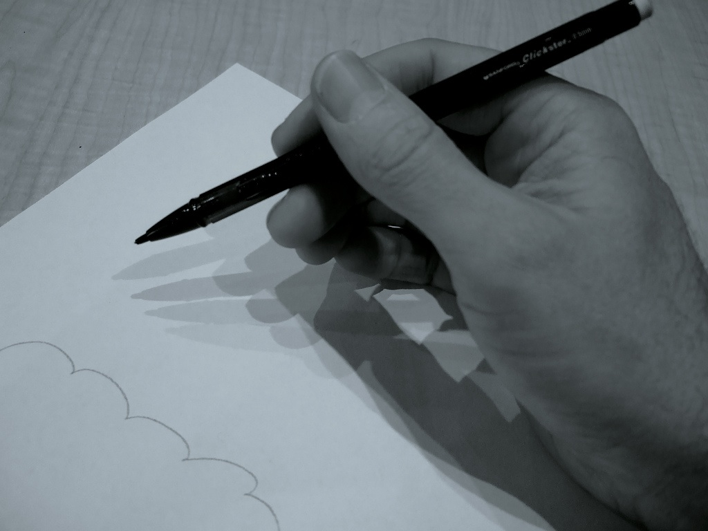

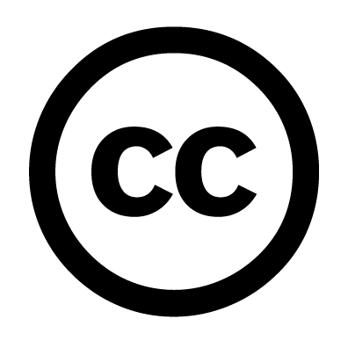
Explanations
April 2009
Original image by lowjumpingfrog (Modified)
flickr.com/photos/jenorton/2229437427

Open Educational Resources and Creative Commons Licensing
Note that Creative Commons Corporation is not a law firm and does not provide legal services. Distribution of this document does not create an attorney-client relationship. Creative Commons provides this information on an "as-is" basis. Creative Commons makes no warranties regarding the information provided, and disclaims liability for damages resulting from its use. The information provided below is not exhaustive—it may not cover important issues that may affect you. We recommend that you familiarize yourself with our licenses before applying them. Please read more at: creativecommons.org/about/licenses/.
What is this document?
If you are a teacher or creator of educational resources, this primer gives you an introduction to the concepts of open education, Creative Commons licensing, and other issues pertinent to putting your educational materials on the Internet. This document is divided into two parts. Part I introduces the concept of open educational resources (OER) and explains why Creative Commons licenses are invaluable for such resources. Part II examines the different Creative Commons licenses that are available.

Who is it for?
Anyone who wants to learn more about OER and the importance of Creative Commons licenses for such resources.


This document is licensed using a Creative Commons Attribution 3.0 Unported License.
Attribute to ccLearn with a link to http://learn.creativecommons.org.

Part I – What are Open Educational Resources, and why do I need Creative
Commons licenses?

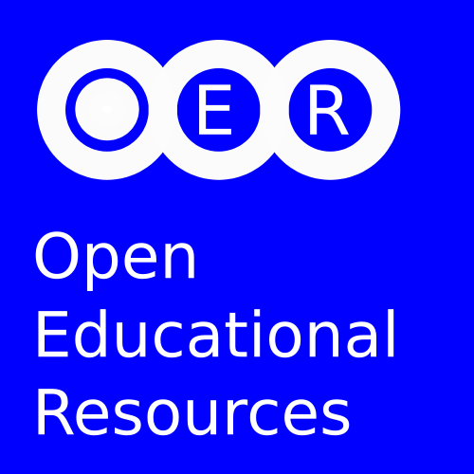
What are open educational resources (OER)?
OER are teaching, learning and research resources that reside in the public domain or have been released under an intellectual property license that permits their free use or re-purposing by others.

I just put my materials online. Now they’re open. Right?
No. Whether you want it or not, you automatically get all-rights-reserved copyright protection for just about anything you publish. This includes your lesson plans, essays, book chapters, drawings, Powerpoint or Keynote slides, home videos, and almost everything else you create. When you place your works on the Internet, those copyright protections remain in place unless you take action to make them open. People might be able to look at your materials, and they may use some portion of your materials via copyright exceptions and limitations, or fair use, in specific circumstances. However, they cannot share most materials with anyone or alter them in any way, unless they contact you first and get permission. You have to apply an open content license, or dedicate your work to the public domain, in order for your materials to actually be open.

Why should I want my educational resources to be open in this manner? How does this advance my educational goals or help students?
Imagine all of the eager learners around the world who might benefit from your educational materials. Imagine, for example, the positive impact your math materials might have for children in indigenous societies around the world, if only they could obtain those materials in their native languages. Imagine if a teacher in a school with one shared computer was able to print, photocopy, and then distribute hard copies of your handouts to help her students to learn a challenging concept better. These outcomes are much more likely to occur when resources are openly licensed, because everyone already has permission to translate, share, and improve on the resources. Also, the materials have a much greater chance of being widely used if they are open.

I see that I need a license for my materials, but can you explain what a license is?
A license gives people permission to do something they are otherwise prohibited by law from doing. As the creator or owner of a copyrighted educational materials, others must ask you first before doing almost anything with it. Since most creators of educational materials are not lawyers and may not know how to grant such a license, Creative Commons (CC) has made it easy by providing cost-free licenses that you can affix to your works when you put them on the Internet. When you use a CC license, you are marking your works with the permissions you want to grant in advance, making it easier for them to use your work as you intend.

Do I have to pay to use these licenses?
No. They cost nothing to use.

Are there other options? Why should I use Creative Commons licenses?
Creative Commons licenses are free-of-charge, easy to use, and help to standardize what is “open” on the Internet. Moreover, CC licenses are the most widely used open licenses in the world. CC licenses accomplish three crucial things: they are machine-readable, they are easy to understand, and they have been written and evaluated by lawyers. Read Part II to learn more about these features and other aspects of Creative Commons licenses.

Why can't I just make up my own, customized license?
Customized licenses are likely to just cause confusion and problems for those you hope will use your works. People may not understand different licenses, and they will not be machine-readable. Combining materials licensed under different, custom licenses into, for example, a single lesson plan is difficult if not impossible without violating the terms of one or more of the licenses. Besides, most customized licenses are not necessary, as one or more of the existing, standardized CC licenses are likely to serve the desired needs. You can read our research report about these issues, available on the ccLearn website: learn.creativecommons.org/productions

How do I actually apply Creative Commons licenses to my works?
It takes only a few minutes. The simplest method for applying CC licenses is to publish your work using an online archive that makes it easy or automatic to apply CC licensing. Many of the known archives are listed on the Creative Commons site (wiki.creativecommons.org/Content_Directories). We do not endorse or take any responsibility for the content or practices of any of these hosting sites, but here is a list of some of the more popular sites that are available:
Flickr – Photo sharing. flickr.com
Connexions – Lesson plans and learning objects. cnx.org
Open Learn – Open educational resources. www.open.ac.uk/openlearn
Wikieducator – Wiki-based learning materials. wikieducator.org
Scivee – Science-oriented videos. scivee.tv
Scribd – Document sharing. scribd.com
Slideshare – Slideshows and presentations. slideshare.com

If you would like to license and publish your work directly, we recommend that you read our “Step by step guide for applying Creative Commons licenses to your educational resources” and then use the License Chooser (creativecommons.org/license) to select and apply the license you want. If you have a larger collection of resources, or are regularly creating or aggregating many OER, then you are probably better served by integrating the licensing process into your distribution site. For more information please see: wiki.creativecommons.org/Web_Integration.



Part II – About Creative Commons licenses

What does it mean that the CC licenses are “machine-readable”?
The machine-readable feature of the licenses makes finding Creative Commons-licensed material on the Internet possible. Machine-readable refers to the fact that the license information about your work includes some software code. This software code allows search engines (e.g., Google, Yahoo, etc) and other software applications to identify materials on the Internet that are licensed using Creative Commons. So if you license your material under CC, others will be able to easily find and identify your work.

How is it that the licenses are easy to understand?
Unlike typical licensing terms (and most other open licenses that are available), Creative Commons licenses include a summary deed which simplifies the terms of each license into a few universal icons and non-technical language. For example, one of the Creative Commons deeds is shown in the image on the next page. It quickly clarifies that you are free to share the work with anyone, and you are also free to remix the work. “Remix” means that you can, among other things, alter the work in some way, such as translate it into another language, or add new information. The deed also specifies conditions of use; in this case, you must attribute the original author of the work. If this was your work, people would have to cite you whenever they use your work. The summary deed is not legally binding in and of itself, however, it’s just informational.

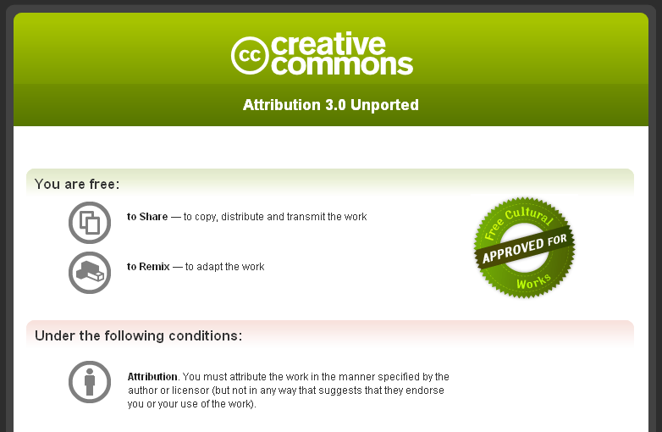
Are Creative Commons licenses specified by valid legal documents?
All Creative Commons licenses have real legal code, written by and for lawyers, that contain the actual, legally binding terms of the license.

Is there just one Creative Commons license? Or are there choices I have to make?
There are several different CC licenses. It helps to know what choices you have when selecting a license.

Creative Commons licensing terms (and associated symbols)
First, all of our licenses require attribution (or credit) to the author of a work.

Attribution. You let others copy, distribute, display and perform your copyrighted work – and derivative works based upon it – but only if they give you credit. All CC licenses contain this condition.

In addition, all of our licenses may have one or more of the following permissions or restrictions:

Non-Commercial. You let others copy, distribute, display and perform your work – and derivative works based upon it – but for non-commercial purposes only. If they want to use your work for commercial purposes, they must contact you for permission.


Share Alike. You allow others to distribute derivative works but only only under the same conditions as you made your work available.

No Derivative Works. You let others copy, distribute, display, and perform only verbatim copies of your work, not make derivative works based on it. If they want to translate, alter, transform, or combine your work with other works, they must contact you for permission.

What are the different licensing combinations?
These licensing terms can be ignored or combined based on your choice in order to generate one of several specific Creative Commons licenses, described on the next page:
 | Attribution | This license lets others copy, share, modify and build upon your work, even commercially, as long as they credit you for your original creation. This is the most accommodating of licenses offered, and is ccLearn’s recommended license for OER.
 | Attribution — Share-Alike | This license lets others copy, share, modify and build upon your work even for commercial purposes, as long as they credit you and license new creations derived from your work under the same conditions.
 | Attribution — No Derivatives | This license allows others to copy and share your work, including commercially, as long as it is passed along unchanged and in whole, with credit to you. Your work can be included in compendiums, but may not be translated or modified without your permission.
 | Attribution — Non-Commercial | This license lets others copy, share, modify and build upon your work non-commercially, as long as they credit you.
 | Attribution — Non-Commercial — Share-Alike | This license lets others copy, share, modify and build upon your work non-commercially, as long as they credit you and license new creations derived from your work under the same conditions.
 | Attribution — Non-Commercial — No Derivatives | This license allows others to copy and share your work non-commercially, as long as they credit you. Your work may not be translated or modified without your permission. This license is the most restrictive of our six main licenses.

How do I know which license to use?
That depends. In what ways do you envision your work being used? What do you want users to be able to do with your work? Do you want your work be as widely accessible as possible, regardless of whether it is used for commercial or noncommercial purposes? Do you want others to be able to improve upon your work? And if so, do you want to require them to make their own improvements available under the same terms as you’ve made your work available? These are the kinds of questions you should be asking yourself.

Do you have a recommended license for open educational resources?
Yes. You should use the first license listed above, the Creative Commons Attribution 3.0 (CC BY) license, whenever possible. Only the CC BY license endows OER with all of the fundamental attributes (e.g., freedom to share and combine resources while giving the author credit) that are important for resources that comprise a global learning commons. While any CC license is better than none, the more restrictive licenses usually affect the usability of your OER in ways that you may not want or expect. We would urge you to review the goals and constraints of your organization regarding the OER you produce, and to only apply more restrictive licensing when fully justified. Examine our FAQ for more details regarding license choices: learn.creativecommons.org/FAQ.

Questions?
This is a highly abbreviated document. For more information about these and related topics, visit Creative Commons (creativecommons.org) or send questions to ccLearn directly by email: cclearn-info@creativecommons.org

The William and Flora Hewlett Foundation. http://www.hewlett.org/oer
"Step by Step Guide" available at: learn.creativecommons.org/productions

