 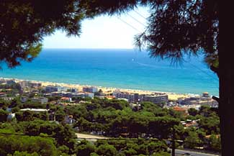

**Fun Event at the Beach**

**Organized by the SFA and ISAPP Board Members**

**Participation by all meeting delegates is encouraged!**

**When and where:** Sunday, August 29th, 16:15 to 19:30, at beach near Restaurant “El Pendulo” in Castelldefels

**Food and refreshments at the beach, bus transportation will be provided.**

**Target schedule**

4:15 pm: first bus leaves for beach

4:35 pm: second bus leaves for beach

5:00 pm: group activities begin, every 20 min (5:00, 5:20, 5:40, 6:00, 6:20, 6:40)

7:00 pm: group activities end

7:15 pm: first bus back to hotel

7:35 pm: second bus back to hotel

8:00 pm: Gala dinner

**Groups**

6 groups randomly assigned from all meeting participants. (Groups will NOT be the same as discussion groups.) Group assignments will be made during the meeting. Accompanying guests are allowed to participate in the same group with their host.

SFA members will serve as group leaders. Their referee decisions are final for all activities!

**Coveted Prizes:** Will be awarded at Gala Dinner, Sunday night.

**Group activities**

Each group will rotate through all 6 activities (20 min per activity). Group leader will provide rules and instructions.

1. Soccer
2. Sand Pictionary
3. Volley ball
4. Treasure hunt
5. Relay race – (each participant please bring T-shirt for this activity)
6. Brain teasers