a list of features that would define a good anchor chart:

• **Anchor charts scaffolds learning.**

[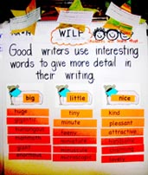](http://www.cornerstoneliteracy.org/NEWSLETTER/volume_8_4/anchor1.jpg)Students benefit from the use of posted anchor charts. Students are successful recalling information even after anchor charts have been removed. They train their brains and bodies to “look for the chart” in their memory to recall information.

• **An anchor chart should have a single focus.**

The anchor chart to the right supports the learner in one of the skills that would lead toward mastery of a broad teaching standard. “*Students will write with a clear focus, coherent organization, and sufficient detail.***”**

• **The anchor chart is co-constructed with the students.**

The brain-based research of Marcia Tate and others support

the use of visuals to incorporate new learning into memory.

When the visual represents a learning event that includes

the students, it becomes an artifact of the learning experience.

It has meaning for the students because they participated in its

construction.  ***One could think of it in terms of food:  The cookies***

***taste better when you help make the dough.***

• **The anchor chart has an organized appearance.**

The importance of clarity is paramount to understanding.  If the

students can’t read the chart or find the statement of explicit

instruction the chart will be of no support to the students when

they return back to the chart as a scaffold.

• **The anchor chart matches the learners’ developmental level.**

The language, the amount of information, the length of the sentences, and the size of lettering should all match the cognitive level of the students for whom the chart will serve.  Following this explanation, there are two anchor charts created for the same lesson: introduction to the comprehension strategy of schema.  The one on the left was designed for second graders, the one in the middle for fourth graders, and the one on the right for first graders.  Notice the differences in language and complexity.

[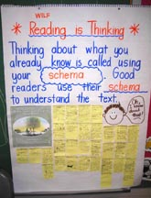](http://www.cornerstoneliteracy.org/NEWSLETTER/volume_8_4/anchor2.jpg)    [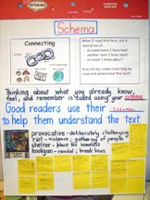](http://www.cornerstoneliteracy.org/NEWSLETTER/volume_8_4/anchor3.jpg)    [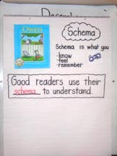](http://www.cornerstoneliteracy.org/NEWSLETTER/volume_8_4/anchor4.jpg)

• **The anchor chart supports on-going learning.**

The chart must be relevant and used by the students.  Charts should reflect recent crafting lessons or concepts that need continued scaffolding.  Teachers can support learning by placing an anchor chart in a classroom library where students can access the information when they are making their literature responses during and after independent reading. A commercial chart could be an anchor chart, if students actually use the chart.