Minitab is a statistics package that is often used for statistics-based process improvement methods. While it is considered to be “software for quality improvement”, Minitab is capable of doing many of the basics that are needed in a statistics package including: Basic statistics, regression and ANOVA, Design of Experiments, as well as control charts and quality tools.

The interface is pull-down, also known as point-and-click, and should be very simple for a non-computer expert to follow along.

As mentioned earlier, Minitab does very basic statistical analysis that may be used at a college/graduate school level. We will start with a step-by-step run through of some basic features.

Getting Started: When first opening Minitab, this is the screen that comes up. The top screen is the Session Window. This is where all the output comes up. The bottom screen is the Data Window. This is where data can be entered into Minitab. In order to demonstrate how to use Minitab, we will use data from a sample data folder in Minitab 15. In order to get to this sample folder, do the following: File>Open Worksheet>Look in Minitab Sample Data Folder (bottom of box).

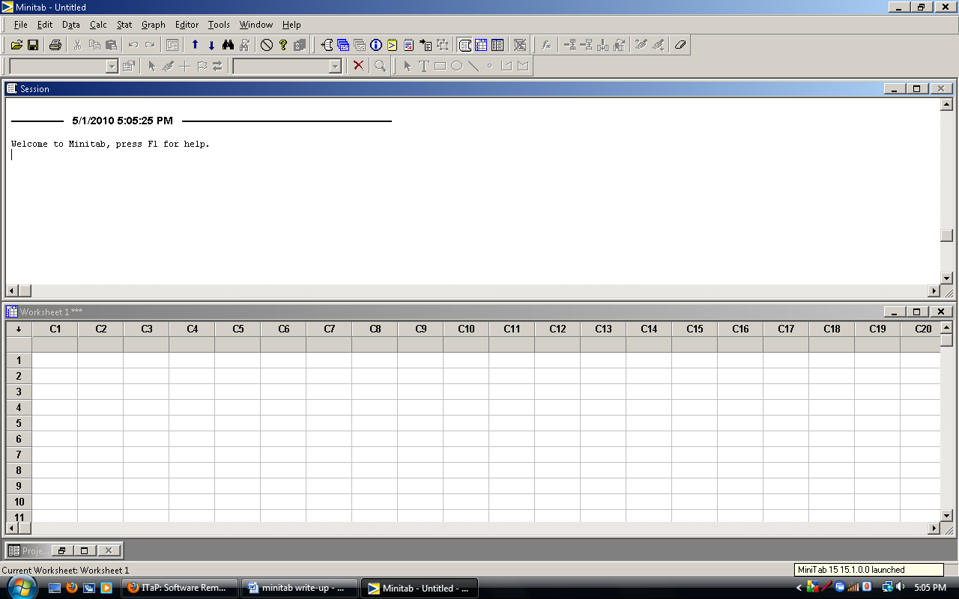

Linear Regression Modeling:

In order to form a simple linear regression model, the following steps are followed: Stat>Regression>Regression. For this example, the dataset Poplar1.MTW was used. After following the steps, a pop-up box comes up and acts what columns we want to use for response and predictors. In this example, C3 ‘Weight’ was used as response and C2 ‘Height’ was used as a predictor. After pressing OK, a regression equation, a table of coefficients, an analysis of variance table and potential outliers and influential observations are all listed in the Session window. This can be seen in the below figure.

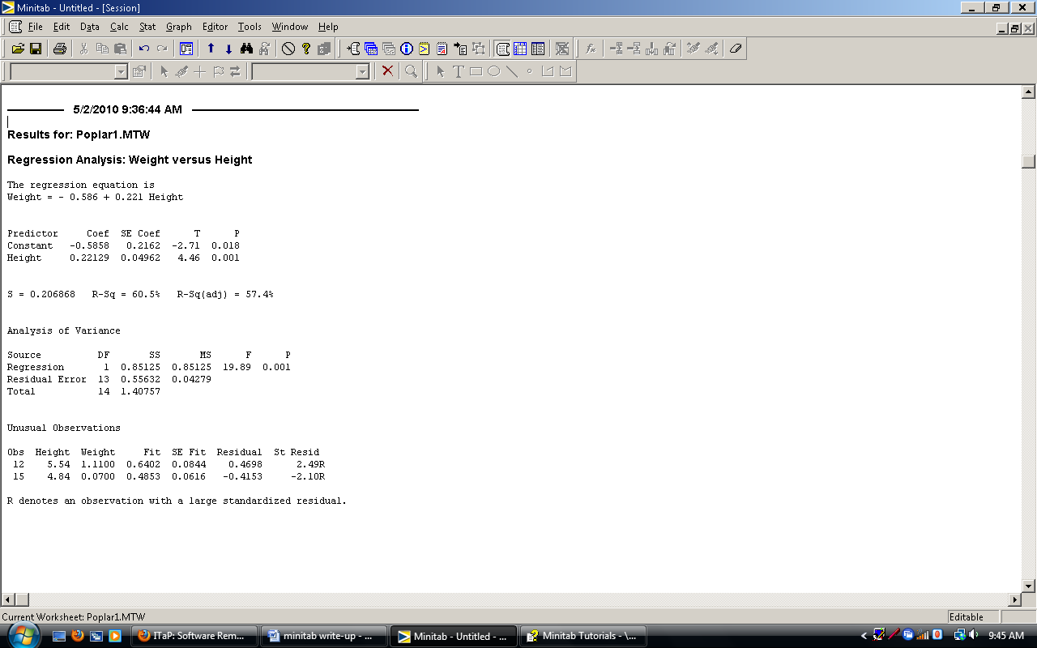

Histograms:

These can be made in Minitab; however, the graphs in Minitab are very easy to manipulate. For this example, we can use the Fabric.MTW data. The following steps are used as how to create a Histogram: Graph>Histogram. There are 4 Choices: Simple, with Normal Fit, with Outline and groups, with fit and groups. The next pop-up allows the user to pick the columns to be used in the graph. Then press the OK button and the Histogram comes up. For this example, we choose with Normal Fit and C3. This is the graph that is created.



However, since Minitab graphics can be easily manipulated, I can chance the graph to have a different line fit (instead on Normal, the fit line can be Weibell, Gamma, etc), the x and y-axis label can be renamed, and the axes can even be written on a different scale. While these manipulations can be good, they can also be very decisive because the person looking at the graph will never know that it has been changed. The following graph is taken from the same data but I used a Gamma line to fit the data instead of Normal but since, I was able to manipulate the graph no one would know and I could publish these graphics and decisive all of the readers. Therefore, Minitab graphs do not seem to be very very good to use for publications.



ANOVA

Stat>ANOVA>One-Way. Next, the user is able to pick which variable is wanted for the response and the factor. After the OK button is pressed, information is printed out in the Session window as shown below. For this example, the Alfalfa.MTW data was used. C1 ‘Yield’ was used for the response and C2 ‘Variety’ was used as the factor. In the Session window, an analysis of variance table, a list of the levels with the means as well as a plot showing the confidence intervals is shown.

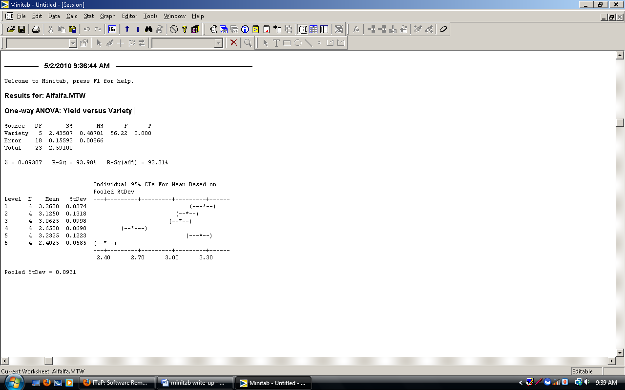

Other things that Minitab is good for

Control charts: In the following figure, we see some of the different control charts that can be made in Minitab, including Xbar and R charts. In order to get to these graphs, the following steps are followed: Stat>Control Charts> Variable Charts for Subgroups OR Variable Charts for Individuals.

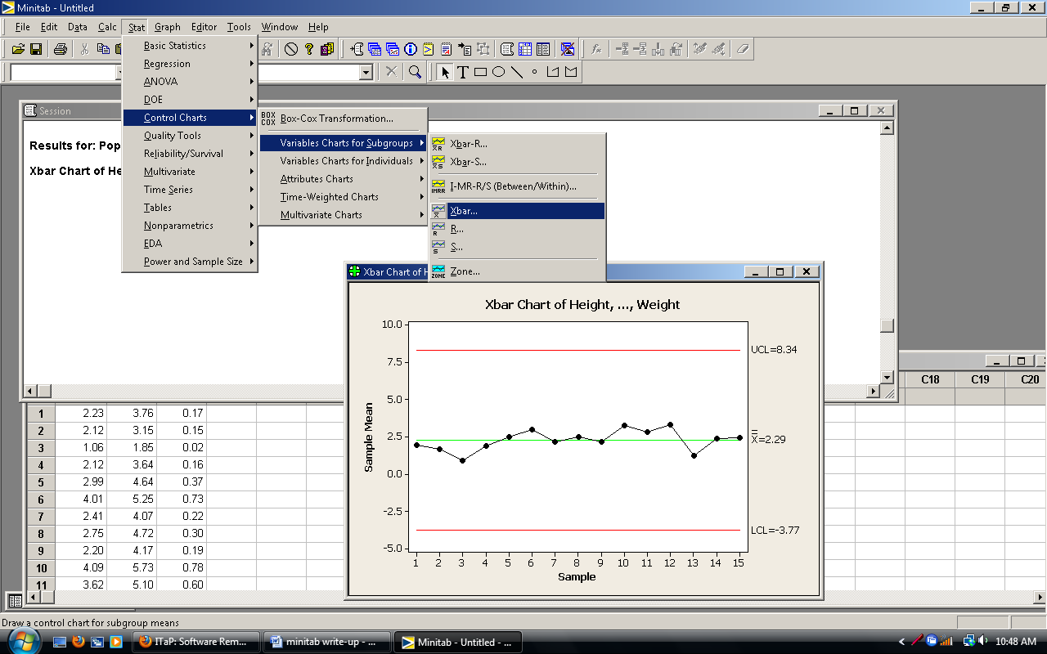

Quality Tools: In the following figure, we see some of the different tools used for quality control that can be made in Minitab, including a Pareto chart and Cause-and-Effect chart. In order to get to these charts, the following steps are followed: Stat>Quality Tools>Pareto Chart OR Cause-and-Effect.

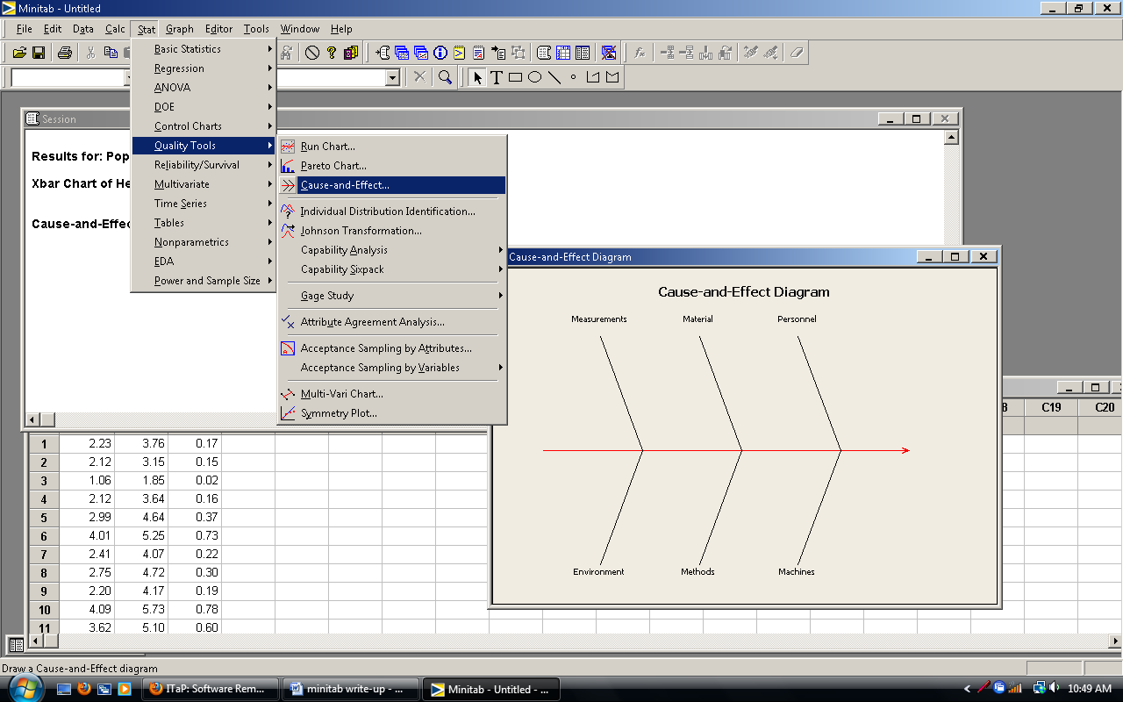

Other important Statistics functions included in Minitab:

**Chi-squared testing**: Stat>Tables>Chi-Square Goodness-of-Fit (One Variable) OR Chi-Square Test (2-way table)

**PCA/factor analysis**: Stat>Multivariate>Principal Components OR Factor Analysis

(Cluster Analysis is also included in this area)

**Sample size calculations**: Stat>Power and Sample Size

**Stepwise, Partial Least Squares, Binary,Ordinal, and Nominal Logistic Regression:** Stat>Regression

**Factorial/Response Surface**: Stat>DOE> Factorial OR Response Surface.