Strategic Planning of the Iskandar Region in Malaysia as a Sustainable Metropolis

Appendices

Andreas Hansen – s042002

Monika Luniewska – s053986

Supervisors:

Arne Wangel

Stig Irving Olsen

Morten Elle

Kongens Lyngby 23.07.2010

Table of Contents

Appendix 1 – Interviews 2

Interview with Faisal Ibrahim 2

Interview with Proffesor Dr. Mohamad Tajuddin Haji Mohamad Rasdi 5

Interview with prof. dr Sharifah Salwa Syed Madzkan 8

Interview with Hong Lim Foo 9

Interview with prof. dr Ho Chin Siong 10

Interview with Faisal Rahman 12

Interview with Suraya Badaruddin 14

Interview with Zainuddin Bin Omar 16

Interview with Abd Halim Bin Mohd Nor 17

Interview with Rahman Hassan 19

Interview with Zulkefley Ariffin 21

Other interviews 23

Appendix 2 –Economy and industry 24

National economy 24

Industry 25

Industrial development plans 29

Costs 30

Appendix 3 – Environment 42

Development of government policies 42

Status of Malaysian environment 43

Appendix 4 – Palm oil 46

Appendix 5 – Malaysian research status 47

Appendix 6 – Sustainable cities 48

Solid waste management 49

Appendix 7 – Sustainable industries 50

Companies in Pasir Gudang 50

Letter from IRDA 73

Palm oil companies in Pasir Gudang 74

Questionnaire 79

Results of the questionnaire 83

Palm oil research 89

# Appendix 1 – Interviews

## Interview with Faisal Ibrahim

### IRDA, Denga Bay, 12.02.2010

### Current position: Vice President of Iskandar Service Centre (point-of-call, one-stop-center), IRDA

### About Faisal:

### Background (education, previous experience, )

* Plant science, major in plant science (physics), minor management, university berlin, 1994,
* Working in Japanese company, electronics,
* 1997, Singapore company, 8 years doing, doing what
* Joint venture vrenco technologies (UK) 5 years,
* Move to pasir gudang, Hydro company, Norewgen 3 years (aluminium, 6 micron, for food industry, used by TetraPack), process manager, knowledge sharing (meeting)
* Move out and settle down in Johor

### In IRDA?

* All operations of ISC, how long

### About Service Center

### Main functions, how formal are the relations, how were they established?

* Services to facilitate the investors and monitor, give overview (more or less detail), but not implement or approve. To deal with authorities.
* Investors come with proposal (hospital, factory), then Iskandar checks match of the interest, and starts one-point-contact or not.

1. For land acquisition, change land use
2. Planning what to do with land, infrastructure
3. Building
4. Licensing
5. Customs (equipment)
6. Immigration

* 5 local authorities
* 40 technical units for approval
* 2 divisions: Agency management (discussed before) and Business process (industry manuals, also on website, have incentive unit, process incentives approval tax expemtions).
* Incentives (hi-tech and strategic incentive no tax for 10 years)

### Focus areas? Do and how they prioritize?

* Not small invenstors, 200 mln RM or above (catalyst project), because they have spill over, strategic projects, smaller projects will come (Legoland contributes to hotel, shop etc. formation).
* When smaller project has problems with formalities, then they can help
* Service industries to be promoted
* Manufacturing in Johor is popular, doesn’t need to be promoted, this is why services need to be promoted, saturated with production industries. Trying to make zones
* Want to supply holistic
* People live in Singapore and have offices in Johor, also many people use Johor as a transit point to Melacca. Onestop place to play on the way (to spend 1 or 2 days and have places to visit), still depend of people going to Singapore.
* Want to attract businesses (knowledge intensive, high end product, R&D) and services (consultancy, ICT) which would make people stop or even leave here.
* 3 types of fund:
  + Retirement fund: 70% of contribution
  + Medical fund: 20%
  + Employment provident fund: 12% of salary by employes, can dispose when you are 25.
* In Singapore medical fund can be used oversees, so opportunity for Johor to attract these people, medical service in Singapore is very expensive, it is used by foreigners but not locals (you can beat them you join them ;)), the idea is to develop this service taking advantage of situation and treat Singaporians (‘develop by Singapore strategy’).
* Singapore did the same, trained people,
* Simplify traffic from Singapore to Malaysia
* RFID, chip in passport, don’t have to stamp passport, 30MR, less than 10 second, ease concesion, already introduced, sponsor have to recommend foreigners
* Human capital development department in the building –?! – get interview, Iskandar is trying to get alignment, get people from KL, increasing level of education.
* Safety programs – blue prints related to health, solid waste management, integrated solid waste disposal
* Blue print is a plan how to run this, still on paper. For local authorities, shared development, difficulties
* Size is a challenge, 20, 25% of what???
* MR9th MR3 malaysia plan, focus on infrastructure (widening, cleaning rivers to avoid floods ☺)
* Money for development from federal government to Iskandar and <Iskandar sends out to companies who build it.
* Entertainment: Formula one, Casino (in Genting highland, partnership for casiono in singapore)

### How many application? Statistics?

* For approval of local authority 90 days, with Iskandar 30 days.
* 3 to for 4 applications per month

### What types of industries?

* Service industries: logistics (infrastructure needed!) deliver a lot in short period of time, factories run 24/7., senai airport needed fast,
* Manufacturing Bahrusth? steel pipe for oil, Spanish,
* What nationalities (percentage?)
* On service sector: madini (middle east), legoland (denmark), newcastle medical uni (UK), hospitals (Singapore)
* Peroperty developers, legoland, Iskandar investment,
* Iskandar investment – under prime minister office, established by hasana national berhad, oversee all government investment (EPF, national aircfrat carrier, national electricity board – public company, shares available etc)
* How they promote it?
* No direct promotion, fund end investor relations, economy business. Agency promotes the service (e.g. in UK) and send to the Iskandar, Service Center in tool to promote Iskandar Malaysia, use to sell idea to investors. Agencies which promote:
* Economy and business -
* Maida
* JSIC – johor state investment corporation (property development, etc
* JCo – johor cooperation (build a factory and lease, ready-made factories)
* Monopolies industries: water not public listed, many catch water areas, electricity, not good. But communication has many different providers, but telecom is public listed company.
* Set up clear procedures, need to avoid confusion for investors, some people can mess up some forms, bouncing forth and back applications. Even if IRDA will stop existing, IRDA wants to prepare government to take over its roles.
* Look at neighbouring countries, responsibility to the one who submits the application, when getting approval for building, can be disapproved, until everything is corrected no approvel, process memo (go into detail of all processes), Iskandar does t differently, checking the plan, to make sure that things will work out, to avoid disapproval. If it comes back disapproved, then it can be corrected immediately by a customer.
* Getting land is the most tedious process. Have to be very careful about that. Iskandar starts all the channels at the same time to speed up the process. Customers want it fast.
* Local authority: service level agreement, have to process application within 30 days, no approval based on relation. If somebody will go, the system can get working.

### Environmental authorities: is it the most difficult to meet requirements?

What is the problem on client and on authority side. Client can believe that they have problem with one aspect while authority will see other problem than claimed. Have to be careful when dealing with authorities, challenging, soft skill.

Complain about zones: want to place different industries in other zones.

## Interview with Proffesor Dr. Mohamad Tajuddin Haji Mohamad Rasdi

UTM, Thursday 11th March, 2010

|  |  |
| --- | --- |
| Current position: Director of KALAM (Center for the Study of Built Environment in the Malay World)  Specializes in theory and history of architecture with emphasis on the ideas of Islamic Architecture  Department of Architecture  Faculty of Built Environment  Universiti Teknologi Malaysia | http://web.utm.my/harikualiti/images/stories/APC%20Khas%20Universiti%202007/Mohd%20Tajuddin%20Mohd%20Rasdi.jpg |

### Background

Through preparation for the meeting it was found that Tajuddin is a critic of the grandeurs designs of modern day Mosques, and that he seems to focus on functionality over form. He has criticized some of the ‘so-called’ modern Islamic architecture of not complying to the humbleness that is described in the Sunnah of Prophet Mohammed. Furthermore he has studied mosques for their function of community centers. He argues that Malay architects should become more self aware of their profession, and actually produce quality residential areas (instead of falling for the bid of the developers). As a director of KALAM he heads an effort to record and document traditional Malay housing to identify trademarks and provide a basis for learning about the origins.

### Interview

Present: Monika, Andreas and Tajuddin

Formalities: Meeting started out with a short introduction of the project, and the two researcher, to give Dr. Tajuddin an overview of why we were there.

* The political realities of the countries are very important when it comes to design and planning of urban areas and new construction. Much can be said in politics but the world view of the governing system can be interpreted from the building project that are left as historical heritage.
* The ruling party UMNO, is also the single biggest party, and it have lead since the independence with a vast majority of voters at each election. Though it have been proved several times that many of the registered members have been signed up by others and are actually not even aware that they are ‘members’ of the party (e.g. found Tajuddin himself to be listed as a member once), and at the elections some of the registered voters that voted for UMNO did either not exist, or actually came from another country (without the legal right to vote).
* During the rule of Mahathir bin Mohamad (prime minister 1981-2003) the positive discrimination of the Bumiputra (Ethnic Malays and all the indigenous races) continued as started by the New Economic Policy from 1971 (succeeded by the National Development Policy in 1991).
* According to Tajuddin Mahathir developed a Feudal System thinking, where it is important to portray the governing power as important though the use of symbolic building monuments like “The Castle on the hill”.
* Comparison of Feudal thinking and the actual physical layout of UTM

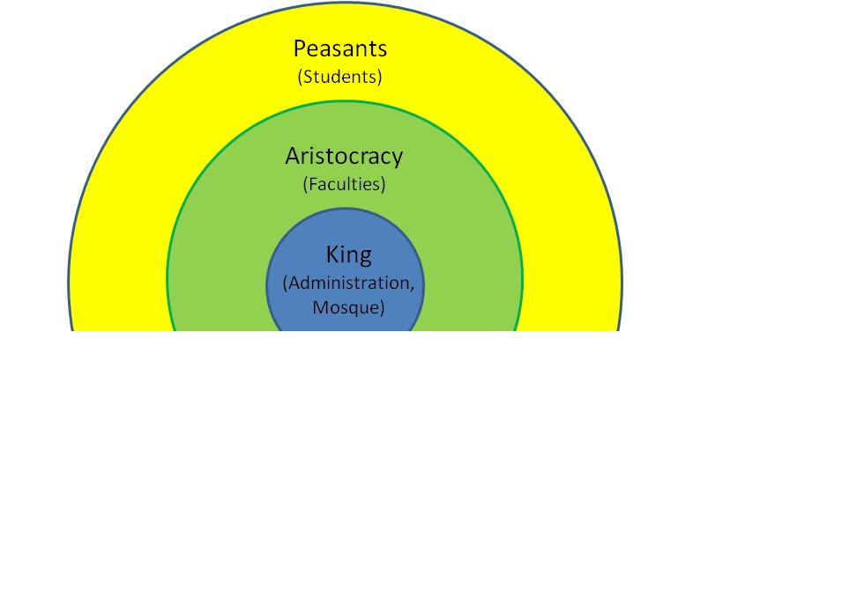

* Putrajaya and Cyberjaya are good examples of showcase cities that have been planned from the ground to be awe-inspiring and portray Malaysian prosperity and abilities. Grandeurs buildings and large wide roads are the major part of these new administrative cities. But Tajuddin ask; when you plan and construct these collections of government facilities then why is it that they are moved away from people and there are no parking spaces available? (only staff parking for the administrative buildings). Is that a democratic signal to send, that the government is out there in the fancy, expensive buildings but they really don’t want the public to come out there, unless it is just to drive around and be amazed of the buildings.
* Nusajaya in Iskandar seems to be planned in the same spirit as Putrajaya, with the same mindset. The new government facilities are placed far from the public in an area that are a part of a new exclusive neighborhood where the common guy will probably never set foot.
* Democracy is not supported by the dividing effect of grand building designs. To look like a king you will have to “waste” (large land areas around you estate, to wide roads, ornamentation and decorations and so on). Things that do not in itself bring any benefit to the rest of the population.
* When the vast majority of the money is spend on grandeur for the purpose of creating monuments for the few instead of function for the masses then the result will not be a uniting democratization but instead a hierarchical split between the rich and the less fortunate.
* The new areas are build without community centers and it is expected that the mosques will suffice. But without active community centers (e.g. if a hall is only used for badminton) where will the different races meet? Not in the mosques, churches and temples.
* In Malaysia where politics, economy and religion is closely knit together the building design and prioritizing also plays another role. By displaying grand projects to show the power and wealth of the (Islamic) malays it might be the hope of the (Islamic) government to convert others by the effect of “look what we got! don’t you want that?”. Furthermore the political power is based on Malays and this power base is only stable as long as Malays keep voting the same party. Therefore there can be political motivation behind the effort to try and maintain some divide between the races.
* With the overall concept of building “by Malays for Malays” this race is kept happy and supported in the belief of the Malays as the superior race (Malay supremacy; *ketuanan Melayu*)
* Tajuddin considers science to be what brings food on the table and religion is why to do it, and how to do it (not physical but in broader perspective). Religion is about values, and all the three book religions (Judaism, Christianity and Islam) are essentially about humanism (how to live together and be civilized towards each other)
* When he questions the development and the designs he does it through what he calls an “armchair view” where he sits at home, studies, thinks and then write his reflections (as articles).
* The fact that some of them are actually published e.g. in the newspaper ‘The Star’ is a sign that the more critiical voices are now allowed into the media. According to Tajuddin it have never been impossible to get opposing views through, but most publishers have been afraid to lose licenses to actually leave room for criticisms, before now. The major loss of votes have made the government “afraid” and made them open more up.
* Tajuddin do not blame the government in any way, and believes that the positive discrimination was a necessity at the time it was introduced to bring about balance in the wealth of society. But when the official numbers now show that the chinese still owe the vast majority of wealth and malays only have 19% he is not longer sure of the statistics. When observing the malay community he knows it seems that they are doing just fine, and an independent organization made a survey showing that the number might be closer to 35-40% (the aim of the New Economic Policy was 30%).
* This downplay of the bumiputra influence could be an attempt to make Malays continue the support for the positive discrimination.
* Instead of being directly political active he urges his students to actually think about what is happening in the country. To look at the realities and react to that.
* One of the reasons why the New Economic Policy have not worked as well as could be expected comes from something that people call the ‘Ali Baba’-effect. The government gave started some companies and sold them very cheap to important (bumiputra) UMNO supporters, in the hope that they would make the company prosper and thereby increase bumiputra wealth. But instead the people would just sell of the company to Chinese business men at a price closer to the real value, and skim the immediate profit.
* There have been a movement in politics where the PAS (Pan-Malaysian Islamic Party), which is generally a part of the opposition have been “flirting” with UMNO. The fear, of Tajuddin, is though that is they join forces the other races will not again trust in islam, as the ruling party is the one creating/maintaining the un-equal real-time distribution of benefits.
* A fun fact is that Terengganu is a state have been controlled by the opposition for many years and therefore never benefitted from nation government support, but there more than 90% of the business is owned by Malays, as opposed to around 15% in Johor (a traditional UMNO state)

## Interview with prof. dr Sharifah Salwa Syed Madzkan

UTM, Thursday 11th March, 2010

Phone: 012 7140985, e-mail: [ssmahazar@utm.my](mailto:ssmahazar@utm.my)

Current position: Lecturer at UTM, cooperation with IRDA

### Key statements of Sharifah Salwa:

Involved in Environmental Planning Footprint of Iskandar region (pictures of the report, not approved yet).

More focus on detailed planning of our project, steps, framework, scope limitation.

Contact MPPG – Pasir Gudang authorities. Should give us access to data regarding factories in the area. Contact Kassim Bin Mohamed Yusoff, Officer of Town Planning, phone: 607-2513720/21/22, [mppg@johor.gov.my](mailto:mppg@johor.gov.my) (refer to prof. Sharifa)

Check out the conference: www.criocm.imrec.my

## Interview with Hong Lim Foo

UTM, Thursday 11th March, 2010

|  |  |
| --- | --- |
| Current position: Lecturer at UTM  Education: B.Sc. Architecture (Melbourne, Australia)  M.Sc. Architecture (UTM, Malaysia)  UTM contact info  Direct line: +607-5530641  Email: [b-hong@utm.my](mailto:b-hong@utm.my)  Personal  [utmhong@gmail.com](mailto:utmhong@gmail.com)  +6016-1869879 | http://www.fab.utm.my/BiodataImej/HongLimFoo.jpg |

This interview was done very informally during the meeting with Sharifah Salwa. She brought Foo as he is a collogue of hers, and he also works with sustainability.

After a short presentation Foo underlined that for in project it will be very important that we have a clear focus and chose a scientific methodology for the research. To avoid spreading the efforts to much and become too “vague”.

### Key statements of Hong:

* For the infrastructure part he was convinced that it would be possible to start with the major power utility company in Malaysia, Tenaga Nasjional Berhad (TNB), and go directly to them and ask for stastistics on power generation and distribution to the customers. Then when the major consumers have been identified you can continue to them, and ask how they use the power in the production to further gain insight into where it will be most relevant to focus the improvements.
* Use statistics, diagrams and figures to illustrate the importance/relevance.
* In general it is important to chose focus and base recommendations on the impact it will have. Therefore indicators and comparisons will have to be defined and measured. Then the best options for reductions/optimizations can be evaluated.
* If e.g. housing/buildings show to have the greatest potential then it might require a change of people mindsets (if it is habbits or traditions that needs changing) and how is this then accomplished?
* For industries a set of criteria for classification will have to be defined so there is a common basis on to which to compare the different companies. And based on this comparison the high impact areas can be identified, and evaluated on account on their effects, costs, and ease of implementation.
* Notions on palm oil: cocoa butter substitute cannot be sold to Australia because of Australian requirements on milk content in chocolate.

## Interview with prof. dr Ho Chin Siong

UTM, Thursday 11th March, 2010

Phone: 019-7768823, e-mail: ho@utm.my

Current position:

* Professor/ Course Director for Post Graduate studies at Department of Urban & Regional Planning Universiti Teknologi Malaysia
* Appointed Senate member of Universiti Te4knologi Malaysia
* Director of a project ‘Low Carbon Society’ (see leaflet) performed with IRDA

Past positions:

* Associate Professor/ Course Director for Post Graduate studies at Department of Urban & Regional Planning Universiti Teknologi Malaysia

Education:

* Doctoral engineering student at Toyohashi University of Technology , Japan
* Doctor of Engineering (System and Information Engineering)Toyohashi University of Technology , Japan
* Master of Science in Construction Management (Project Management) – with Distinction at Heriot Watt University , Edinburgh, United Kingdom
* Bachelor of Urban and Regional Planning ( Honours ) at Universiti Teknologi Malaysia

### Key statements of Ho Chin Siong:

Currently involved in Low Carbon City – CO2 has been chosen to be the best (only!) parameter to evaluate environmental performance within the area. Currently there are no regulations regarding CO2 footprint for factories in Malaysia.

The brochure (has just been released):

* Try to look at transport, power generation and social behavior.
* Combined with GDP
* Data included in the brochure originate from CDP (Comprehensive Development Plan).
* Concrete measure to achieve desired decrease (nationally from 185 mln ton CO2 in 2005 to 45 mln ton in 2025 – 40%)
* Incorporated within NPP – national Policy Plan

Our opinion: brochure contains questionable quality data without explanation regarding data collection and plans contain general guidelines regarding CO2 reduction and hardly refer to current situation in Malaysia and concrete measure which need to be taken.

* Ho Chin Siong agrees that specific data regarding separate industries should be collected and used in creation of new regulatory policies.
* CCS - Carbon Capture and Storage – already done in India and China, possible to be implemented in Malaysia.
* Biofuels – present and highly encouraged in Malaysia.
* We could contact SCORE – Sawah Corridor of Renewable Energy and read about SCREP Small Renewable Energy Project.
* Transportation in Johor – only 18-20% of trips are by public transportation, plans for trains are far from implementation (Ismail Brahim, CEO if IRDA should be contacted within this matter).
* The vision is to make the city more compact, which could reduce its CO2 footprint (our comment: far from that!)
* To improve CO2 profile of industry, three approaches should be employed: operations improvement, high efficiency - equipment improvement, increasing share of natural gas. Boundries/industrial policies regarding eco-efficiency are needed.
* Agriculture is a serious polluter, only several companies perform biogas treatment.
* Research in palm oil industry – contact Palm Oil BOT at Ministry of Agriculture ad FMM. Also, look at the plantation areas.
* Close societies are needed to protect from workers from Indonesia and protect property from burglars.

## Interview with Faisal Rahman

Pasir Gudang, 24th March, 2010

E-mail: [alfaisals@yahoo.com](mailto:alfaisals@yahoo.com)

Current position:

* Plant Manager at Mensilin

Previous positions:

* Supervisory Engineer at Intelectron Inc.,
* Senior Advance Manufacturing engineer at Mattel (M) Sdn. Bhd.

Education:

* Colorado School of Mines

### Key statements of Faisal Rahman:

### History of the company

The company was started in 1997 as a consultancy company for energy efficiency solutions and services. From 2001 they entered National Renewable Energy Program, as the goal was that at least 5% of energy should come from renewable resources. Since 2000 they started trading CO2 quotas. In 2003 they bought small thermal oil heater MDF and also got involved in a number of biomass and biogas projects. They worked on concept of cogeneration for industry. Also they thought about using biomass for energy generation, but the power grid control had other company registered for such a project and no other company was allowed to do the same (although the other project failed). Once they have discovered that processing and storage of palm oil requires a lot of steam they started the project on steam production from palm oil industry waste.

### Value proposition

Mensilin supplies customers with lower cost steam with the sufficient operational parameters. Due to high energy efficiency technology it is cheaper for the companies to buy steam than produce it on their own. Also, it gives green labeling on industrial activities by removal of waste material and replacement of fossil fuels.

### Operationa parameters

The company employs 35 people (10 executive (all studied or worked abroad), 29 skilled, 2 females (office), 100% Malays). 35 000 kg/hr of steam is produced. They collect 200 tones material a day from government agencies and private companies. The boiler used in the production is of Danish design, Vølmol, and it is of very high energy efficiency – more than 80%. Steam is delivered to customers in insulated pipelines for a distance of 2700 m with minimum temperature and pressure drop. Steam parameters are 212 C degrees and 17 bar pressure. Danish consultants did not believe that the direct piping can work, and after first trial it didn’t, but it worked in 3rd iteration. The manager beleves that they could deliver steam at a distance of 3500 m.

Reversed osmosis is used to pretreat water. Other companies use activated carbon or softeners, which us less environmentally friendly solution. No condensate recirculation is employed, although it would save a lot of energy, because the water has to comply with food grade standards.

Highly automatized production system – biomass feed of biomass, pressure and temperature regulation, control of combustion and discharged. Wireless internet and full constant monitoring of the entire area are present.

At the moment of visit company was stopped due to technical issues. After replacement if broken part the boiler should be working again.

### Plantation plans

The company possesses 100 acres area for energy crops plantation. Acacia has been chosen as a short cycle crop, energy dense, low maintenance and high biomass increase plan. This project is performed with Forest Research Institute Malaysia.

### Network

Company’s customers are Palmaju and Carotino. Old companies have their own supply (internal or external), so Mensilin approaches only new ones or these which expand production. They also collaborate with Forest Research Institute, UTM, Physical Research Institute, Indonesian research units and industrial regulation authorities in terms of emissions and effluent discharge. They ran business with USA, Canada, Hong Kong, Iraq, Netherlands, France, Spain, Japan, Singapore, Korea, Austria and Germany.

### Social development

The company is a pioneer in new technologies and therefore it is difficult to find skilled employees. Everyone starts with training and a lot of focus is put on human capital development. Every new employee has competence training and every 3 months there is some training organized depending on situation (e.g. biomass, chemicals, etc).

### Dissemination of clean technologies

The company has been involved in several projects regarding dissemination of clean technologies. The level of environmental awareness in Malaysia is very low and they are not aware of depletion of fossil fuels. Some efforts are made (e.g. 25th plastic bag free day or SHIN energy project). They were involved in promotion of biodegradable materials and food containers and carbon footprint determination.

The agencies to speak to are: FMM, MEF (Malaysian Employee Federation), MIDA, Green Technology Ministry, DOE, SIRIM, Palm oil BOT.

## Interview with Suraya Badaruddin

IRDA, 7th April, 2010

Current position:

* Infrastructure in IRDA, responsible for blueprints in solid waste management, water supply, energy and renewable energy

### Key statements of Suraya Badaruddin:

### Solid waste management

* Waste production: 2583 tons/day of domestic solid waste and 1060 ton/day from industry.
* Promotion of recycling (segregation and sorting)
* Solid Waste Act – segregation will be mandatory, needs to be implemented gradually due to resistance from authorities (waste will be given to concessioner by federal government, now they are under jurisdiction of local authorities).
* 3 landfills – 2 proper and 1 dumpsite.
* Reduction is promoted – public need to be educated (public awareness in terms of recycling activities) by special initiatives.
* The plan is to make 1 area specific for Iskandar with integrated waste management system
* Incineration plant with plasma gasification is an option as it is cost efficient and sustainable.

### Water supply

* Implementation program based on input from relevant agencies, has a special implementation committee.
* Quality of water and pollution of rivers
* 2 standards: A – drinkable, B – safe but non drinkable
* Costs of water treatment (expensive)
* 2400 mm/year of rainwater
* CDP – water shortage by 2025
* 25% of water is lost due to pope leakages
* Currently sell water to Singapore
* Identify water resources and protect catchment areas
* Currently 2 water resources – one outside Iskandar
* Integrated system for water treatment is needed
* Currently the system of filtration is not appropriate
* Sewage treatment plants STP:
  + Centralized Sewage Treatment Plan
  + 1 plant is required for every 150 units (5 people)
  + Industrial sewage is monitored by DOE – approved by license
  + Modernization is required as the system is old and inefficient

### Energy

* Based on GDP and population growth.
* Coal and gas based
* 40% excess of energy in Malaysia
* Reliability and quality needs to be improved (electricity disruption fixed in 20 min for Singapore, 60 min for Malaysia (target is 20) and Cyberjaya 5-20 min)
* Opposite data of IRDA and TNB (IRDA has data that domestic energy use is higher than industrial and TNB claims the opposite)
* Energy Efficiency Policy – Federal
  + Building design – green building index MS 125
* Green technology policies, incentives, tax reductions or exemptions, etc…
* The subsidies on oil and electricity are gradually reduced by the government (gradually because of the public resistance)
* Gas – facing shortage

### Renewable energy

* Focus on potential in Malaysia, they are trying to identify the most promising candidates
* So far have been discussed:
  + Solar
  + Biomass
  + Biodiesel

## Interview with Zainuddin Bin Omar

Pasir Gudang, 19th April, 2010

Current position:

* Production Manager at Felda Vegetable Oil Products (FVOP)

### Key statements of Zainuddin Bin Omar:

* FVOP has a policy of transparency of information – supply people with data whenever requested
* Stakeholders and shareholders
* Main activity is refining crude palm oil
* Products are RBD PO, RBP PL – for feed, RBD – for butter and B5 biodiesel
* Other facilities – flexibag fillind and drumming, warehouse rental
* Data on refining scheme, production capacity and operational performance (in the report)
* Accreditations (in the report)
* List of palm oil fractions and possible products (in the report)
* Composition and types of palm oil fruit bunches
* High position of the company in the environment index in Pasir Gudang refineries ranking

## Interview with Abd Halim Bin Mohd Nor

IRDA, 19th April, 2010

Current position:

* Infrastructure at IRDA

Education:

* Civil Engineering

### Key statements of Abd Halim Bin Mohd Nor:

Population will grow from 1.3 to 3.1 million by 2025.

Problems with infrastructure need to be identified and 1-2 years project for implementation should be suggested.

Guidelines are good but people don’t comply. Special studies on improvement of compliance are performed. Also mentality of society needs to be changed by enforcements and campaigns.

Guidelines need to be promoted. Guidelines are created by developers, but they don’t have to be followed by government. Examples of good guidelines which are promoted are: rainwater harvesting or cleaning rivers.

### Transportation

* Benchmark with international cities – blueprint of the current situation is being prepared.
* Bus – short term improvement – identify where busses don’t go and send them there.
* Rail transportation, no trains for transportation in Iskandar area – in plans, but highway comes first, capacity of station is not utilized at the moment. Fast train KL – JB with ticketing system and platform is now in the governments’ decision. MRT could be introduced in the city.
* No parks, jogging areas or public outdoor facilities.
* Federal funds to build highways, however it is believed that number of busses cars need to be reduced. Currently banks give loans for cars and they are subsidized by government.
* Connectivity to Singapore – new road, Causeway, was designed by the previous minister, but the new one cancelled and so large part of investment got wasted.

### River

* Projects to improve river – clean it, deepen, rubber pitching, etc… - to prevent floods.
* Pollution due to squatters living on river due to direct garbage discharge – they need to be relocated.

### Drainage

* Drainage system needs to be improved.
* External consultants have been employed.

### Gas supply

* 2 suppliers of bulk gas industrial: Petronas (transmission supplies – PGU line across Malaysia) and Gas Malaysia Sdn Bhd (distribute gas to industrial customers)
* For commercial use there are other suppliers
* Shortage expected, therefore efficiency of use has to be improved
* Supply prioritized to value added industry (e.g. nit steam producer as he can use biomass).

### Renewable energy

* Large amount of biomass from palm oil industry
* Wind turbine not efficient for Malaysia
* Incineration plant – to reduce landfills. 1 is present in Kuala Lumpur area, but it is not working because of the bad opinion of public (complain about emission due to lack of filters). Initial expenditure for incineration plant is also high. Plasma gasification is good in theory but difficult to be implemented. There are better ways to improve environmental performance.

### Electricity

* Quality, reliability and efficiency needs to be improved.
* Putrajaya uses Korean technology which is very environmentally friendly.

## Interview with Rahman Hassan

IRDA, 19th April, 2010

Current position:

* Senior Vice President, Social Development at IRDA

### Key statements of Rahman Hassan

IRDA wants to attract skilled workforce to come and stay in Iskandar.

The goal is to encourage Malaysians to invest in their country and show to the world what Malaysia has to offer.

### Manpower

* Human capital blueprint is being prepared for long term strategy and action items to be taken.
* Look into future courses and try to fill out the gaps.
* When investors come and want to set up e.g. petrochemical plant in 2, 3 years, then number of engineers needs to be increased and skills have to be enhanced.
* For managers there is longer lead time.
* Johor Bahru – lack of experts in IT, accounting, banking, tourism and recreational.
* Activation and upgrade of skills is performed by increasing number of places at universities and special trainings. Training centers are available for people in the field who are interested.

### Foreign nationalities

* Indians are brought to work on plantations.
* Whenever new plantation workers are brought, Ministry of Human Resources needs to be informed and approve. If plantation is closed, some of them will move to other plantation, some will try to learn new skills and some will not want to work anymore.
* Chinese also were brought to work on plantations, but they moved to financial sector. They were gaining more and more of country’s wealth. To establish balance, number of privileges was formulated for Malays. If Chinese people want to start a business and if they have one Malay in top structure of the company, then they can enjoy these privileges. This phenomenon is acknowledged and as long as Malays benefit from it, it is accepted.
* Major Chinese companies are owned by Chinese people – usually family businesses. However, every company must have at least 30% Malay shareholding. In this way many successful joint ventures are formed and they learn how to cooperate.

### Palm oil

* In 1960 many people didn’t have jobs.
* To open new areas palm oil industry has been developed.
* Palm oil was the key product for the country development. Also rubber and tin, but now tin production is more expensive than price.

### Poverty

* There are aids for people who are poor. Also, special help in finding job and upgrading skills is organized, but sometimes they are not interested.
* Some Malays do not declare their incomes and therefore background checking is used before offering help.
* Social sources do profiling of people how they are able and willing to work and what they can do.
* Trainings are offered, in 2009 2000 people participated in trainings in Iskandar region,
* NGOs also provide aids for Malays.
* There is no central ‘work center’, so it is difficult to be monitored.

### University – Industry linkage

* The government keeps track of number of graduates and types of courses at universities.
* More highly educated in needed for the development.
* Practically no initiatives to link university – industry has been identified in IRDA. Rather focus on ensuring that the new companies will have enough employees with the required skills.
* Trade Missions handle sending students abroad.
* To work for the government, a person needs to live and work abroad for a while.
* Government approves and sends students for studies abroad and covers all the expenses according to special programs.
* Companies give students scholarships for study. The idea is that scholarships could bind students with local companies in Iskandar (to make them stay and work there)

## Interview with Zulkefley Ariffin

IRDA, April 30th 2010

Contact: zulkefley@irda.com.my

Current position: Assistant Vice President at IRDA Malaysia

### Background:

For some time there had been efforts to get an interview with someone in charge of the infrastructure developments and the overall planning in the Iskandar region. Two previous interviews on general infrastructure subjects had more or less only given information in the range of what was already stated in the CDP and almost nothing related to transportation.

This interview was supposed to be with the responsible for the transportation planning but unfortunately she was called to Putrajaya to make a presentation for the national government and was therefore not available. Instead the interview was conducted with Mr. Zul who had been consulted during the planning and therefore had some insight into what was done.

The interview only took about half an hour and took place around a map where the different areas were pointed out.

### Key statements

The transportation planning in Iskandar is described in the CDP but the planning there is preliminary in the sense that there is several different stages of development where the road network is the only one where construction work would be started immediately. The public transportation network described is based on rails and the entire system would consist of several different kinds of rail transport. These have a timeline where some of the construction should have been initiated within the last year, but still the actual construction is still on hold.

Zul has insight into the more detailed planning where the bus system have been revised. There have been an evaluation of the bus system with focus on coverage and usage to discover how well the system connects the urban centres and primary transport notes as well as to find out if the working population can actually use the system to commute.

The new transportation plan is now comprised of three steps; short, medium and long term actions. The short term is an expansion of the current bus system with a separate bus operator funded by money from the Iskandar project. This operator provide routes that service the residential areas that have previously not had any good connections to the industrial areas or shopping centres. This way the bus system will be more attractive to a larger part of the population and serve as a possible alternative to private transportation. The next step is to make the bus system more effective , safe and welcoming. This should happen through a series of steps such as getting better busses that drive regularly and after schedules, busses that are surveyed with e.g. CCTV (closed circuit television), and by education drivers to perform better in traffic and be more polite towards the customers.

Instead of the rail way there are evidence that a BRT (Bus rapid transit) system will be more achievable as this will not require the same large initial investments and therefore be more economical sustainable. Unfortunately does the current road network planning and construction not account for the need for separate / dedicated bus lanes and this means that to implement a BRT extensive road reconstruction will be necessary. It is estimated that the roads in most places exept in the central city centre are wide enough to allow for dedicated lanes in the mid road as can be found in e.g. Curitiba but still this requires that the existing car lanes are moved to the edge of the roads and that the bus lanes are constructed in the central reserve of the roads. This will have consequences for the traffic flow both during the extended construction period affecting the traffic that is already pressured by the extensive high-way construction taking place within the last couple of years.

## Other interviews

* Masri Zohani Indris, Director at MIDA, Phone: +607-224-2550, Email: [masri@mida.gov.my](mailto:masri@mida.gov.my), [johor@mida.gov.my](mailto:johor@mida.gov.my)

Discussion about potential for industrial development, costs, brochures (included in report)

* Mohd Toaha Bin Arshad, Executive Corporate Communication at Johor Corporation, Phone: +607-223-2692. E-mail: [toha@jcorp.com.my](mailto:toha@jcorp.com.my)

Discussion about biodiesel industry in Malaysia and creation of biodiesel specialized port in Tanjung Langsat

* Sazela Mohd Safie, Assistant Manager of Strategic Marketing at UEM Land (part of UEM group), Phone: +607-277-3700, E-mail: [sazela.safie@uemland.uemnet.com](mailto:sazela.safie@uemland.uemnet.com)

Discussion about development in Nusahaya region

* Boyd Dionysius Joeman, Vice President (Environmental Planning), Integrated Planning at IRDA, Phone: +6019-772-3553, E-mail: boyd@irda.com.my

Guidlines and assistance during the entire 3 months period

* Hana Badriah Zulkifli, Associate in Intergrated Planning at IRDA, Phone: +6012 339 7838, E-mail: [hana.badriah@irda.com.my](mailto:hana.badriah@irda.com.my)

Guidlines and assistance during the entire 3 months period

* Sharifah Shahidah Syed Ahmad, Associate in Intergrated Planning at IRDA, Phone: +6013-725-5422, E-mail: [shahidah@irda.com.my](mailto:shahidah@irda.com.my)

Guidlines and assistance during the entire 3 months period

# Appendix 2 –Economy and industry

This Appendix includes all the graphs and tables which give more information on theory described in section ‘2.2 Economy, industry and business’ of the main report.

## National economy

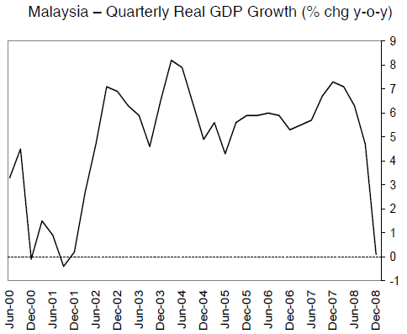

Figure A. Malaysia – Quarterly Real GDP Growth. Source: BMI view, MALAYSIA: DATA & FORECASTS, Asia Monitor: South East Asia Monitor Volume 2; Apr2009, Vol. 20 Issue 4, p3-3.

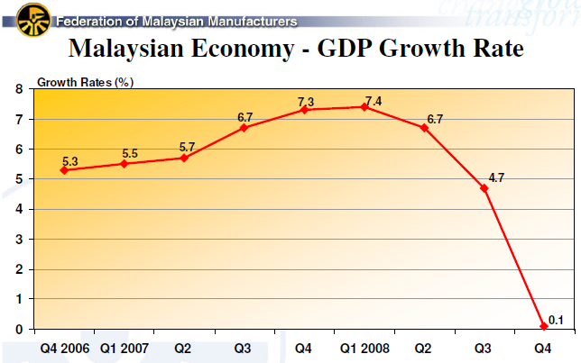

Figure A. Malaysian GDP growth rate in the last years quarterly. Source: Federation of Malaysian Manufacturers, http://www.fmm.org.my

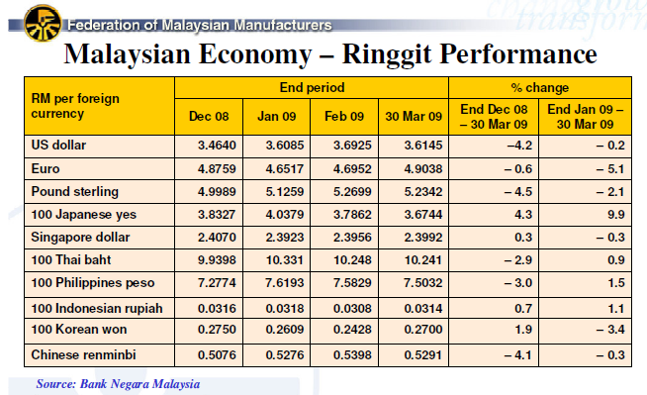

Table A. Malaysian Ringgit Performance in 2008 and 2009. Source: Federation of Malaysian Manufacturers, http://www.fmm.org.my.

## Industry

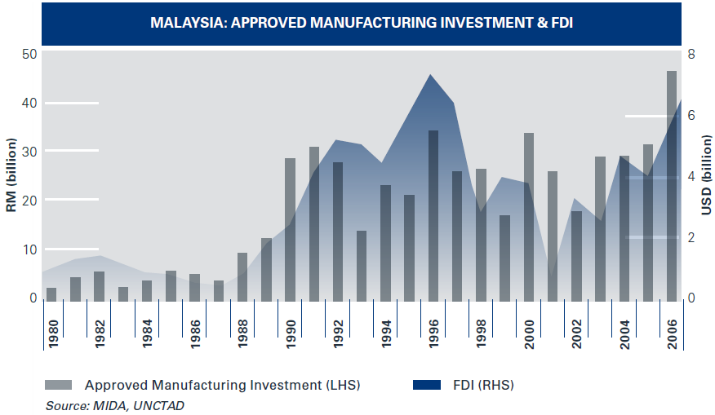

Figure A. Approved manufacturing investment and FDI. Source: Investment in Iskandar Malaysia. http://www.iskandarmalaysia.com.my/pdf/brochures/Investing_in_Iskandar.pdf

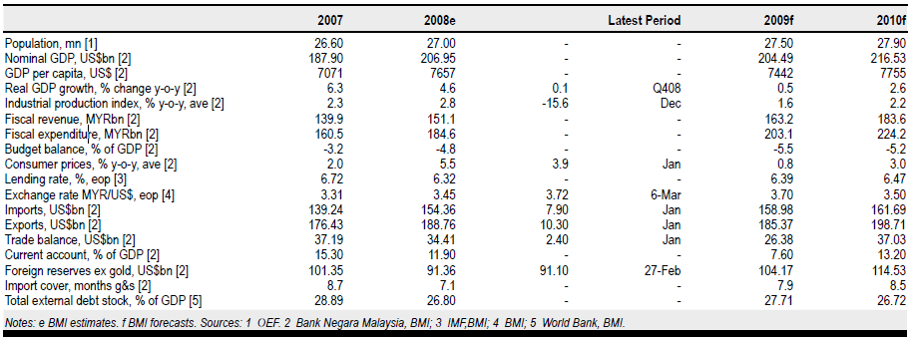

Table A. Detailed data on Malaysian economic/industrial performance in the last years and predictions for 2009 and 2010. Source: BMI view, MALAYSIA: DATA & FORECASTS, Asia Monitor: South East Asia Monitor Volume 2; Apr2009, Vol. 20 Issue 4, p3-3.

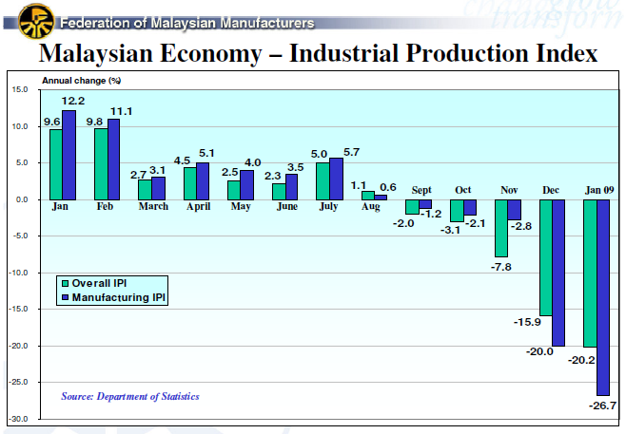

Figure A. Malaysian industrial production index. Source: Federation of Malaysian Manufacturers, http://www.fmm.org.my

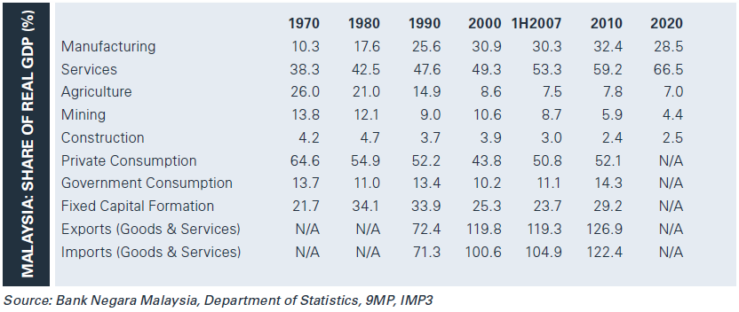

Table A. Malaysian share of real GDP by industry sector since 1970. Source: Investment in Iskandar Malaysia. http://www.iskandarmalaysia.com.my/pdf/brochures/Investing_in_Iskandar.pdf

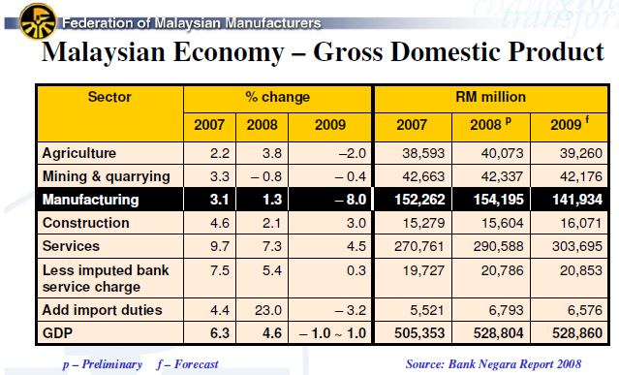

Table A. Malaysian GDP by industry sector in the last years. Source: Bank Negara Report 2008.

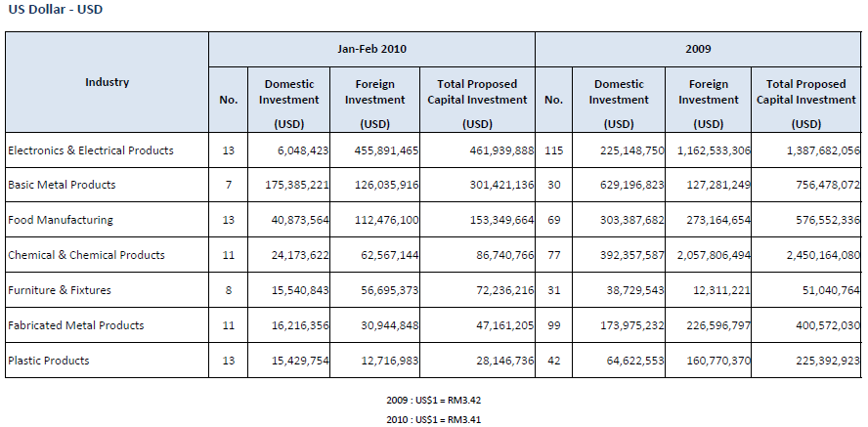

Table A. Domestic and foreign investment by industry sector in 2009 and 2010. Source: Source: Investment in Iskandar Malaysia. <http://www.iskandarmalaysia.com.my/pdf/brochures/Investing_in_Iskandar.pdf>

|  |  |  |  |
| --- | --- | --- | --- |
|  | Micro-enterprise | Small enterprise | Medium enterprise |
| Manufacturing, Manufacturing-Related Services and Agro-based industries | Sales turnover of less than RM250,000 OR full time employees less than 5 | Sales turnover between RM250,000 and less than RM10 million OR full time employees between 5 and 50 | Sales turnover between RM10 million and RM25 million OR full time employees between 51 and 150 |
| Services, Primary Agriculture and Information & Communication Technology (ICT) | Sales turnover of less than RM200,000 OR full time employees less than 5 | Sales turnover between RM200,000 and less than RM1 million OR full time employees between 5 and 19 | Sales turnover between RM1 million and RM5 million OR full time employees between 20 and 50 |

Table A. Definition of SMEs in Malaysia. Source: <http://www.smidec.gov.my>.

## Industrial development plans

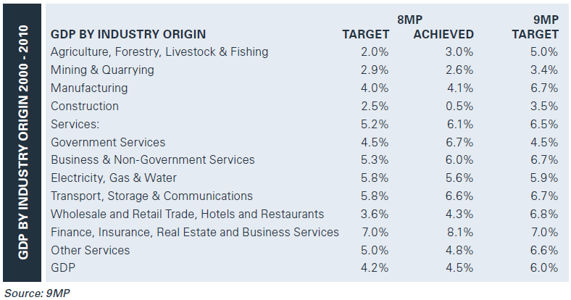

Figure A. Industrial development plans formulated in 8th and 9th Malaysia plans. Source: Investment in Iskandar Malaysia. http://www.iskandarmalaysia.com.my/pdf/brochures/Investing_in_Iskandar.pdf.

## Costs

### Workforce

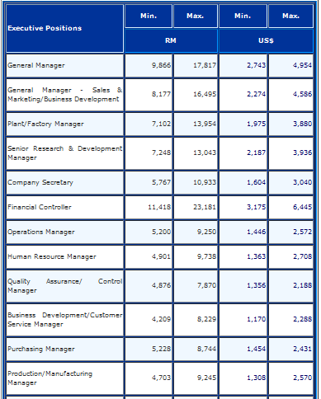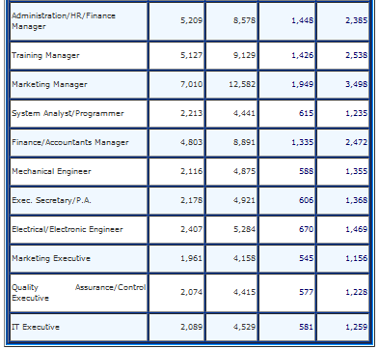

Table A. Employees wages, executive positions. Source: MIDA, http://www.mida.gov.my/en_v2/index.php?page=wage-rates.

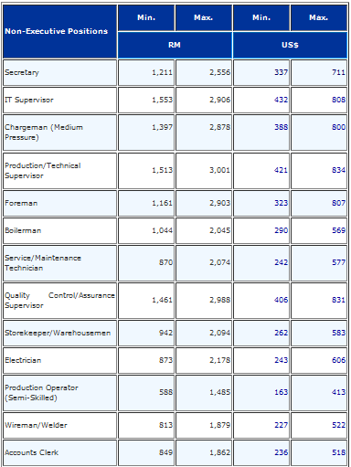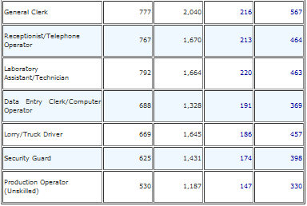

Table A. Employees wages, non-executive positions. Source: MIDA, http://www.mida.gov.my/en_v2/index.php?page=wage-rates.

### Electricity

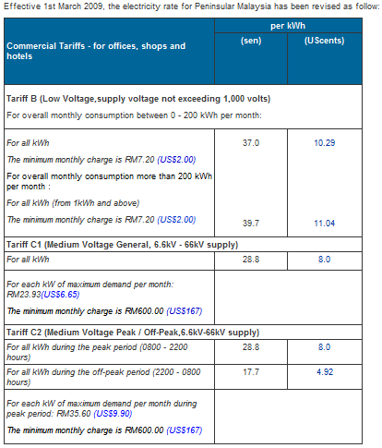

Table A. Electricity costs in Penisular Malaysia, commercial tarrifs - Tenaga rates. Source: MIDA. http://www.mida.gov.my/en_v2/index.php?page=electricity-rates

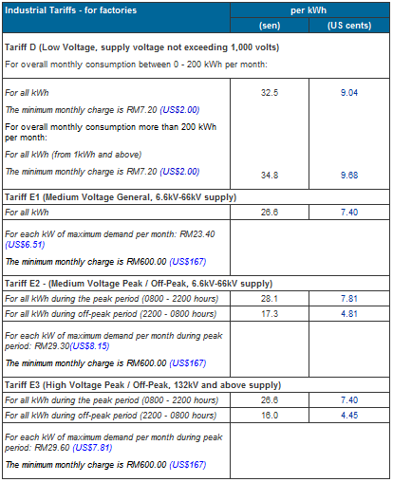

Table A. Electricity costs in Penisular Malaysia, industrial tariffs - Tenaga rates. Source: MIDA. http://www.mida.gov.my/en_v2/index.php?page=electricity-rates

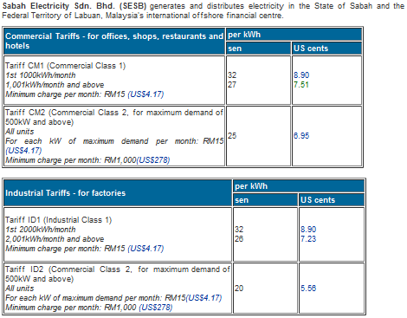

Table A. Electricity costs on Sabah. Source: MIDA. http://www.mida.gov.my/en_v2/index.php?page=electricity-rates

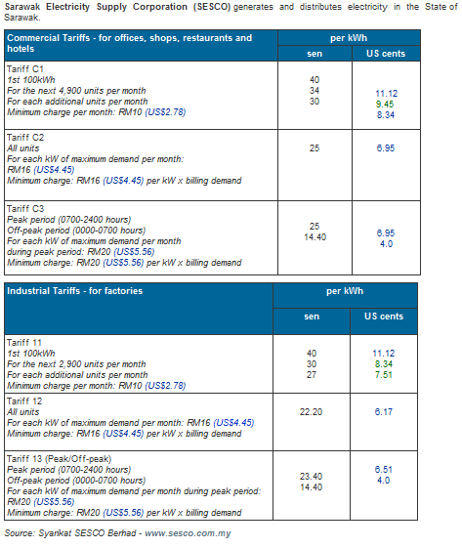

Table A. Electricity costs on Sarawak. Source: MIDA. <http://www.mida.gov.my/en_v2/index.php?page=electricity-rates>

### Water

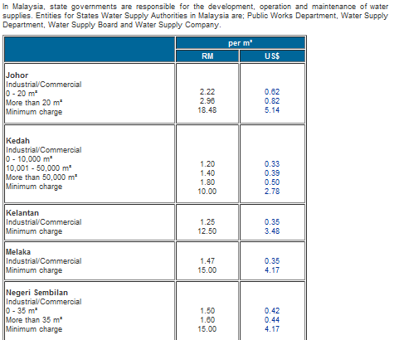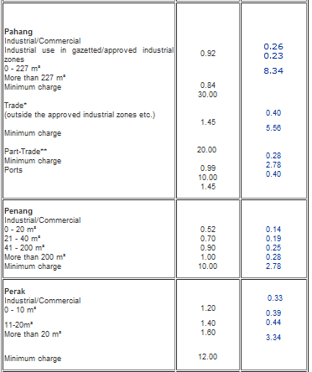

Table A. Water prices in Malaysia, part 1. Source: MIDA, http://www.mida.gov.my/en_v2/index.php?page=water-rates.

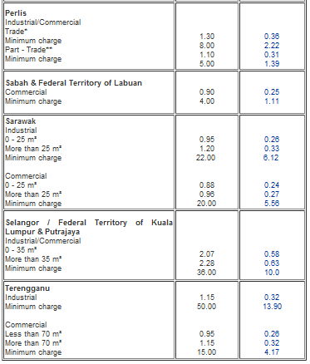

Table A. Water prices in Malaysia, part 2. Source: MIDA, http://www.mida.gov.my/en_v2/index.php?page=water-rates.

### Sewerage

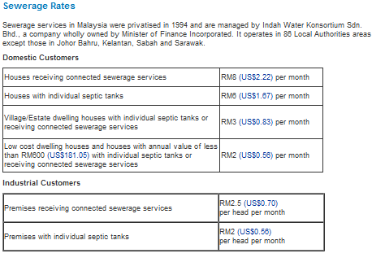

Table A. Sewerage cost rates – domestic and industrial. Source: MIDA, http://www.mida.gov.my/en_v2/index.php?page=sewerage-rates.

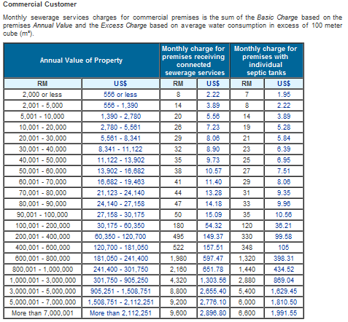 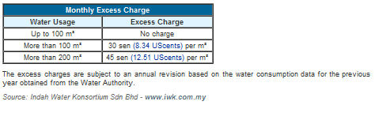

Table A. Sewerage cost rates – commercial. Source: MIDA, http://www.mida.gov.my/en_v2/index.php?page=sewerage-rates.

### Scheduled waste treatment

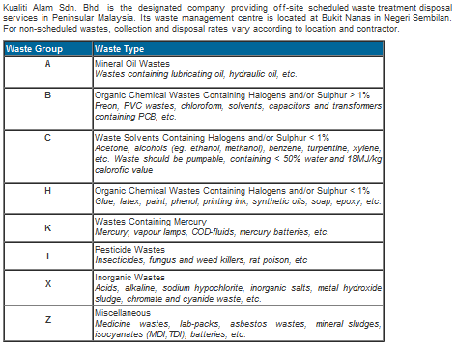

Table A. Waste groups for scheduled waste treatment rates. Source: MIDA, http://www.mida.gov.my/en_v2/index.php?page=scheduled-waste-treatment-rates.

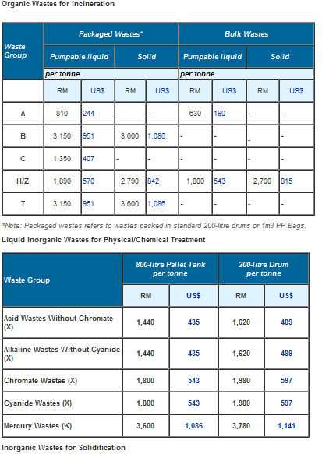

Table A. Rates for treatment of organic wastes for incineration. Source: MIDA, http://www.mida.gov.my/en_v2/index.php?page=scheduled-waste-treatment-rates.

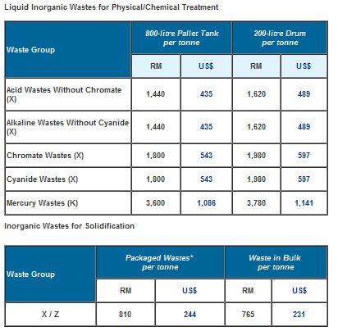

Table A. Rates for treatment of inorganic wastes. Source: MIDA, http://www.mida.gov.my/en_v2/index.php?page=scheduled-waste-treatment-rates.

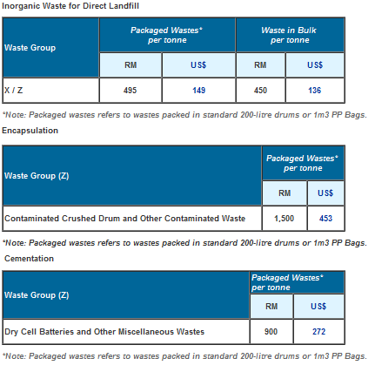

Table A. Rates for treatment of other wastes. Source: MIDA, http://www.mida.gov.my/en_v2/index.php?page=scheduled-waste-treatment-rates.

### Transportation

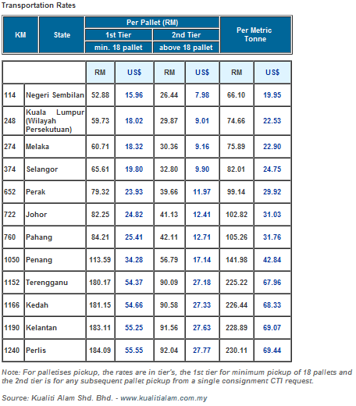

Table A. Transportation rates. Source: MIDA, http://www.mida.gov.my/en_v2/index.php?page=transportation-cost.

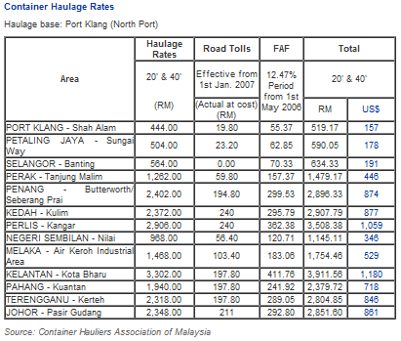

Table A. Container haulage rates. Source: MIDA: http://www.mida.gov.my/en_v2/index.php?page=transportation-cost.

### Gas and fuel

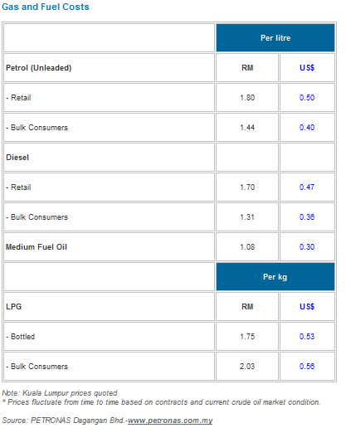

Table A. Gas and fuel costs in Malaysia (Petronas). Source: MIDA, http://www.mida.gov.my/en_v2/index.php?page=gas-and-fuel-costs.

# Appendix 3 – Environment

This Appendix includes all the graphs and tables which give more information on theory described in section ‘2.3 Environment’ of the main report.

## Development of government policies

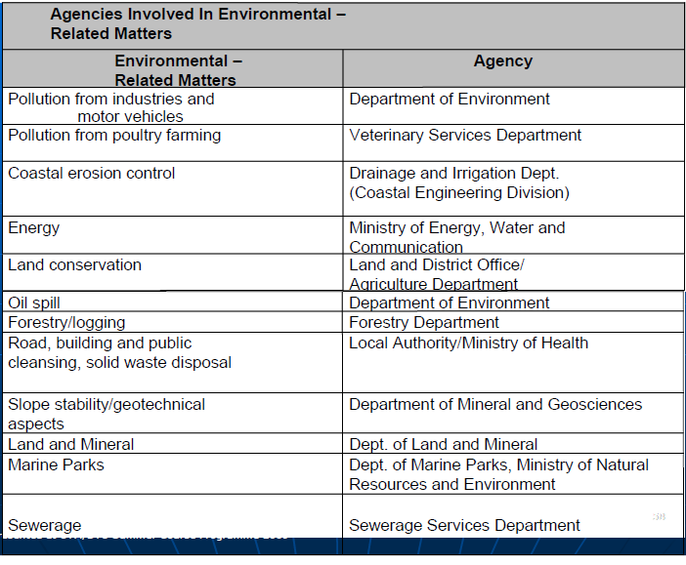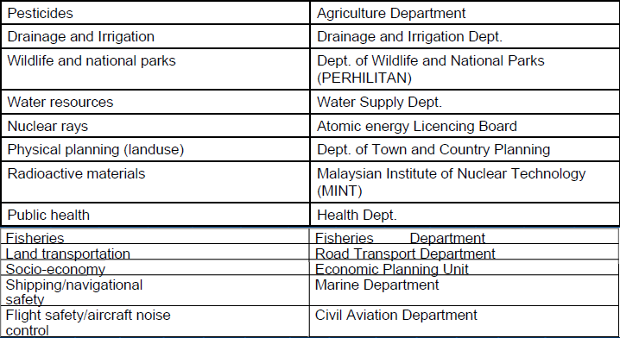

Table A. Environmental institutions in Malaysia. Source: Dr. Zulkifli Abdul Rahman, Director of Department of Environment, Johor, UTM/DTU course ‘Sustainable Production in Industrializing Countries’, June 2009.

## Status of Malaysian environment

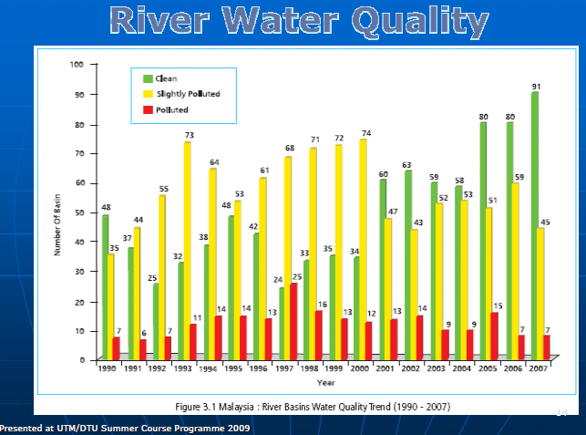

Figure A. River basins water quality trend (1990-2007). Source: Dr. Zulkifli Abdul Rahman, DEO.

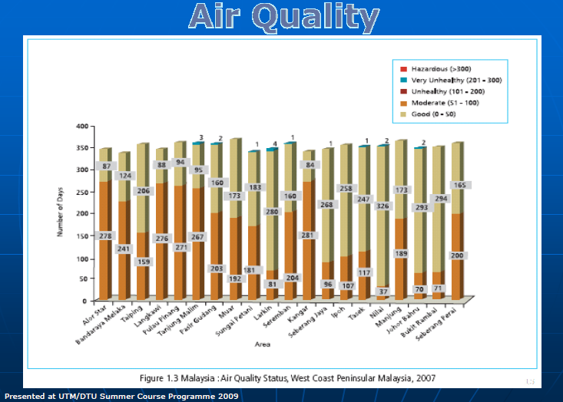

Figure A. Air quality status, west coast peninsular Malaysia, 2007. Source: Dr. Zulkifli Abdul Rahman, DEO.

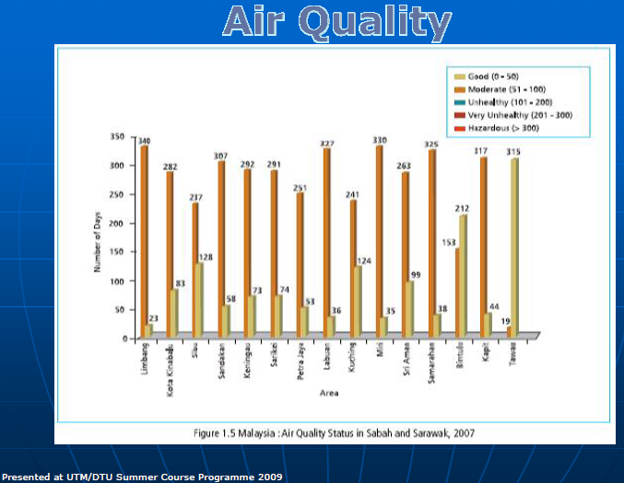

Figure A. Air quality status, Sabah and Sarawak, 2007. Source: Dr. Zulkifli Abdul Rahman, DOE.

|  |  |  |  |
| --- | --- | --- | --- |
| SCORES AND RAW DATA (MALAYSIA) | Score  (% proximity to target) | Raw value | Raw value target and unit |
| ENVIRONMENTAL HEALTH | **81.31** |  |  |
| Water (effects on humans) | **95.77** |  |  |
| Access to Sanitation | 93.266 | 94.0 | 100.0% of population with access |
| Access to Water | 98.2759 | 99.0 | 100.0% of population with access |
| Air Pollution (effects on humans) | **93.81** |  |  |
| Indoor Air Pollution | 94.7368 | 5.0 | 0.0% of population exposed |
| Outdoor Air Pollution | 92.8911 | 22.8877 | 20.0 ug/m3 |
| Environmental Burden of Disease | **67.82** |  |  |
| Environmental Burden of Disease | 67.82 | 27.0 | 10.0 Disability Adjusted Life Years per 1,000 population |
| ECOSYSTEM VITALITY | **48.67** |  |  |
| Forestry | **89.11** |  |  |
| Forest Cover Change | 78.2271 | -0.7 | 0.0 decline in forest cover |
| Growing Stock Change | 100.0 | 1.00653 | 1.0 ratio of growing stock in time2 to time1 |
| Fisheries | **52.83** |  |  |
| Marine Trophic Index | 100.0 | 0.005466 | 0.0 decline |
| Trawling Intensity | 5.66352 | 94.3365 | 0.0% of exclusive economic zone trawled |
| Agriculture | **94.75** |  |  |
| Agricultural Water Intensity | 100.0 | 0.96 | 10.0% of all water resources |
| Agricultural Subsidies | 97.6576 | 0.0065069 | 0.0 subsidies |
| Pesticide Regulation | 90.9091 | 20.0 | 22.0 points |
| Climate Change | **42.33** |  |  |
| Greenhouse Gas Emissions Per Capita | 41.9171 | 14.4721 | 2.5 Mt CO2 eq. (Estimated value associated with 50% reduction in global GHG emissions by 2050, against 1990 levels) |
| CO2 Emissions Per Electricity Generation | 8.87401 | 619.076 | 0.0 g CO2 per kWh |
| Industrial Greenhouse Gas Emissions Intensity | 76.5985 | 59.4161 | 36.3 tons of CO2 per $mill (USD, 2005, PPP) of industrial GDP(Estimated value associated with 50% reduction in global GHGemissions by 2050, against 1990 levels) |
| Air Pollution (effects on ecosystem) | **44.72** |  |  |
| Nitrogen Oxides Emissions | 44.9843 | 1.85085 | 0.01 Gg/sq km populated land area |
| Ecosystem Ozone | 35.2118 | 380622.0 | 3000.0 AOT40 |
| Sulfur Dioxide Emissions | 51.8453 | 1.02642 | 0.01 Gg/sq km populated land area |
| Non-Methane Volatile Organic Compound Emissions | 32.5925 | 4.53437 | 0.01 Gg/sq km populated land area |
| Water (effects on ecosystem) | **74.01** |  |  |
| Water Quality Index | 54.6281 |  | 100.0 score |
| Water Stress Index | 86.7877 | 0.74 | 0.0% territory under water stress |
| Water Scarcity Index | 100.0 | 0.0 | 0.0% water overuse |
| Biodiversity & Habitat | **74.07** |  |  |
| Biome Protection | 100.0 | 10.0 | 10.0% weighted average of biomes protected |
| Critical Habitat Protection | 66.6667 | 66.6667 | 100.0% of critical habitats protected |
| Marine Protection | 29.6128 | 1.03416 | 10.0% of country’s exclussive economic zone protected |

Table A. Factors contributing to EPI in Malaysia in 2009. Source: http://epi.yale.edu.

# Appendix 4 – Palm oil

This Appendix includes all the graphs and tables which give more information on theory described in section ‘2.4 Palm oil industry’ of the main report.

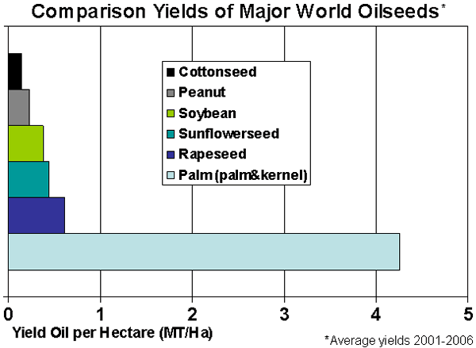

Figure A. Comparison yields of major world oilseeds. Source: USDA, Indonesia:  Palm Oil Production Prospects Continue to Grow, 2007, Commodity Intelligence Report, Vol. 12.

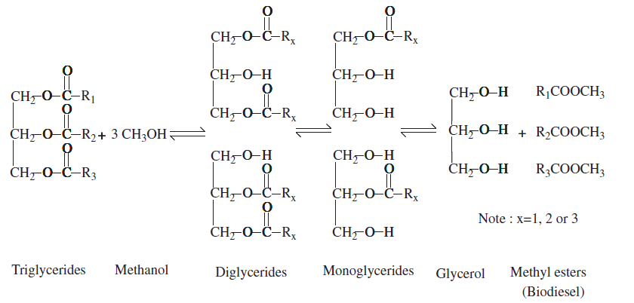

**Figure 10A. Chemical equation for biodiesel production from palm oil (triglycerides fraction). Source: Abdullah, A.Z., Salamatinia, B., Mootabadi, H., Bhatia, S, Current status and policies on biodiesel industry in Malaysia as the world’s leading producer of palm oil, 2009, Energy Policy, Vol 37, p.5440–5448**

# Appendix 5 – Malaysian research status

This Appendix includes all the graphs and tables which give more information on theory described in section ‘4.1.1 Case 1 – Environment: Status and policies’ of the main report.

|  |  |  |  |
| --- | --- | --- | --- |
|  | Malaysia | Indonesia | Denmark |
| 2009 | 6953 | 1375 | 14306 |
| 2008 | 5775 | 1154 | 13998 |
| 2007 | 3666 | 946 | 13635 |
| 2006 | 2966 | 954 | 12613 |
| 2005 | 2298 | 811 | 12303 |
| 2004 | 2031 | 671 | 11442 |
| 2003 | 1895 | 699 | 10813 |
| 2002 | 1490 | 678 | 10580 |
| 2001 | 1282 | 644 | 10356 |
| 2000 | 1331 | 603 | 10274 |
| 1999 | 1238 | 547 | 10045 |
| 1998 | 1046 | 505 | 9775 |
| 1997 | 848 | 563 | 9313 |
| 1996 | 791 | 437 | 8503 |
| 1995 | 789 | 418 | 8426 |
| 1994 | 725 | 403 | 8248 |
| 1993 | 553 | 307 | 7133 |
| 1992 | 427 | 195 | 6609 |
| 1991 | 425 | 224 | 5781 |
| 1990 | 422 | 208 | 5646 |

Table A. Number of articles published in a year from Malaysia, Indonesia and Denmark.

# Appendix 6 – Sustainable cities

This Appendix includes all the graphs and tables which give more information on theory described in section ‘4.1 Sustainable cities’ of the main report.

|  |  |  |  |
| --- | --- | --- | --- |
|  | Melbourne Principles  *10 statements on how a sustainable city must function* | Copenhagen Agenda  *10 principles for sustainable city governance* | Vancouver EcoDensity Charter: Green liveable cities  *8 pillars that support a sustainable city* |
| *1* | Provide a long-term vision for cities based on: sustainability; intergenerational, social, economic and political equity; and their individuality. | Rediscover the city | A complete walkable community |
| *2* | Achieve long-term economic and social security. | Redefine city value | A low-impact transportation system |
| *3* | Recognise the intrinsic value of biodiversity and natural ecosystems, and protect and restore them. | Involve everyday experts | Green buildings |
| *4* | Enable communities to minimise their ecological footprint. | Breakdown silos | Flexible open space |
| *5* | Build on the characteristics of ecosystems in the development and nurturing of healthy and sustainable cities. | Redistribute urban decision making | Green infrastructure |
| *6* | Recognise and build on the distinctive characteristics of cities, including their human and cultural values, history and natural systems. | De-design urban planning | A healthy food system |
| *7* | Empower people and foster participation. | Promote corporate urban responsibility | Community facilities and programmes |
| *8* | Expand and enable cooperative networks to work towards a common, sustainable future. | Go global | Economic development |
| *9* | Promote sustainable production and consumption, through appropriate use of environmentally sound technologies and effective demand management. | Embrace chaos, crisis and change |  |
| *10* | Enable continual improvement, based on accountability, transparency and good governance. | Encourage passion in urban leadership |  |
|  | *Sources: UNEP (2002);“Melbourne Principles for Sustainable Cities”* | *Sources: http://www.ifhp.org/* | *Sources:http://sustainablecities.dk/en/actions/a-paradigm-in-progress/vancouver-ecodensity-charter-green-liveable-cities* |

Table A. Comparison of key points from three different conferences on sustainable cities.

## Solid waste management

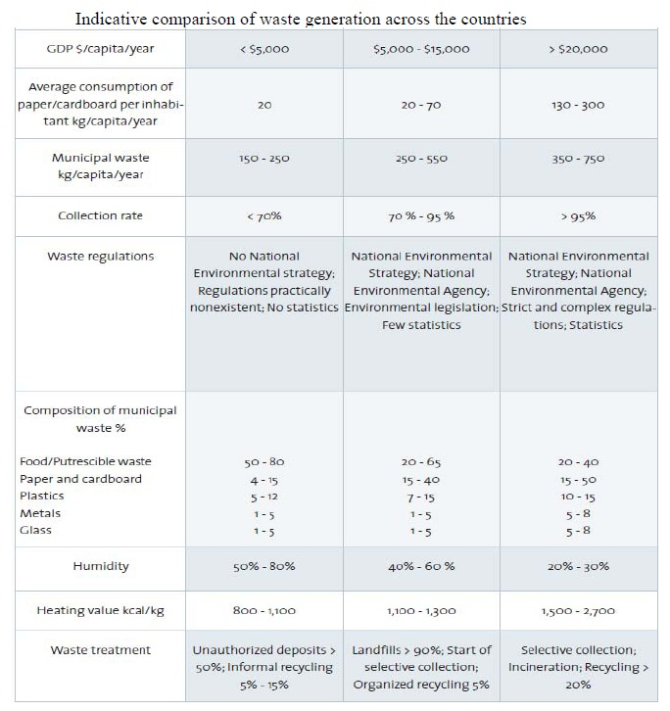

Table A. Indicative comparison of waste generation across the countries. Source: Lacoste, E. and Chalmin, P. (2007);”From Waste to Resource: 2006 World Waste Survey”, Economica, Paris. Taken from: United Nations, Economic and Social Commission for Asia and the Pacific; ”Waste Management (Hazardous and solid wastes)”, Region Implementation Meeting for Asia and the Pacific ahead of the eighteenth session of the Commission on Sustainable Development, 30 November – 1 December 2009, Bangkok.

# Appendix 7 – Sustainable industries

This Appendix includes all the graphs and tables which give more information on theory described in section ‘4.3 Sustainable industry’ of the main report.

## Companies in Pasir Gudang

|  |  |  |  |  |  |  |  |
| --- | --- | --- | --- | --- | --- | --- | --- |
| No | Company name | Address | Product | Category | Size | Contact person | Phone no |
| 1 | 5E Resources Sdn. Bhd. | PLO 317, Jln Perak,, Pasir Gudang I.E.,, 81700 Pasir Gudang,, Johor Darul Takzim. | Recycling of waste oil & spent solvent to produce coolant, hydraulic oil & lubri | Chemicals | 15 | Joo Sok Ching | 07-2361319 |
| 2 | Able Perfect Sdn Bhd | Pasir Gudang | Containerised palm based edible oil | Palm oil | 11-50 |  |  |
| 3 | Accurate Plastic Technology Sdn. Bhd. | Plo 413 & 414 Jalan, Perak Kaw. Perind., Pasir Gudang 81700, Pasir Gudang Johor | Plastic injectio nmoulded parts &components for theE&E industry,furniture industryand householdware. | Plastic | 87 | Lau Peng Kee | 07-2522677 |
| 4 | AGRICULTURE OIL MILL COMPLEX SDN. BHD. | Johor Darul Takzim | RBD palm oil, palmolein, palmstearin, palm fattyacid distillate | Palm oil | 135 |  |  |
| 5 | Aida Manufacturing(M) Sdn. Bhd. | PLO 524,, Jalan Keluli 9, 81700 Johor Darul Takzim | Single & double crank press, single crank press &double crank press& parts for pressmachine. | Machinery | 114 | Vincent Qu | 07-3341740 |
| 6 | AIK Joo Can Factory Sdn. Bhd. | Lot 718,Jln Keluli 8, K.P. Pasir Gudang, 81700 Pasir Gudang, Johor Darul Ridzuan | General line tin cans & parts excluding high speedopen top tin cans, packing clips, solder sticks, printed tinplate &jerry can. | Metal | 60 | Mr Tan Beng Wah | 04-3314560 |
| 7 | Akzo Nobel Ind. Coatings (M) S/B | Plo 335, Jalan Tembaga 1, 81700 Pasir Gudang, Johor Darul Ta'zim | Powder coatings, coil paints, woodcoatings & specialtyplastic coatings. | Chemicals | 30 |  |  |
| 8 | ALFAGOMA-MARDEC SDN.BHD | KP. Pasir Gudang,, Johor Darul Takzim., , | Mandrell built wirebraided hydraulichose & industrialrubber hose (80%export) | Rubber | 37 |  |  |
| 9 | All Cosmos Indus tries Sdn. Bhd. | PLO 442 Jalan Suasa, Pasir Gudang IE, 47100 Pasir Gudang, Johor Darul Takzim | Organic fertilizer | Fertilizers | 148 | Huang Yan Teo | 07-3326925 |
| 10 | All Pack Industries Sdn Bhd | Pasir Gudang | Galvanizing center, civil & construction industry | Metal, Engineering | - |  |  |
| 11 | ALUMINIUM INDS. SDN. BHD. | Johor Darul Takzim | Unlaminatedaluminium foil | Metal | 99 |  |  |
| 12 | Aluminium Industries Sdn. Bhd. | Lot 4,Jln.Pekeliling, Pasir Gudang Ind.Est, 81700 Pasir Gudang, Johor Darul Takzim | Aluminium finstock &other medium gaugefoil of 80 microns -95 microns &aluminium foil ofthickness 6 microns& below. | Metal | 41 | R.S.Vatsan | 07-2513918 |
| 13 | Aluputer  Mfg. (M) Sdn Bhd | Plo 400-402, Jlan Perak,, K.P.P.Gudang,81700, J.Bahru, Johor Darul Takzim | Plating. | Metal | 75 | Tarlochan | 07-2518332 |
| 14 | AM Biofuels Sdn. Bhd. | Plo 81, Jln. Timah 3, P.Gudang Ind.Complex, 81700 Pasir Gudang, Johor Darul Takzim | 1) Biodiesel (palmmethyl ester)2) Crude glycerine | Palm oil | 35 | Ir William Ting | 03-6157616 |
| 15 | AMERICAN MARINE (S)PTE LTD. | KP.Pasir Gudang,, Johor Darul Ta'zim., , | Fibreglass yachts(90% export) | Moulding | 259 |  |  |
| 16 | AMPRI RUBBERWARE INDUSTRIES SDN. BHD. | Johor Darul Takzim | Examination gloves & surgical gloves | Rubber | 217 |  |  |
| 17 | Antah FMC Services& Equipment Sdn.Bhd. | Pasir Gudang IE,, 81700 Pasir Gudang,, Johor Darul Takzim | Surface/subseawellheads & christmas tree. | Equipment | 48 |  | 510930 |
| 18 | Antara Steel Mills Sdn. Bhd. | Plot 277 & 417,, Jalan Gangsa 1,, K.P. Pasir Gudang,, 81707 P.Gudang,Johor | 1) Steel billets,2) Steel bars ofdiameter 3/8" &above, angle bars,flat bars,sqr.bars &sections, steel rodsof 1/4" used forconst. Purposes, Trapezoid webprofile (corrugatedH & Ibeams), Steel billets(expansion) (WTI),medium & largesteel sections(add) (ITA 60%), 1) Oxygen2) Nitrogen3) Argon4) Acetylene, carbondioxide, nitrousoxide. | Metal | 594 | Romazi Yaakub, Wan Abdul | 07-2512021, 07-2512021 |
| 19 | APP Food Industries Sdn.Bhd. | PLO 351 K.P. Miel, Phase 111 Jln.Gangsa, Dua, Pasir Gudang, Johor Darul Takzim | Specialty coffee,teas & confections. | Food | 108 | Henry Mich | 02-7335049 |

|  |  |  |  |  |  |  |  |
| --- | --- | --- | --- | --- | --- | --- | --- |
| No | Company name | Address | Product | Category | Size | Contact person | Phone no |
| 20 | Asahi Mokuzai (M) Sdn. Bhd. | Plo 1, Jalan Suasa, Pasir Gudang Ind Est, 81707 Pasir Gudang, Johor | Metal furniture -cabinets. | Metal | 0 | Encik Khalid bin Abd. Rahman | 07-2518933 |
| 21 | ASAHI MOKUZAI (M) SDN.BHD. | PLO 1,, KP.Pasir Gudang,, Pasir Gudang, 81707, Johor Darul Ta'zim. | Wooden cabinets forelectrical &electronic products(80% export), Wooden furniture &parts (80% export) | Wood | 116 |  |  |
| 22 | Asia Pacific Monomer(Malaysia) Sdn Bhd | KP Pasir Gudang,, Johor Darul Takzim | Polyvinyl chloride(PVC) resin(50% export), Vinyl chloridemonomer (80% export) | Chemicals | 68 | Francis Pe, Choo Ting | 03-2534222, 03-2534222 |
| 23 | ASIA PACIFIC PETROCHEMICAL (M) SDN. BHD. | Johor Darul Takzim | Ethylene & propylene | Chemicals | 242 |  |  |
| 24 | ASIA PACIFIC POLYETHYLENE (M) SDN. BHD. | Johor Darul Takzim | High densitypolyethylene resin(HDPE) & linear lowdensitypolyethylene resin(LLDPE) | Chemicals | 211 |  |  |
| 25 | ASIA POLYMER SDN. BHD. | Johor Darul Takzim | Polypropylene | Chemicals | 99 |  |  |
| 26 | Asian Oils And Derivatives S.B. | PLO-672,, Jalan Keluli 9,, Pasir Gudang Indst,, Area,P.Gudang,Johor | Calcium soap, animalfeed supplement,specialty pats suchas lauric fats,fullysaturated palm oiltriglycerides,tranfree palm basedfilling fats & etc. | Cosmetics, Palm Oil, Food, Chemicals | 40 | Sabrina Ainie | 03-2094953 |
| 27 | Asse Technologies Sdn Bhd | Pasir Gudang | Spraying Equipment & Supplies | Equipment | - |  | 07-251 0325 |
| 28 | AUSTASIAN PLASTICS SDN. BHD. | Johor Darul Takzim | Fibre glass tanks/containers,umbrellas & settings | Plastic | 82 |  |  |
| 29 | AY ENGINEERING (M) SDN. BHD. | Johor Darul Takzim | Fabricated processequipment, steelstructure forenergy relatedindustry,fabricated steelproducts, structurefor high rise | Moulding | 471 |  |  |
| 30 | B.M. NaganoIndustries Sdn. Bhd. | PLO 544 Jln.Keluli 3, Zon II Pasir Gudang, IE,81700 Pasir Guda-, ng,Johor Darul Takzim | Telecommunication equipment such astelephones, cordlesstelephones, cordlesstelephones withanswering machine &answering machines. | Electronics | 165 | Nelson Wee | 07-2528988 |
| 31 | Baiduri Dimensi Johor (M) Sdn Bhd | Pasir Gudang | Steel products | Metal | - |  | 60-7-2561763 |
| 32 | BAKELS (MALAYSIA) SDN. BHD. | Johor Darul Takzim | Flour premixes,baking powder,bakery emulsifiers,sub powder foreggs, stabilizers &extenders for fruitcake & jam | Food | 20 |  |  |
| 33 | Bantex (Malaysia) Sdn. Bhd. | PLO 374 Jalan Perak, Pasir Gudang IE, 81700 Pasir Gudang, Johor Darul Takzim | Stationery & files. | Other | 127 | Lee Chong | 07-2510990 |
| 34 | Bernas Logistic Sdn Bhd | Pasir Gudang | Logistics | Logistics | - |  |  |
| 35 | BFW | Pasir Gudang | Piping | Equipment | - |  |  |
| 36 | BASF AKTIENGESELLSCHAFT | KP.Bebas,Kawasan, Lembaga Pelabuhan, Johor,Pasir Gudang,, Johor Darul Takzim. | Expandablepolystyrene resin(80% export) | Chemicals | 112 |  |  |
| 37 | Behn Meuer Sdn Bhd | Pasir Gudang | Warehouse | Warehouse | - |  |  |
| 38 | Bestsun Sdn.Bhd. | Plo 290 Jln Perak 2, KP Pasir Gudang, 81700 Johor DT, | Jelly & pudding. | Food | 0 | Ranjeet Bh | 01-2519150 |
| 39 | BESTSUN SDN.BHD. | Plo 290, Jln. Perak, Dua, Pasir Gudang, Ind. Est., 81700, Pasir Gudang Johor. | Video cassettemechanisms &electronic toys | Electronics | 187 |  |  |
| 40 | BHP Lysaght(Malaysia) Sdn.Bhd. | KP Pasir Gudang, Johor DT, , | - | - | 0 |  | 5592000 |
| 41 | Bigwest Industries Sdn. Bhd. | Pasir Gudang Ind., Estate, Johor Darul Takzim | 1) Food seasonings(morom2) Flexible plasticcontainer. | Food | 30 | Yoshitoki | 02-2613888 |
| 42 | Biogreen Supply Sdn. Bhd. | Plot 338, Jalan Tembaga Dua, Pasir Gudang I. E., 81707 P.Gudang,Johor | 1) Biodiesel (palmmethyl ester)2) Crude glycerine. | Palm oil | 30 | Haji Mohd Rashid | 07-2688222 |
| 43 | BLOXWICH ENGINEERINGLTD. | Pasir Gudang,, Johor Port FTZ,, Johor Darul Ta'zim., | Locking machanisms & hinges forfreight containers & motor vehicles(80% export) | Equipment | 143 |  |  |
| 44 | BOON & CHEAH STEEL PIPES SDN. BHD. | Johor Darul Takzim | Spiral welded steelpipe, pipe fittings | Equipment | 103 |  |  |
| 45 | BPC Edible Oils Sdn Bhd | 128 Kawasan Perindustrian Lembaga Pelabuhan Johor, Pasir Gudang | Edible Oil | Palm oil | - |  | 607-2511520 |

|  |  |  |  |  |  |  |  |
| --- | --- | --- | --- | --- | --- | --- | --- |
| No | Company name | Address | Product | Category | Size | Contact person | Phone no |
| 46 | BREDERO PRICE (PRICE (M) SDN.BHD.) | Johor Darul Takzim | Anti-corrosivecoating, concretecoating of steelpipes for onshore/offshore oil & gasindustry | Equipment | 175 |  |  |
| 47 | C. Uyemura & Co. Ltd | Pasir Gudang Ind., Est.,, Johor Darul Takzim, | Electroless nickelplating chemicals. | Metal | 17 | Ken Araki |  |
| 48 | Calsonic Compressors (Malaysia) Sdn Bhd | PLO 673 Jln Keluli 3, Pasir Gudang I.E.,, 81700 Pasir Gudang, Johor Darul Takzim | Automobile airconditionin gcompressors. | Equipment | 175 | Josh Yeem | 07-2562288 |
| 49 | Capstone Aluminium Sdn. Bhd. | No 23-26, Jln Gangsa, Pasir Gudang I.E, 81700 Pasir Gudang, Johor Darul Takzim | 1) Aluminiumarchitectural panels2) Extrusionmachined bars,3) Railing,4) Windows &doors. | Equipment | 37 | Tan Chin Eng | 07-2345285 |
| 50 | Carotino Sdn Bhd | Pt 519, Jalan Besi 1, Pasir Gudang Ind Est, 81700 Pasir Gudang, Johor Darul Takzim | 1) Biodiesel (palmmethyl ester)2) Refined glycerine3) Acid oil,4) Palm fatty aciddistillate, 1) Palmitic acidmethyl ester (C16ME)2) Fatty acid methylester,3) Light methylester,4) Heavy methylester, 1) Fat powder2) Animal feedgranules, Caroteneconcentrate,vit. E concentrate,distilled methylester & crudeglycerine. | Palm oil, Food, Chemicals | 126 | M.Rizal Hj Abd Sani, Muhd. Sallehuddin, Chang Chu Shien | 07-2522888, 07-2522888, 07-2522888 |
| 51 | Cemex | Pasir Gudang | Cement, ready-mix concrete and aggregates | Concrete | - |  |  |
| 52 | Cepco BHD | Plo 337, Pasir Gudang | Concrete engineering products | Concrete | - |  |  |
| 53 | CHAINXEN METAL (M) SDN.BHD. | Pasir Gudang,, Johor Bahru,, Johor Darul Ta'zim., | Steel cold forging,precision metalstamping parts (PS)(100% export) | Metal | 100 |  |  |
| 54 | CHEW CHUAN SENG | Plo 319,, Jalan Perak Dua,, Pasir Gudang Ind.Est, Johor Bharu. | Disk drive parts, tools & diesmanufacturing &precision machining(100% export) | Equipment | 319 |  |  |
| 55 | CHIP HONG HEAVY MACHINERY SDN. BHD. | Johor Darul Takzim | Reconditioning, reassembling of heavy earth moving equipment & machinery | Equipment | 49 |  |  |
| 56 | Chuan Cement Industries (M) Sdn. Bhd. | PLO 538 Jln.Emas Dua, Pasir Gudang I.E., 81700 Pasir Gudang, Johor Darul Takzim | Dry-mix cementproducts. | Concrete | 30 | Cik Tan Si | 07-3356700 |
| 57 | Chugoku Paints(Malaysia) Sdn. Bhd. | PLO 430 Jln.Emas 2, Pasir Gudang IE, 81700 Pasir Gudang, Johor Darul Takzim | Wood coatings. | Wood | 0 | Shahnib Bu |  |
| 58 | CIRCUITS TECHNOLOGY SDN.BHD | PLO 351, Fasa III,, Kawasan MIEL,, KP. Pasir Gudang,, Johor Bahru. | Printed circuitboard (80% export) | Electronics | 82 |  |  |
| 59 | CLP Industries Sdn. Bhd. | Plo 467,Jalan Keluli, Pasir Gudang Ind Est, 81700 Johor, Johor Darul Takzim | Coatings, varnishes,thinners, waterproofing preparationbonding agents,adhesives, sealant,cleaners dan copperoxide | Chemicals | 51 | Ms Vivian Lee/Ms Stella Ngoe | 03-3176509 |
| 60 | CMKS (Malaysia) Sdn.Bhd. | Pasir Gudang Ind., Estate, Johor., , | PCB (printedcircuit board) | Electronics | 534 |  |  |
| 61 | CMP (M) SDN.BHD. | Jalan Cecair,Fasa 2,, KP.Bebas,P'buhan, JOhor,81700 P.Gudang, Johor Darul Ta'zim. | Paint for steelcontainer & steelstructure (80%export) | Chemicals | 43 |  |  |
| 62 | CMP Chugaku Paints Limetreat (Malaysia) Sdn Bhd | Pasir Gudang | - | - | - |  |  |
| 63 | COMBINED OIL AND GAS NL (FLOLINE INT'AL | Johor Darul Takzim | High technology thermo plasticpipes & fittings, acrylonitrilebuttadienestyreneindustrial pipes & fitting,demountable pipe & | Equipment | 30 |  |  |

|  |  |  |  |  |  |  |  |
| --- | --- | --- | --- | --- | --- | --- | --- |
| No | Company name | Address | Product | Category | Size | Contact person | Phone no |
| 64 | COMMERCIALMINERALS SDN.BHD. | Zon Perdagangan, Bebas,Pelabuhan, Johor,Pasir Gudang,, Johor Darul Ta'zim. | Industrial minerals (eg feldspar talc,silica etc) (80%export) | Chemicals | 50 |  |  |
| 65 | Concrete Engineering Products Sdn.Bhd. | Pasir Gudang Ind., Estate, Johor., , | Prestressed spunconcrete piles | Concrete | 59 |  |  |
| 66 | CONTAINER MAKERS SDN.BHD. | PLO 283,Jln.Besi 1,, KP.Pasir Gudang,, 81700 Pasir Gudang,, Johor Darul Ta'zim. | Palm oil & palmoilproducts (80%export) | Packaging | 96 |  | 03-8137772 |
| 67 | Continental Johor Land Manfacturing | Pasir Gudang | - | - | - |  |  |
| 68 | Core Pax (M) Sdn. Bhd. | PLO204, Jln Tembaga, K.P. Pasir Gudang, 81700 Pasir Gudang, Johor Darul Ta'zim | Kraft paper bags, Polyethylene bags & polystyrene film. | Plastics | 43 | En.Chan Boon Liang, Mitsuo Tak | 03-6203530 |
| 69 | Cray Valley Resins (Malaysia) Sdn. Bhd. | Plot 491,Jln Keluli,, Pasir Gudang, Indust. Estate 81700, Pasir Gudang, Johor | Alkyds/ modifiedalkyds, acrylics/styrene - acrylicsresins, oil freepolyesters &polyamodes, Corrosion intibitor | Chemicals | 0 | David Vern, Dominique Namer | 41356868, 07-2528282 |
| 70 | Creative Brass Sdn. Bhd. | K.P.Pasir Gudang,, Johor., , | Hi-tech furniture & sofa | Equipment | 83 |  |  |
| 71 | Dai Hwa Electronics(M) Sdn. Bhd. | PLO 247 Jln. Pekeli, ling  P.Gudang I.E., P.O.Box 12, 81707, P.Gudang, Johor Darul Takzim | Computer monitors | Electronics | 204 | See Chou S | 07-2511921 |
| 72 | DAIMAN MARINE PRODUCTS SDN.BHD. | KP.Pasir Gudang,, Johor Bahru,, Johor Darul Ta'zim., | Concrete roofingtiles | Construction | 21 |  |  |
| 73 | Dainichi Mold (Malaysia) Sdn. Bhd. | Plo 479,Kaw.P'trian, Zone 13,Jln.Keluli 3, Pasir Gudang,J.Bahru, Johor Darul Takzim | Plastic injectionmoulded parts forelectrical,electronic,telecommunication,automotive & toyindustries. | Moulding | 301 | Mr.Katsumi Ayabe | 03-5541606 |
| 74 | DALIT FARM SDN.BHD. | Pasir Gudang,, Johor., , | Rock phospate, nutrex granularblends, ammoniummixtures, ureamixtures & tobaccomixtures | Chemicals | 11 |  |  |
| 75 | Dawa Timber Industries Sdn. Bhd. | Lot 9, 443, Jln. Gangsa 2, Kaw. MIEL, 81700 Pasir Gudang, Johor Darul Takzim | Fancy laminated medium density fibreboard, fancy laminated chipboard/particleboard, facedveneer sheet. | Moulding | 31 | Mary Hereitta Lim | 07-2511390 |
| 76 | Delfi Cocoa (Malaysia) Sdn. Bhd. | Plo 732,Jln Keluli 8 K.P Pasir Gudang 81700 Johor Johor Darul Takzim | 1) Cocoa cake, 2) Cocoa powder. | Food | 30 |  |  |
| 77 | Delima Oil Products Sdn Bhd (Felda) | Pasir Gudang | Palm oil, refining and packaging | Palm oil, Food | 141 |  |  |
| 78 | DIC Epoxy (Malaysia) Sdn. Bhd. | K.P. Pasir Gudang, Pasir Gudang, Johor  Darul Takzim, | Epoxy resin. | Chemicals | 75 |  |  |
| 79 | DISSON PAPER PRODUCTS SDN. BHD. | Johor Darul Takzim | Corrugatedfibreboard carton,corrugatedfibreboard, printedgift boxes | Other | 26 |  |  |
| 80 | Dunlop Hiflex Sdn. Bhd. | Plo 405, PTD 190528, Jalan Perak 4, K.P. Pasir Gudang, 81700 P.Gudang,Johor | 1)High pressure wirespiral reinforcedhydraulic hose2) Textile/steelreinforcedindustrial hose3)High pressure wirebraid reinforced, Rubber compound. | Metal, Rubber | 300 | Mr Dennis Iguatius | 07-2510852 |
| 81 | Dynac Sdn Bhd | PLO 17 Jalan Gangsa, P.Gudang Ind. Area, 81707 Pasir Gudang, Johor Darul Takzim | 1) Air cooled Heatexchanger,2) Cable tray/ladder | Equipment | 85 | Md Jasman Bongkek |  |

|  |  |  |  |  |  |  |  |
| --- | --- | --- | --- | --- | --- | --- | --- |
| No | Company name | Address | Product | Category | Size | Contact person | Phone no |
| 82 | Dynac Solutions Sdn. Bhd. | PLO 17 Jln Gangsa, P.Gudang Ind. Area, 81707 Pasir Gudang, Johor Darul Takzim | 1) Low voltageswitchgear,2) Motor controlcentre. | Equipment | 28 | Adli bin Shahriman | 07-5562988 |
| 83 | Dynomer (M) Sdn. Bhd | PLO 491 Jalan Keluli, Pasir Gudang Ind.Est, 81700 Pasir Gudang, Johor Darul Takzim | Alkyds resins &polyester resistors(saturated &unsaturated)(exp),di-cyclo-penta-dieneresins & urethanealkyd resins (add). | Chemicals | 13 | Mr. Christopher Tan | 07-2528282 |
| 84 | DYNOMER (MALAYSIA) SDN.BHD. | KP.Pasir Gudang,, Johor Darul Ta'zim., , | Alkyd resinspolyester resins,amino resins,phenol formaldehyde(novolak) resins &polyacrylamideresins (80% export) | Chemicals | 99 |  |  |
| 85 | EAST ASIAN MARINE FARMS SDN. BHD. | Johor Darul Takzim | Processed shrimps | Food | 136 |  |  |
| 86 | Ecolnnovation Sdn. Bhd. | Lot 303 J.Pekeliling, Pasir Gudang I.E., 81700 Pasir Gudang, Johor Darul Takzim | Eco-pozzolan, eco-silicon fertilizer &eco-asphalt filler. | Fertilizers | 7 | Mr. Chan Beng Chye | 07-2272451 |
| 87 | EcoOils Sdn. Bhd. | Lot 303, Jalan Pekeliling, Pasir Gudang IE, 81700 P.Gudang,Johor | Industrial gradepalm oil from recycling of agricultural waste, Burnt clay. | Palm oil | 78 | Subha Segaran | 03-2144233 |
| 88 | Ecoscience Engineering Sdn.Bhd. | PLO 555, Jalan Keluli 8, K.P. Pasir Gudang, 81700 P.Gudang Johor | Palm oil & biomassmachinery & parts. | Equipment | 60 | Pam Kum Wan | 07-2553126 |
| 89 | EDARAN PEKEMASBHD. | Lot 3, Lembaga, perlabuhan Johor,, Pasir Gudang Ind.Est, Johor Darul Ehsan. | Reconditioning of used motor vehicles (100% export) | Equipment | 200 |  |  |
| 90 | EN.C.GODTHELP | Jalan Timah,, KP.Pasir Gudang,, 81707 Pasir Gudang,, Johor Darul Ta'zim. | Caproic/ caprylic/capric acid, lauricacid, myristic acid& etc, (99.5% exp)split palm fattyacid (100% export) | Chemicals | 63 |  |  |
| 91 | Envoi Chemicals Sdn.Bhd. | KP.Pasir Gudang,, Johor D.T, , | Formalin, ureaformaldehyde resin,urea-formaldehydeconcentrate &phenol-formaldehyderesin. | Chemicals | 43 | Ho Chee Ko | 02-3653330 |
| 92 | Eonchem Technology Sdn. Bhd. | Lot 525 Jln.Keluli 9, KP Pasir Gudang, Johor Darul Takzim, | Machinery and equipment for edible oils, pharmaceutical, chemical and oleochemical industries. | Equipment | 36 | Ma Eng Yau |  |
| 93 | Eonlipids Sdn. Bhd. | Lot 525,Jln Keluli 9, KP Pasir Gudang, Johor, | Vanaspati,shortening,margarines & coffeewhitener. | Food, Palm oil | 35 | Goh Kee Seng, Mr. Goh Kee Seng | 07-5211385, 07-2524870 |
| 94 | EVERGREEN DECORPRODUCTS (M) S.B. | Plo 416,Mkm.Plentong, Daerah Johor Bahru,, Pasir Gudang Ind.Est, J.Bahru,Johor Darul Takzim | Fancy plywood &block board (80%export) & veneer(20% export) | Wood | 219 |  |  |
| 95 | EVERGREEN INTER-NATIONAL S.A. | KP.Prai Gudang,, Johor Darul Takzim., , | Freight containers(95% export) | Moulding | 1.515 |  |  |
| 96 | Firgee Engineering Bhd | Pasir Gudang | Galvanizing Plant | Metal | - |  |  |
| 97 | Flexomers Sdn Bhd | Pasir Gudang | Rubber | Rubber | - |  |  |
| 98 | F.P.M. SDN. BHD. | Johor Darul Takzim | Granulated compound fertilizers | Fertilizers | 74 |  |  |
| 99 | F.S. OILS SDN. BHD. | Johor Darul Takzim | Margarine, ghee, vanaspati, shortening, confectionery fats, salad, frying oil,mayonnaise, bakeryfats | Palm oil, food | 89 |  |  |
| 100 | Faci Pacific Sdn. Bhd. | Pasir Gudang Ind., Park, Johor Darul Takzim | Metallic & organicstearates, oleates,palmitates,miristates &laurates. | Palm oil | 24 | Mr.K.Yayas | 03-2380133 |
| 101 | FAIRTIMBER FURNITUREMFRG.(M) SDN. BHD. | Lot PLO 236, Jln. H,, Pasir Gudang,, Johor Bahru,, Johor Darul Takzim. | Wooden diningtables, chairs &components (100%export) | Wood | 586 |  |  |
| 102 | FAJAR PALMKEL SDN. BHD. | Johor Darul Takzim | Palm kernel oil,palm kernel cake | Palm oil | 35 |  |  |
| 103 | Far East OilTerminal One (M) S.B | PLO 473 Zone 3, Pasir Gudang IE.,, Johor Bahru, Johor, | Blended marine & other fuel oil. | Palm oil | 52 | K.L.Ng | 03-2320711 |
| 104 | FEDRUMS SDN. BHD. | PLO 338,Jln.Tembaga, Dua,KP.Pasir Gudang,, Johor Darul Takzim., | Tab seals & steeldrums-plugs &flanges | Metal | 21 |  |  |
| 105 | FEDRUMS SDN.BHD | PLO 338, Jalan, Tembaga Dua,, KP.Pasir Gudang,, Johor Darul Takzim. | 45 gallons steeldrums | Equipment, Metal | 84 |  |  |

|  |  |  |  |  |  |  |  |
| --- | --- | --- | --- | --- | --- | --- | --- |
| No | Company name | Address | Product | Category | Size | Contact person | Phone no |
| 106 | Felda Inproser Biopalma Feeds S.B. | PLO 90, Jalan Besi Dua, KP Pasir Gudang, Johor | Development, testing& production of feed | Food | 16 | Rosnah Mahmood | 03-2287766 |
| 107 | FELDA OIL PRODUCTS SDN. BHD. | Johor Darul Takzim | Cocoa buttersubstitute,refining &fractionation, RBD palm oil,olein, stearin,palm fatt yaciddistillate | Food, Palm oil | 195 |  |  |
| 108 | Felda Transport Services Sdn Bhd | Pasir Gudang | Logistics | Logistics | - |  |  |
| 109 | FJB (Felda-Johore Bulkers Sdn Bhd) | Pasir Gudang | Vegetable oil | Palm oil | - |  |  |
| 110 | FMC PETROLEUM EQUIP-MENT (M) SDN.BHD. | No.91,Jalan Timah,, Pasir Gudang Ind.Est, 81700 Pasir Gudang,, Johor Darul Ta'zim. | Surface well head & christmas tree,subsea wellhead &mudline suspensionsystem, marineloading arm etc(85% export) | Equipment | 68 |  |  |
| 111 | Fuzzy Technologies Sdn. Bhd. | Plo 493,, Jalan Keluli 3,, K.P. Pasir Gudang,, 81700 P.Gudang,Johor | High yield fuzzycontrol system forvegetable oil & fatsfractionation. | Equipment | 8 | Mojo Yap | 012-702887 |
| 112 | Gas Malaysia Sdn Bhd | Pasir Gudang | Gas | Chemicals | - |  |  |
| 113 | GCB Foods Sdn. Bhd. | Plo 736,, Jalan Keluli 9,, 81700 Pasir Gudang,, Johor Darul Ta'zim | Chocolate drinkpowder, chocolate &chocolateconfectionery. | Food | 85 | Alice Tey Lam Boo | 07-2511588 |
| 114 | GCB Trading and Transport Agency | Pasir Gudang | Transport and training | Logistics, Other | - |  |  |
| 115 | GENERAL CONTAINER SDN. BHD. | Johor Darul Takzim | General line tincan parts, tinplate printing line | Equipment | 63 |  |  |
| 116 | Geocycle Malaysia Sdn Bhd | Pasir Gudang | Cement and concrete | Concrete | - |  |  |
| 117 | GHIM LI FASHION(MALAYSIA) SDN.BHD | Plo 355,Fasa III,, KP. Pasir Gudang,, 81709 Pasir Gudang,, Johor Darul Takzim. | Made-up garments (eg dresses,jogging sets infantsets etc (100%export) | Other | 108 |  |  |
| 118 | GIN LIN INDUSTRIES(M) SDN.BHD. | Lot 302,Jln Perak 2,, KP.Pasir Gudang,, 81700 Johor Bahru,, Johor Darul Ta'zim. | Precision metalstamped parts forelectrical & electronicindustries (100%export) | Equipment | 82 |  |  |
| 119 | Glasslite Sdn. Bhd. | Plo 688,Jln Keluli 8, K.P. Pasir Gudang, 81700 Pasir Gudang, Johor Darul Takzim | Candles. | Other | 138 | K. Bhanu | 07-8617421 |
| 120 | Global Palm Products Sdn.Bhd. | Zone 3 Pasir Gudang, I.E., Johor., | Vitamin rich RBDpalm oil, vitaminrich RBD palm superolein, vitamin richmargarine gheeshortening, palmfatty aciddistillated, etc | Palm oil, Food | 95 | Tan Sri Da | 07-2231633 |
| 121 | Gold Coin Feedmills (M) Sdn Bhd | Pasir Gudang | Feed | Food | - |  |  |
| 122 | Gorin Technical Ind. (Malaysia) S.B. | PLO 683 Jln. Keluli, Zone 11,Pasir Gudang, I.E, 81700 Pasir, Gudang,Johor Darul Takzim | Insulation parts,acoustic parts,antivibration parts, dust proofing parts, filtering parts andcomponents foreletrical & eletronicsproducts. | Electronics | 51 | Puan Theresa Lim | 03-2931077 |
| 123 | GPM ENGINEERING (JB) SDN.BHD. | Lot 27 & 28,, Jalan Gangsa Dua,, Pasir Gudang,, Johor Darul Ta'zim. | Cassettemechanisms,compacts diskmechanisms, floppydiskdrives,precision turned &machined parts(100% export), Video cassetterecorders,modulatorshi-fi audio equip-ment and partsthereof.(80% export) | Electronics | 790 |  |  |
| 124 | GRACE DAVISON (M) SDN.BHD. | KP.Pasir Gudang,, Johor Darul Ta'zim., , | Micronisedamorphous silica(90% export) | Chemicals | 43 |  |  |
| 125 | Grand Bank Yachts Sdn. Bhd. | PLO 488 Jln. Suasa, K.P. Pasir Gudang, 81700 Pasir Gudang, Johor Darul Takzim | Repair &reconditioning ofboats. | Other | 160 | Normala Ab | 07-2517488 |
| 126 | Grand Bank Yachts Sdn.Bhd. | Plo 488 Jalan Suasa, K.P. Pasir Gudang,, P.O.Box 148, Johor Darul Takzim | Commercial boats,life boats, boatparts & components. | Other | 73 | Tan Tiau K | 07-2517488 |
| 127 | Great Wall NutritionTechnologies S.B. | Plo 511 Zone 12, Jalan Keluli, Pasir GudangInd.Area, 81700 Johor Darul Takzim | Animal feed &ingredients foranimal feed. | Food | 32 | Tan Siew L, Ms.Tay | 07-3356700, 07-2517212 |
| 128 | Grobest Frozen (M) Sdn Bhd | Lot PLO 678,Zone 12, Jalan Keluli, IE Pasir Gudang, Johor | Processed seafood. | Food | 334 | Mr. Lim | 06-9541818 |
| 129 | GUAN CHONG COCOAMANUFACTURER SDN.BHD (Favorich) | Plo 273,Jln.Timah 2,, KP.Pasir Gudang,, 81700 Johor Bahru,, Johor Darul Ta'zim. | Cocoa shell, butter cocoacake, cocoa liquor/ masse & cocoapowder | Food | 43 | Tey How Ke, Tay Hoe Lian | 06-9524328, 07-2511588 |

|  |  |  |  |  |  |  |  |
| --- | --- | --- | --- | --- | --- | --- | --- |
| No | Company name | Address | Product | Category | Size | Contact person | Phone no |
| 130 | H.MARK SDN.BHD. | PLO 335,, Jalan Tembaga Satu,, 81700 Pasir Gudang,, Johor Darul Ta'zim. | Printed packagingboxes & otherprinted articles of paper & paperboard | Wood | 108 |  |  |
| 131 | Hanson | Pasir Gudang | Cement | Concrete | - |  |  |
| 132 | Harmony Marine Products | Pasir Gudang | Processing frozen sea cucumber, shark fins, fish maw and other marine products | Food | - |  |  |
| 133 | Hartmann Malaysia Sdn. Bhd. | Plo 548,, Jln Keluli  11,, Pasir Gudang I.E., Pasir Gudang Johor | Mould. | Moulding | 0 | Loh Kong Fee | 07-2532200 |
| 134 | Hishi Plastics Asli Sdn.Bhd. | KP. Pasir Gudang, Johor Darul Takzim | PVC heat shrinkable tubing. | Equipment | 125 |  | 03-2931077 |
| 135 | Hitachi Chemical(Johor) Sdn.Bhd | PLO 458 K.P.Zone 13, Jln. Bandar,, 81700 Pasir Gudang, Johor Darul Takzim | Varnish forelectrical coating &photosensitive dryfilm, polyurethane resin, pre-pegs and itslaminates | Electronics | 113 | Naoki Tera, Daniel Nat, Ahmad Ridwan B Abdurauf | 07-2514601, 07-2514601, 07-2514601 |
| 136 | HITACHI CHEMICAL(MALAYSIA) SDN.BHD. | KP.Pasir Gudang,, Johor Darul Ta'zim., , | Copper clad laminates (100%export) | Metal | 128 |  |  |
| 137 | Hitech Displays Sdn Bhd | Pasir Gudang | Electronics | Electronics | - |  |  |
| 138 | Holcim (Malaysia) Sdn. Bhd. | Lot 119 Jalan Pukal, K.P. Pasir Gudang, 81700 Pasir Gudang, Johor Darul Takzim | Ready mixed concrete. | Concrete | 11 | Tan King Nwa | 07-2513411 |
| 139 | HOME-SHIFFON GARMENTS MFG. J.V. SDN. BHD | Johor Darul Takzim | Made-up garments (eg ski/windjackets, pants,shorts) | Other | 828 |  |  |
| 140 | HONG LEONG INDUS.MANUFACTURING LTD. | KP. Pasir Gudang,, Johor Bahru,, Johor Darul Ta'zim, | Concrete pipes,precast prestressedconcrete slabs &concrete productsetc(100% export) | Concrete | 116 |  |  |
| 141 | Hoysan Logistics Sdn Bhd | Pasir Gudang | Logistics | Logistics | - |  |  |
| 142 | HUME INDUSTRIES (M) SDN. BHD. | Johor Darul Takzim | Asbestos cementpipes & joints,welded steel pipes& related fitting,fabrication onjobbing basis,pressure vessels, Asbestos cementsheets, mouldedproducts | Cement, Moulding | 199 |  |  |
| 143 | HUME INDUSTRIES (M)BHD. | KP.Pasir Gudang,, Johor Darul Ta'zim., , | Readymixed concrete | Concrete | 0 |  |  |
| 144 | Hydro | Pasir Gudang | Hydroaluminium | Metal | - |  |  |
| 145 | IOI Lipid Enzymtec Sdn. Bhd. (belongs to IOI Group) | Plot 8 &9 Jln Timah, Pasir Gudang I.E., 81700 Pasir Gudang, Johor Darul Takzim | Base for human milkfat replacer,enzymatic cocoabutter equivalent,palm mid fraction,palm olein fractionIV65 crude glycerineoleic acid. | Food | 109 | Choo Kah Yean | 603-894788 |
| 146 | ICI IndustrialChemicals (M) S.B. | Kp.Pasir Gudang, Johor Darul Takzim | Hydrochloric acid,chlorine, sodiumhypochloride, sodiumhydroxide & hydrogen(exp), ferricchloride &polyaluminiumchloride, Ferric chlorosulphate & ferricsulphate. | Chemicals | 70 |  |  |
| 147 | Idemitsu Chemicals(M) Sdn.Bhd. | Pasir Gudang, Ind.Area, Jln.Peke, liling, 81700, Pasir Gudang, Johor | Poly carbonateresin, ABS resin (72%export), Styrene monomer,(65% export) | Chemicals | 171 | Yuji Sugim | 03-2309053 |
| 148 | Idemitsu SM (M) Sdn Bhd | PLO 409,Pasir Gudang, Industrial Estate, Pasir Gudang, Johor | Benzene toluene (BT)mixture. | Chemicals | 146 | Mashide Yasuda | 07-2525350 |
| 149 | IFFCO Malaysia Sdn. Bhd. | PLO 406, Jalan Emas, 81700 Pasir Gudang, Johor Darul Takzim, | Refined glycerine,distilled fattyacids, fractionatedfatty acids, stearicacids, soap noodles,soap bars, animal feed | Palm oil, Chemicals, Cosmetics | 114 |  |  |
| 150 | INDUSTRIAL PACKAGING SDN. BHD. | Johor Darul Takzim | Crown corks, metalcaps | Metal | 50 |  |  |
| 151 | Industrial Training Institute | Pasir Gudang | Education unit | Other | - |  |  |
| 152 | Innovalues (M) Sdn. Bhd. | Plo 505 Jln.Keluli 3, P.Gudang Ind.Est., 81700 Pasir Gudang, Johor Darul Takzim | Precision machinedparts. | Equipment | 96 | Hoon Eel A | 07-2542355 |

|  |  |  |  |  |  |  |  |
| --- | --- | --- | --- | --- | --- | --- | --- |
| No | Company name | Address | Product | Category | Size | Contact person | Phone no |
| 153 | Innovalues Microtech Sdn. Bhd. | PLO 591, 597, 598 Jln.MIEL I, Kaw.MIEL P.Gudang, (Phase IV),81700, P.Gudang,Johor Darul Takzim | Electroplating. | Metal | 127 | Cik Elaine | 07-2543231 |
| 154 | Innovalues Precision Sdn. Bhd. | PLO 599, 607, 608, Jln MIEL,, Kaw. MIEL,Phase IV,, Pasir Gudang IE,, 81700 Johor. | Rubber roller foroffice equipment, Precision machinedparts, Precision machinedparts, Rubber roller foroffice equipment. | Rubber, Equipment | 70 | Fredie | 07-2542355 |
| 155 | Innovalues Technology Sdn. Bhd. | PLO 607, Jln. MIEL 1, K.P. MIEL Phase IV, Pasir Gudang Ind Est, 81700 P.Gudang,Johor | Grit coated roller, Electroplating. | Metal | 210 | Huang Kian Kok, Richard Lim, Zul'idham Md Noh | 07-2542178, 07-2522607. 072522978 |
| 156 | Intelchem Industries Sdn.Bhd. | PLO 572 Zone 12, Pasir Gudang IE, Plentong Johor, Darul Takzim | Lacquer, thinner & wax polish. | Chemicals | 127 | John Wong | 07-2529000 |
| 157 | INTERNATIONAL PAINTPLS | Johor Darul Takzim | Coating marine, industrialprotective, powder, finishes yacht, packaging coating & coil | Chemicals | 34 |  |  |
| 158 | INTERSTATE PACKAGES SDN.BHD. | PLO 206,Jalan Besi,, KP.Pasir Gudang,, 81700 Pasir Gudang,, Johor Darul Ta'zim. | Corrugated boards &carton boxes | Wood | 92 |  |  |
| 159 | Interstate PackagesSdn Bhd. | K.P.Pasir Gudang,, Johor Darul Takzim | Corugated boards &carton boxes | Wood | 21 |  |  |
| 160 | Intifurin Sdn. Bhd. | Warehouse 3,, Jalan Cecair,, Pasir Gudang FTZ, 81707 P.Gudang,Johor | 1) Biodiesel (palmmethyl ester).2) Refined glycerine3) Palm fatty aciddistillate. | Chemicals, Palm oil | 60 | Cheong Wee Kian | 07-2388266 |
| 161 | IOI Loders Croklaan Oils Sdn. Bhd. | Plo 8 & 9, Jln Timah, Pasir Gudang IE, 81700 Pasir Gudang, Johor Darul Takzim | Cocoa butter equivalent, margerine and interesterificated oil. | Food, Palm oil | 28 | Mohd Yusri Bin Abdullah | 07-2512967 |
| 162 | Ire-Tex (Johor) Sdn Bhd | Pt 259,Jln Tembaga 2, Pasir Gudang I. A., 81700 Pasir Gudang, Johor Darul Aman | Moulded polystyrenefoam & mouldedpolypropylene foam. | Chemicals | 42 | See Toh Kean Yaw | 04-5022752 |
| 163 | Isolite CeramicFibres Sdn bhd | Plo 345, Jln.Emas 2,, Pasir Gudang,, Johor Darul Takzim | High purity alumina-silicate ceramic fibre. | Chemicals | 27 |  |  |
| 164 | Iwaki Corning (M) Sdn.Bhd. | Kaw. Perindustrian, Pasir Gudang, Johor., Johor Darul Takzim | Corning ware, correle | Other | 293 |  |  |
| 165 | Iwaki Glass Sdn Bhd | Pasir Gudang | Glassware | Glass | - |  |  |
| 166 | JALCO ELECTRONICS (M) SDN. BHD. | Johor Darul Takzim | Jack concentric, pin, board, antenna, terminalboard | Electronics | 225 |  |  |
| 167 | Jalco Electronics(M) Sdn. Bhd. | Lot 25 & 26, Jalan, Gangsa, Kaw. MIEL,, Pasir Gudang,, Johor Darul Takzim | Lever terminalboard adaptors, molded part & others coxialcables & windingcoils, Satellite receiver, Satellite receivers& components andparts used inconsumer electronics | Wood | 881 |  |  |
| 168 | Jami-Swilynn Sdn.Bhd | Pasir Gudang Ind.Est, 81700 Pasir Gudang,, Johor Darul Ta'zim., | Polished granitetiles & slabs &marble tiles &slabs (80% export) | Other | 263 |  |  |
| 169 | JCY HDD Technology Sdn. Bhd. | Lot 40, 41, Jalan Timah, K.P. Pasir Gudang, 81700 Pasir Gudang, Johor Darul Ta'zim | Components, parts & modules for harddisk drives (HDD). | Electronics | 63 | Rick Cheong Pang Choun | 07-3525822 |
| 170 | Jin Lee Oil Mills Sdn Bhd | Lot 14, Jalan Gangsa 2, Kawasan MIEL, Pasir Gudang | Palm oil mills | Palm oil | - |  |  |
| 171 | JOHOR BAHRU FLOUR MILL SDN. BHD. | Johor Darul Takzim, Pasir Gudang | Animal feeds, Wheat, flour wheatbran & wheat pollard | Food | 242 |  |  |
| 172 | JOHORE GLASS ENAMELFACTORY SDN.BHD | KP. Pasir Gudang,, Johor Darul Takzim., , | Gas cooker & parts thereof | Equipment | 88 |  |  |
| 173 | JOLLY FRUIT JUICEMANUFACTURING (M) SB | Plo 364,Off Jalan, Gangsa,Kaw.MIEL,, Fasa III,81700, P.Gudang,Johor Darul Takzim | Fruit juice, juiceconcentrate &preserved fruit(80% export) | Food | 125 |  |  |
| 174 | JTS Engineering Sdn. Bhd. | Lot 227 Jln.Tembaga, 2,K.P. Pasir Gudang, 81700 Pasir Gudang, Johor Darul Takzim | Recycling of aluminium dross to produce aluminium sow & aluminiumoxide or fluxes. | Metal | 15 | Ng Yoke Be | 2529107 |

|  |  |  |  |  |  |  |  |
| --- | --- | --- | --- | --- | --- | --- | --- |
| No | Company name | Address | Product | Category | Size | Contact person | Phone no |
| 175 | K. Yamada IndustriesSdn. Bhd | Plo 412, Jln Tembaga, 1, Pasir Gudang, Ind Estate, 81700, Pasir Gudang, Johor. | Iron netting panel,aluminium heat-sink,metal stamping partsfor electroniccomponent. | Electronics | 21 | Kenichiro |  |
| 176 | K.M. Fine Street Sdn. Bhd. | K.P. Pasir Gudang, Tambahan,, Johor Bahru, Johor Darul Takzim | Metal stamped parts for electrical &electronicsindustries. | Equipment | 25 |  |  |
| 177 | Katini IndustriesCorporation Sdn.Bhd. | Pasir Gudang Ind., Est, Johor Darul Takzim | PVC pipes & fitting. | Equipment | 30 | Ang Thai K |  |
| 178 | Kawasan Per | Pasir Gudang | - | - | - |  |  |
| 179 | Kayangan Mutiara | PLO299, Jln Besi, 81700 Pasir Gudang, Johor | Salt/waste water treatment | Other | - |  | 07-251 2630 |
| 180 | Kebayan Jalan Timach Sdn Bhd | Pasir Gudang | - | - | - |  |  |
| 181 | KEDAH CEMENT SDN. BHD. | Johor Darul Takzim | Portland cement bygrinding clinkers | Concrete | 93 |  |  |
| 182 | Kempas Edible Oil Sendirian Berhad | PLO 79, Jalan Besi 2, Pasir Gudang Ind Est, Pasir Gudang, Johor | 1) Biodiesel (palmmethyl ester)2) Refined glycerine | Food, Palm oil, Chemicals | 18 | Alan Hamzah Sendut | 07-2511206 |
| 183 | Kewalram Oils Sdn. Bhd. | KP.Pasir Gudang, Johor, , | Recovery of industrial grade palm oil from spent bleaching earth and palm fatty acid distillate. | Palm oil, Chemicals | 0 | J.D. Sehga |  |
| 184 | KIAN JOO CAN FACTORYBHD | PLO 456,, KP.Pasir Gudang,, Johor Darul Ta'zim., | Metal cans of 30litres capacity &below excludingbeverage cans | Packaging | 128 |  |  |
| 185 | KIG Glass Industrial Berhad | Plo 497 Zone 4,, P.Gudang IE,, Pasir Gudang,, Johor Darul Takzim | Glassware. | Glass | 453 | Chai Chong | 2515282 |
| 186 | KILANG ISI SAWIT PASIR GUDANG (FELDA) | Johor Darul Takzim | To increase capacity for palmkernel oil & meal | Palm oil, Food | 5 |  |  |
| 187 | KINOS FOOD INDUSTRY(M) SDN. BHD. | Johor Darul Takzim | Snack food | Food | 37 |  |  |
| 188 | Kiswell Sdn. Bhd. | PLO 63,, Jln Keluli 2,, Pasir Gudang,81707, Johor Darul Takzim | 1) Flux coredwelding wire,2) Arc weldingelectrode,3) Alloy steelwelding wire of mag-metal active gas, 4) Bead wire | Equipment | 63 | Zainuddin Abdul Hamid | 07-2512474 |
| 189 | Koko Budi Sdn | Pasir Gudang | Cocoa butter | Food, Palm oil | - |  | 07-2760130 |
| 190 | KL - Kepong EdibleOils Sdn. Bhd. | Plot 251,, K.P. Pasir Gudang, 81700 Pasir Gudang, Johor Darul Takzim | Refined palm oil,palm olein & palmstearin. | Palm oil, Chemicals | 0 | Yew Voon C | 05-2417844 |
| 191 | KNSime | Pasir Gudang | Logistics | Logistics | - |  |  |
| 192 | Komag USA (Malaysia) Sdn. Bhd. | PLO 526,Jln Keluli 3, Pasir Gudang I.E., 81700 Pasir Gudang,, Johor Darul Ta'zim | Thin film magnetic disk using advanced multi layer longitudinal magnetic recording, Aluminium substrates plated substrates & plated polished subatrates. | Electronics | 862 | George Seow, Lena Chang | 04-6439449, 04-2637762 |
| 193 | Kontena Nasional | Pasir Gudang | Logistics | Logistics | - |  |  |
| 194 | KOON SENG SDN.BHD. | PLO 89,, Jln.Tembaga Dua,, 81707 Pasir Gudang,, Johor Darul Ta'zim. | Examination gloves | Rubber | 75 |  |  |
| 195 | KOREA WELDINGELECTRODE CO. LTD | Pasir Gudang,, Johor Darul Ta'zim., , | 1) Flux coredwelding wire2)copper coated alloy steel wire of gas shielded & submerged welding3) etc (80% export) | Metal, Equipment | 265 |  |  |
| 196 | KOVAX (MALAYSIA) SDN. BHD. | PLO 415,, KP.Pasir Gudang,, Johor Bahru,, Johor Darul Takzim. | Coated abrasives(95% export) | Chemicals | 65 |  |  |
| 197 | KP PARTS INDUSTRIES(M) SDN.BHD. | Plo 450,, KP.Pasir Gudang,, Johor Darul Ta'zim,, | Engine gaskets, alltypes (80% export) | Equipment | 84 |  |  |
| 198 | KPS Coatings (Johor) Sdn. Bhd. | PLO 467,Jln.Keluli, KP.Pasir Gudang, 81700 Pasir Gudang, Johor Darul Takzim | Paint & thinner. | Chemicals | 21 | Mohd. Rizal Goh | 07-2525390 |
| 199 | KRANJI WOOD INDUSTRIAL SDN. BHD. | Johor Darul Takzim | Plywood printed & laminated | Wood | 23 |  |  |
| 200 | KUPAK SDN. BHD. | Johor Darul Takzim | RBD palm oil,olein, stearin,fatty aciddistillate,neutralised oil,acid oil, crudepalm kernel oil,palm kernel cake | Palm oil, Food, Chemicals | 158 |  |  |
| 201 | L.P. Pacific Films Sdn. Bhd. | K.P. Pasir Gudang, Johor Darul Takzim | Resin impregnated paper. | Plastic | 17 | Kari Lampi | 2025377 |

|  |  |  |  |  |  |  |  |
| --- | --- | --- | --- | --- | --- | --- | --- |
| No | Company name | Address | Product | Category | Size | Contact person | Phone no |
| 202 | Lafarge | Pasir Gudang | Cement | Concrete | - |  |  |
| 203 | Lam Soon Edible Oils | Pasir Gudang | Oils, soaps | Chemicals | - |  |  |
| 204 | LAPORTE INDUSTRIES (HOLDINGS) LTD. | Johor Darul Takzim | Acid activate dbleaching earths | Chemicals | 79 |  |  |
| 205 | Larvick Pigment(Asia Pacific) S.B. | Plo 376,Jln Perak 4,, K.P. Pasir Gudang,, 81700 Johor Darul Takzim | Zinc dust (pigment) | Chemicals | 2 | Arne Berg |  |
| 206 | Magajin Sapurai (Malaysia) Sdn. Bhd. | Plo 683,Jalan Keluli, KP Pasir Gudang, 81700 Pasir Gudang, Johor, Johor D.T | Reconditioned ICtrays & crushed ICtrays. | Other | 76 | Venkatash s/o Mamiar & Mannar | 07-2528930 |
| 207 | MALAYAN FLOURMILLS BERHAD | Kawasan Lembaga, Pelabuhan Johor,, Pasir Gudang,, Johor Darul Ta'zim. | Wheat flour, wheatbran & wheat pollard | Food | 66 |  |  |
| 208 | Malaysia Vegetable Oil Refineries | Pasir Gudang | Oil | Palm oil, Chemicals | - |  |  |
| 209 | Malaysian Oxygen Bhd | K.P. Pasir Gudang,, Johor Darul Takzim | Hydrogen. | Chemicals | 0 | Lim Jit Te |  |
| 210 | Malaysian SheetGlass Berhad | Zone II,Mk.Plentong, Jln.Keluli3,KP.Pasir, Gudang, 81700, Pasir Gudang, Johor | Float glass. | Glass | 124 | Masaru Tsu | 03-6565011 |
| 211 | MALAYSIAN SHEETGLASS BHD. | Pasir Gudang Ind.Est, Johor Darul Takzim., , | Float glass (100%export) | Glass | 461 |  |  |
| 212 | Mapo Industries Sdn. Bhd. | PLO 298, Jln Perak 2, K.P. Pasir Gudang, 81700 Pasir Gudang, Johor Darul Takzim | Plastic container,caps & inserts,plastic chairs &plastic dustbins. | Plastic | 95 | Lim Teck Sing | 03-3101488 |
| 213 | MARBELLA SDN. BHD. | Johor Darul Takzim | Agglomerated marble | Other | 50 |  |  |
| 214 | MARSING (J.B) SDN. BHD. | Johor Darul Takzim | Clay bricks | Other | 15 |  |  |
| 215 | Martelpoint Engineeing Sdn Bhd | Pasir Gudang | Engineering, construction, maintenance | Engineering | - |  |  |
| 216 | MARUSHIN CANNERIES (M'SIA) SDN. BHD. | Johor Darul Takzim | Canned sardines | Food | 90 |  |  |
| 217 | Mascot Engineering and Construction Sdn Bhd | Pasir Gudang | Engineering and construction | Engineering | - |  |  |
| 218 | Matak (M) Sdn. Bhd. | PLO 1 Jalan Suasa, K.P. Pasir Gudang, 81707 Pasir Gudang, Johor Darul Takzim | Closet door, window& door frame. | Wood | 61 | K.Kolandavelu | 07-2514985 |
| 219 | Mateo | Pasir Gudang | - | - | - |  |  |
| 220 | MATRIX CORPORATION (M) SDN. BHD. | Johor Darul Takzim | Examination gloves& household gloves | Rubber | 80 |  |  |
| 221 | Matsushita AudioVideo (M) Sdn.Bhd. | PLO 460, Jln Bandar,, KP Pasir Gudang,, 81700 Pasir Gudang, Johor DT. | RCR & VCR, compactdisc player, hi-fistereo system (exp),VCR & RCR mechanismscylinder & head forVCR (add), Audio productsincluding radios,CR, RCR, VCR,remote controllers,video cassetteadaptors, PCBassemblies (90%export) | Electronics | 1.491 | Manohar /M | 07-2519130 |
| 222 | Mc Alister Engineering Sdn. Bhd. | 454,Zone 10, Jalan Keluli, Pasir, Gudang Ind. Est., 81700 P.Gudang,Johor | Steel pipes & steelpipe fittings, Aluminium tanks,tank trailers,unfired pressurevessels, alternatormounting structure,light metalfabrications & etc., Heavy steelstructure, tanktrunks, doublestack trailers, Freight tankcontainer (90%export) | Metal, Equipment | 178 | Racheal Tan | 07-2518408, 03-7187505 |
| 223 | MECH MAR KEJURUTERAAN SDN. BHD. | Johor Darul Takzim | Thermal oil heater | Equipment | 48 |  |  |
| 224 | Meiyer Industries Sdn Bhd | Pasir Gudang | Waste water treatment | Other | - |  |  |
| 225 | Mensilin Steam Plant Sdn Bhd | Pasir Gudang | Steam from biomass leftovers | Other | 35 |  |  |

|  |  |  |  |  |  |  |  |
| --- | --- | --- | --- | --- | --- | --- | --- |
| No | Company name | Address | Product | Category | Size | Contact person | Phone no |
| 226 | MELANDAS MFRG. SDN. BHD. | Lot 15, Jalan Timah,, KP. 81700,, Pasir Gudang,, Johor Darul Takzim. | Furniture of leather & fabrics(90% export) | Other | 90 |  |  |
| 227 | Menjual Bahan - Bahan Kimia (Chemique Chemicals and Engineering) | Pasir Gudang | Chemicals and engineering | Chemicals | - |  |  |
| 228 | Mentrade Marine Equipments Sdn. Bhd. | PLO 504,Jln Keluli 1, P.Gudang Ind. Area, 81700 Pasir Gudang, Johor. | Cranes for marine industry & part sthereof such ashydraulic winch/capstan & hydraulicpower pack. | Equipment, Engineering | 79 | Mr Joe Lim | 07-2512833 |
| 229 | Metal-Like Surface Treatment Sdn. Bhd. | Plot 580, Jln Miel 2, Kaw Miel Psr Gudang, 81700 Pasir Gudang, Johor Darul Takzim | Surface treatment. | Other | 26 | Poh Sen Teck | 07-2523572 |
| 230 | Metroll (Malaysia) Sdn.Bhd. | Lot 4 Jln.Pekeliling, Pasir Gudang I.E., 81700 Pasir Gudang, Johor Darul Takzim | Metal roofingsheets, foamin-place panels & prepainted sheets incoils. | Metal | 70 | R.S. Vatsa | 07-2241117 |
| 231 | Metropolitan Industries Sdn Bhd | Pasir Gudang | Aluminium | Metal | - |  |  |
| 232 | Mewaholeo Industries Sdn. Bhd. | PLO 283 Jln Besi 1, Pasir Gudang Ind.Est, 81700 Pasir Gudang, Johor Darul Takzim | Soya bean acid oil &sunflower seed oil. | Food | 3 | Mr. Beh Kok Wai | 07-2767333 |
| 233 | MFM FEEDMILL (JOHOR) SDN. BHD. | Johor Darul Takzim | Animal feeds | Food | 78 |  |  |
| 234 | MitsubishiShindon Co. Ltd. | Pasir Gudang Ind.Est, Johor Darul Takzim | Dual profiled copperalloy strips. | Metal | 34 | Takeshi Ma | 03-2948788 |
| 235 | MKI-KELENGKAPAN (M) SDN. BHD. | Johor Darul Takzim | Anti-corrosion coating & concrete coating of steelpipes for onshore/offshore oil & gasindustry, Isopropylamine saltof glyphosate,mixing/ formulationof herbicides based, Isopropylamine saltof dicamba | Concrete, Chemicals | 329 |  |  |
| 236 | MSTS Asia | Pasir Gudang | Fire and prevency response training center | Other | - |  |  |
| 237 | Monsanto (M) Sdn. Bhd. | Jalan Emas 1, Pasir Gudang I.E., 81700 Pasir Gudang, Johor Darul Takzim | Potassium salt of glyphosate & herbicides formulation thereof. | Fertilizers, Chemicals | 200 | Cham Tau Boon | 07-2514588 |
| 238 | Mox-Linde Gases Sdn. Bhd. | PLo 13, 87, 435, Zone II, Pasir Gudang I.E., 81700 Pasir Gudang, Johor Darul Takzim | 1) Argon,2) Refilling ofcarbon dioxide,argon, nitrogen &acetylene. | Chemicals | 0 | Cammie Leong | 03-7955423 |
| 239 | MTTJ Engineering Sdn Bhd. | Lot 431, 522,J. Keluli 7 Pasir Gudang IE 81700 Pasir Gudang Johor Darul Takzim | Steel fabrication products. | Metal | 123 | Adeline Wong | 07-2513714 |
| 240 | MULTIMEND OIL-CHEMINDUSTRIES SDN.BHD. | Pasir Gudang,, Johor Darul Ta'zim., , | Recycling of oil sludge (100% export) | Chemicals | 100 |  |  |
| 241 | NALFICO PREMIER OILS SDN. BHD. | Johor Darul Takzim | Refined/ bleached/deodorised palm kernel oil,olein, stearin | Palm oil, Chemicals | 0 |  |  |
| 242 | NALIN CHEMICALS SDN.BHD. | PLO 283,Jln.Besi 1,, KP.Pasir Gudang,, 81707 Pasir Gudang,, Johor Darul Ta'zim. | Fatty acids & itsfractions &glycerine (80%export) | Palm oil, Chemicals | 59 |  |  |
| 243 | Narsco-Kuok Fertilizers | Plo 66, Jalan Pukal, Kawasan LPJ, Pasir Gudang | Fertilizers | Fertilizers | - |  | 03-79577644 03-79577670 |
| 244 | Natoleo (Kulim) | PLO 428, Jalan Besi Satu,  81700 Pasir Gudang,  Johor, Malaysia | Natural oils | Palm oil, Chemicals, Food | - | Tn Hj Abdul Rahman Sulaiman, natoleo@natoleo.com | +60-7-2533888, +60-7-2523177, +60-7-2533788 |

|  |  |  |  |  |  |  |  |
| --- | --- | --- | --- | --- | --- | --- | --- |
| No | Company name | Address | Product | Category | Size | Contact person | Phone no |
| 245 | Natural Oleochemi cals Sdn. Bhd. | Plo 283, 428, 502 Jalan Besi, Satu Pasir Gudang IE, 81700 Pasir Gudang, Johor Darul Takzim | RBD palm oil, RBDpalm olein, RBD palmstearin & palm fattyacid distillate, fatty acid & itsfractions, glycerine(Exp) & soap noodles(Add), fatty alcohols, Hydrogenated crudepalm kernel oil,crude coconut oil &refined palm stearin(add)(WTI), fattyacid & its fractions& glycerine (exp)(PS). | Palm oil, Chemicals, Food | 272 | Cheoo Pei Fang, En. Norzein Abdul Kadir, Hussein Ib | 07-2533841, 607-253388, 2516700 |
| 246 | Natural Soaps (Kulim) Sdn Bhd | Pasir Gudang | Soaps | Cosmetics, Palm Oil | - | Tn Hj Abdul Rahman Sulaiman, natoleo@natoleo.com | +60-7-2533888, +60-7-2523177, +60-7-2533788 |
| 247 | NCAB (M) SDN.BHD. | Lot 348 & 349,, Jln.Gangsa Dua,, 81700 Pasir Gudang,, Johor Darul Ta'zim. | Printed circuitboard (doublesided) (85% export)PCB (multilayer)(PS) & PCBassemblies (WTI)(90% export), Wirewinding fortransformer | Electronics | 240 |  |  |
| 248 | NGO CHIEW HONG EDIBLE OIL (M) SDN. BHD. | Johor Darul Takzim | RBD/ neutralised/bleached/ NBD palmoil, olein,stearin, palm acidoil, palm fattyacid distillate,soap stock | Palm oil, Chemicals, Cosmetics | 158 |  |  |
| 249 | Nilam Kekal Sdn.Bhd. | Plo 518, Jln. Besi, Satu, P.Gudang I.E, 81700 Pasir Gudang,, Johor. | Palm mid fraction,special olein/RBDpalm olien, RBD palmstearin,fractionatedpalm fatty aciddistillate, cookingoils / blended oils/ blended fats. | Palm oil, Chemicals, Cosmetics, Food | 350 | Wong Lai Wan | 02-9169208 |
| 250 | Nippon Kodoshi Kogyo (Malaysia) Sdn. Bhd. | Plo 683, Jln Keluli, Zon II,KP Pasir, Gudang, 81700, Pasir Gudang,Johor | Separators for capacitor/battery. | Equipment | 24 | Chizuko Rice | 03-7726183 |
| 251 | Niro Ceramic (M) Sdn. Bhd. | Plo 419,420,421,Jln., Emas 2,KP.Pasir Gud-, ang,81700 P.Gudang, Johor Darul Takzim | Unglazed ceramic floor tiles. | Other | 29 |  |  |
| 252 | Nisonics Sdn Bhd | Plo 226, Jalan Tembaga 2, Kaw Perindustrian Pasir Gudang, Pasir Gudang 81700 | Plastic injection moulding, Polymer / Plastic / Rubber / Tyres | Plastic, Moulding | 50 |  | 07-252 2208 |
| 253 | Nissan IndustrialOxygen Bhd. | Pasir Gudang,, Johor., , | Hydrogen | Chemical | 0 |  |  |
| 254 | Nissohatsu Elastomer (M) Sdn. Bhd. | Plo 609 Jln Keluli 8, K.P. Miel, 81700 Pasir Gudang, Johor Darul Takzim | Bridge bearing, floor joint, rubbercompounds, rubbermoulded products. | Rubber, Moulding | 32 | Zul Idham Md Noh | 07-2522978 |
| 255 | Nobel Carpets Sdn.Bhd. | PLO 371 Jln.Tembaga, Pasir Gudang,, Pasir Gudang, Johor DT | Bulk continuousfilament (BCF) yarn, Tufted carpets,woven rugs (55%export) & naturalrubber underlay(80% export) | Rubber | 142 |  |  |
| 256 | Nomad Engineering | Pasir Gudang | Scaffolding, insulation and fire-proofing | Other | - |  |  |
| 257 | NORZINK A/S | KP. Pasir Gudang,, Johor Darul Ta'zim., , | Zinc dust(pigment)(80%export) | Chemical | 35 |  |  |
| 258 | ONAMBA (M) SDN. BHD. | Johor Darul Takzim | Wire harness | Rubber | 100 |  |  |
| 259 | Overseas Quest Sdn. Bhd. | PLO 434 Jln. Perak 4, Pasir Gudang Ind., Estate,81700 Pasir, Gudang,Johor Darul Takzim | Pressure sensitive label stock. | Other | 69 |  |  |
| 260 | Pacific ActivatedCarbon Sdn. Bhd. | Pasir Gudang, Ind.Complex, Johor., , | Activated carbon | Chemicals | 25 |  |  |

|  |  |  |  |  |  |  |  |
| --- | --- | --- | --- | --- | --- | --- | --- |
| No | Company name | Address | Product | Category | Size | Contact person | Phone no |
| 261 | Pacific Oils & Fats Industries Sdn Bhd | No 142,Jln Dermaga, F.T.Z.,Lemb P'buhan, Pasir Gudang, 81700 P.Gudang,Johor | RBD palm kernel oilRBD palm kernel olein,RBD palm kernelstearin,palm kernelfatty acid distillate,hdrrogenated palmkernel oil,hydrogenated palm kernel, Special olein (lowcloud point),special stearin(low melting point), soap | Palm oil, chemicals, cosmetics | 156 | Puan KL Tan | 07-6526314 |
| 262 | Pacific Oleochemicals S.B. | PLO 285, Jalan Pekeling Timur, PO Box 143, 81707, Pasir Gudang, Johor | Caproic acid,caprylic acid,capric acid, lauricacid, myristic acid,palmitic acid, splitpalm kernel & splitpalm fatty acid,palmfatty acid residue | Palm oil, chemicals, cosmetics | 6 |  |  |
| 263 | Pacific World Sdn. Bhd. | PLO 330 Jln.Perak, Tiga,Pasir Gudang IE, 81700 Pasir Gudang, Johor Darul Takzim | Snack food &confectionery | Food | 121 | Shirley Tan | 07-2225988 |
| 264 | PALMAJU EDIBLE OIL SDN. BHD. | Johor Darul Takzim | Palm oil products,palm kernel oilproducts | Palm oil, chemicals, cosmetics, Food | 131 |  |  |
| 265 | PAN ASIAN CONSTRUCTION SDN. BHD. | Johor Darul Takzim | Cold formed galvanised steel section for building construction using metal framing system | Metal, Engineering | 25 |  |  |
| 266 | Pan Century EdibleOils Sdn. Bhd. | Lot 2401 Jalan Timah, Tiga,K.P. P.Gudang, 81700 Pasir Gudang, Johor Darul Takzim | Soap noodles, fattyacids, glycerine &fatty aciddistillate, Polyethyleneterephthalate (PET)resins, phthalic anhyride, Lauric acid,myristicacid, caprylic acid,bistilled topped,palm kernel fattyacid & residue, Distilled palm,palm kernel fattyacid, glycerine,crude & refined,lauric acid,stearic acid,caprylic acid,myristic acid, Crude/hydrogenated/interesterified/refined palm kerneloil, meal, olein,and stearin,shortening, bakeryfat, biscuits, | Palm oil, Food, Chemicals, Cosmetics | 770 | En.R.L. Pa, MP Pathak | 07-2511580, 07-2511580 |
| 267 | Panagawa Sdn. Bhd. | Plo 527, 561, Zone 11,, Jalan Keluli 4,, 81700 Pasir Gudang,, Johor Darul Ta'zim | 1) High impact polystyrene packaging products.2) Polypropylenepackaging products and foams | Packaging, Plastic | 201 |  |  |
| 268 | Pantech Corporation Sdn Bhd | Pasir Gudang | carbon steel elbows, stockist of carbon and stainless steel pipe, fittings, valves, flanges, and hardware. | Metal | 100 |  |  |
| 269 | PAPER AUTOMATION SDN.BHD. | Jalan Perak,, KP.Pasir Gudang,, 81700 Pasir Gudang,, Johor Darul Ta'zim. | Non-carbon required paper (50% export) | Wood | 12 |  |  |
| 270 | PAPER PACKAGING INDUSTRIES SDN. BHD. | Johor Darul Takzim | Corrugated fibreboard carton, corrugated fibreboard | Wood | 63 |  |  |
| 271 | PASIR GUDANG EDIBLEOILS SDN. BHD. | PLO 338 & 329,Jalan, Tembaga 2, KP.Pasir, Gudang,Pasir Gudang, Johor Bahru. | Neutralisedbleached deodorisedcoconut & corn oil,corn & coconut acidoil, NBD/NB groundnutoil, NBD refinedrapeseed oil,winterised cornoil, margarine,shortening,neutralised palmoil, NBD/NB oil etc, Paint & pet bottles, PVC bottles, Plastic caps, Jerry cans. | Palm oil, Food, Chemicals, Cosmetics, Packaging | 46 | Hj. Ahmad | 07-2512011 |
| 272 | Pasir Gudang Grains Terminal | No. 129, Jln Pukal, Kaw Perindustrian Pasir Gudang, 81700, Pasir Gudang, Johor | Grain dealers | Food | - |  | 07-2515337 |
| 273 | Pec (Malaysia) Sdn Bhd | PLO 331 Jalan Tembaga 1 Kaw. Pasir Gudang Industrial Estate Pasir Gudang, 81700 | Civil, mechanical, and electrical engineering services to construction projects. | Engineering | - |  | 60 7 252 1633 |
| 274 | PELADANG KIMIA SDN.BHD. | Johor Darul Takzim | Granulated compound fertilizer | Fertilizer | 157 |  |  |

|  |  |  |  |  |  |  |  |
| --- | --- | --- | --- | --- | --- | --- | --- |
| No | Company name | Address | Product | Category | Size | Contact person | Phone no |
| 275 | PELANGI CONCRETE INDUSTRIES SDN. BHD. | Johor Darul Takzim | Cement roofing tiles | Concrete | 27 |  |  |
| 276 | PELANGI PROPERTIES SDN. BHD. | Johor Darul Takzim | Rubber latexthread, examinationgloves | Rubber | 110 |  |  |
| 277 | Pembinaan Prefab Sdn. Bhd. | Plo 565, Jln Keluli,, KP Pasir Gudang,, Pasir Gudang,, Johor DT. | Ready-mixed concrete(exp) & cementbricks (add) | Concrete | 10 |  |  |
| 278 | PERUSAHAAN SADUR TIMAH (M)(PERSTIMA)S.B. | Johor Darul Takzim | Tin free steel & tinplate | Metal | 154 |  |  |
| 279 | Petrochemicals (M) Sdn. Bhd. | PLO 409, Off Jalan, Pekeliling,, Pasir Gudang I.E., 81700 P.Gudang,Johor | High impact polystyrene resin (HIPS) | Chemicals | 109 | Mr. Tan Chai Puan | 07-3391010 |
| 280 | Petrochemicals (Malaysia) Sdn. Bhd. | PLO 409, Off Jln Pekeliling, Pasir Gudang IE, 81700 P.Gudang,Johor | Plastic colour compound & plastic master batch. | Chemicals | 75 | Mr. Tan Chai Puan, Tan Chai P | 07-3391010, 07-3322557 |
| 281 | Petronas Gas | Pasir Gudang | Operation office, gas (not production) | Chemicals | - |  |  |
| 282 | PGD Container Yard (M) Sdn Bhd | PLO 485, Jalan Emas 3, Pasir Gudang Ind. Estate, 81700 Pasir Gudang, Johor | Container terminal services and solutions | Logistics, Warehouse | - |  |  |
| 283 | Pgeo Edible Oils Sdn. Bhd. | 338&329, J.Tembaga 2, K.P. Pasir Gudang, P.O.Box 80, 81707, Pasir Gudang Johor | RBD (H) palm stearinRBD palm kernelolein, RBD palmkernel stearin, RBD (H) palm kernelstearin, RBD (H)palm kernel olein,hydrogenated palmstearin & palm oil, Hydrogenated RBDcoconut oil, RBD (H)soya bean oil/palmoil/rapeseed oil/palm kernel oil/cornoil, refined RBDpalm oil/stearin &RBD palm olein, 1) Crude shea olein,2) Crude sheastearin, RBD palm olein &palm mid fraction. | Palm oil, Food, Chemicals, Cosmetics | - | Mohan Shunmugam, Rashid Chelsa | 07-2688240, 07-2514971 |
| 284 | PFM (Panasonic Foundry Malaysia) Sdn Bhd | IE PLO 460, Jalan Bandar, 81700, Pasir Gudang Johor Darul Takzim | Design, development and manufacture of consumer audio and video products. | Electronics | - |  | +607-251 9130/251 9117 |
| 285 | Pioneer BuildingMaterials (M) S.B. | Plot 295 Jalan Suasa, Pasir Gudang I.E., Johor Darul Takzim | Ready mixed concrete | Concete |  | Christophe |  |
| 286 | Pivot Group Sdn.Bhd. | PLO 12 Zone 12, Mkm., Plentong, Pasir, Gudang Ind. Area,, Johor Darul Takzim | Pail, cabinets, fan& basket & plastic injection mouldedparts. | Plastic, Moulding | 115 | Koh Kiat S |  |
| 287 | PK Fertilizers Sdn Bhd | Pasir Gudang | Fertilizers | Fertilizers | - |  |  |
| 288 | PNE PCB Bhd. | PLO 465 Jln. Keluli, K.P.Pasir Gudang, Johor Darul Takzim | Ferric chloride from regeneration of spent ferricchloride, copper dust. | Chemicals | 16 |  |  |
| 289 | Polymer Latex GmbH | Pasir Gudang, Johor Darul Takzim, , | Synthetic latex. | Rubber | 103 |  |  |
| 290 | Poongsan (M) Sdn. Bhd. | Plo 683, Jln Keluli Zone II, Pasir Gudang I.E.,, 81700 P.Gudang,Johor | Copper & copperalloy strips, Stainless SteelStrips | Metal | 8 | Mr Yang Enung Mo | 07-2553501 |
| 291 | Precimold PlasticIndustries Sdn Bhd | Lot 13 Jln.Gangsa 2,, Kaw. MIEL,, Pasir Gudang,, Johor Darul Takzim | Moulds and plastic injection mouldedparts and componentsfor the electrical and electronic industries. | Plastic, Moulding | 145 | Lim Se Yon | 03-2482501 |
| 292 | PRECISION TUBEPRODUCT (M) SDN.BHD. | Lot 294,Jln.Perak 2,, KP.Pasir Gudang,, Johor Darul Ta'zim., | Steel pipes, tubes& shapes (30%export) | Metal, Equipment | 61 |  |  |
| 293 | Premier Bleaching Earth Sdn Bhd | Plo 228 Jalan Perak P.O. Box 43, Pasir Gudang, Johor, 81707, Malaysia | Manufacturing of bleaching Earth | Chemicals | - |  | 607-2512411 |
| 294 | PREMIUM BEVERAGES SDN. BHD. | Johor Darul Takzim | Canned aerated, non-aerated softdrink | Food | 72 |  |  |
| 295 | Premium Fats Sdn. Bhd. | Plo 66,Jln.Timah Dua, Pasir Gudang Inds., Est,81700 Pasir Guda, ng | Specialty fats, salad dressings &cheese. | Food, Palm oil | 53 | Pares Nath Agarwaral | 03-2274673 |

|  |  |  |  |  |  |  |  |
| --- | --- | --- | --- | --- | --- | --- | --- |
| No | Company name | Address | Product | Category | Size | Contact person | Phone no |
| 296 | Premium VegetableOils Sdn.Bhd. | P.O.Box 39, PLO 66, Jln. Timah Dua, Pasir Gudang Ind.Est, 81707 Johor D.T | Margarine/shorteninghydrogenated / orinteresterified palmkernel oil, olein &stearin, soyabeanoil, rape seed oil,corn & coconut oil& etc., Refined Palm olein &Refined Hard Stearin, Hydrogenated and/orinteresterifiedRBD palm oil, olein& stearin. | Palm oil, Chemicals, Food, Cosmetics | 35 | U.R. Sahas | 07-2513880 |
| 297 | Prima Energy Sdn Bhd | PLO 493, JALAN KELULI 3, KAWASAN PERINDUSTRIAN PASIR GUDANG | Energy | Other | - |  |  |
| 298 | Promac Industries Sdn Bhd | Lot 16 & 17, Jalan Gangsa 2, Kawasan Industri Pasir Gudang, 81700, Pasir Gudang, | Contract Packer For Edible Oil | Packaging | - | promac@streamyx.com | 03-625847582532437 |
| 299 | PTP Manufacturing Sdn. Bhd. | Lot No.294,, Jln Perak Dua,, Pasir Gudang I.E.,, Pasir Gudang, Johor | Slitting & shearing of steel sheet shearing of flatbars. | Metal | 121 | Tan Kee Lean | 07-2515559 |
| 300 | PUM Cullet Sdn Bhd | PLO 340 HS(D) 234756, Jalan Perak 4, Pasir Gudang Ind Est, Pasir Gudang, Johor | Recycling of glass to produce recycled cullet glass. | Glass | 96 | Mr. Ng Yong Chee | 07-2370458 |
| 301 | Purata Keuntungan Sdn Bhd | Lot Plo 293, Jalan Suasa, P.Gudang I.A. (PBT), Pasir Gudang, Johor | Iron lumps,aggregates, ash &residue of iron. | Metal | 52 | JP Jaiswant | 65 9693484 |
| 302 | R.M.C. SDN. BHD. | Johor Darul Takzim | Made-up garments(eg children'swear, t-shirts,shorts, rompers) | Other | 135 |  |  |
| 303 | Raflatac (M) Sdn.Bhd. | PLO 434 Jln. Perak 4, K.P. Pasir Gudang, 81700 Pasir Gudang, Johor Darul Takzim | Pressure sensitive labelstock. | Other | 2 | Nazri Omar | 07-2551510 |
| 304 | RAHAM HOLDINGS SDN.BHD. | Johor Darul Takzim | Car stereo with cassette player & cassette playerwith headphones | Electronics | 152 |  |  |
| 305 | RANGKAIBENA SDN. BHD. | Johor Darul Takzim | Finished &knock-down woodenpallets & woodencontainers | Wood | 84 |  |  |
| 306 | Real Strong (M) Sdn.Bhd. | Lot PlO 539,, Jalan Keluli, Pasir Gudang 9nd., Est, Johor Darul Takzim | Wood chips/Bio-organic fertilizer | Wood | 88 | Nordiana K |  |
| 307 | RED BOX HOLDINGS SDN. BHD. | Johor Darul Takzim | Photo albums & stationery of PVC &paper | Other | 85 |  |  |
| 308 | Reiswan Oil Industries Sdn Bhd | Pasir Gudang | Cooking Oil,Vegetable Ghee,Shortening,Vegetable Margarine | Palm oil, Food | - |  |  |
| 309 | Renesola (Malaysia) Sdn. Bhd. | Plo 742, Jalan Keluli 12, K.P Pasir Gudang, 81700 P.Gudang,Johor | 1) Processed siliconmaterials 2) Solar wafers. | Electronics | 516 | Steven Ng Wai Han | 07-2379128 |
| 310 | Ryoshindoh Manufacturing Sdn. Bhd. | K.P.Pasir Gudang, Johor Darul Takzim | Single profiled copper & copperalloy strips, platedcopper & copperalloy strips & leadframes. | Metal | 174 |  |  |
| 311 | Saniton Pottery (M) Sdn.Bhd. | PLO 560 Zone 12A, Pasir Gudang I.E., Johor Bahru, Johor Darul Takzim | Ceramic sanitary wares. | Other | 87 | Ang Moo Ke |  |
| 312 | Sabaka Contiso - Ricebarn | Pasir Gudang | Landscape constructions | Engineering | - |  |  |

|  |  |  |  |  |  |  |  |
| --- | --- | --- | --- | --- | --- | --- | --- |
| No | Company name | Address | Product | Category | Size | Contact person | Phone no |
| 313 | Sanden International (Malaysia) Sdn Bhd | Lot PLO 212, Jalan Pekeliling, Pasir Gudang Industrial Estate, Pasir Gudang | Aircon Equipment & Systems | Equipment | - |  |  |
| 314 | SANKYO INTER. (MALAYSIA) SDN. BHD. | Johor Darul Takzim | Compressors/clutches/compressors partsfor automotiveair-conditioning | Equipment | 94 |  |  |
| 315 | Sanwa Resin (M) Sdn. Bhd. | PLO 541,Zon 12A, Jln. Keluli 3,, K.P. P.Gudang,81700, Johor Darul Takzim | MDF with overlayMDF/timber mouldingsdecorative plywood &MDF (cut-to size) | Wood, Moulding | 26 | Husion Abd | 07-2521500 |
| 316 | SCOTT PAPER CO. INTER'NAL INC. LSPP LTD. | Johor Darul Takzim | Tissue paperstoilet, facial, MGsulphite, bleachedcrepe sulphite,paper serviette,kitchen rolls etc | Wood | 196 |  |  |
| 317 | Seatrade Agency Service Sdn Bhd | Pasir Gudang | Logistics | Logistics | - |  |  |
| 318 | SEE SEN CHEMICALBHD. | Plo 276,Jln.P'liling, KP.Pasir Gudang,, Pasir Gudang,81700, Jogor Darul Ta'zim. | Sulphur powder 325mesh, Sodium Hypochlorite. | Chemicals | 10 | Chong Kee | 07-512490 |
| 319 | SEHCOM INDUSTRIES SDN.BHD. | PLO 291,, Jalan Timah Dua,, KP.Pasir Gudang,, Johor Darul Ta'zim. | 1) Coconut oil2)copra cake 3)palmkernel oil 4)palmkernel cake (80%export) | Palm oil, food | 20 |  |  |
| 320 | Seiko Electric Asia (M) Sdn. Bhd. | Plo 407 Jalan Perak, KP Pasir Gudang, 81700 Pasir Gudang, Johor Darul Takzim | Terminal blocks,control switchesmoulded & metalpressed parts ofterminal blocks &control switches,control panels &parts thereof, Plastic injectionmoulded parts forstationery, Control panel & partthereof (exp),plastic injectionmoulded parts forautomotive industry(add), Terminal blocks,control switches,wiring conne ectors& low-voltageswitches etc (95%export) | Electronics, Plastic, Equipment, Metal | 202 | Ms.Anita Jamaludin, Yoshihiro |  |
| 321 | SELACO HOLDINGS BERHAD | Johor Darul Takzim | Aluminium extrusions | Metal | 89 |  |  |
| 322 | SERBA KIMIA SDN. BHD. | Johor Darul Takzim | Cocktail of hexazinone & diuron | Chemicals | 10 |  |  |
| 323 | Seun Steel (M) Sdn. Bhd. | Pasir Gudang, Johor Darul Takzim, , | Slitting/shearing of metal coils/sheets/strips. | Metal | 37 | Mr. Francis Lee | 03-2161514 |
| 324 | SGS | Pasir Gudang | Inspection, testing, certification & verification services | Other | - |  |  |
| 325 | Shang Wei Industries Sdn. Bhd. | Plo 414 Jln. Perak, Kaw.P'trian Pasir, Gudang,     81700, Pasir Gudang, Johor | Polystyrene containers, trays & cups. | Moulding | 136 | Madam Santhi/ Mr.Mogan | 07-2276711 |
| 326 | Shell Trading and Installation | Pasir Gudang | Trading gas | Chemicals | - |  |  |
| 327 | Shima ElectronicIndustry (M) Sdn.Bhd | PLO 683 Jln.Keluli, Zone 11,P.Gudang I.E, 81700 Pasir Gudang, Johor Darul Takzim | PCB assemblies,electronic alarming devices & testingdevices/ systems forsurface mounttechnologies (SMT), Telephone sub-assemblies in semifinished form. | Elechtronics | 196 | Ms. Margar, Ichiro Yos | 03-2931077, 07-2543466 |
| 328 | SHINWA TRANSTECH (M) SDN.BHD | L2-25A,Kompleks, Pusat Bandar Pasir, Gudang,Pasir Gudang,, Johor Darul Ta'zim. | Audio mechanisms & audio mechanismsub-assemblies (100% export) | Elechtronics | 608 |  |  |
| 329 | Sibelco | Pasir Gudang | Silica and feldspar grinding plant | Chemicals | - |  |  |
| 330 | Sime Darby Engineering Sdn Bhd | Pasir Gudang | Energy, Palm oil, Plantation | Palm oil, Other | 500+ |  |  |
| 331 | Simpac Marine Sdn Bhd | Pasir Gudang | Manufacturing of hull outfittings and total solutions for merchant ships. | Equipment, Engineering | - |  |  |
| 332 | Singatac Engineering Pte Ltd. (Singapore) | No.21,Jln Cempedak 4, Kota Masai, 81700 Pasir Gudang, Johor Darul Takzim | Shiprepairing &metal fabricatedproducts. | Metal, Equipment | 99 |  |  |
| 333 | SJD INDUSTRIES (M) SDN.BHD. | Plot 246,, KP.Pasir Gudang,, Johor Darul Ta'zim., | 1) Pencil knives2)pencil sharpeners3)binder clips4)cutter knives &etc (80% export) | Other | 138 |  |  |
| 334 | SKELLERUP INDUSTRIES LTD. NEW ZEALAND. | Johor Darul Takzim | General rubber goods excluding automotive tyres | Rubber | 128 |  |  |

|  |  |  |  |  |  |  |  |
| --- | --- | --- | --- | --- | --- | --- | --- |
| No | Company name | Address | Product | Category | Size | Contact person | Phone no |
| 336 | SNC Industrial Laminates Sdn.Bhd. | Plo 38, Jln. Keluli, Satu,Pasir Gudang IE, 81700 Pasir Gudang, Johor Darul Takzim | Copperclad laminates | Plastic | 60 |  |  |
| 337 | SOCTECK EDIBLE OIL SDN.BHD | PLO 8 & 9,Jln. Timah, KP. Pasir Gudang,, Johor Darul Takzim., | Crude palm k'nelolein, stearin, rbdpalm kernel olein,stea-rin, oil, freefatty acid etc (90%export), Hydrogenated RBDpalm oil, RBD palmolein, RBD palmstearin (ITA 95%),hydrogenated RBDsoyabean oil(WTI), Sugar butter/prepared fats, Special olein 11 &palm oilmid-fraction, Vegetable ghee, RBD palm kerneloil, olein,stearin, fatty aciddistillate, Palm oil & palm oilproducts. | Palm oil, Chemicals, Food, Cosmetics | 136 | Toh Pang H | 2427211 |
| 338 | SOON SENG ASBESTOS CEMENT PROD. SDN.BHD. | Johor Darul Takzim | Asbestos cementsheets & mouldedproducts | Concrete | 71 |  |  |
| 339 | SOUTH EAST ASIA WOOD MOULDINGS (M) S. B. | Johor Darul Takzim | Tanalised timber | Moulding | 29 |  |  |
| 340 | SOUTH SEA PLASTIC INDUSTRY SDN. BHD. | Johor Darul Takzim | Polypropylene/polyethylene wovenbag | Chemicals | 90 |  |  |
| 341 | SOUTHERN BOLTS AND NUTS SDN. BHD. | Johor Darul Takzim | Mild steel bolts & nuts | Metal | 20 |  |  |
| 342 | SOUTHERN CABLE SDN.BHD. | Plo 422,, KP.Pasir Gudang,, Johor Darul Ta'zim., | Fire resistantcables & cables &wires forelectronic devices(50% export) | Rubber | 87 |  | 03-2482501 |
| 343 | SOUTHERN IRON &STEEL WORKS SDN.BHD | KP.Pasir Gudang,, Johor Darul Ta'zim., , | Steel billets,steel wire rods &steel bars | Metal | 550 |  |  |
| 344 | Southern Nissihin Bio-Tech Sdn. Bhd. | Lot 10, Jalan Timah, K.P. Pasir Gudang, 81700 Pasir Gudang, Johor Darul Takzim | Blended vegetableoil, RBD super palmolein, RBD palm midfraction. | Palm oil, Chemicals, Food, Cosmetics | 0 | Yeo Ser Tong | 07-2511027 |
| 345 | Special Elastomerics Sdn Bhd | KP Pasir Gudang,, Johor Darul Takzim | Styrene butadienerubber. | Chemicals | 250 |  |  |
| 346 | SPHERETECH ENGINEERING SDN.BHD. | Plo 17,Jalan Gangsa,, Pasir Gudang Ind.Est, 81700 Pasir Gudang,, Johor Darul Ta'zim. | Steel tanks,pressure vessel,steel structures,f'cation of modularskid process&thermal power plantstructures (80%export) | Metal, Equipment | 106 |  |  |
| 347 | Star Asia Electric Sdn. Bhd. | Warehouse 3,J.Cecair, F.T.Z. Pasir Gudang, 81707 Pasir Gudang, Johor Darul Takzim | Colour television receivers, VCD/DVDplayers/recorders,refrigerators, oven/grills, washing &/drying machines,electrical fans, dig-ital video cameras. | Electronics | 27 | Mohd. Sabri Mohamed | 07-2561529 |
| 348 | Stone World Sdn. Bhd | PLO 466 Jalan Gangsa, Pasir Gudang Ind.Est, 81700 Pasir Gudang, Johor Darul Takzim | Finished dimension stone slabs & tiles,all type. | Other | 2 | Susan Tan | 07-2517632 |
| 349 | STRAITS BUILDERS SDN. BHD. | Johor Darul Takzim | Offshore structures & allied equipment for oil & gas industry excludingship | Equipment, Engineering | 414 |  |  |
| 350 | SUMILITE (MALAYSIA) SDN.BHD. | KP.Pasir Gudang,, Johor Darul Ta'zim., , | Copper cladlaminates (80%export) | Metal | 144 |  |  |
| 351 | SUNPLY INDUSTRIES (M) SDN. BHD. | Johor Darul Takzim | Plywood polyester,printed | Wood | 80 |  |  |
| 352 | SUPERGLIDE (MALAYSIA) SDN. BHD. | Johor Darul Takzim | Oil lubricating, gear, hydraulic, transmission & marine | Chemicals | 26 |  |  |
| 353 | Swiss Premium Corpo-ration Sdn. Bhd. | Pasir Gudang I.E, Johor Darul Takzim | Cocoa butterequivalent, specialolein II & III, hardstearin, exotic fats& fractions,RBD palmkernel stearin &RBD palm kernelolein & etc. | Palm oil, Food, Chemicals | 149 | Agarwal Pa | 03-2746732 |
| 354 | SYARIKAT KAYUWANGI KEMAJUAN S.B. | Lot No. PLO 279,, KP.Pasir Gudang,, Johor Darul Takzim., | Wooden furniture(80% export) | Wood | 18 |  |  |
| 355 | SYARIKAT PELADANG KIMIA SDN. BHD. | Johor Darul Takzim | Ground rockphosphate, nutrexgranularblends,urea mixture,ammonium, tobaccomixture | Chemicals | 42 |  |  |

|  |  |  |  |  |  |  |  |
| --- | --- | --- | --- | --- | --- | --- | --- |
| No | Company name | Address | Product | Category | Size | Contact person | Phone no |
| 356 | Taiko Fertilizer Marketing Sdn Bhd | Pasir Gudang | Marketing fertilizers | Fertilizers | - |  |  |
| 357 | Taiko NPK Sdn Bhd | Pasir Gudang | Fertlizers | Fertilizers | - |  |  |
| 358 | Takechi RubberIndustry (M'sia) S.B | Zone 12 Pasir Gudang, Ind. Estate,, Johor Darul Takzim | Rubber wedge. | Rubber | 25 | Hideo Take | 2930997 |
| 359 | Techno Indah Sdn.Bhd | PLO 3 Pasir Gudang, Ind Est, Johor Darul Takzim | Recovered petroleum products. | Chemicals | 24 | Shamsul Sa | 07-2592890 |
| 360 | TENGGARA CEMENT MFG. SDN.BHD. | Lot 61, 119,, KP.Pasir Gudang,, Johor Darul Ta'zim., | Portland & cement, Slag cement and flyash cement. | Concrete | 55 | Abd. Rahim |  |
| 361 | TIME-CARLEE ELECTRONIC SDN. BHD. | Johor Darul Takzim | Printed circuitboard assemblies | Electronics | 91 |  |  |
| 362 | Tionale Industries Sdn Bhd | Plo 449, Jalan Suasa, Pasir Gudang Johor Darul Takzim | Vegetable oils | Food, Palm oil | - |  |  |
| 363 | Titan Ethylene Glycol (M) Sdn. Bhd. | Pasir Gudang I.E., 81700 Pasir Gudang, Johor Darul Takzim, | Liquefied petroleumgas (LPG), naphtha,sulphur, kerosene/jet fuel, diesel/gasoil & fuil oil | Chemicals | 47 | Warren William Wilder | 03-2093422 |
| 364 | TITAN HIMONTPOLYMERS (M) SDN.BHD | KP.Pasir Gudang,, Johor Darul Ta'zim., , | Polypropylene (50%export) | Chemicals | 0 |  |  |
| 365 | Titan Petrochemicals(M) Sdn. Bhd. | PLO 312 Jln Tembaga, 4, Pasir Gudang IE,, 81700 Pasir Gudang,, Johor Darul Takzim | Ethylene, propylene& by-products suchas pyrolysisgasoline & fuel(exp), benzene,toluene & xylene(add). By-products such asfuel oil &pyrolysis gasoline, Ethylene & propylene, 1) Iso butene blend,2) Iso butene/raffinate - 3,3) Raffinate - 1,4) Raffinate - 2, 1) Ethylene,2) Crude butane,3) Light cycle oil,4) Tertiary buthylalcohol. | Chemicals | 179 | Francis Pe, Hoong Ling Kuan, En. Muhammad Fauzi | 03-2534222, 07-2538888, 03-2093422 |
| 366 | Titan Polyethylene(M) Sdn. Bhd. | Plo 312, Jalan Tembaga 4, Pasir Gudang Ind.Est, Pasir Gudang Johor | High DensityPolyethylene (HDPE)Resin, Low densitypolyethylene (LDPE) | Chemicals | 88 | Francis Pe | 03-2534222 |
| 367 | Titan PP Polymers(M) Sdn. Bhd. | Plo 312 Jln.Tembaga, 4,Pasir Gudang IE, 81700 Pasir Gudang, Johor Darul Takzim | Polypropylene. | Chemicals | 122 | Francis Pe | 03-2534222 |
| 368 | TMA-Joy Industries Asia Pacific S.B. | Plo 762, Jalan Keluli 6, 81700 Pasir Gudang Johor Darul Takzim | Heat exchanger (air cooled exchanger, shell & tube heat exch. & radiator) & proc | Equipment | 32 |  |  |
| 369 | Tokopak | Pasir Gudang | Packaging | Packaging | - |  |  |
| 370 | TOKUSOW DIE CASTINGINDUSTRIES SDN.BHD. | PLO 414,Jln.Perak,, KP.Pasir Gudang,, 81700 Pasir Gudang,, Johor Darul Ta'zim. | Die casting of computer parts & moulds & die (80%export) | Plastic | 112 |  |  |
| 371 | TOP BUILT ENGINEERING & CONSTRUCTION S.B | Johor Darul Takzim | Self supporting steel tower, guyedmast, steel pylon,tropo, antennasystem, steelframe, beams forstructural building& transmission lines | Equipment, Engineering | 315 |  |  |
| 372 | Toyo Rubber(Malaysia) Sdn. Bhd. | PLO 557,Jln. Keluli, 3,K.P. Pasir Gudang, 81700 Pasir Gudang, Johor Darul Takzim | Rubber linings. | Rubber | 33 | Kenji Mats | 07-3531869 |
| 373 | TRACTORS MFG. & ASSEMBLY SDN. BHD. | Johor Darul Takzim | Hydraulicexcavator, loadertrack typewheelloader, motorgrader,tractor backhole,vibratory roadrollers, forklift | Equipment | 608 |  |  |
| 374 | TRACTORS MFG. &ASSEMBLY SDN.BHD. | Plot 6,Jln.Gangsa,, Mukim Plentong,, Pasir Gudang,, Johor Darul Ta'zim. | Crawler drillcomponents, yardtractorchasis, semitrailer, dump truckbody, logging trailer & asphalt paver | Equipment | 37 |  |  |
| 375 | Transea Projects Sdn Bhd | Pasir Gudang | Logistics | Logistics | - |  |  |
| 376 | Trapezoid WebProfile Sdn. Bhd. | PLO 522 Jalan Keluli, KP Pasir Gudang,, 81700 Johor D.T, | Trapezoidal webprofile girders (beams) of height of200 mm or more. | Other | 34 | Azizah Abd | 07-2232692 |
| 377 | TROPICAL FINEWOOD INDUSTRIES SDN. BHD. | Johor Darul Takzim | Wooden furniture &furniture component& wooden soliddoors/ windows | Wood | 141 |  |  |

|  |  |  |  |  |  |  |  |
| --- | --- | --- | --- | --- | --- | --- | --- |
| No | Company name | Address | Product | Category | Size | Contact person | Phone no |
| 378 | TRU-TECH ELECTRONICS(M) SDN. BHD. | L1,L2-25,Kompleks, Pusat Bandar Pasir, Gudang,, Johor Darul Takzim. | Tel. & computerchess games(PS)(100% export)speaker (80%export) audio mech.assembly (60%export) (ITA 75%), Compact disc - Romdrives | Electronics | 559 |  |  |
| 379 | TWENTY FIRST CENTURYOLEOCHEMICALS S.B. | Pasir Gudang,, Johor Bahru,, Johor Darul Ta'zim., | Lauric acid,caprylic, palmitic& capric acid,distilled palm &palm kernel fattyacid (100% export) | Palm oil, Chemicals, Food, Cosmetics | 36 |  |  |
| 380 | Umicore Malaysia Sdn Bhd | Pasir Gudang, Plo 376 | Fine zinc powder | Chemicals | - |  |  |
| 381 | UPM Raflatac | Pasir Gudang | Self-Adhesive Labelstock and RFID Products | Other | - |  |  |
| 382 | V.K. MANUFACTURING SDN. BHD. | Johor Darul Takzim | Electronic modules | Electronics | 149 |  |  |
| 383 | Vance Bioenergy Sdn. Bhd. | PLO 668, J. Keluli 5, K.P. Pasir Gudang, 81700 Pasir Gudang, Johor Darul Ta'zim | 1) Biodiesel (palmmethyl ester)2) Glycerine 3) Production of palmbased:-1) Tocotrienols &tocopherols,2) Carotenoids,3) Squalene,4) Ubiquinones,5) Phytosterols | Palm oil, Food, Chemicals, Other | 41 | Long Tian Ching | 6596306619 |
| 384 | Vantage Connection Sdn.Bhd. | PLO 428,Jln.Besi 1,, KP.Pasir Gudang,, 81700 P.Gudang,, Johor Darul Takzim | Fatty esters. | Chemicals | 16 | Wong Seng | 07-5589936 |
| 385 | VICTORY PACKAGING INDUSTRIES S.B. | PLO 89,Jln.Tembaga 2, 81700 Pasir Gudang,, Johor Darul Ta'zim., | Corrugated paperboards, corrugated cartons & single face paperrolls | Packaging | 135 |  |  |
| 386 | VIKAY INDUSTRIAL PTE. LTD. | Johor Darul Takzim | Liquid crystal displays | Electronics | 403 |  |  |
| 387 | Volac Ingredients Sdn Bhd | Plo 679, Jln Tembaga, Kaw. P'trian Pasir, Gudang, Pasir Gudang, Johor Darul Takzim | Animal feed additivefrom agriculturalby product | Food | 15 | Mohan Shunmugam | 07-2688240 |
| 388 | W.H. CERAMICINDUSTRIES SDN.BHD. | Zon 13, KP.Pasir Gudang, Johor Darul Ta'zim., | Ceramic floor &wall tiles (75%export) | Other | 127 |  |  |
| 389 | Wawasan Tebrau Sdn. Bhd. | PLO 493 Jln Keluli 3, K.P. Pasir Gudang, 81700 Pasir Gudang, Johor | Palm based animalfeed additive(calcium soap) | Palm oil, Food | 31 | Loh Moh Sing | 07-2522880 |
| 390 | Waynum Hardware Sdn. Bhd. | PLO 56, Jln Perak 1 K.P. Pasir Gudang 81700 Pasir Gudang Johor Darul Takzim | 1) Welded tubes & welded pipes, 2) Slitted & sheared steel sheets. | Equipment | 90 |  |  |
| 391 | Welli Edible Oil Sdn. Bhd. | Plo 502 Jalan Besi, Satu Pasir Gudang, Indust. Area 81700, Pasir Gudang Johor | Crude palm kerneloil & palm kernelcake | Palm oil, Food | 23 | Tan Kok Ch | 05-6926828 |
| 392 | Western Shipping and Forwarding Agency Sdn Bhd | Pasir Gudang | Logistics | Logistics | - |  |  |
| 393 | Westone Sdn. Bhd. | PLO 602 & 603, Jln., MIEL Caw.2,Kaw. MIEL, P.Gudang, Fasa 4, P.Gudang,Johor | Plastic injection &blow mouldedproducts. | Moulding, plastic | 52 | Suzie M.Johari | 03-9075616 |
| 394 | White HorseIndustries Sdn.Bhd. | PLO 464 Zone 11, Jln. Gangsa,, KP. Pasir Gudang, Johor | Ceramic floor andwall tiles. | Other | 300 | Rich Teo | 07-3321578 |

|  |  |  |  |  |  |  |  |
| --- | --- | --- | --- | --- | --- | --- | --- |
| No | Company name | Address | Product | Category | Size | Contact person | Phone no |
| 395 | Wisma Pelaut | Pasir Gudang | Marine Department Malaysia | Other | - |  |  |
| 396 | Wonderful Metal Sdn | Pasir Gudang | Brass rods and Bars | Metal | - |  |  |
| 397 | WONDERFUL WIRE &CABLE SDN.BHD. | PLO 423,Jln.Tembaga, Satu,KP.Pasir Gudang, Johor Darul Ta'zim., | Cables & wires forelectronic devices(60% export), Ecgrade copper rod(70% export), Aluminiumconductor, alloy &steel reinforced, Plastic insulatedpower cablesarmoured/non-armoured &plastic insulatedtelecommunicationcables (70% export) | Rubber, Plastic, Equipment, Moulding | 288 |  |  |
| 398 | Ye Chiu Metal Smelting Berhad | Plo 37,472 & 474, Jalan Keluli, K.P. Pasir Gudang, 81700 P.Gudang,Johor | Aluminium alloyingot (recycledgrade), Aluminium deoxidiser | Metal | 148 | Goh Chong Shin, Huan Kok Sy | 07-2518763, 07-2518763 |
| 399 | Yeh Brothers Electronic Works SB | Plo 271, Jln Gangsa, Pasir Gudang Ind Est, 81700 Pasir Gudang, Johor Darul Takzim | 1) Lightings,accessories & partsthereof2) Electricalheaters, accessories& parts thereof, Flexible kitchencabinet, cooker hood& induction heatercooker. | Equipment | 226 | Mr Hu, Mr. Wong | 07-2517666, 07-2541650 |
| 400 | YTL Sdn Bhd | Pasir Gudang | Cement | Concrete | - |  |  |
| 401 |  |  |  |  |  |  |  |
| 402 | Kong Long Huat Chemicals Sdn Bhd | Pasir Gudang | Wide range of chemicals for food, adhesives, electronics, boilers, feed, soap, detergents and fertilizers | Chemicals |  | Dato Peter Tan - CEO | 60-3-6257 8888 |
| 403 | Konsortium Logistik Berhad | Plo 492, Jalan Keluli 12, Kawasan Perindustrian Pasir Gudang, 81700 Pasir Gudang | Logistics | Logistics | 1445 |  |  |
| 404 | Yasawa | Pasir Gudang | - |  |  |  |  |
| 405 | B.I.G. Industrial Gas Sdn Bhd | Plo 752, Jalan Keluli 12, Pasir Gudang Industrial Area, 81700 Pasir Gudang, Johor Darul Takzim | Oil, gas, industrial gases, concrete | Chemicals | 75 |  |  |
| 406 | MISC Berhad, MMHE (Malaysia Marine and Heavy Engineering Sdn Bhd) | Plo 537, Jalan Keluli 12, Kawasan Perindustrian Pasir Gudang , 81700 Pasir Gudang | Marine engineering | Engineering | 1500 | Wan Yusoff Wan Hamat, CEO | 60-03-55128989 |
| 407 | AG-seven Palm Oil Sdn Bhd | Plo 758, Jalan Keluli 3, Kawasan Perindustrian Pasir Gudang , 81700 Pasir Gudang | Packaging palm oil | Packaging | - | Ng Su Chai , Sales Manager | 60-12-5493533 |
| 408 | Jangkauan Galaksi Sdn Bhd | E34, Taman Muhibbah 81800 Ulu Tiram, Johor | Logistics | Logistics | - | Geraldine Chin | 6(07) 2544 188/189 |
| 409 | Tylon Manufacturing (Malaysia) Sdn Bhd | Pasir Gudang | Injection molding | Plastics | - | Kiyokazu ENDO | 603 5541 6066 |
| 410 | StoraEnso Sdn Bhd | Pasir Gudang | Packaging | Packaging | - |  |  |
| 411 | WT Specialty Ingredients Sdn Bhd | Plo 541 Jalan Keluli 3 Kawasan Perindustrian Pasir Gudang 81700 Pasir Gudang Johor Malaysia | Shipment | Logistics | - |  | 07-251 1515 |
| 412 | Showa Rubber (Malaysia) Sdn Bhd | Plo 557, Jalan Keluli 3, 81700 Pasir Gudang | Anti-corrosion rubber lining / inspection services, FRP lining, PVDF lining, PVC lining, Epoxy coating, metal fabrications, repairs and engineering works, sand and grit-blasting and painting works. | Rubber | - | Mineo Sato, CEO | - |

|  |  |  |  |  |  |  |  |
| --- | --- | --- | --- | --- | --- | --- | --- |
| No | Company name | Address | Product | Category | Size | Contact person | Phone no |
| 413 | Calsonic Kansei Malaysia Sdn Bhd | Plo 673, Jalan Keluli 3, Pasir Gudang Industrial Estate, 81700 Pasir Gudang | high Technology Vane Rotary Air Car Conditioning Compressors for automobil | Equipment | - |  | 60-7-256-2288 |
| 414 | SL Container Terminal Sdn Bhd | Plo 523, Jalan Keluli 3, 81700 Pasir Gudang | Storage Container | Equipment | - | - | - |
| 415 | ASM Technology (M) Sdn Bhd | Plo 534, Jalan Keluli 3, Kawasan Perindustrian Pasir Gudang , 81700 Pasir Gudang | Semiconductor automation equipment | Equipment, Electronics | 550 |  | +607-2533533 |
| 416 | Western Digital | - | Hard drives | Electronics | - | - | 6,038E+10 |
| 417 | Honda Autoparts Manufacturing (M) Sdn Bhd | Plo480 Jln Keluli 3 Kaw Perindustrian Pasir Gudang 81700 | Manufacture of parts for Honda products | Equipment | - | - | 72511680 |
| 418 | SJ Varied Sdn Bhd | Plo 566, Jalan Keluli 11, Zon 12A Kawasan Perindustrian Pasir Gudang , 81700 Pasir Gudang | Buy and sell scrap metals | Metals |  |  |  |
| 419 | Cuci Lori | Jalan Keluli 11 | - |  |  |  |  |
| 420 | Jurunature Sdn Bhd |  | Oil & Gas/Petrochemical and Construction industry. | Chemicals, Engineering | 300 |  |  |
| 421 | Kinabalu Processing Gas |  | N | Chemicals |  |  |  |
| 422 | AGILE Logistics (M) Sdn Bhd | Plo 537 (gate A3), Jalan Keluli 12, Kawasan Perindustrian Pasir Gudang , 81700 Pasir Gudang,  Plo 3 (gate A1) and Plo 4 (gate A2), Jalan Keluli 11, Zon 12A, Kawasan Perindustrian Pasir Gudang , 81700 Pasir Gudang | N | [Logistics](http://www.agilegroup.com.my/) |  |  | 07-252 8030, 07-255 2090 |
| 423 | Luvata Malaysia Sdn Bhd |  | N | Metal |  |  |  |
| 424 | Isotank Container Service Sdn Bhd | Plo 709 | N | Equipment |  |  |  |
| 425 | EDO Chemical Sdn Bhd | Plo 576, Jalan Keluli 9, Kawasan Perindustrian Pasir Gudang , 81700 Pasir Gudang | soap noodles | Chemicals, Cosmetics |  |  |  |
| 426 | KT&R Engineering Construction Sdn Bhd | Plo 73?, Jalan Keluli 9, Kawasan Perindustrian Pasir Gudang , 81700 Pasir Gudang | N | Engineering |  |  |  |
| 427 | Positive Chemicals Sendirian Berhad | Plo 617, Jalan Miel 1 off Jalan Keluli 9, Kawasan Perindustrian Miel Fasa 4 , 81700 Pasir Gudang | Sell and recycle Chemicals | Chemicals |  |  |  |
| 428 | Estalco Sdn Bhd | Plo 616, Jalan Miel 1 off Jalan Keluli 9, Kawasan Perindustrian Miel IV , 81700 Pasir Gudang | Metal Recycle Company | Metal |  |  |  |
| 429 | OLST Petroleum (M) Sdn Bhd | Plo 596, Jalan Miel 1, 81700 Pasir Gudang | Sell and recycle Chemicals | Chemicals |  |  |  |
| 430 | Tepe Kimya (M) Sdn Bhd |  | Zinc Stearate, Calcium Stearate, Magnesium Stearate, Lithium Stearate, Lead Stearate, Ca/Zn PVC Stabilizer For Cable, Lead Stabilizer for Cable, Ca/Zn Stabilizer for Profile, Lead Stabilizer for Panel, PVC Pipe Stabilizer, PVC Fitting Stabilizer, Rubber Process | Chemicals |  |  |  |
| 431 | ENG KONG CONTAINER SERVICES (J) SDN. BHD | Plo 675, Jalan Keluli, Kawasan Perindustrian Pasir Gudang , 81700 Pasir Gudang | N | Equipment |  |  |  |
| 432 | MGS Shipping & Forwarding Sdn Bhd | Plo 675, Jalan Keluli, Kawasan Perindustrian Pasir Gudang , 81700 Pasir Gudang | N | Logistics |  |  | 07-255 5977 |
| 433 | Metal-Like Surface Treatment Sdn Bhd | Plo 580, Jalan Miel 2, off Jalan Keluli 9, Kawasan Miel Pasir Gudang Fasa 4 , 81700 Pasir Gudang | N | Metal |  |  |  |
| 434 | Perceptive Logistics Sdn Bhd |  | N | Logistics |  |  |  |
| 435 | Depot Kontena Sdn Bhd | Plo 699, Jalan Keluli 8, 81700 Pasir Gudang | N | Equipment |  |  |  |

|  |  |  |  |  |  |  |  |
| --- | --- | --- | --- | --- | --- | --- | --- |
| No | Company name | Address | Product | Category | Size | Contact person | Phone no |
| 436 | Integrated Container Services (Johor) Sdn Bhd | Plo 699, Jalan Keluli 8, 81700 Pasir Gudang | N | Equipment |  |  |  |
| 437 | Treffert Coatings (S.E.A.) Sdn Bhd | Plo 577, Jalan Keluli 8, 81700 Pasir Gudang | Asphalt Products | Chemical | 40 | Wong John Kee Leong |  |
| 438 | Darmah Haulage Sdn Bhd | Plo 711, Pasir Gudang | Wholesale of transport equipment | Equipment |  |  |  |
| 439 | SWI (Shang Wei Industrial) | PLO 528, Jalan Keluli 3, Kawasan Perindustrian Pasir Gudang, 81700 Pasir Gudang, Johor, Malaysia | Protective and food packaging, insulation | Packaging |  |  | 60-7-2552-131 |
| 440 | Laiwell Sdn Bhd | PLO 528, Jalan Keluli 3, Kawasan Perindustrian Pasir Gudang, 81700 Pasir Gudang, Johor, Malaysia | Protective and food packaging, insulation | Packaging |  |  | 60-7-2552-131 |
| 441 | BTA Group | Plo 545 & 5??, Jalan Keluli 7, 81700 Pasir Gudang | Advisory, consultancy | Other |  |  |  |
| 442 | AG7 Palm Oil Sdn Bhd | Pasir Gudang | N | Palm oil, Chemicals |  |  |  |
| 443 | Teck & Guan Metal Finishing Sdn Bhd | Pasir Gudang | N | Metal |  |  |  |
| 444 | AM Tech Chemicals Sdn Bhd | Pasir Gudang | Degreaser, inhibitors, biocide, decontaminants | Chemicals |  |  |  |
| 445 | Amer Strand Eng. Sdn Bhd | Pasir Gudang | N | . |  |  |  |
| 446 | Eng Kong Containers Sdn Bhd | Pasir Gudang | N | Equipment |  |  |  |
| 447 | Akademi Menton | Pasir Gudang | Driving School | Other |  |  |  |
| 448 | FOX Corporation Sdn Bhd | Pasir Gudang | N | Chemicals |  |  |  |
| 449 | Yon Ming Lorry Service | Pasir Gudang | Lorry parts and service | Machinery |  |  |  |
| 450 | Keluli Warehouse Sdn Bhd | Pasir Gudang | Warehouse | Warehouse |  |  |  |
| 451 | Alam Gala Resources Sdn Bhd | Pasir Gudang | - | - |  |  |  |
| 452 | Logwin Sdn Bhd | Pasir Gudang | Logistics | Logistics | - |  |  |
| 453 | Guo Wood Sdn Bhd | Pasir Gudang | Wood products | Wood | - |  |  |
| 454 | Dawa Timber Industries Sdn Bhd | Lot 9 10 Jalan Gangsa Dua Kawasan Miel 81700 Pasir Gudang | Construction supply | Logistics | - |  | 607-2511390 |
| 455 | Hynergy Engineering Sdn Bhd | NO. 73A, JALAN KUNING DUA. TAMAN PELANGI. Postcode, 80400. Town : JOHOR BAHRU | Contractor | Engineering | - | Fauzi Bin Ahmad Muhamad | 07-2526126 |
| 456 | SHH Snd Bhd | Pasir Gudang | Trading with furniture | Equipment | - |  |  |
| 457 | Great Allied Engineering Sdn Bhd | Pasir Gudang | General construction and special trade construction for buildings and civil engineering, building installation and building completion. | Engineering | - |  |  |
| 458 | Yinson Haliage Sdn Bhd | Pasir Gudang | Transportation | Logistics | - |  |  |
| 459 | Chye Hup Heng Sdn Bhd | Pasir Gudang | Metal waste | Metal | - |  |  |
| 460 | Cramoil Sdn Bhd | Pasir Gudang | Chemical toxic waste disposal | Chemicals | - |  |  |
| 461 | Alot of Logistics Clustering Sdn Bhd | Pasir Gudang | Logistics | Logistics | - |  |  |
| 462 | MOX | Pasir Gudang | Total gas solutions, namely manufacturing and distributing industrial, special and medical gases, installations of gas equipment, pipelines and engineering services | Engineering, Equipment | 887 |  |  |
| 463 | Warehouse Gense | Pasir Gudang | Warehouse | Warehouse | - |  |  |
| 464 | Kiswire | Pasir Gudang | Metal wires | Metal | - |  |  |
| 465 | Cogee Asia Sdn Bhd | Pasir Gudang | Copper oxide | Metal | - |  |  |
| 466 | Yall Bulk Package Services Sdn Bhd | Pasir Gudang | Packaging | Packaing | - |  |  |
| 467 | Nian Cemerlang Sdn Bhd | 7-A,Jalan Serangkai 11,Taman Bukit Dahlia,Pasir Gudang 81700 Johor | Engineering | Engineering | - |  | 07-2525588 |
| 468 | Mesb Tank Center Sdn Bhd | Pasir Gudang | Tank design | Engineering | - |  |  |

|  |  |  |  |  |  |  |  |
| --- | --- | --- | --- | --- | --- | --- | --- |
| No | Company name | Address | Product | Category | Size | Contact person | Phone no |
| 469 | PPNJ Sdn Bhd | Kahang | Agricultural / Plantation / Poultry / Fisheries | Food | - |  |  |
| 470 | Integrated Logistics Solution Sdn Bhd | Pasir Gudang | Container haulage, freight forwarding, shipping agent, warehousing, and transportation services. | Logistics, Warehouse | - |  | 60 3 258 3888 |
| 471 | Pride Chemical Industries Sdn Bhd | Pasir Gudang | Copper oxide | Steel | - |  |  |
| 472 | Palmoil Vegetable Oil Products Packaging Sdn Bhd | Pasir Gudang | Containers for palm oil products, packaging | Packaging | - |  |  |
| 473 | Tiong Nam Allied Container Depot Srvices Sdn Bhd | Terminal Stesyen Keretapi Tanah Melayu Jalan Kampung Pasir Puteh, Pasir Gudang 81700, Johor | Transportation, containers | Equipment | - |  | 607-2518812 |
| 474 | Sing Chuan Aik Transportation Sdn Bhd | Plot 327 Jalan Perak 2 Kawasan Perindustrian Pasir Gudang, Pasir Gudang 81700, Johor | Transporting of goods in container, freight-forwarding services, warehousing facilities, crane facilities, shifting and positioning of machinery and industrial equipment. | Logistics | 400 |  |  |
| 475 | Interway Transport Sdn Bhd (part of Sing Chuan Aik Transportation Sdn Bhd) | Plot 327, Jalan Perak 2, Kawasan Perindustrian Pasir Gudang | Transporting of goods in container, freight-forwarding services, warehousing facilities, crane facilities, shifting and positioning of machinery and industrial equipment. | Logistics | - |  |  |
| 476 | LLSH Hardware Industrial Sdn Bhd | Pasir Gudang | Metal waste recycling | Metal | - |  |  |
| 477 | MC - JTP Concept Sdn Bhd (Johor Corporation) | Plo 683 Jalan Keluli, Zone 11, Pasir Gudang Industrial Estate, 81700 Pasir Gudang, Johor | Electronicelements and devices | Electronics | - |  | 07-254 3466 |
| 478 | Kejuruteraan Besi Dan Logam | Pasir Gudang | - | - | - |  |  |
| 479 | Kejuruteraan Multitask | PLO 512, Jalan Keluli, 81700 Pasir Gudang | Construction contactor in oil, marine and petrochemical industries | Engineering | 800 | Ong Peck Hwee |  |
| 480 | Antara Steel Mills Sdn Bhd | PLO 277 & 417, Jalan Gangsa 1 Pasir Gudang Industrial Estate Pasir Gudang 81707 | Steel bars for construction industry | Metal | 765 |  | 07-2515175 |
| 481 | YEH BROTHERS WOOD WORKS (M) SDN. BHD. | Johor Darul Takzim | Wooden furniture & components, rattan furniture & components, rubber,wood, mouldings, door & door components, parquet flooring, Electric heaters | Wood, Equipment | 658 | Hu Pay Chin, Kwong Yen | 07-2517666, 07-2517666 |

Table A. Industries in Pasir Gudang.

## Letter from IRDA

## 

## Palm oil companies in Pasir Gudang

|  |  |  |  |  |  |  |  |  |  |
| --- | --- | --- | --- | --- | --- | --- | --- | --- | --- |
| No | Company name | HQ | Product | Rank | Size | URL | Email | Contact person | Phone no |
| 1 | 5E Resources Sdn. Bhd. | Malaysia | Recycling of waste oil & spent solvent to produce coolant, hydraulic oil & lubri | 1 | 15 | Found | Found | Joo Sok Ching | 07-2361319, 07-252 1288/388 |
| 2 | Able Perfect Sdn Bhd | Malaysia | Containerised palm based edible oil | 2 | 11-50 (all) | Found | Found |  | 607 - 2543 388 |
| 3 | AGRICULTURE OIL MILL COMPLEX SDN. BHD. | - | RBD palm oil, palmolein, palmstearin, palm fattyacid distillate |  | 135 | Found | Found |  |  |
| 4 | AM Biofuels Sdn. Bhd. | Malaysia | 1) Biodiesel (palmmethyl ester)2) Crude glycerine | 1 | 35 | Found | Found | Ir William Ting | 03-6157616, (+6) 012 312 3032 |
| 5 | Asian Oils And Derivatives S.B. | Malaysia | Calcium soap, animal feed supplement, specialty fats suchas lauric fats, fullysaturated palm oiltriglycerides,tranfree palm basedfilling fats & etc. | 1 | 40 | Found | Found | Sabrina Ainie, Dilip Agrawal | 03-2094953, +601 27231337 |
| 6 | Biogreen Supply Sdn. Bhd. (belongs to PGEO group) | Malaysia | 1) Biodiesel (palmmethyl ester)2) Crude glycerine. | 2 | 30 | Found | Found | Haji Mohd Rashid | 07-2688222 |
| 7 | BPC Edible Oils Sdn Bhd | Malaysia | Edible Oil |  | - | Found | Found |  | 607-2511520 |
| 8 | Carotino Sdn Bhd | Singapore | 1) Biodiesel (palmmethyl ester)2) Refined glycerine3) Acid oil,4) Palm fatty aciddistillate, 1) Palmitic acidmethyl ester (C16ME)2) Fatty acid methylester,3) Light methylester,4) Heavy methylester, 1) Fat powder2) Animal feedgranules, Caroteneconcentrate,vit. E concentrate,distilled methylester & crudeglycerine. | 1 | 126 | Found | Found | M.Rizal Hj Abd Sani, Muhd. Sallehuddin, Chang Chu Shien | 07-2522888, 07-2522888, 07-2522888 |
| 9 | CONTAINER MAKERS SDN.BHD. | - | Palm oil & palmoilproducts (80%export) | 2 | 96 | Found | Found |  | 03-8137772 |
| 10 | Delfi Cocoa (Malaysia) Sdn. Bhd. | Singapore | 1) Cocoa cake, 2) Cocoa powder. | 2 | 30 | Found | Found |  |  |
| 11 | Delima Oil Products Sdn Bhd (Felda Holding) | Malaysia | Oil, refining and packaging | 1 | 141 | Found | Found |  | 603 2692 9800 |
| 12 | EcoOils Sdn. Bhd. | Singapore | Industrial grade palm oil from recycling of agricultural waste, Burnt clay. | 1 | 78 | Found | Found | Mr Shailendra Bhandari (Chief Executive Officer/Director), Subha Segaran | 07-2513531, 03-2144233 |
| 13 | Ecoscience Engineering Sdn.Bhd. | Malaysia | Palm oil & biomassmachinery & parts. | 2 | 60 | Found | Found | Pam Kum Wan | 07-2553126 |
| 14 | EN.C.GODTHELP |  | Caproic/ caprylic/capric acid, lauricacid, myristic acid& etc, (99.5% exp)split palm fattyacid (100% export) | 2 | 63 | Found | Found |  |  |
| 15 | Eonchem Technology Sdn. Bhd. | Malaysia | Machinery and equipment for the edible oils, pharmaceutical, chemical and oleochemical industries. | 1 | 36 | Found | Found | Ma Eng Yau | 07-2520870 |
| 16 | Eonlipids Sdn. Bhd. | Malaysia | Vanaspati,shortening,margarines & coffeewhitener. | 2 | 35 | Found | Found | Goh Kee Seng, Mr. Goh Kee Seng | 07-5211385, 07-2524870 |
| 17 | F.S. OILS SDN. BHD. | Malaysia | Margarine, ghee, vanaspati, shortening,confectionery fats, salad, frying oil,mayonnaise, bakeryfats | 2 | 89 | Found | Found | - | 72511289 |

|  |  |  |  |  |  |  |  |  |  |
| --- | --- | --- | --- | --- | --- | --- | --- | --- | --- |
| No | Company name | HQ | Product | Rank | Size | URL | Email | Contact person | Phone no |
| 18 | Faci Pacific Sdn. Bhd. | Malaysia | Metallic & organicstearates, oleates,palmitates,miristates &laurates. | 2 | 24 | Found | Found | Mr.K.Yayas | 03-2380133 |
| 19 | FAJAR PALMKEL SDN. BHD. | Malaysia | Palm kernel oil,palm kernel cake | 2 | 35 | Found | Found |  | 60-5-2418444 |
| 20 | Far East OilTerminal One (M) S.B | China | Blended marine & other fuel oil. | 2 | 52 | Found | Found | K.L.Ng | 03-2320711 |
| 21 | FELDA OIL PRODUCTS SDN. BHD. | Malaysia | Cocoa buttersubstitute,refining &fractionation, RBD palm oil,olein, stearin,palm fatt yaciddistillate | 1 | 195 | Found | Found |  |  |
| 22 | FJB (Felda-Johore Bulkers Sdn Bhd) | Malaysia | Vegetable oil storage | 1 | - | Found | Found | Frank Baginsky |  |
| 23 | DKSH DataCare Technologies Sdn Bhd (Fuzzy Technologies Sdn. Bhd.) | Malaysia | IT, High yield fuzzy control system for vegetable oil & fats fractionation. | 1 | 8 | Found | Found | Mojo Yap | 012-702887, |
| 24 | GCB Foods Sdn. Bhd. | Malaysia | Chocolate drink powder, chocolate & chocolate confectionery. | 2 | 85 | Found | Found | Alice Tey Lam Boo | 07-2511588, 07-2552203 |
| 25 | Glasslite Sdn. Bhd. | Malaysia | Candles. | 2 | 138 | Found | Found | K. Bhanu | 07-8617421, 60-07-2515888 |
| 26 | Global Palm Products Sdn.Bhd. | - | Vitamin rich RBDpalm oil, vitaminrich RBD palm superolein, vitamin richmargarine gheeshortening, palmfatty aciddistillated, etc | 2 | 95 | Found | Found | Tan Sri Da | 07-2231633 |
| 27 | Guan Chong Indus-tries Sdn. Bhd. (Favorich) | Malaysia | Cocoa buter, cocoacake, cocoa powder,cocoa liquor/ masse. | 2 | 43 | Found | Found | Tey How Ke, Tay Hoe Lian | 06-9524328, 07-2511588, |
| 28 | IOI Lipid Enzymtec Sdn. Bhd. (belongs to IOI Group) | Malaysia | Base for human milkfat replacer, enzymatic cocoabutter equivalent,palm mid fraction,palm olein fractionIV65 crude glycerineoleic acid. | 1 | 109 | Found | Found | Choo Kah Yean | 603-894788 |
| 29 | IFFCO Malaysia Sdn. Bhd. (belongs to Felda group) | Malaysia | Refined glycerine,distilled fattyacids, fractionatedfatty acids, stearicacids, soap noodles,soap bars, animal feed | 1 | 114 | Found | Found |  | 60 (07) 2543188 |
| 30 | Intifurin Sdn. Bhd. | - | 1) Biodiesel (palmmethyl ester).2) Refined glycerine3) Palm fatty aciddistillate. |  | 60 | Found | Found | Cheong Wee Kian | 07-2388266 |
| 31 | IOI Loders Croklaan Oils Sdn. Bhd. | Malaysia | Cocoa butter equivalent, margerine and interesterificated oil. | 1 | 28 | Found | Found | Mohd Yusri Bin Abdullah | 07-2512967 |
| 32 | Jin Lee Oil Mills Sdn Bhd | Malaysia | Palm oil mills | 1 | - | Found | Found |  | 607-2511949, 072511949,072519213 |
| 33 | Kempas Edible Oil Sendirian Berhad | Malaysia | 1) Biodiesel (palmmethyl ester)2) Refined glycerine | 1 | 18 | Found | Found | Mr. Asngari Sai’on, Alan Hamzah Sendut | 07-2511206 |
| 34 | Kewalram Oils Sdn. Bhd. | Malaysia | Oil and Fats for Animal and Poultry Feed, Lubricant for Cold Rolling Steel, Fatty Acid Blends for Toilet Soap, Resin, Oleochemical, Gold Mining | 1 | - | Found | Found | Mr J D Sehgal , J.D. Sehga | +607-2513531/3532 |

|  |  |  |  |  |  |  |  |  |  |
| --- | --- | --- | --- | --- | --- | --- | --- | --- | --- |
| No | Company name | HQ | Product | Rank | Size | URL | Email | Contact person | Phone no |
| 35 | KILANG ISI SAWIT PASIR GUDANG (belong to FELDA) | Malaysia | To increase capacity for palmkernel oil & meal | 2 | 5 | Found | Found |  | 07-276 4391, 07-276 4390, 07-276 4392 |
| 36 | Koko Budi Sdn | Malaysia | Cocoa butter | 1 | - | Found | Found | Mr. Chum You Heng | 07-251 3962, 07-2760130, |
| 37 | KL - Kepong EdibleOils Sdn. Bhd. | Malaysia | Refined palm oil,palm olein & palmstearin. |  | - | Found | Found | Yew Voon C | 05-2417844, 072511402, 072514310 |
| 38 | KUPAK SDN. BHD. - now Cargill Palm Products Sdn. Bhd | Malaysia | RBD palm oil,olein, stearin,fatty aciddistillate,neutralised oil,acid oil, crudepalm kernel oil,palm kernel cake | 2 | 158 | Found | Found |  |  |
| 39 | Lam Soon Edible Oils | Malaysia | Oils, soaps | 1 | - | Found | Found |  |  |
| 40 | Malaysia Vegetable Oil Refineries | Malaysia | Oil | 2 | - | Found | Found |  |  |
| 41 | Malaysian Oxygen Bhd | Malaysia | Hydrogen. | 2 | 200+ | Found | Found | Lim Jit Te |  |
| 42 | Mensilin Steam Plant Sdn Bhd | Malaysia | Steam from biomass leftovers | - | 35 | Found | Found | Faisal Abd Rahman |  |
| 43 | Mewaholeo Industries Sdn. Bhd. (Mewah Group) | Malaysia | Soya bean acid oil & sunflower seed oil. | 2 | 3 | Found | Found | Mr. Beh Kok Wai | 07-2767333, 607-2677111 (main line)/ 607-276 7333 / 607-251 7663 |
| 44 | MULTIMEND OIL-CHEMINDUSTRIES SDN.BHD. | Malaysia | Recycling of oil sludge (100% export) | 2 | 100 | Found | Found |  | 607-2523385 |
| 45 | NALFICO PREMIER OILS SDN. BHD. (now Premium Vegetable Oils Sdn Bhd) | Malaysia | Refined/ bleached/deodorisedpalmkernel oil,olein, stearin | 2 | - |  | Found |  |  |
| 46 | NALIN CHEMICALS SDN.BHD. (now Premium Vegetable Oils Sdn Bhd) | Malaysia | Fatty acids & itsfractions &glycerine (80%export) | 2 | 59 | Found | Found |  |  |
| 47 | Natural Oleochemi cals Sdn. Bhd. (Kulim) | Malaysia | RBD palm oil, RBDpalm olein, RBD palmstearin & palm fattyacid distillate, fatty acid & itsfractions, glycerine(Exp) & soap noodles(Add), fatty alcohols, Hydrogenated crudepalm kernel oil,crude coconut oil &refined palm stearin(add)(WTI), fattyacid & its fractions& glycerine (exp)(PS), soaps | 1 | 272 | Found | Found | Cheoo Pei Fang, En. Norzein Abdul Kadir, Hussein Ib, Tn Hj Abdul Rahman Sulaiman, natoleo@natoleo.com | 07-2533841, 607-253388, 2516700, +607 861 1611, +60-7-2533888, +60-7-2523177, +60-7-2533788 |
| 48 | NGO CHIEW HONG EDIBLE OIL (M) SDN. BHD. | Singapore | RBD/ neutralised/bleached/ NBD palmoil, olein,stearin, palm acidoil, palm fattyacid distillate,soap stock | 2 | 158 | Found | Found |  |  |
| 49 | Nilam Kekal Sdn.Bhd. |  | Palm mid fraction,special olein/RBDpalm olien, RBD palmstearin,fractionatedpalm fatty aciddistillate, cookingoils / blended oils/ blended fats. | 2 | 350 | Found | Found | Wong Lai Wan | 02-9169208 |

|  |  |  |  |  |  |  |  |  |  |
| --- | --- | --- | --- | --- | --- | --- | --- | --- | --- |
| No | Company name | HQ | Product | Rank | Size | URL | Email | Contact person | Phone no |
| 50 | Pacific Oils & Fats Industries Sdn Bhd | Malaysia | RBD palm kernel oilRBD palm kernel olein,RBD palm kernelstearin,palm kernelfatty acid distillate,hdrrogenated palmkernel oil,hydrogenated palm kernel, Special olein (lowcloud point),special stearin(low melting point), soap | 1 | 156 | Found | Found | Puan KL Tan | 07-6526314, +60-7-652 6314 / 17 / 18 / 19, + 603-4042 3933 |
| 51 | Pacific Oleochemicals Sdn. Bhd. (formerly Akzo Nobel Oleochemicals) | Malaysia | Caproic acid,caprylic acid,capric acid, lauricacid, myristic acid,palmitic acid, splitpalm kernel & splitpalm fatty acid,palm fatty acid residue | 2 | 6 | Found | Found |  | +60 7 2518000 |
| 52 | PALM AJU EDIBLE OIL SDN. BHD. (belongs to Fuji Oil Corporation and ITOCHU Corporation) | Japan | Palm oil products,palm kernel oilproducts | 2 | 131 | Found | Found |  | 72514630 |
| 53 | Pan Century Edible Oils Sdn. Bhd. (now IOI Oleaochemicals) | Malaysia | Soap noodles, fattyacids, glycerine &fatty aciddistillate, Polyethyleneterephthalate (PET)resins, phthalic anhyride, Lauric acid,myristicacid, caprylic acid,bistilled topped,palm kernel fattyacid & residue, Distilled palm,palm kernel fattyacid, glycerine,crude & refined,lauric acid,stearic acid,caprylic acid,myristic acid, Fatty acids & itsfractions,hydrogenated fattyacids, crude &refine glycerine &fatty aciddistillate, crude/hydrogenated/interesterified/refined palm kerneloil, meal, olein,and stearin,shortening, bakeryfat, biscuits, | 1 | 770 | Found | Found | En.R.L. Pa, MP Pathak, Hj. Ahmad | 07-2511580, 07-2511580, 07-2512011, ()60 07 251 1580, 60 07 251 4621 |
| 54 | PASIR GUDANG EDIBLE OILS (PGEO) SDN. BHD. | Malaysia | Neutralisedbleached deodorisedcoconut & corn oil,corn & coconut acidoil, NBD/NB groundnutoil, NBD refinedrapeseed oil,winterised cornoil, margarine,shortening,neutralised palmoil, NBD/NB oil etc, Paint & pet bottles, PVC bottles, Plastic caps, Jerry cans. | 1 | 46 | Found | Found | Mohan Shunmugam, Rashid Chelsa | 07-2688240, 07-2514971, 07-2512011 |
| 55 | Premium Fats Sdn. Bhd. (Premium Group) | Malaysia | Specialty fats, salad dressings & cheese. | 1 | 53 | Found | Found | Pares Nath Agarwaral | 03-2274673 |
| 56 | Premium VegetableOils Sdn.Bhd. (Premium Group) | Malaysia | Margarine/shorteninghydrogenated / orinteresterified palmkernel oil, olein &stearin, soyabeanoil, rape seed oil,corn & coconut oil& etc., Refined Palm olein &Refined Hard Stearin, Hydrogenated and/orinteresterifiedRBD palm oil, olein& stearin. | 1 | 35 | Found | Found | U.R. Sahas | 07-2513880 |
| 57 | Promac Industries Sdn Bhd | Malaysia | Contract Packer For Edible Oil | 1 | - | Found | Found |  | 03-625847582532437 |
| 58 | Reiswan Oil Industries Sdn Bhd | Malaysia | Cooking Oil, Vegetable Ghee, Shortening, Vegetable Margarine | 2 | - | Found | Found |  | 07-255 2378, 607-255 2391 |
| 59 | SEHCOM INDUSTRIES SDN.BHD. | Malaysia | 1) Coconut oil2)copra cake 3)palmkernel oil 4)palmkernel cake (80%export) |  | 20 | Found | Found |  |  |

|  |  |  |  |  |  |  |  |  |  |
| --- | --- | --- | --- | --- | --- | --- | --- | --- | --- |
| No | Company name | HQ | Product | Rank | Size | URL | Email | Contact person | Phone no |
| 60 | SOCTECK EDIBLE OIL SDN.BHD | Malaysia | Crude palm k'nelolein, stearin, rbdpalm kernel olein,stea-rin, oil, freefatty acid etc (90%export), Hydrogenated RBDpalm oil, RBD palmolein, RBD palmstearin (ITA 95%),hydrogenated RBDsoyabean oil(WTI), Sugar butter/prepared fats, Special olein 11 &palm oilmid-fraction, Vegetable ghee, RBD palm kerneloil, olein,stearin, fatty aciddistillate, Palm oil & palm oilproducts. | 1 | 136 | Found | Found | Toh Pang H | 2427211 |
| 61 | Southern Nisshin Bio-Tech Sdn. Bhd (a joint -venture between Nisshin OilliO Ltd (Japan), Lam Soon (M) Bhd (Malaysia) and Mitsubishi Corporation (Japan)) | Malaysia | Blended vegetableoil, RBD super palmolein, RBD palm midfraction. | 2 | - | Found | Found | Yeo Ser Tong | 07-2511027, +607-251 1027 |
| 62 | Swiss Premium Corpo-ration Sdn. Bhd. (belongs to  Premium Vegetable Oils Sdn Bhd) | Malaysia | Cocoa butter equivalent, specialolein II & III, hardstearin, exotic fats& fractions,RBD palmkernel stearin &RBD palm kernelolein & etc. | 1 | 149 | Found | Found | Agarwal Pa | 03-2746732 |
| 63 | Tionale Industries Sdn Bhd | Singapore | Vegetable oils | 2 | - | Found | Found |  | 607-254 2402 |
| 64 | Vance Bioenergy Sdn. Bhd. | Singapore | 1) Biodiesel (palmmethyl ester)2) Glycerine 3) Production of palmbased:-1) Tocotrienols &tocopherols,2) Carotenoids,3) Squalene,4) Ubiquinones,5) Phytosterols | 1 | 41 | Found | Found | Long Tian Ching | 6596306619 |
| 65 | Vantage Connection Sdn.Bhd. | Malaysia | Fatty esters. |  | 16 | Found | Found | Wong Seng | 07-5589936 |
| 66 | Wawasan Tebrau Sdn. Bhd. | Malaysia | Palm based animal feed additive and calcium soap | 1 | 31 | Found | Found | Gareth  Cheong, Loh Moh Sing | 6012-3863923, 07-2522880 |
| 67 | Welli Edible Oil Sdn. Bhd. (belongs to Energreen Corporation Berhad) | Malaysia | Crude palm kerneloil & palm kernel cake | 1 | 23 | Found | Found | Tan Kok Ch | 05-6926828 |
| 68 | AG Seven Palm Oil Sdn Bhd | Malaysia | Packaging of palm oil | 2 | - | Found | Found | Mr Lee Yow Ling | 60-12-5493533 |
| 69 | EDO Chemical Sdn Bhd | Malaysia | Soap noodles | 2 | - | Found |  |  |  |
| 70 | Palmoil Vegetable Oil Products Packaging Sdn Bhd | Malaysia | Packaging of palm oil | 2 | - | Found |  |  |  |

Table A. Palm oil industry related companies in Pasir Gudang.

## Questionnaire

### Sustainable industrial development in palm oil industry

The purpose of this is questionnaire is to investigate the current status of the palm oil industry in Pasir Gudang from the perspective of environmental, economic and social sustainability and industrial symbiosis.

Please, take approx. 15 minutes to answer to the questions below. In check boxes type X whenever valid.

### General

Company name:

Number of employees:

Location of headquarters (country, city):

Ownership:

Private Federal State Other:

Number of plants in Pasir Gudang and in general:

Name of person surveyed:

Position of person surveyed:

### Technology used at Pasir Gudang plant

Please, name main stages/processes used at Pasir Gudang plant and their energy and material efficiencies. How do you handle solid waste, effluent and emissions from your factory?

### Position in the chain

Figure illustrates the basic elements of palm oil industry chain. Please, mark which activities your company is involved in.



Please, name your suppliers:

Please, name companies used for supporting services (e.g. packaging, logistics)

Please, name your customers:

### Development status at Pasir Gudang plant

Please, write which stages are automated.

R&D department present: Yes / No.

Patents: Yes (numbers: ) / No.

Certifications: Yes (which: )/ No.

No. of computers:

Internet access: Yes / No / Sometimes.

### Utilities

Please, write how much energy, water and steam is consumed monthly at your factory and if they fulfill the requirements and are reliable:

Power:

Water:

Steam:

Other:

### Social

Number of workers:

Number of executive vs. non-executives:

Skilled vs. labour workers:

Male vs. female:

Nationalities:

Trainings (types and frequencies):

### Reasons for running business in Malaysia (for non-Malaysia based companies)

### Plans for the future

### Comments

Having completed this form, please, send it to [monikaluniewska@gmail.com](mailto:monikaluniewska@gmail.com).

Thank you for your time.

## Results of the questionnaire

### General

|  |  |  |  |  |  |  |
| --- | --- | --- | --- | --- | --- | --- |
| Company name | Total no of employees | Location of HQ | Ownership | Belong to | No of plants in PG | Processes |
| FELDA Oil Products Sdn Bhd | 82 | Pasir Gudang | Private | FELDA Holdings, F.P.I Sdn Bhd, Mitsui Pte Ltd, Japan, Adeka Pte Ltd, Japan | 1 | Fractionation |
| FELDA Johor Bulkers Sdn Bhd | 217 | Pasir Gudang | Private | FELDA Holdings | 1 | Storage and pumping. Generated waste water will be processed by Effluent Treatment Plant, and the effluent discharged will be channeled to RO plant to generate RO water for boiler operations. Boiler stack-air emission is sampled and analysed monthly for monitoring purpose. |
| PPNJ Palm Oil Mill Sdn Bhd | - | Kahang | State | PPNJ organization | 0 | Collecting the fresh fruit bunches (FFB) from the plantation, extraction of palm oil, wastewater and effluent from boiler used to supply heat and generate, energy for the mill, rest given to the farmers for free, 1:1.3 bunches to water consupmtion |
| Kempas Edible Oil Sdn Bhd | 26000 | Pasir Gudang | Private | Sime Darby | 1 | Dry fractionation (more environmentally friendly), physical refining, hydrogenation, inter-esterification, texturisation and packing |
| Carotino Sdn Bhd | 126 | Pasir Gudang | Private | J C Chang group | 1 | Plantation, milling to refining up to the packaging stage. |
| Mensilin Sdn Bhd | 35 | Kuala Lumpur | Private | Mensilin Holdings Sdn Bhd | 1 | Conversion of waste biomass to steam |
| IOI Oleochemical Industries Bhd | 30000 | Putrajaya | Private | IOI Group | 5 | The group: plantation (+research), mills, fractionation plants, finished products, sales and real estate |
| PGEO Edible Oils Sdn Bhd | 304 | Pasir Gudang | Private | Wilmar International Limited | 1 | Processing of CPO to finished products, marketing, packaging, equipment, biomass steam generation plants to supply steam, electricity and chilled water |
| VANCE Bioenergy Sdn Bhd | 41 | Singapore | Private | Vance Bioenergy | 2(biodiesel) +2(glycerine) | Biodiesel and glycerine processing |
| Cargill Palm Products Sdn Bhd | 153000 | US | Private | Subsidary of Cargill United States | 0 (2 in Port Klang and Kuantan) | Refinery, fractionation, hydrigenation |

Table A. Companies' reponse/data found with regards to general questions.

### Chain

|  |  |  |  |  |  |
| --- | --- | --- | --- | --- | --- |
| Company name | Role in the chain | Product | Suppliers | Service suppliers | Customers |
| FELDA Oil Products Sdn Bhd | Processes CPO and sells its fractions | RBD Palm Oil, Olein and Strearin, PFAD, approx 400 Mt CPO processed a year. Also services of Flexibag, Drumming, Warehouse Rental |  |  | 1. Internal: FVOPSB & FELDA IFFCO, 2. External: Natural Oleochemicals Sdn Bhd, Mewah Oleo Industries Sdn Bhd, PGEO Edible Oil Sdn Bhd, Vance Bioenergy Sdn Bhd, SIME DARBY Group Bhd, Tejana Trading (Mitsui), Meetco Sdn Bhd |
| FELDA Johor Bulkers Sdn Bhd | VEGETABLE OIL BULKING INSTALLATION - WE STORE CUSTOMERS OIL. | Storage (service provider) | - | SHIPPING AGENTS, FORWARDING AGENTS | List below |
| PPNJ Palm Oil Mill Sdn Bhd | Palm oil mill | Crude palm oil and crude palm kernel oil**, process 60 tons fresh fruit bunches per hour,** produces CPO – 600 T/year, PK - 180 T/year | Own plantations |  | Pan Centuri Edible Oil, Facific Interlink, Pasir Gudang Edible Oil, Mewah, BPC Edible Oil, Sehcom Edible Oil and Jin Lee Edible Oil, Edible Oil and Felda |
| Kempas Edible Oil Sdn Bhd | Refinery | Frying fats, bakery fats, chocolate confectionary fats, coating fats, confectionary fats, creaming fats, creaming fats, filling fats, low trans cocoa butter replacers, margarine, milk fat replacers, pastry margarine, spraying fats, and tailored made fats., 1 kg of CBS out of 3.125kg | Sime Darby (mainly) 272,600 MT of CPO a year | ECO Oils - 1163 mt of waste, Aldwich Berhad - scheduled waste |  |
| Carotino Sdn Bhd | Fully integrated - Plantation, mill, refinery, packaging, logistics | Finished products and biodiesel | Own plantations |  | World sales |
| Mensilin Sdn Bhd | Steam supplier, biomass waste buyer, sell CO2 quotas | Steam (35 000 kg/h of biomass) delivered through pipeline, ash sold to concrete | State (agricultural and forestry waste), private plantations | Danish technology Vølmol | Carotino, Palmaju (Japananese) |
| IOI Oleochemical Industries Bhd | Refinery, oleochemicals | Fatty acids (350 000 MT7year) and soap noodles (110 000 MT/year) | Own mills and plantations |  | Direct sales |
| PGEO Edible Oils Sdn Bhd | Buying CPO, selling finished products | RBD Palm Olein, RBD Palm Stearin, RBD Palm Oil, Palm Fatty Acid Distillate. 4 million metric tones of palm oil processed annualy |  | Utilities partly self supplied, own packaging equipment |  |
| VANCE Bioenergy Sdn Bhd | Production of biodiesel | Biodiesel (European EN 14214, American ASTM 6751 and Australian standard), refined glycerine and crude glycerine, processes 7 million metric tons of palm oil |  | Production technology from Desmet Ballestra Oleo | Most is exported to US, Europe and Australia |
| Cargill Palm Products Sdn Bhd | CPO refinery and fractionation | Palm products (450,000 ton/year) such as olein, stearin and palm fatty acid from crude palm oil |  |  |  |

Table A. Companies' reponse/data found with regards to their role in the chain.

List: 1) Aumcom oils Sdn Bhd, 2) Carotino Sdn Bhd, 3) Delfi Cocoa (M) Sdn Bhd, 4) Delima Oil Product Sdn Bhd, 5) Felda Vegetale Oil Products Sdn Bhd, 6) Iffco (M) Sdn Bhd, 7) Ioi Loders Croaklaan Asia Sdn Bhd, 8) Ioi Loders Croaklaan Procurement Sdn Bhd, 9) Keck Seng (M) Berhad, 10) Kempas Edible oil Sdn Bhd, 11) KL-Kepong Edible Oils Sdn Bhd, 12) Lam Soon Edible Oils industries Sdn Bhd, 13) Mewaholeo Industries Sdn Bhd, 14) Natural Oleochemicals Snd Bhd, 15) Sehcom Industries, 16) Palmaju Edible Oils Sdn Bhd, 17) Pan Century Edible Oils Sdn Bhd, 18) Pan Century Oleochemicals Sdn Bhd, 19) Pacific Oleochemicals Sdn Bhd, 20) Pgeo Sdn Bhd, 21) Premium Vegetable Oils Sdn Bhd, 22) Tropical Network Sdn Bhd, 23) Vance Bioenergy Sdn Bhd, 24) Peter Cremer Pte Ltd, 25) Kalmart System, 26) Just Oils & Grains Pte Ltd, 27) CC Palm Trading Sdn Bhd, 28) Jbs International Implex, 29) Gardner Smith Pty Limited, 30) Carotech Shb Bhd, 31) Denali Trading Limited, 32) Fuji Oil (Singapore) Pte Ltd, 33) Bunge Agribusiness Singapore Pte Ltd, 34) International Specialty Fats Sdn Bhd, 35) Sime Darby Edible Ltd, 36) Ed F & Man Sdn Bhd, 37) Noba Vetvereedeling Bv, 38) Itochu Singapore Pte Ltd, 39) Timuran Enterprise, 40) FPG Oleochemicals Sdn Bhd

### Development status

|  |  |  |  |  |  |
| --- | --- | --- | --- | --- | --- |
| Company name | Automation | R&D | Patents | Certifications | Internet access |
| FELDA Oil Products Sdn Bhd | Tank heating and control, filling drums | Yes (quality check unit) | No | ISO 9001 : 2000, ISO 14001: 2004 EMS, HACCP (Hazard Analysis Critical Control Points), OSHAS 18001, HALAL CERTIFICATE, KOSHER CERTIFICATE | Yes |
| FELDA Johor Bulkers Sdn Bhd | AUTOMATIC TANK HEATING CONTROL SYSTEM AND TANK GAUGING SYSTEM TO MONITOR THE LEVEL AND TEMPERATURE OF THE PRODUCT IN THE TANK | No | No | ISO 9001, OHSAS 18001, ISO/IEC 17025, ISO 22000, ISO 14001 | Yes |
| PPNJ Palm Oil Mill Sdn Bhd |  | No | No | ISO9002 International Standard Quality Certificate | Yes |
| Kempas Edible Oil Sdn Bhd | Tank heating and control | Yes | No | ISO 9001:2000, HACCP, Kosher, Halal and OHSAS, RSPO plantation of Sime Darby, (ISO14000 in progress) | Yes |
| Carotino Sdn Bhd | Automated | Yes | Yes | HACCP and ISO9001:2000, RSPO, Good Agricultural Practices | Yes |
| Mensilin Sdn Bhd | Feeding the boiler, controls, exhaust filtration | No | No | Innovation accreditation from MOSTI | Yes |
| IOI Oleochemical Industries Bhd |  | Yes | No | ISO 9002, ISO 14001, HACCP, GMP, OHSAS 18001, HALAL, KOSHER, RSPO | Yes |
| PGEO Edible Oils Sdn Bhd |  | Yes | No | ISO, GMO, Halal, Kosher, Hazard Analysis and Critical Control Point (HACCP), UKAS Quality Management, | Yes |
| VANCE Bioenergy Sdn Bhd |  | Yes | No | ISO 9001:2000, Kosher- and Halal certified | Yes |
| Cargill Palm Products Sdn Bhd |  | No | Yes | HACCP compliance, ISO 9001:2000, Kosher and Halal certified and ISO14000. | Yes |

Table A. Companies' reponse/data found with regards to development/technology status related questions.

### Utilities

|  |  |  |  |  |
| --- | --- | --- | --- | --- |
| Company name | Electricity | Water | Steam | Other |
| FELDA Oil Products Sdn Bhd | 6RM/ton of CPO | Very little |  | 10 RM/ton of CPO |
| FELDA Johor Bulkers Sdn Bhd | 350,000 kWh | 8000 M3 | 27,815 mmBTU |  |
| PPNJ Palm Oil Mill Sdn Bhd | 1.1MW | 32 ton/water per day for boiler plus 1.3/ton product |  |  |
| Kempas Edible Oil Sdn Bhd | 877 093 kWh a year | 128 324 m3 a year | 222 413 m3 a year | Hydrogen - 222 413 m3 from MOX in a pipeline, 31 122 mt biomass, Natural gas - 1 544 387 Sm3 a year |
| Carotino Sdn Bhd |  |  |  |  |
| Mensilin Sdn Bhd |  | Collect rainwater |  |  |
| IOI Oleochemical Industries Bhd |  |  |  |  |
| PGEO Edible Oils Sdn Bhd | Partly from biomass |  | Partly from biomass |  |
| VANCE Bioenergy Sdn Bhd |  |  |  |  |
| Cargill Palm Products Sdn Bhd | See tables in the text |  |  |  |

Table A. Companies' reponse/data found with regards to utilities related questions.

### Employees

|  |  |  |  |  |  |  |
| --- | --- | --- | --- | --- | --- | --- |
| Company name | Total | Executive | Skilled | Male | Nationality | Training |
| FELDA Oil Products Sdn Bhd | 82 | 18 | 41 | 75 | Malaysians + 4 Indonesians | At the beginning + regular internal and external when needed |
| FELDA Johor Bulkers Sdn Bhd | 217 | 63 |  | 196 | MALAYSIANS | INTERNAL AND EXTERNAL TRAININGS. FREQUENCIES BASED ON PREPLANNED TRAININGS AND REQUEST |
| PPNJ Palm Oil Mill Sdn Bhd |  |  |  |  |  |  |
| Kempas Edible Oil Sdn Bhd | 18 |  |  |  |  |  |
| Carotino Sdn Bhd | 126 |  |  |  |  |  |
| Mensilin Sdn Bhd | 35 | 10 | 29 | 33 | Malaysians | A lot of focus on employees development |
| IOI Oleochemical Industries Bhd |  |  |  |  |  |  |
| PGEO Edible Oils Sdn Bhd | 304 | 14 | 228 | 270 | 264 Malays, rest Chinese and Indian |  |
| VANCE Bioenergy Sdn Bhd |  |  |  |  |  |  |
| Cargill Palm Products Sdn Bhd | 70 |  |  |  |  |  |

Table A. Companies' reponse/data found with regards to employees related questions.

### Motivation and plans

|  |  |  |  |
| --- | --- | --- | --- |
| Company name | Why Malaysia? | Plans | Comments |
| FELDA Oil Products Sdn Bhd | Malaysia based | Further process improvement | Source: Company visit, company materials |
| FELDA Johor Bulkers Sdn Bhd | Malaysia based | TO EXPAND STORAGE CAPACITY, TO DIVERSIFY IN HANDLING OTHER PRODUCTS SUCH AS CHEMICALS, TO PROVIDE BETTER LOGISTICS ASSISTANCE TO TRADERS AND EXPORTERS TO USE FJB FACILITIES, TO UPGRADE FACILITIES TO IMPROVE OPERATIONAL EFFICIENCIES, UPGRADE THE SKILLS OF STAFF TO INCREASE PRODUCTIVITY AND EFFICIENCY. | Source: Company questionnaire, company website |
| PPNJ Palm Oil Mill Sdn Bhd | Malaysia based | Composting technology for the empty fruit bunches | Source: Giap Chu Van et al., Pertubuhan Peladang Negeri Johor (PPNJ) Kahang Palm Oil Mill, SUMMER COURSE 2009 DTU/UTM, SUSTAINABLE PRODUCTION: IMPROVING ECO-EFFICIENCY, company website |
| Kempas Edible Oil Sdn Bhd | Malaysia based | Get environmental performance certifications, improve efficiency of operations. Collect rainfall water. | Source: KOLDO SAEZ DE BIKUNA et al., COMPANY CASE STUDY: KEMPAS EDIBLE OIL SDN BHD, SUMMER COURSE 2009 DTU/UTM, SUSTAINABLE PRODUCTION: IMPROVING ECO-EFFICIENCY, company website |
| Carotino Sdn Bhd | Malaysia/Singapore based | Improvement of environmental performance of plantations and mills | Source: correspondence with the company, company website |
| Mensilin Sdn Bhd | Malaysia based | Other projects within renewable energies | Source: Company visit, company materials, company page |
| IOI Oleochemical Industries Bhd | Malaysia based | Pursue sustainable palm oil development concept, highly developed CSR profile and many social and environmental activities | Source: IOI website, IOI Oleochemical Industries Bhd, Company materials |
| PGEO Edible Oils Sdn Bhd | Malaysia based | Biodiesel plant (in implementation) | Source: Pasir Gudang Edible Oil Sdn. Bhd Johor Bahru report. Company website |
| VANCE Bioenergy Sdn Bhd | Malaysia/Singapore based | Further improvement of the product | Source: http://www.vancebioenergy.com |
| Cargill Palm Products Sdn Bhd | Plantations | The company targets to reduce its energy consumption by 10% | Source: http://www.cargill.com.my/, http://www.ptm.org.my/mieeip/cargill.html |

Table A. Companies' reponse/data found with regards to their plans for the future and motivation.

## Palm oil research

|  |  |  |  |  |
| --- | --- | --- | --- | --- |
|  | Malaysia | Indonesia | Denmark | World |
| 2009 | 206 | 19 | 7 | 622 |
| 2008 | 158 | 9 | 10 | 523 |
| 2007 | 121 | 5 | 4 | 397 |
| 2006 | 77 | 6 | 1 | 295 |
| 2005 | 94 | 10 | 4 | 299 |
| 2004 | 68 | 3 | 5 | 252 |
| 2003 | 59 | 5 | 1 | 223 |
| 2002 | 58 | 5 | 0 | 230 |
| 2001 | 60 | 5 | 2 | 233 |
| 2000 | 58 | 3 | 7 | 236 |
| 1999 | 75 | 5 | 3 | 218 |
| 1998 | 43 | 14 | 1 | 190 |
| 1997 | 54 | 3 | 3 | 179 |
| 1996 | 41 | 3 | 2 | 166 |
| 1995 | 43 | 0 | 2 | 173 |
| 1994 | 36 | 1 | 2 | 142 |
| 1993 | 19 | 3 | 0 | 142 |
| 1992 | 29 | 1 | 0 | 155 |
| 1991 | 21 | 2 | 0 | 121 |
| 1990 | 7 | 2 | 2 | 80 |

Table A. Number of palm oil related articles published in a year from Malaysia, Indonesia, Denmark and the entire world. Database: Derwent, search string: ‘Palm oil’. Years 1990-2009.