**Off the Charts:**

**How Tesoro and Valero Routinely Violate**

**California's Health and Environmental Laws**

**Off the charts emissions**

Hundreds of pages of internal reports by California state environmental regulators obtained by the *No on 23 Campaign* reveal serious leaks of toxic substances and prolific violations of health and environmental safety rules by the Texas oil companies Tesoro and Valero.

One 2007 leak at a Tesoro refinery in the Bay Area included a spike in hazardous sulfur dioxide emissions so massive it was literally "off-scale" and could not be measured by the company's instruments. Valero, meanwhile, has chronic problems complying with water regulations at its refinery in Wilmington.

In addition to spewing hazardous pollutants into the air and water of California, the reports obtained by *No on 23* show Tesoro and Valero routinely fail to monitor their refineries, conduct the proper tests, and report defective equipment and other problems.

These kinds of lapses are familiar. They also have consequences, as was the case when an April explosion at a Tesoro refinery in Anacortes, WA killed 7 workers. On Monday, Washington state imposed a record $2.39 million fine on Tesoro for 44 "willful" or "serious" violations, such as failing to test and maintain its equipment.[1] In the years before the blast, Tesoro negotiated steep cuts in fines levied by Washington state for health and safety violations[2], much as the No on 23 documents show both Tesoro and Valero have done in California.

If these Texas companies do not care enough about the health and environment of Californians to act as responsible stewards of their own refineries, they can hardly be trusted by California voters to provide the best economic and environmental policies for our state.

**Significant impacts on human health**

A review of hundreds of violation notices obtained by the *No on 23 Campaign* shows that the four primary chemicals which Valero and Tesoro have repeatedly been caught illegally releasing into the California atmosphere are hydrogen sulfide, carbon monoxide, sulfur dioxide, and nitrogen oxide. All are hazardous to human health.

* Hydrogen Sulfide, or H2S, is a highly poisonous gas that smells like rotten eggs. At low levels it causes eye and skin irritation. At higher levels it damages the central nervous system and penetrates the brain. H2S was used as a chemical warfare agent in World War I.
* Nitrogen Oxides, or NOx, are a primary contributor to smog. They are also a major lung irritant.
* Sulfur Dioxide, or SO2, is a colorless gas with a rank odor that contributes to acid rain. It damages the air passages and the lungs. Children exposed to sulfur dioxide pollution often develop respiratory illness.
* Carbon Monoxide, or CO, is a primary contributor to smog. It causes headaches, nausea and vomiting.

The refineries that the two companies run in southern California and the Bay Area also illegally pump out large quantities of particulate matter, otherwise known as soot. Particulate matter is a serious lung irritant and also reduces visibility.

The violation notices, internal regulatory reports, settlement agreements and related correspondence were obtained through a series of California Public Records Act requests to state Air Quality Management Districts made by the *No on 23 Campaign*. Additional information regarding the violations was obtained form government web sites and securities filings.

**Chronic Violations**

(See Appendices B, C, and I)

Tesoro's Golden Eagle refinery in Martinez has been slapped with more than 200 violation notices since 2006, according to state records and Tesoro's own securities filings. The facility repeatedly failed to report and fix leaks and had repeated excess emissions of hazardous chemicals. According to the documents and emails, Tesoro also misled state officials regarding its response to a 2007 incident at its Golden Eagle refinery in Martinez. The company has negotiated deals with regulators to reduce its fines by more than 50 percent, Tesoro securities filings state.

Across the Carquinez Strait in Benicia, Valero's refinery has received more than 120 violation notices since the start of 2007, according to a spreadsheet provided by the Bay Area Air Quality Management District. The company has been negotiating to settle the claims, Valero securities filings state.

In addition, both Valero and Tesoro have received more than 30 violation notices from the South Coast Air Quality Management District for their facilities in Wilmington, a low-income neighborhood in south Los Angeles.

While the Bay Area and South Coast districts made a commendable effort to respond to the No on 23 requests in the timely fashion required by state law, the records disclosed thus far are only a portion of the material these agencies possess on violations by Tesoro and Valero.

**Case Study: Missing Report & Mystery Investigation**

(See Appendices D, E, F.)

In March of 2007, a boiler tube ruptured at Tesoro’s refinery in Martinez, resulting in an excessively high level of smoke from the facility and at least three complaints from residents living near the plant.

On April 12, a senior Tesoro executive sent a letter by certified mail to the chief of enforcement at the Bay Area Air Quality Management District claiming that the rupture was a “breakdown” that was unforeseeable and beyond its control – and therefore not a violation of environmental regulations.

The Tesoro executive, environmental manager Alan Savage, also said there was an “incident investigation currently in progress by a multi-disciplined team.”

But according to e-mails obtained by the *No on 23 Campaign*, when state investigators inquired about the matter with Tesoro a month later, they received a big surprise. Tesoro executive Robert Mayers replied that the investigation wasn’t actually underway, but had been “scheduled” for the following Monday.

That elicited a dismayed reaction from state investigator John Swanson:

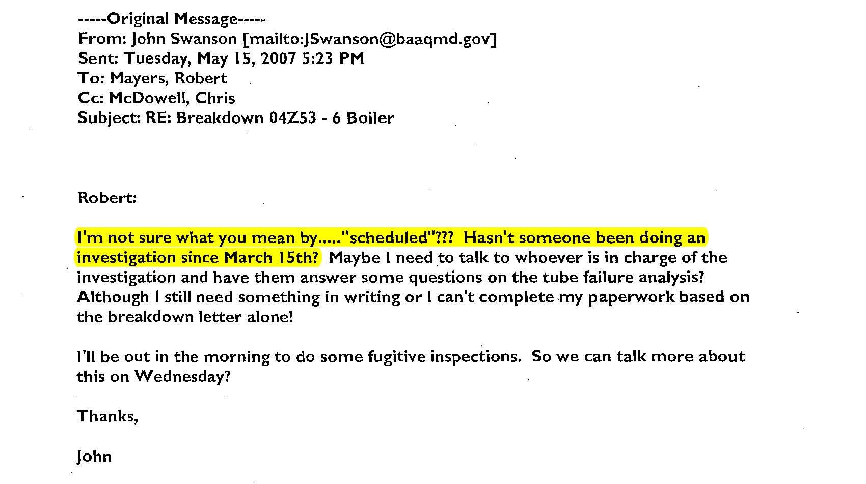

Subsequently, Tesoro was forced to admit that in fact the letter the company sent to regulators by certified mail was wrong—there had been no investigation. In a May 16 email, a company official promised instead to “try again” to obtain a written report of the incident.

Despite follow-up requests by regulators and the company's claims to have scheduled an investigation, no results were ever produced for inspectors. “Tesoro never did submit such a report,” state investigator John Swanson concluded in his final findings.

In reality, Swanson concluded, the so-called “breakdown” was not an unforeseeable accident, and “this failure was the result of improper maintenance.” It turned out that Tesoro employees had skipped a critical step in the maintenance process.

Confronted with this information and the investigator’s conclusion that Tesoro had violated the law, a Tesoro official simply went mute. “Mr. Mayers made no statements regarding the issuance of this violation notice,” Swanson reported.

This incident raises serious questions about the credibility of Tesoro on environmental issues. According to state regulators, Tesoro falsely claimed via a certified letter that it was investigating, then failed to provide a promised report justifying its assertions the incident was an unforeseeable accident. It is reasonable for the voters of California to ask whether Tesoro's claims about the benefits and costs of rolling back AB32 might be similarly dubious.

Ultimately, it appears this case was included in settlements between Tesoro and Bay Area Air Quality Management District prosecutors.

**Case Study: Settlements at pennies on the dollar**

(See Appendices G, H, I)

Confidential settlement documents reveal Tesoro's strategy of persuading regulators to allow the company to buy itself new equipment with money that was supposed to be paid to the state of California as a penalty for violating environmental laws.

In August 2009, a lawyer for Tesoro sent a letter to South Coast environmental prosecutors offering to pay $110,000 to settle a slew of violations. But the lawyer added in a proviso that nearly half of the money, $49,800, would be used to buy new infrared cameras in order to detect leaks of hazardous gases.

Given that the law already requires Tesoro to detect and repair gas leaks, it appears that Tesoro found a way to use its environmental fines to defray its own compliance costs. This seems to defeat the purpose of the penalties, by rewarding non-compliance.

In all of the settlement agreements obtained by *No on 23*, Tesoro and Valero won an explicit promise from the state not to take further civil or criminal actions against the companies for these violations.

Other South Coast settlement agreements disclose that Valero holds its Wilmington assets through shell companies in Nevada and Delaware, a strategy which some out of state companies use to reduce their tax liability in California.

The settlement agreements generally don't state how much Tesoro and Valero were able to cut their fine in negotiations, but securities filings by Tesoro show it has settled numerous cases with the Bay Area Air Quality Management District for half or less of the initial amount.

Tesoro negotiated a deal with prosecutors in 2008 to reduce fines for 77 violations by 63%, from $4 million to $1.5 million, the filings show. In July, Tesoro struck another great deal, reducing $740,000 in fines to $366,375 for 44 violations. A third offer from Bay Area regulators is currently on the table to resolve 46 violations for $620,000. Based on past cases, it is likely to settle for less than half that amount.

**Case Study: Off-scale**

(See Appendix J)

A vivid illustration of the haphazard manner in which Tesoro operates is a Dec. 6, 2007 incident at its plant in Martinez. On that date, monitoring equipment detected a large leak of sulfur dioxide from Tesoro's sulfuric acid plant*.*

Sulfur dioxide is a major contributor to acid rain and other atmospheric pollution problems.

At one point, the leak was so enormous that it couldn't be measured by Tesoro's equipment and was determined to be "off-scale" – literally off the charts.

When asked for an explanation, a Tesoro office responded that the plant's workers had started up the machinery too quickly and overwhelmed the unit. He promised that they would be given "refresher training."

*(NOTE: The chart is shown at the end of this document.)*

**Key Additional Findings:**

The records obtained by No on 23 also reveal the following:

* On May 22, 2007, an inspector found that Valero’s Benicia refinery had “missed” replacing the filters in the plant’s most critical piece of equipment for reducing emissions of volatile organic compounds such as hydrogen sulfide, sulfur dioxide, and nitrogen oxide. That piece of equipment, called a carbon adsorber, filters the toxic chemicals out of the refinery’s waste stream. But replacing the carbon regularly, as environmental regulations require, is expensive and companies can cut costs by skipping a carbon change-out. (See Appendix K.)
* In another 2007 incident, Tesoro employees in Martinez conceded to inspectors that they were not even able to identify the source of a leak of deadly hydrogen sulfide. (See Appendix L.)
* Since the beginning of 2007, Valero's plant in Benicia has been cited on at least 25 occasions for illegal leaks or venting of hazardous substances, and on at least 23 occasions for failing to keep records, conduct required tests, or file reports. According to a spreadsheet of Valero violations, the plant has been cited 7 times for excessive nitrogen oxide emissions, 7 times for excess hydrogen sulfide, and 3 times for carbon monoxide. Regulators have also cited Valero four times based on complaints from neighbors and workers over foul odors emanating from the facility. (See Appendix C)\
* The investigation into a deadly explosion in Washington State released Monday found some of the same types of maintenance and safety violations by Tesoro that are contained in the No on 23 reports. (See Appendix M)

# The Spike

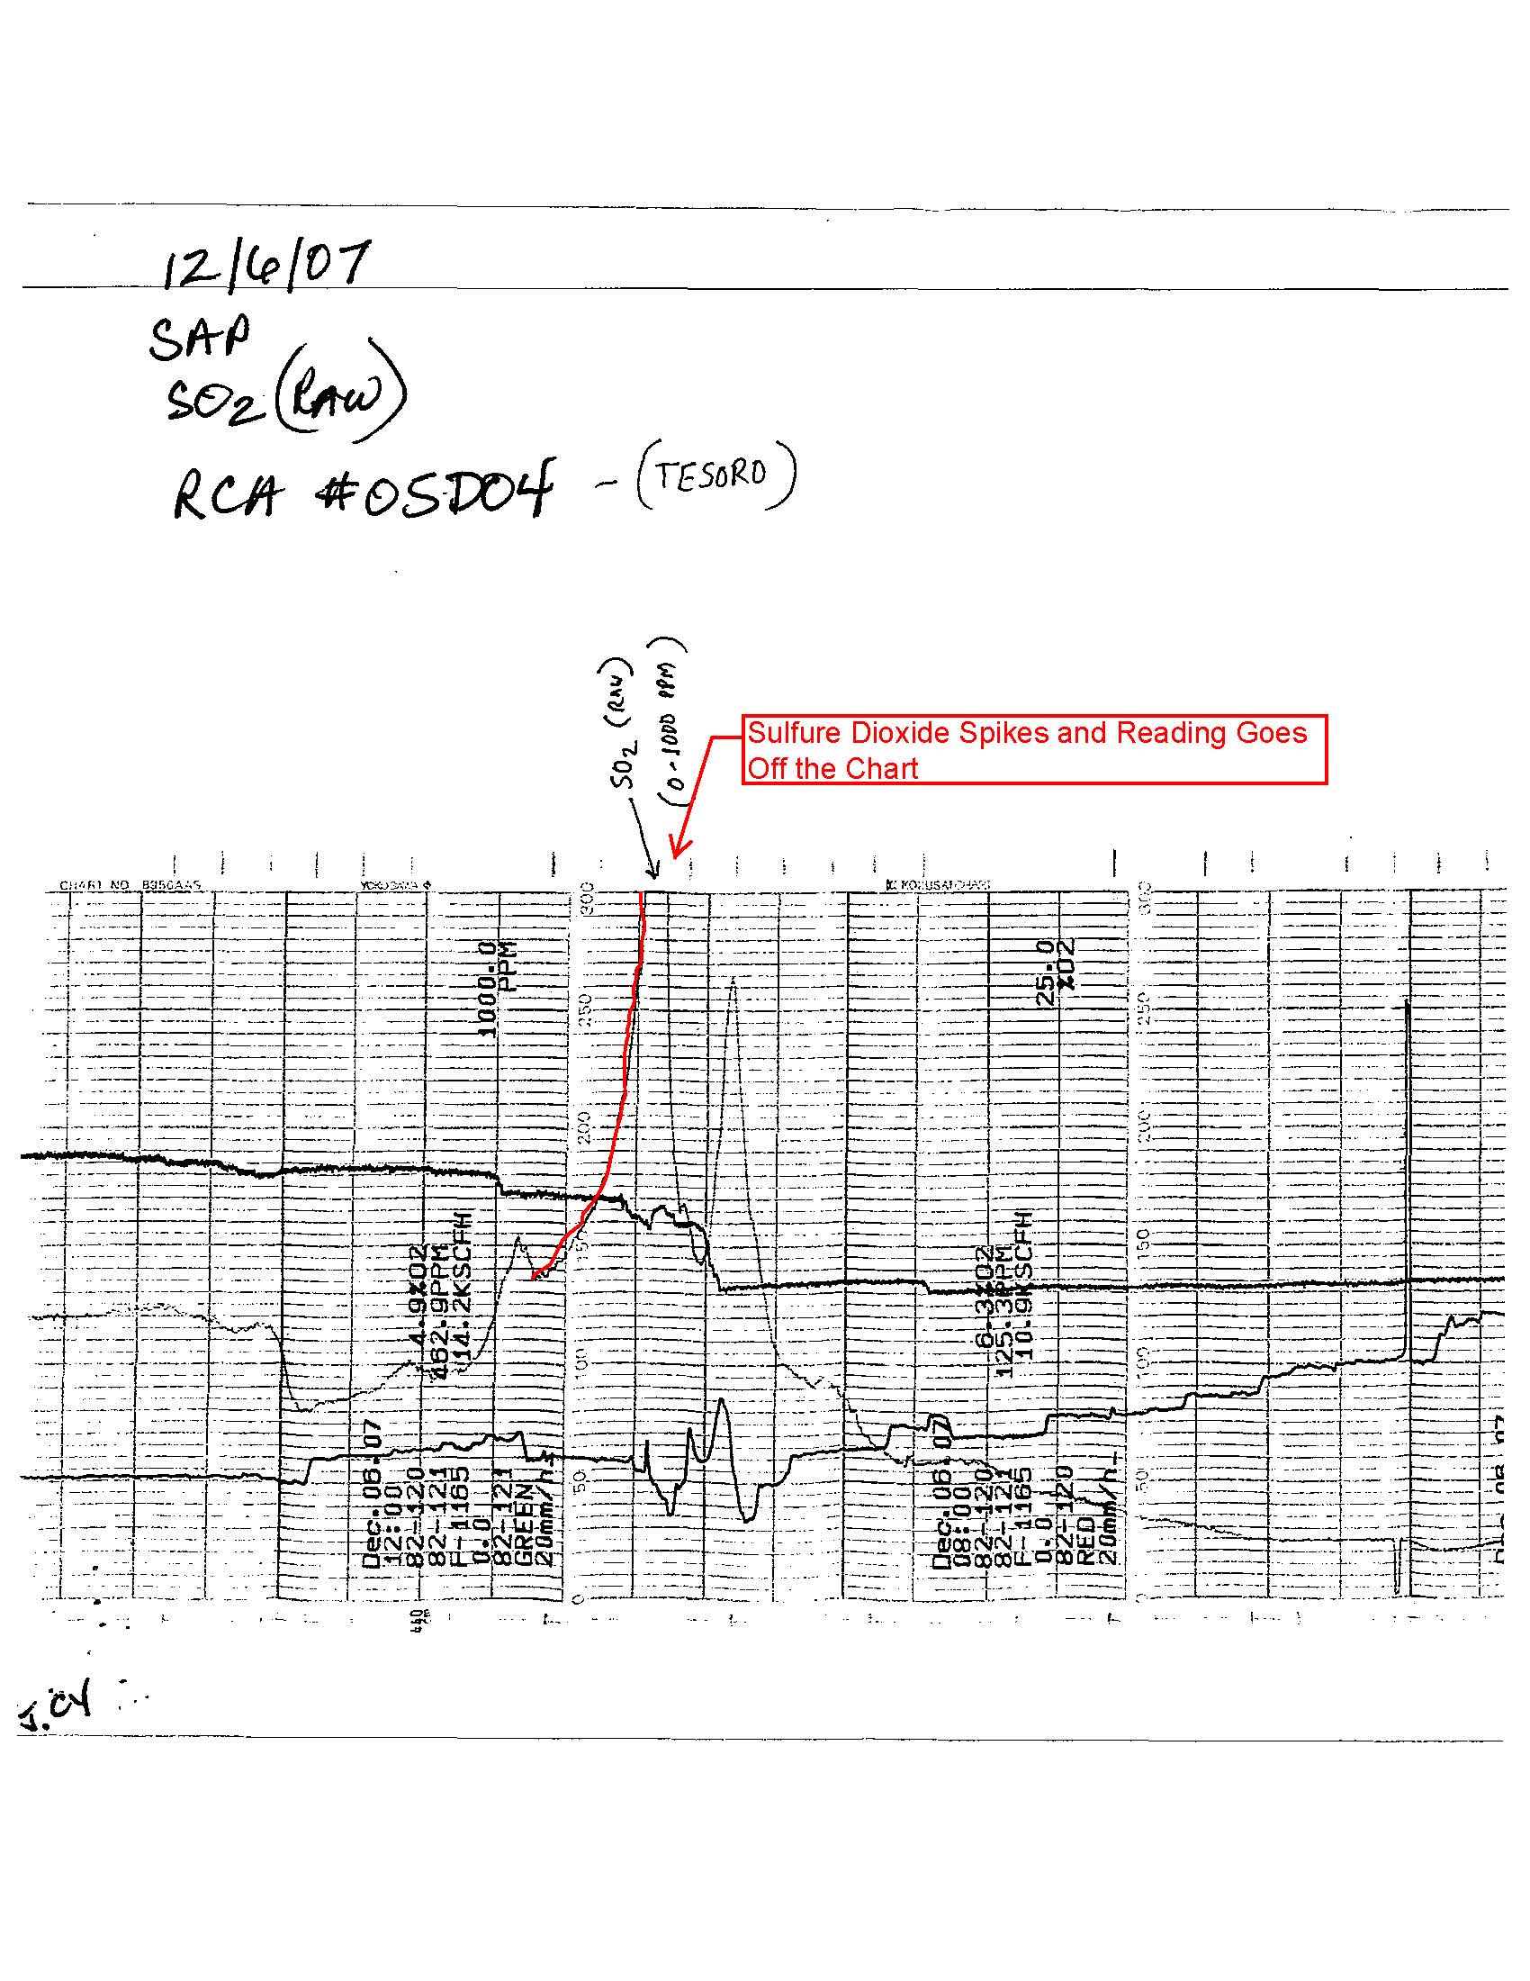

1. <http://lni.wa.gov/News/2010/pr101004b.asp>. Report at <http://seattletimes.nwsource.com/ABPub/2010/10/04/2013070729.pdf>
2. See Exhibit A or <http://seattletimes.nwsource.com/html/localnews/2011509207_refinerysafety03m.html>