Table of Content
1. About this document 2
1.1 Degree of difficulty 2
1.2 Information about the icons 2
2. Introduction 2
3. WiMAX 4
3.1 Range and coverage 5
3.2 Scalability and throughput 7
3.3 Quality of service (QoS) 8
3.4 IEEE 802.16 d-2004 8
3.4.1 Basic Configuration 8
3.4.2 General features 9
3.5 WiBro 10
3.6 Conclusion 10
4. Nonstandard solutions 11
4.1 MIKROTIK 11
4.2 Alvarion 13
4.3 Canopy 16
5. Conclusions 17
6. Additional resources 18
6.1 On line 18
7. Intellectual Property Rights 18

About this document
This material is part of the course package created for TRICALCAR project. For information on TRICALCAR, please consult the introductory module or, www.wilac.net/tricalcar/. This material was originally developed in Spanish for the TRICALCAR project. This unit is available under the terms of the Attribution-Noncommercial-Share Alike 3.0 Unported license (Creative Commons licences: http://creativecommons.org/).

Degree of difficulty
The degree of difficulty of this unit is “intermediate”.

Information about the icons
In this unit you will find 5 types of icons whose meaning is described below:
Central concept | Important practice recommended | Exercise | Intellectual property | Intellectual property
 |  |  |  | 

Introduction
Back in 2000, the Venezuelan spectrum regulator conducted a public auction of the frequency band between 3400 and 3500 MHz with the aim of providing voice and data services via wireless technology, in what was known as WLL (Wireless Local Loop).

Although several operatators paid large sums for the right to use 25 MHz in one or more of the five regions of the country, and two of the winning deployed in several cities, the overall plan failed, and in 2006 the licenses were revoked.

Analising the causes of failure we conclude that they were basically the following:
- Lack of standards for providing this type of service.
- Requirements for line of sight. The existing commercial solutions required line of sight between the base station and the subscriber, implying that the installations for each subscriber had to be carried out by qualified personnel.
These factors strongly affected the cost to be paid by the user rendering the system not viable.
Fortunately, great progress has been made nowadays in both respects, thanks to IEEE802.16 standards, which allow, in some cases, to overcome the need for line of sight between the base station and the subscriber.
On the other hand, the mobile phone industry has considerably reduced costs and improved the transmission rate offered, so it can be a valid solution in certain applications.
In addition, several companies are offering proprietary, nonstandard solutions that have nontheless achieved some commercial success. We will mention them briefly, taking into account that most of them promise to migrate to WIMAX, the commercial implementation of IEEE802.16.
Still others use Wireless DOCSIS, which adapts the standard for data transmission over cable television systems to the wireless environment.
On the other hand, two-way satellite access technology remains very expensive in developing countries.
IEEE802.16 born as a solution for metropolitan networks, with a reach of tens of kilometers and tranmission rates of several Mbit/s. It was originally aimed at operating frequencies above 10 GHz and did not have much impact. In 2003, an amendment of the standard extended the range of operation to the frequencies between 2 and 10 GHz. This allows for greater range and, and, with the use of OFDM (Orthogonal Frequency Diversity Modulation), it can overcome the line of sight requirement. The purpose of the new standard was to address the basic constraints of 802.11 as an outdoor access technology: range and Quality of Service (QoS). For this purpose, 802.16 uses a different medium access method and offers a great variety of modulation and channel-sharing techniques, hence great versatility with both licensed and unlicensed spectrum solutions.

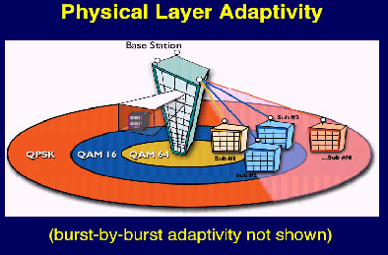
Figure 1: Different modulation types as a function of distance to the base station.
All this versatility renders the standard too complex, hence difficult to implement in practice. For this reason, several vendors in the telecommunication field decided to found a nonprofit organisation that would establish typical profiles responding to what was perceived as the most immediate requirements of the market, and would create mechanisms to test the interoperability of devices developed by different manufacturers. This organisation is called WiMAX (Wireless Microwave Access) and nowadays includes among its members the most large enterprises in the area.
The interoperability tests are being performed at two laboratories, one in Spain and the other in South Corea. A third one will soon operate in China. WiMAX aims to attain for 802.16 what WiFi did for 802.11: the wide diffusion of technology.
According to the application two different markets are identified:

- In developing countries, the limited amount of land lines makes room for a fixed wireless access technology, based on the IEEE 802.16-2004 amendement known as 802.16d.
- In developed countries, mobile broadband services are better served with the 2005 amendement of the standard, dubbed 802.16 e .

The IEEE802.16d (ratified June 29, 2004) is meant for fixed service (but can also be used for nomadic applications), while IEEE802.16e is geared to mobile service but can also be used for fixed services. Although the two versions are not interoperable, some vendors have opted to implement both in their offering, and others aim to provide fixed service using IEEE802.16e.
This is not a strict classification since IEEE802.16d has been employed to offer nomadic service (limited mobility, such as laptops) meanwhile IEEE802.16e can be used to offer fixed services). In fact, some companies have decided to concentrate on IEEE802.16e and position it as contender for third generation mobile telephony.

In sum, 802.16 aims to overcome the 802.11 limitations in outdoor applications by using a deterministic medium access layer, which ensures quality of service, important feature for voice applications. In addition, it is well suited for long distance transmission and a high number of nodes. 802.16 also introduces new modulation schemes and different channel bandwidths, which makes it a more versatile but more complex system.

WiMAX
In the last few years WiMAX has been promoted as the wireless broadband future standard. Many Internet wireless providers (WISP) and governmental institutions are considering migrating IEEE 802.11-based solutions and investment to WiMAX technologies. The first challenge to address is the objective evaluation of WiMAX proposals and costs. The question frequently asked is whether WiMAX is a technology à la mode or a true realistic option for broadband wireless service.

The IEEE 802.16 protocol has been specially designed for outdoor point to multipoint point links with a shared medium access (MAC). One of the most interesting aspects of IEEE 802.16 is the possibility of using different mechanisms on the physical layer while preserving the same medium access mechanism (MAC). This feature allows the creators of IEEE 802.16-based solutions to design equipment that is easily adapted to any spectrum band. The gear share most of the components, except the physical layer logic and the RF.

In other words, although the modulation techniques change depending on the operating frequency, the datagram format (packets), error control, medium access, etc., are totallly independent of the frequency.

IEEE 802.16 is an ambitious protocol geared to satisfy the needs of broadband wireless operators and industry. In many cases the decision towards a specific technology depends on tens of aspects such as efficient spectrum utilization, legislation, access to technology and investment capacity.

The discussion should not be purely techno-centric, and other aspects are also to be considered for the final decision, delving on which is the more appropriate technology in regard to local context and application. It is not easy therefore to answer the question: WiFi or WiMAX?

Range and coverage
IEEE 802.11 is a local area protocol intended to operate in small size cells (about 100 meters). Its access layer suffers from the so called "hidden node" problem and is one of the reasons why this technology does not perform well in long distance links or with many nodes.

The IEEE 802.11 medium access method (CSMA/CA) assumes that all nodes communicating with an access point are able to "hear the others" and hence avoid collisions. Collisions are avoided when all nodes in the network can detect whether the channel is busy or not. Unfortunately, this requirement is not met in the majority of cases when using this technology outdoors. When more than 10 nodes (some would say 5, others 50) are associated to the same access point, the amount of retransmission increases to the point that medium access time is no longer viable.

In simple terms, IEEE 802.11 does not work well in cases where many users are connected to the same access point in an outdoor net. In order to cope with this problem many proprietary solutions have incorporated a mechanism known as polling. The access point is responsible of monitoring the client's requests and granting access to the medium. IEEE 802.11 also contemplates a polling mechanism where the access point decides at what moment a client station is authorised to communicate with the access point, thereby solving the hidden node problem. This method is part of the 802.11standard but not common in most implementations that relay only in CSMA/CA.The problem of collision due to hidden nodes is not new and even before the standards were aproved solutions to solve it were found (for example, Carlnet TurboCell incorporated in the Solectek commercial products, installed in Merida, Venezuela, 1997. See Figure 2).

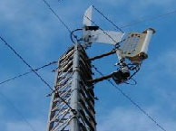
Figure 2: Solectek Antenna installed in Mérida, Venezuela,1997 as part of RETIEM, (Merida State Teleinformatic Network) with links of up to 40 km.

The basic reason why polling is not commonly used is that for the short distances that are the scope of IEEE802.11, CSMA/CA is more efficient (less overhead). Nevertheless several vendors offer proprietary solutions for long distance WLANs that forego compatibility with standard products.

The development of EEE 802.11 goes on and to date (October, 2007) there are products that incorporate some quality of service mechanisms based on the IEEE 802.11e amendment of the standard which mandates the use of polling. The WMM (WiFi Multimedia) interoperability certification, based on IEEE 11e, defines four traffic categories (drawing on 802.1d DiffServ): voice, video, best effort and low priority background traffic.
Amendment n of the 801.11 standard, not officially approved yet, but whose use has been sanctioned by WiFi Alliance, incorporates more sophisticated modulation methods that allow greater spectrum efficiency than 802.16 and also incorporate MIMO technology (Multiple Input, Multiple Output) that tmproves transmison rates and range, taking advantage of the reflections that hinder conventional systems.

Reflections are responsible for the multipath phenomenon by which at a given moment several signals going through different paths, hence phase-shifted, coincide on the receiver antenna thus causing decision errors in the receiver. This effect increases twith bandwitdth. Therefore, a way to deal with the problem is to split the transmiting signal into several subcarriers, each one transporting only a fraction of the througput in what is known as OFDM technique (Orthogonal Frequency Division Multiplexing).

OFDM is already utilised in 802.11 a and g, but in 802.16 the number of subcarriers is increased and the possibility to make this number variable in relation to the broadband included, using it as a channel sharing mechanism in the so called (Orthogonal Frequency Division Multiple Access)

The term “orthogonal” means, in this case, that carriers are selected taking advantage of the mathematical property of orthogonality to minimise interference.

IEEE 802.16 makes a more efficient use of the communication channel because the base station is able to schedule the access time for each client.
As mentioned before, useful coverage of a IEEE 802.11 network depends on the amount of hidden nodes. In this sense, IEEE 802.16 is far superior because it allows the assignement of a specific bandwidth to a client (using TDMA) without having to worry about possible collisions.

The use of TDMA also favours the incorporation of smart antennas capable of dinamically modifying the direction and shape of their beam. A smart antenna combines several elements associated to a signal processor capable of automatically optimising the beam.
In 802.16, a direct connection among clients, and even the relaying of information to other nodes is allowed bypassing the base station, in what is known as mesh technology.
In 802.16, up and downlink channels are totally independent, which also permits the utilisation of different modulation types.

Scalability and throughput
While IEEE 802.11 has a fixed channel bandwidth of 20 MHz, IEEE 802.16 allows a range of channel bandwidths from 1,5 MHz to a maximum of 20 MHz enhancing the flexibility of spectrum usage. In IEEE 802.11b the maximum number of non-overlapping channels is 3, whereas in IEEE 802.11a is 8. In the case of IEEE 802.16, this number is only limited by the available spectrum, which is very convenient for the planning of cellular networks.

Regarding spectral efficiency, legacy IEEE 802.11 is able to send a maximum of 2,7 bps/Hz. In a 20 MHz channel, maximum transfer rate is 54 Mbps. In the same 20 MHz channel, IEEE 802.16 can send up to 70 Mbps. These are maximum values since throughput depends on the existence of line of sight, amount of interference and other factors. It is realistic to talk about useful values of around 50 Mbps for short distances. IEEE802.11n has theorethical maximum throughput of 200 MPs in the same 20 MHz channel.

Quality of service (QoS)
QoS in IEEE 802.11 has improved after approval of the IEEE 802e amendment. Unfortunately, IEEE 802.11e includes only a limited support based on traffic prioritisation. IEEE 802.16 implements more complex rules and allows the assignment of attributes of QoS for each data stream between the client station and the access point.

IEEE 802.16 d-2004
This amendment considers only one medium access mechanism, but three physical layers: one based on single carrier, another that uses OFDM (Orthogonal Frequency Division Multiplexing) with 256 subcarriers, and a third one with 2048 OFDM subcarriers. This agrees with the ETSI (European Telecommunication Standards Institute) HiperMAN standard, except for the fact that the latter uses OFDM only. The modulation and codification schemes can be adaptive depending on the distance from the subscriber to the base station, giving priority to service to the farthest subscribers over transmission rate. Spectral efficiency is greater than the one for 802.11a/g, but smaller than the one for 802.11n.

Basic Configuration
Basic configuration includes a Base Station (BS) connected to the PSTN either through fiber optics, satellite link, or any other radio link that provides service to a certain amount of Subscriber Stations (SS) in Point to Multipoint configuration, although the standard also considers a direct connection between SS using mesh relaying. Multiple services with different QoS levels can be offered simultaneously, which is very convenient for multimedia. Traffic is connection oriented providing the required QoS level.
The base and subscribers' station are both fixed, and the latter can provide service to a whole building in combination with different technologies such as WiFi or PLC (Power Line Communication), also known as BPL (Broadband over Power Lines) that consists of utilising the existent electric wiring for high speed data transmission.

General features
The medium access mechanism is TDM/TDMA (Time Division Multiplexing/Time Division Multiple Access), which means that the base station transmits to different subscribers in different time slots. When a SS needs to send a frame, it sends a request to the BS, which will allocate a certain number of time slots in the uplink channel depending on the solicited service and availability. The capabilities of the SS will be manifested at initialisation.
There are thre ways to handle the two directions of traffic: FDD (Frequency Diversity Duplexing) , TDD (Time Diversity Duplexing) and Half Duplex.
In the first one, two frequency bands are utilised, one for direction. Both bands must be separated by an interval that allows the RF filters to separate the two traffic channels. This means that the operator must have paired channels separated by a space that cannot be used, which subtracts flexibility and efficiency in the use of the spectrum to this solution.
In TDD the same frequency is used for both traffic directions, but in different intervals of time. In fact, intervals are so short, that the user perceives traffic as simultaneous. This is a more affordable and widespread solution since it does not require expensive filters as the precedent one, and is more flexible in the use of the spectrum, not calling for paired channels or guard band among them. In the uplink, each SS gets a burst assigned, while in the downlink, a variable number of time slots is assigned to each SS. This allows the use of asymmetric channels, i.e., with different transmission speeds for each traffic direction, dinamically variable according to requirements.
In Half Duplex only one frequency is used for both uplink and downlink, but not at the same time, so simulataneous transmission and reception is not possible and the switchover from transmission to reception wstes some time.

WiBro
The first large-scale application of WiMAX technology took place in Corea, in 2006, in the 2.3 GHz band with 9 Mhz channels using a national standard called WiBro. Ermanno Pietrosemoli had the chance to observe the demonstration of this product made by Samsung in Jeju island, South Corea, in August 2005. The handover was proved in a vehicle moving at 80 km/h. The transmission rate allowed good quality video and fast file transfer.

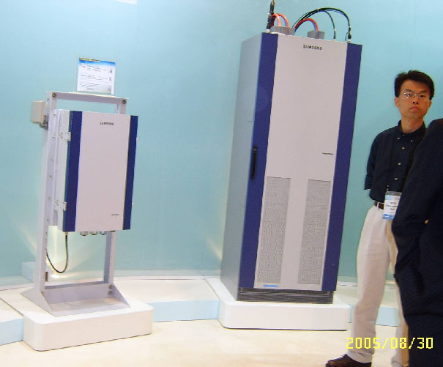
Figure 3: Samsug WiBRO Base Station. South Corea. August, 2005.
Currently, WiBro is part of the 802.16e-2005 standard and is ine of the profiles accepted for mobile WiMAX.

Conclusion
From a technical point of view it is clear that WiMAX meets most current challenges relating outdoor wireless links. When it comes to selecting a technology, one muist consider not only the technical aspects, but the whole scenario we are planning to build. We should consider what are the functionalities we want to implement, and whether the price and improvements of these functionalities is justified. As of today, WiFi solutions, or the ones that make use of proprietary extensions are the most cost effective.
The explanation for this relation quality-price is simple. WiMAX market orientation is not community networks or the local consumer. WiMAX wants to penetrate the telecommunication market of the operators, and especially the lucrative wireless access in metropolitan environments.
MAN (Metropolitan Area Network) is an urban market with a high population density that allows quick returns of the investments in infrastructure. Equipments are more expensive, but the market is also bigger. Prices of base stations are close to the 10.000 USD for a single sector, and they can reach the 30.000 USD for a multisector solution. To this price, we have to add the energy supply equipment, towers, physical security, etc.

In order to understand WiMAX market, we have to understand the business model of the mobile phone companies. The cost of client equipment is likely to be subsidised (350-500 USD), as was the cost of cell phones initially. This model is hardly replicable in a rural setting where the investment capacity is very small. That's why networks using WiFi offer a more linear investment model: high-quality base stations cost around 1000 USD, and CPE (Customer Premises Equipment) cost about 130 USD.

WiMAX is a technology to be considered for rural settings where the international bandwidth costs are relatively low. Installing a network with WiMAX using an international satellite access is an option difficult to justify.
Another aspect that we must not forget is energy consumption. WiMAX solutions require more energy than WiFi. A typical station operating six sectors needs about 1500 W. The current clients need around 15-30 W.

Nonstandard solutions
As we mentioned in the introduction, several vendors and integrators offer equipment that, stepping a bit away from the established standards, achieve good performance at reasonable prices. Althouhg it is generally preferable to look for a standardised equipment, it may also be convenient to use one of these solutions.

MIKROTIK
Mikrotik is a company based in Riga, Latvia, with many years of experience in wireless networks. It has developed its own routing software and sells the respective licencing in function of the required performance.Their star product, RouterOS, is Linux-based and offers most functionalities required by a router, with functions like firewalls, virtual private networks (VPN), traffic saping, and also access point and wireless bridge functionalities.
This software allows to implement a router withany Linux-supporting PC with the required interfaces. Mikrotik also provides devices known as routerboards which represent a specific case of single board computers (SBC) specifically designed for routing purposes, hence supporting several network interfaces, some of which can be wireless, generally using the miniPCI format.
The most common routerboards are the RB 532 and the new RB 333 with better performance.
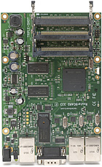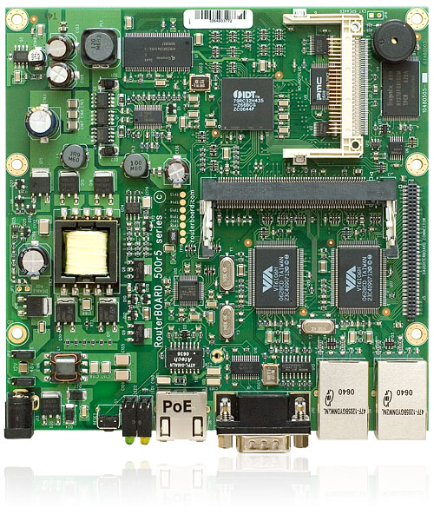
Figure 4: RB 532 and RB333 Routerboards
RB333 has a PowerPC processor and three slots for miniPCI cards so that it can handle up to three radios in different frequency bands. http://routerboard.com/comparison.html

Mikrotik also has a more sofisticated software, called Nstreme, that facilitates the implementation of links of hundreds of kilometers by simply setting the distance at which it will operate.
Nstreme2 furthermore allows the implementation of Frequency Diversity Duplexing (FDD), so in platforms with two radios simultaneous transmission and reception can be achieved with the consequent increase in performance. Nstreme can also operate in point-to-multipoint mode, in which case it uses polling to provide a more efficient medium access at long distances than CSMA / CA.
Note that Mikrotic devices can be connected with standard compliant 802.11 gear, but sacrificing the features of greater range and transmission speed.

Alvarion
This company of Israeli origin for several years has been manufacturing wireless equipment suitable for work in hostile environments. In 2002, when selecting a wireless bridge that could operate at 4765 m of altitude, Ermanno stumbled on the fact that most manufacturers only guarantee their equipment up to 3000 meters. While researching on the subject, he found that the reason is that due to the decreasing of air density with altitude, the heat transfer mechanism becomes less efficient because of the decrease in the number of air molecules available for transferring heat to the environment. Therefore, to operate at high altitudes, electronic devices must be fitted with oversized heat sinks.
It is a topic worth mentioning because frequently one choose high places to site stations to increase the transmission range, and in South America many cities are at high elevations.
In October 2002 we installed a link between Pico Espejo, at 4765m and a laboratory of the University of the Andes at 1800 m altitude, on a 16 km path, using the DS 5800 Alvarion equipment which operate in the 5,8 GHz band. This link is used to transmit scientific data collected by various instrument as shown in Fig. 5.
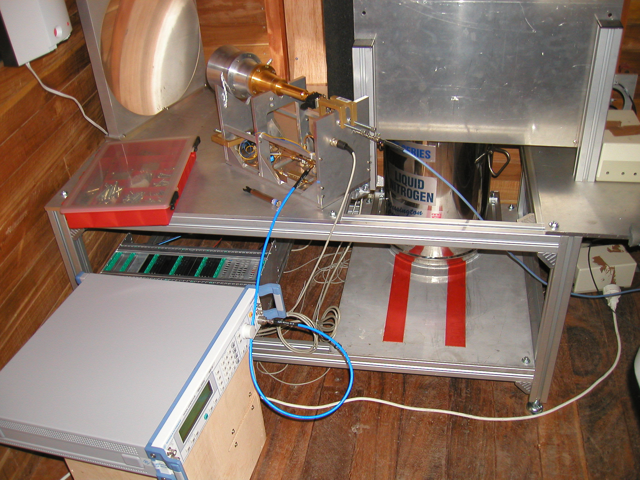
Figure 5: 270 GHz. Signal receiver. Note the receiving antenna quality and the use of liquid nitrogen to reduce receiver noise temperature. Estación Alejandro Humboldt, Pico Espejo, Estado Mérida, Venezuela. http://www.cecalc.ula.ve/redbc/estaciones/estacion_pico_espejo_mars.html
These instruments poll the climate and atmosphere, particularly for monitoringthe ozone layer, as part of the MARS project (Merida Atmospheric Research Station). A webcam was also installed that transmits live images of Pico Bolivar, besides data of solar radiation, atmospheric pressure and temperature. These data is available at http://www-imk.fzk.de/imk2/mira/Merida/Merida.html
Like many systems of this kind, the DS5800 consists of an indoor installation unit (IDU-InDoor Unit-), shown in Figure 3, and an outdoor weather-proof unit (ODU -OutDoorUnit-), shown in Figure 4. Note the heat dissipation fins and embedded patch antenna.

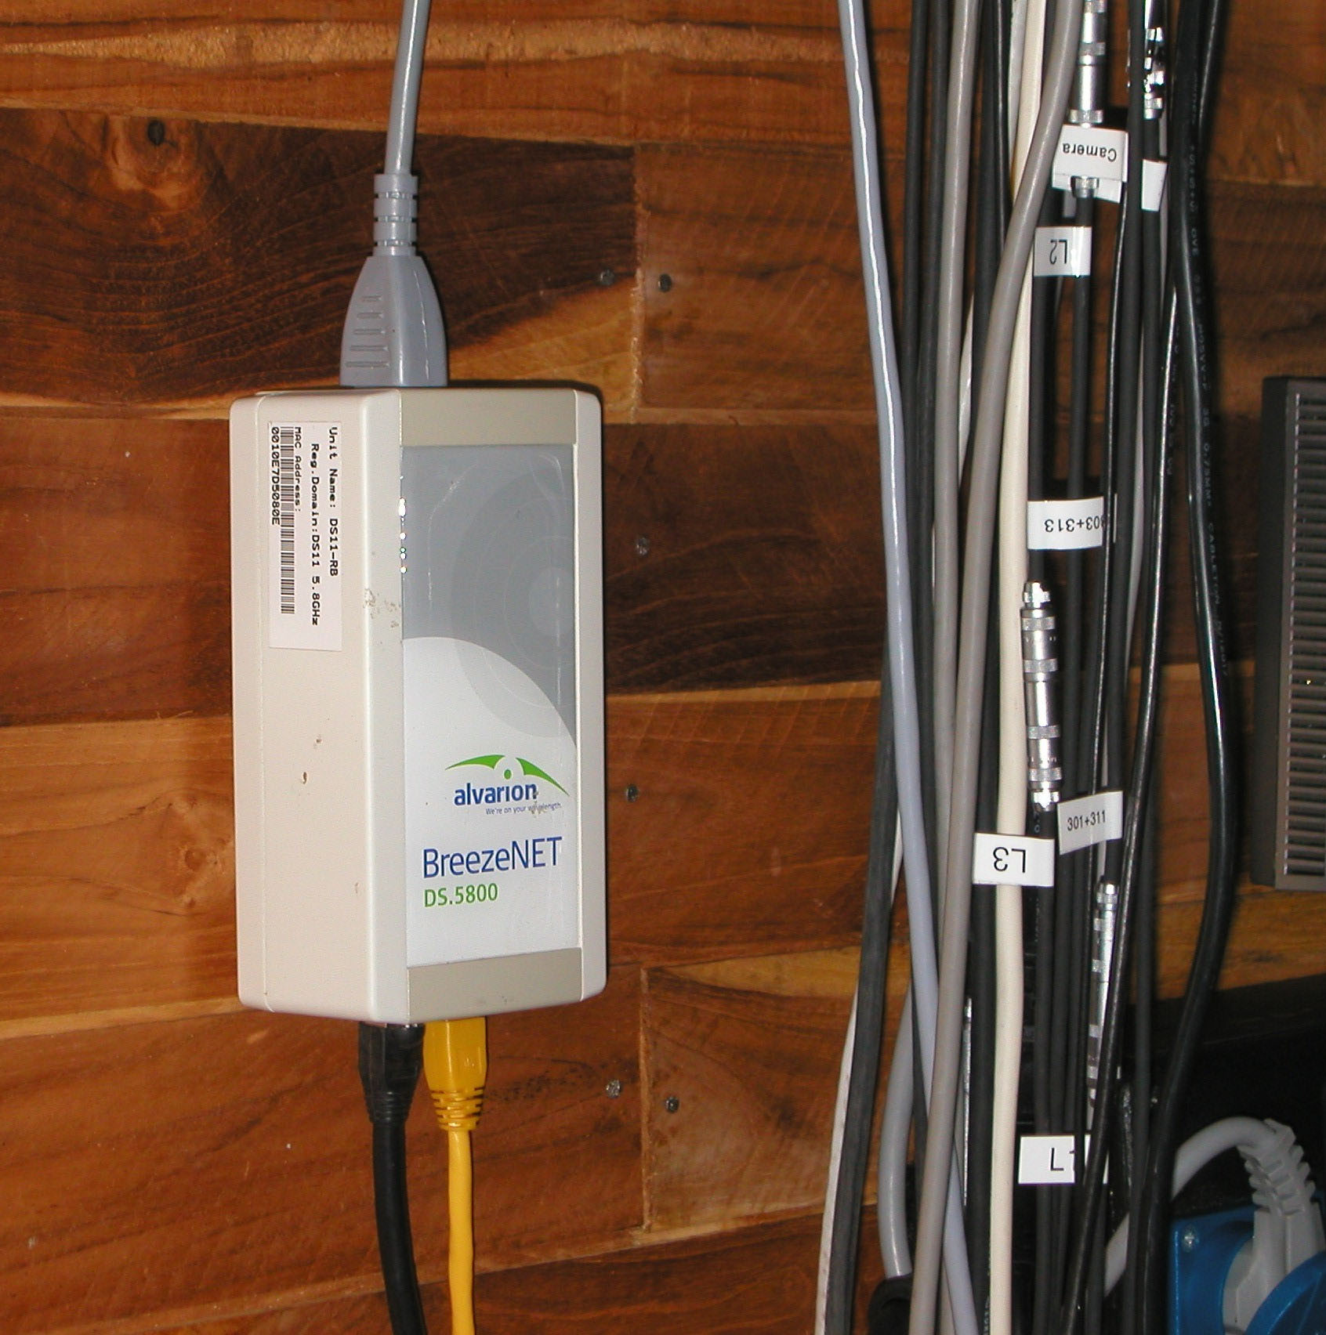
Figure 6: Alvarion DS5800 IDU installed in Pico Espejo.

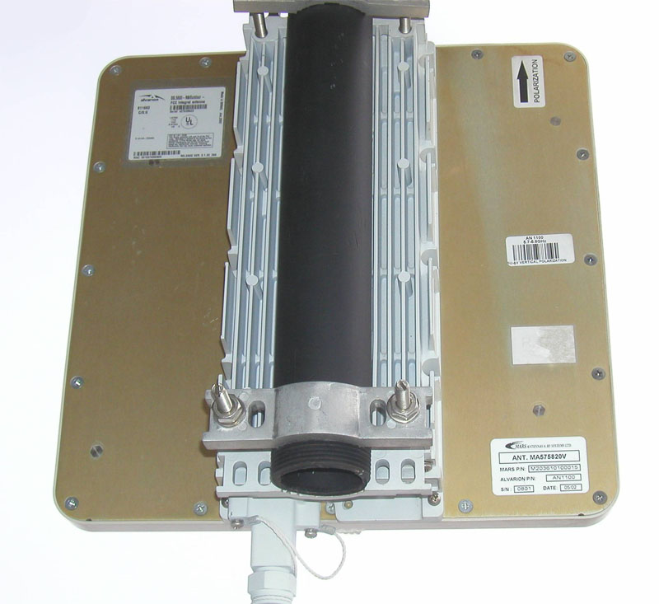
Figure 7: Alvarion DS5800 outdoor unit with patch antenna.

Currently Alvarion has migarted this line of products to the WiMAX standard, being one of the founders of the WiMAX Forum. They were among the first manufacturers to submit their equipment to the interoperability testing of fixed WiMAX.

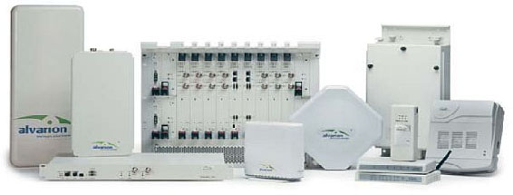
Figure 8: Alvarion WiMAX product line.
The Alvarion solution for mobile WiMAX is being evaluated for deployment in Rosario, Argentina, by ERTACH at 3.5 GHz. http://www.dailywireless.org/2007/10/10/

Canopy
This Motorola product line has been widely accepted, thanks to the vast experience of the company in wireless technology. Offered in several frequency ranges, 900 MHz, 2400 MHz, 5,15 GHz, 5,4 GHz and 5,8 GHz. They are very versatile solutions with a plastic weather-proof box that incorporates the radio and an 8 dBi antenna fed through the UTP outdoor cable via PoE. The range can be easily increased by adding a parabolic reflector that increments the gain to 26 dBi. There are several options with different troughputs with ranges several tens of kilometers in point-to-point configuration, or a few km in point-to-multipoint. In the latter case, you can combine up to 6 units, each equipped with a 60 degrees sector antenna, to get a base station with 360 degrees of coverage. As this is a TDMA system, combining several AP in the same place requires a GPS receiver for synchronization. The modulation system used is very robust, so it can withstand considerable interference, as it requires only 3 dB carrier-to-interference ratio. The drawback is that the spectral efficiency is modest, so Motorola is also offering solutions based on mobile WiMAX, called motoWi4. See www.motorola.com/motowi4
Motorola also continues to offer other products that provide great performance in terms of distance and transmission rate, reaching 300Mbps and 200km, but at significant cost.
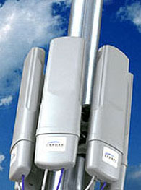
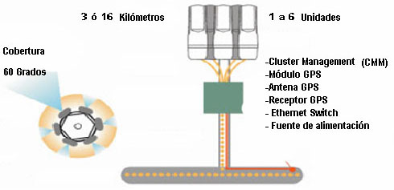
Figure 9: Motorola Canopy Base Station
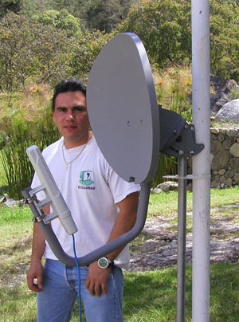
Figure 10: Motorola Canopy wireless router with parabolic reflector to increase gain

The Canopy wireless router is housed in a weather-proof plastic box which also contains an 8 dBi antenna. It can be used independently, or with a parabolic reflector increasing the gain to 26 dBi.

Conclusions
The offer of wireless solutions for outdoor links has patently improved in recent years, both in product range and prices. It remains to be seen whether WiMAX can really corner the market and become the preferred solution, or if it is going to face the same fate of ATM, a solution that was technically flawless, but unable to compete on price with Ethernet. The equivalent of Ethernet in this case is WiFi, which with the 802.11 e and n amendments competes with WiMAX in many features, while maintaining a lower price.
The five main points that you must remember in this unit can be summarised as:
- The IEEE 802.16 Standard is the basis of WiMAX.
- There are two versions of WiMAX, one, for fixed clients, based on IEEE 802.16-2004 (802.16d) and another for mobile clients, based on IEEE 802.16-2005 (802.16e).
- While WiMAX has many technical advantages with respect to WiFi, the latter continues progressing and filling many of the gaps in the original standard and, at the same time, maintaining a significant economic advantage.
- WiFi is more amenable to organizations that want to install their own infrastructure, while WiMAX is usually installed by a big operator.
- Although there are commercial solutions for wireless networks that may be the most suitable in some cases, it is generally preferable to use standard solutions with better guarantees of continuing support.

Additional resources

On line
www.wimaxforum.org
This is the official site of WiMAX forum.
http://wireless.ictp.it
All information about wireless networks courses held annually at ICTP, and a good collection of materials in English on wireless networks.
http://es.wikipedia.org/wiki/WiMAX
Good review of WiMax deployments in Latin America in addition to WiMAX basics in Spanish.

Intellectual Property Rights
The materials developed for the TRICALCAR project utilise a short version of the MMTK – Multimedia Training Kit, and have been created to be used and freely shared by instructors connected to new technologies for human development. All materials are available under one of the Creative Commons licences. <http://creativecommons.org/>.
These licenses have been created with the objective of promoting and facilitating the sharing of materials while retaining some rights over intellectual property of the authors.
Due to the fact that TRICALCAR organisations using MMTK have different needs and work in different contexts, there is not a single license that covers all the contents. For a more detailed account of the terms and conditions under which you can use and distribute each unit, please verify the declaration of intellectual property specified for each one of them.
Stipulations of intellectual property for this unit:
This unit is available under the terms of the Attribution-Noncommercial-Share Alike 3.0 Unported license:
- Attribution.You must attribute the work in the manner specified by the author or licensor (but not in any way that suggests that they endorse you or your use of the work).
- Noncommercial. You may not use this work for commercial purposes.
- Share Alike. If you alter, transform, or build upon this work, you may distribute the resulting work only under the same or similar license to this one.

For links longer than 3 km you must consider distance effects

