

Miscellaneous Icons And Scroll Bars
Table of Contents
Insert Large Images In Your Document 2
Insert Small Images To Be In Line With The Text 3
Add/Delete Spaces Between Image And Text 3
Image Too Large Or Too Small 3
Anchor 3
AutoText 3
Bullets and Numbering 3
Double Triangle 3
Computer Pointers 3
Busy 3
Help Select 4
Normal Select 4
Paint Pointer 4
Precision Select 4
Text Select 4
Working In Background 4
Pointer On Image (Four way arrow) 4
Downward Facing Triangle 4
Downward Facing Triangle on far right of toolbar 4
Downward Facing V 4
Flashing Cursor 4
Left Facing V 4
Minimize 5
Right Arrow on keyboard 5
Right Facing V 5
Scroll Bars 5
Horizontal Scroll Bar 5
Status Bar And The Horizontal Scroll Bar 5
Vertical Scroll Bar 5
Start 5
Templates 5
Up and Down arrows (to change the position of icons on toolbar) 6
Up and Down arrows 6
Down arrow 6
Up arrow 6

Insert Large Images In Your Document
Large Images will need to be placed below the paragraphs. For example, the large image below is placed beneath this paragraph.
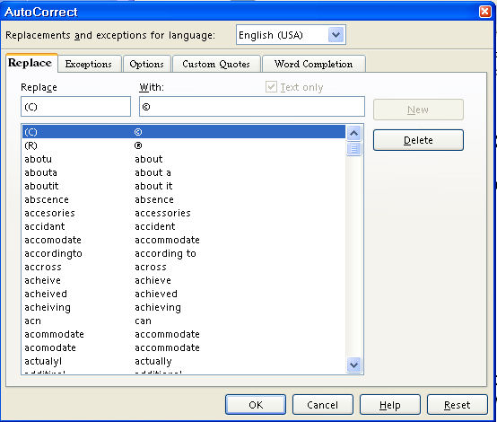
- Open the Navigator Images document
- Open a new document to write your tutorial
- Begin writing your tutorial
- To add the image, do one of the following:
- Right-click on the image in the Navigator Images that you will use. (A menu will appear.)
- Click Copy.
- Go to your document and click where you want the image then right click on your document. (A menu will appear.)
- Click Paste.
- The image is now in your document.
Or
- Click on the image in the Navigator Images that you want to use.
- Click the Copy icon on the Standard Toolbar.
- Go to your document and click where you want the image then click the Paste 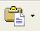 icon .
- The image is now on your document.

Insert Small Images To Be In Line With The Text
Small images can be inserted in line with the text such as this one, the Copy icon.

Add/Delete Spaces Between Image And Text
The images are saved "As Character" and can be moved up or down on your line of text. After insertion, you may delete spaces by clicking the Del key or add spaces by clicking the space bar between the image and your text.

Image Too Large Or Too Small
If the image is too large, there will be additional space between your lines of text. To correct this:
- Click on the image. (The green handles will appear.)
- Place your pointer on one of the handles.
- Hold down the Shift key and drag to make the image smaller.

Anchor
The Anchor icon

AutoText
The AutoText icon

Bullets and Numbering
The Bullets and Numbering 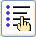 icon

Double Triangle
The Double Triangle icon or

Computer Pointers

Busy
Busy 

Help Select
Help Select

Normal Select
Normal Select

Paint Pointer
Paint Pointer

Precision Select
Precision Select Pointer

Text Select
Text Select

Working In Background
Working In Background 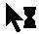

Pointer On Image (Four way arrow)
Pointer On Image (Four way arrow)

Downward Facing Triangle
The Downward Facing Triangle icon

Downward Facing Triangle on far right of toolbar
The Downward Facing Triangle or on far right of toolbar

Downward Facing V
The Downward Facing V or icon

Flashing Cursor
The Flashing Cursor

Left Facing V
Left Facing V,

Minimize
The Minimize button located on top right of the screen

Right Arrow on keyboard
Right Arrow on keyboard 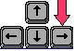

Right Facing V
Right Facing V

Scroll Bars

Horizontal Scroll Bar

Status Bar And The Horizontal Scroll Bar
The Status Bar and the Horizontal Scroll Bar

Vertical Scroll Bar
The Vertical Scroll Bar

Start
The Start icon.

Templates
The Templates 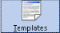 icon

Up and Down arrows (to change the position of icons on toolbar)

Up and Down arrows
The Up and Down arrows 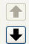 to change the position of icons on toolbar

Down arrow
The Down arrow 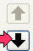 icon

Up arrow
The Up arrow 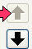 icon

Notes

Tutorials are improved by input from users. We welcome your constructive criticism.
E-mail suggestions and comments to: contact@tutorialsforopenoffice.org
For other free tutorials go to: http://www.tutorialsforopenoffice.org

This work is licensed under a Creative Commons Attribution 3.0 License

