My Yearling Journal
Austin Mitchell
Language Arts – Per 3
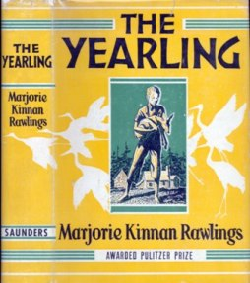
Main Themes:
All kids must grow up and this might not be easy.
Life is never easy. You might have give up something you want due to family responsibility.
Man versus nature
Chapter 1: The Flutter-mill
Marjorie Kinnan Rawlings is very descriptive about things in everyday life. For example, on page 15, she writes this about smoke “A column of smoke rose thin and straight from the cabin chimney. The smoke was blue where it left the red of the clay. It trailed into the blue of the April sky and was no longer blue but gray. “
I learned that a Flutter-mill is like a water wheel only it is supported by 2 forked trees, like a slingshot, with a stick running across of the forked sticks and sturdy leaves for the wheels. It is used in a small stream for fun.
Chapter 2: Memories
In this chapter there is a conflict between Penny and his Dad. His Dad is a preacher a “stern as the old testament god”. He was very stern with his kids and made them work really hard. “From the time they could toddle behind him down the corn rows, carrying the sack of seed, had toiled until their small bones ached and their growing fingers cramped. “ Of course, no kid wants to work that hard.(theme: family responsibility)
Because he was worked so hard by his father as a child, the grown up and married Penny found it easier for him to move into the wild Florida scrub instead of staying in a town. He could never get used to having an easy life. (Theme: Like is never easy)
Chapter 3: Old Slewfoot
I decided to name the chapter “Old Slew Foot” because in the book Old Slewfoot, a bear that is missing a toe on the right front foot, shows up in this chapter and kills a sow. (theme: Man versus Nature)
Like any boy Jody loves to sleep in late.
Cracker Talk:
“ Hey ol’ Ma, he said at the door. “I like you, Ma”.
“You and them hounds and all the rest o’ the stock,” she said. Mighty lovin’ on an empty belly and me with a dish in my hand.”
That’s the way you’re purtiest.” He said and grinned.
Chapter 4: The Hunt
In this chapter Penny and Jody go hunting for Old Slewfoot. This is one of my favorite parts of the book because when they finally find Old Slewfoot there is a big fight between the bear and their hunting dogs. (theme: Man versus Nature)
I felt sad when one of their hunting dogs gets injured.
Chapter 5: Tradin’ with the Forresters
As part of the kid’s responsibility to their family, they have to supply wood and water for Ma before they go off to trade with the Forresters and visit Jody’s friend Fodder-wing.(theme: Family responsibility)
In chapter five Penny tells Jody about the Spainards occupying Florida. I like this because it’s historical and I’m a big history buff.
More Cracker Talk: The word Indians is spelled funny : “Injuns”
In this chapter we meet a bunch of Fodder-wing’s pets:
Baby raccoon: Racket
Pair of black swamp rabbits
Fox-Squirrel (I looked this animal up just to see what it was. It’s the largest squirrel in the western hemisphere. The sub species found in the Ocala National Forest is called Sherman’s Fox-squirrel and is a threatened species)
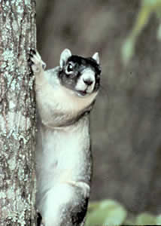
Eagle (who died)
Chapter 6: The new gun
In this chapter Penny trades one of his dogs for a brand new shotgun.
Good quote about Forrester’s gun collection
“The array” Jody thought “would stock a gun shop.”
The funniest thing in the entire chapter was that Penny did not lie about his dog being worthless when he traded it. By telling the truth he made the Forresters think the dog was good (Reverse psychology)
Chapter 7: The Sleepover
In this chapter Jody sleeps over at the Forresters.
Notes about Forrester Family life – They are extremely rowdy and rough mountain men who hunt a lot. They usually have giant feasts for their meals and drink a lot. They have a lot of wild animals as pets. The enjoy playing music.
Chapter 8: Testing 1,2,3
Penny tests out the new gun in this chapter and kills a buck. They enjoy a feast of venison.
(theme: man versus nature)
Chapter 9: The Sinkhole
This is a boring yet descriptive chapter. She mostly describes the sinkhole where they get their water from and how they get most of the food from their land.
“Jody looked down into a great cupped garden, feathered with green leaves, cool and moist and, always, mysterious. The sink-hole was set in the arid scrub, at the core of the pine island, like a lush green heart.”
List of some of the wildlife and plants in this chapter:
A white raccoon, sweet gum tree, dogwood tree, ironwood tree, holly, ferns, magnolia, frogs, and palmettos
I had to look up what an ironwood tree was. It’s a large shrub found on the hammocks of central Florida. They get their name from the dense wood which is hard to cut with an axe.
Chapter 10: Dance of the Whooping Cranes
Jody goes fishing and catches a giant 10 pound bass. His excitement reminds me of when I caught a huge redfish. Just like Jody, I was fishing with my Dad. Unlike Jody, I had a motor boat and I was in the Gulf of Mexico.
I really liked the part of the chapter where she describes the dance of the whooping crane.
“Magic birds were dancing in a mystic marsh. The grass swayed with them, and the shallow waters, and the earth fluttered with them. The earth was dancing with the cranes, and the low sun, and the wind and sky.”
I found out that young whooping cranes dance to build social and physical skills. When they are older, they dance to court a mate.
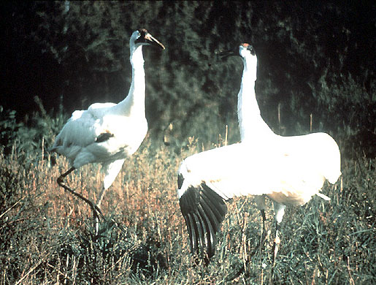

Chapter 11: Gone Huntin’
This is the chapter where Jody starts thinking that he might want a pet fawn. Even though Jody does not think this will be a problem, I foreshadow this event to be disastrous. The family is short on food, especially milk needed to nurse a fawn. Also, the older wild animals get, the more uncontrollable they become.
Jody also gets to use a gun for the first time. His Dad gives him his old muzzle loading gun. (theme: all kids must grow up)
I think getting the gun symbolizes Jody growing up and getting more responsibility.
Since my Dad is a Civil War re-enactor he has 3 muzzle loading rifles. I hope he gives one of them to me one day. Here is a picture of us at the Brooksville Raid.
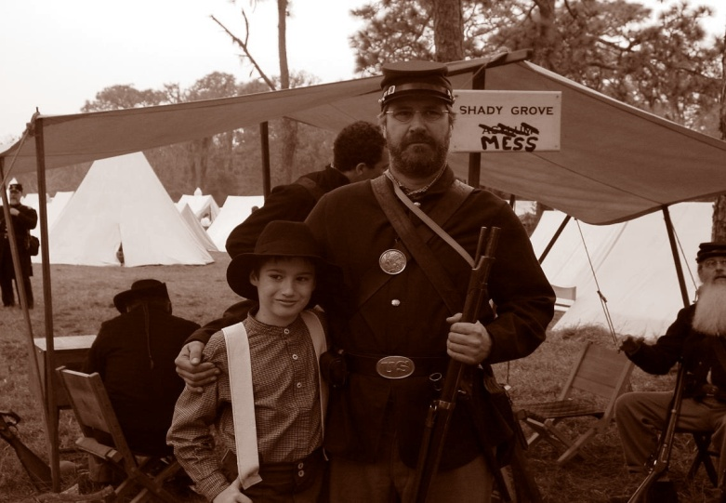
At the end of this chapter they visit Grandma Hutto.
Chapter 12: The Return of Oliver
In this chapter Oliver gets into a fight with Lem, Mill-wheel, and Buck Forrester over a girl. Jody has to choose between Buck and Oliver since they are both his friends. He chooses to help Oliver because it’s not fair for the 3 of them to fight Oliver. (Theme: life is difficult)
It’s touching moment when Oliver comes home because he is in the Navy and only comes home twice a year. He comes home with tales of adventures from around the world.
Chapter 13: Recovery
Speaks for itself…..
Chapter 14: Rattlesnake in the brush
This is the chapter where Jody first meets the fawn. It’s ironic that the death of the fawn’s mother saves the life of Jody’s Dad (by using it’s liver to draw out rattlesnake poisen). This make Jody feel obligated to help save the fawn’s life.
Here is Jody’s first impression of the fawn: “ He looked back. A spotted fawn stood peering from the edge of the clearing, wavering on uncertain legs. It’s dark eyes were wide and wondering.”
His first feeling for the fawn is : “An agony for the fawn came over him. He hesitated. It tossed it’s small head, bewildered. It wobbled to the carcass of the doe and leaned to smell it. It bleated.”
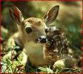
Chapter 15: The Fawn
Jody gets the fawn as a pet in this chapter. I predict that this will become a problem for the family.
Jody has to go back into the woods to find the fawn.
There are a lot of very cute images of the fawn in this chapter, for example:
“He remembered his father saying that a fawn would follow that had been first carried. He started away slowly. The fawn stared after him. He came back to it and stroked it and walked away again. It took a few wobbling steps towards him and cried piteously. It was willing to follow him. It belonged to him. It was his own.”
Chapter 16: Invaders in the Corn
Buck Forrester and Jody go night hunting for foxes because the foxes were eating their corn. One of the foxes is described as a “dog-fox” and the other a “vixen”. I had to look this up but a dog-fox is a male and a vixen is a female fox.
Buck and Jody also harvest a bee tree for the honey and kill a bear. It think it’s interesting how they got the honey. First you get some cloths and set them on fire and smoke a lot. Then stuff them into the hole in the tree where the bee nest is. The smoke makes the bees sleepy so you can chop the tree down and harvest the homey. . If the bees start attacking you, run to the nearest water source and cover yourself with mud.
A bear shows up while they are hunting the foxes at night. The bear is looking for the honey that they harvested and is now at their house. Jody and Buck mistakenly think the screams from Jody’s Mom and Penny are because Ma is doing something to Penny.
Buck says “That’s women’s killin’ him”.
Chapter 17: The Death of Fodder-Wing
This is a very sad chapter because Fodder-Wing dies from a lung disease.
Here is a good passage about death: “This was death. Death was a silence that gave back no answer.”
Before Fodder-Wing died he named Jody’s fawn Flag.
Chapter 18: Remembering
In this chapter Jody sees a mother raccoon with her 2 kids fishing in the sinkhole. He notices how human the raccoons are with their opposable thumbs and how the mother seems to “spank” her kids when they misbehave.
One of the best feelings that Marjorie Kinnan Rawlings ever described was in this paragraph:
“Suddenly it seemed to Jody that Fodder-Wing had only now gone away with the raccoons. Something of him had been always where the wild creatures fed and played. Something of him would be always near them. Fodder-wing was like the trees. He was of the earth, as they were earthly, with his gnarled, frail roots deep in the sand. He was like the changing clouds and the setting sun and the rising moon. A part of him had been always outside his twisted body. It had come and gone like the wind. It came to Jody that he need not be lonely for his friend again. He could endure his going.”
That is a beautiful passage!
Chapter 19: The Storm
In this chapter there is a gigantic hurricane. Here is a good descriptive passage about the storm: “The wind had been high overhead. The rain was a solid wall, from sky to earth. Jody struck it flat, as though he had dived against it from a great height. It hurled him back and threw him off balance. A second wind seemed now to reach long muscular fingers through the wall of rain and scoop up everything in it’s path. It reached down his shirt and into his mouth and eyes and ears and tried to strangle him.”
Chapter 20: The Expedition
Buck, Millwheel, Forrester, Jody, and Penny take a trip into the woods to see the damage from the storm. They find that most of the scrub is flooded and most of the small game animals are dead. Even the bear and deer population is decreased. They find a panther and 2 cubs which they kill. Jody tried to save one of the cubs from the dogs but the dogs killed both cubs. (Theme: Man versus nature)
Chapter 21: The Plague
Black tongue is an animal disease which kills off a lot of the game animals. They don’t eat any of the animals killed by the plague because they don’t want to get it themselves. Jody is afraid that Flag is going to get the disease so he tries to keep him inside Baxter’s Island. Penny thinks that it is the rain water that is tainted from all of the dead animals in it from the storm.
I looked up black tongue disease in deer and found that it was caused by a virus that is transmitted by flies in the late summer or fall. It is sometimes fatal and the tongue will be swollen. It can cause large deer population die offs in Southeastern United States.

Chapter 22: The trouble begins
In this chapter Flag gets a little bit on the wild side for he begins to figure out how to break out of his pen and cause havoc around the homestead. He destroys almost all of their taters and began to lick the salt off of their meat that was in the smokehouse. He also butted over a can of lard which had to be cleaned up by Jody.
Chapter 23: Attack!
In this chapter wolves attack the family’s calf and kill it (Theme: Man versus Nature). Old Julia, one of their dogs, kills one of the wolves. Here is a good description about when Penny and Jody first see the wolves: “A band of them, three dozen or more, milled about the enclosure. Their eyes caught the light in pairs, like corrupt pools of shining water. They were emaciated and rough coated. Their fangs glistened as white as gar-fish bones.”
The Forresters set out poisoned meat all over the forest kill the wolves (again: Man versus Nature)
Chapter 24:Extermination
In this chapter the wolf poisoning begins to take hold. It has killed 30 wolves and 2 dogs. The Forresters have also shot six wolves. Jody, Penny, and the Forresters decide to eradicate the remaining wolves by trap and gun. (maybe that’s why Forida Red wolves are extinct). I found out that Red wolves are being re-introduced into North Carolina in the wild. Here is a picture of a Red Wolf:
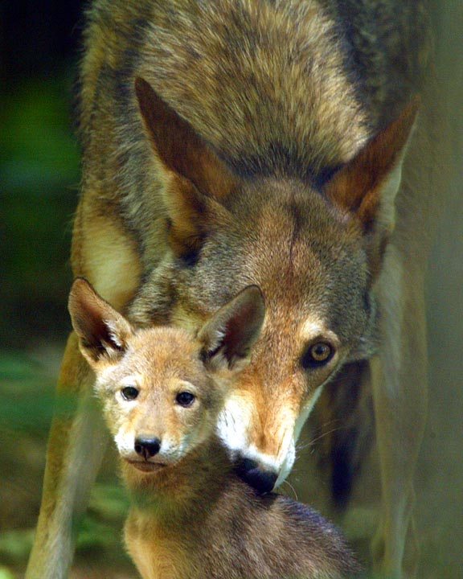

Chapter 25: Holiday Preparations
In this chapter Christmas is coming upon them and they go to Volusia to trade at the General Store and to visit Grandma Hutto. Jody made a necklace for his mother for a Christmas present. He used Cherokee beans (also known as coral beans) which is from a plant native to the hardwood hammocks. This is what the beans look like:
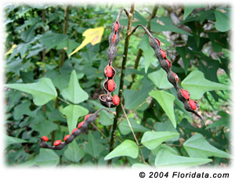
Chapter 26:Goodbye Ol’ Slewfoot
In this chapter Penny and Jody go on a hunt for Old Slewfoot that lasted for 3 days and ened on Christmas Eve. They were successful in killing Old Slewfoot (Theme: Man versus nature and man wins this round) . They manage to come back in time for their church’s Christmas eve celebrations. Everyone brings food and presents to the church to exchange, just like we do today. The Forresters are also at the Christmas celebration. Oliver comes home married to Twink Weatherby . The Forresters burn down Grandma Hutto’s house because they really hate Oliver. Lem has a grudge against Oliver for stealing Twink from him. Grandma Hutto, Penny, Ma, and Jody don’t tell Oliver about this because they don’t want him to get into another fight with the Forresters and get himself killed. Grandma Hutto decides to leave for Boston.
Chapter 27:Goodbye Grandma
Grandma Hutto leaves for Boston and that’s all she wrote (literally!)

On a side note (I’m going to brag now) My Great-great-great-great grandfather Captain Jacob Brock owned one of the first steam ship lines up and down the St. John ’s River. His boat was called the “Darlington” and here it what it looked like:

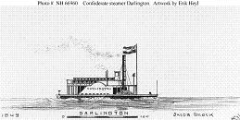
Maybe Grandma Hutto traveled on his boat!
I think the theme of this chapter is that you sometimes have to give up what you like for your family. Grandma left with Oliver to avoid him getting hurt by the Forresters.
Chapter 28:The play date
I decided to name this chapter the “play date” because a wolf has a play date with Rip, one of the family’s dogs, in the middle of the night.
Chapter 29:Things keep getting worse
In this chapter Penny is temporarily crippled from being over worked (Theme: Life is never easy) and Flag is banned from the house for being a bad little deer. Flag destroys their entire money crop of tobacco so they no longer have enough tobacco to sell for money. (Theme: Man versus nature)
Chapter 30: The beginning of the end
Penny is beginning to see Flag as a real nuisance in this chapter. Planting season has begun. They had to replant the tobacco fields (or as Pa says “’baccy”). There is something in Penny’s eyes when he talks about Flag that suggests that he has regrets about Jody keeping the deer. “You’re a pair o’ yearlin’s” he said “Hit grieves me”. That also foreshadows that Penny is sad about Jody growing up (Theme: all kids must grow up).

Chapter 31: All downhill from here
In this chapter Flag, who is becoming extremely unruly, has eaten almost all of their corn crop. Penny tells Jody to build a tall fence around all of the crops to keep that yearlin’ out. Jody begins to build the fence along the north fault line because he thinks that is how Flag will enter corn field. His ma helps him with the fence and they complete the northern fence. As they begin to build the rest of the fence, Flag gets in by jumping the fence. Jody dejectedly goes to his room to wait for his father to call him. It’s best described in this passage:”He was prepared for trouble. He was prepared for something ominous that had dogged him for days. He was not prepared for the impossible. He was not prepared for his father’s words.” His dad tells him to shoot Flag!
Chapter 32: The gunshot
Jody is extremely shocked by his father’s orders to kill Flag. So shocked that he flat out refuses to do it. He walks away from the house and has an imaginary fight with his parents. In his mind he physically fights with his parents until he is exhausted. So he goes to Buck for help but Buck is gone until April. His mom finds his shotgun and then discovers that Flag as eaten a lot of their cowpeas. Jody goes back inside and faces his parent’s rage but still refuses to kill his deer. He’s not going to kill the only friend that he has left. Jody gets sent to his room and hears a gunshot. He runs out and sees his Mom standing on the porch with a smoking shotgun. Flag has been shot. Jody runs to help Flag but Flag in his fear runs away from Jody and falls into the sinkhole. Jody follows him down there and ends his misery by killing him with one final bang.
(Theme: Life is never easy. You might have give up something you want due to family responsibility.)
Chapter 33: Runaway
Jody decides to run away from home and go to Boston to live with Oliver. He sets out on the St. John ’s River in a canoe. He gets picked up by the postal service steamboat and returned to Volusia. He decides to go back home since it’s the only safe haven he knows. He resigns himself to life back home. He promises himself that he will never love anyone or anything as much as he loved Flag.

