

Bullets And Numbering Toolbar
Table of Contents
Insert Large Images In Your Document 1
Insert Small Images To Be In Line With The Text 3
Add/Delete Spaces Between Image And Text 3
Image Too Large Or Too Small 3
The Bullets and Numbering Toolbar 3
The Bullets And Numbering Toolbar Icons 3
Bullets and Numbering Icon 3
Bullets On/Of 3
Demote One Level 3
Demote One Level With Subpoints 3
Insert Unnumbered Entry 4
Move Down 4
Move Down With Subpoints 4
Move Up 4
Move Up With Subpoints 4
Numbering Off 4
Numbering On/Off 4
Promote One Level 4
Promote One Level With Subpoints 4
Restart Numbering 4

Insert Large Images In Your Document
Large Images will need to be placed below the paragraphs. For example, the large image below is placed beneath this paragraph.
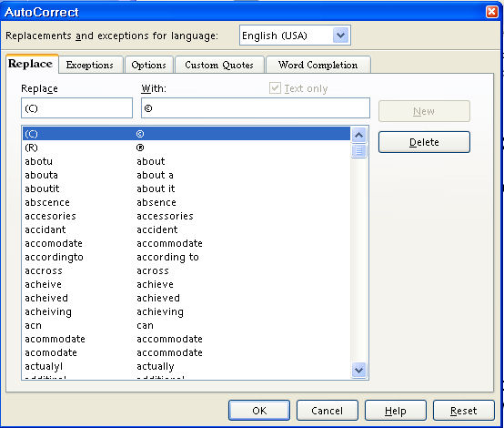
- Open the Navigator Images document
- Open a new document to write your tutorial
- Begin writing your tutorial
- To add the image, do one of the following:
- Right-click on the image in the Navigator Images that you will use. (A menu will appear.)
- Click Copy.
- Go to your document and click where you want the image then right click on your document. (A menu will appear.)
- Click Paste.
- The image is now in your document.
Or
- Click on the image in the Navigator Images that you want to use.
- Click the Copy icon on the Standard Toolbar.
- Go to your document and click where you want the image then click the Paste 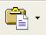 icon .
- The image is now on your document.

Insert Small Images To Be In Line With The Text
Small images can be inserted in line with the text such as this one, the Copy icon.

Add/Delete Spaces Between Image And Text
The images are saved "As Character" and can be moved up or down on your line of text. After insertion, you may delete spaces by clicking the Del key or add spaces by clicking the space bar between the image and your text.

Image Too Large Or Too Small
If the image is too large, there will be additional space between your lines of text. To correct this:
- Click on the image. (The green handles will appear.)
- Place your pointer on one of the handles.
- Hold down the Shift key and drag to make the image smaller.

The Bullets and Numbering Toolbar
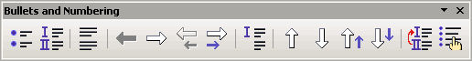

The Bullets And Numbering Toolbar Icons

Bullets and Numbering Icon
The Bullets and Numbering 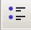 icon

Bullets On/Of
The Bullets On/Off icon

Demote One Level
The Demote One Level  icon

Demote One Level With Subpoints
The Demote One Level With Subpoints icon

Insert Unnumbered Entry
The Insert Unnumbered Entry  icon

Move Down
The Move Down icon

Move Down With Subpoints
The Move Down With Subpoints icon

Move Up
The Move Up icon

Move Up With Subpoints
The Move Up With Subpoints icon

Numbering Off
The Numbering Off  icon

Numbering On/Off
The Numbering On/Off  icon

Promote One Level
The Promote One Level  icon

Promote One Level With Subpoints
The Promote One Level With Subpoints icon

Restart Numbering
The Restart Numbering icon

Notes

Tutorials are improved by input from users. We welcome your constructive criticism.
E-mail suggestions and comments to: contact@tutorialsforopenoffice.org
For other free tutorials go to: http://www.tutorialsforopenoffice.org

This work is licensed under a Creative Commons Attribution 3.0 License

