

The "Styles and Formatting" Window
Table of Contents
Insert Large Images In Your Document 1
Insert Small Images To Be In Line With The Text 3
Add/Delete Spaces Between Image And Text 3
Image Too Large Or Too Small 3
The "Styles And Formatting" Window 3
Icons In The "Styles And Formatting" Window 3
Character Styles 4
Fill Format Mode 4
Frames Styles 4
List Styles 4
New Style From Selection 4
Page Styles 4
Paragraph Styles 4
New/ Modify -Small Menu 4

Insert Large Images In Your Document
Large Images will need to be placed below the paragraphs. For example, the large image below is placed beneath this paragraph.
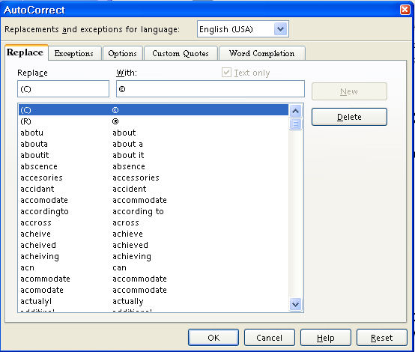
- Open the Navigator Images document
- Open a new document to write your tutorial
- Begin writing your tutorial
- To add the image, do one of the following:
- Right-click on the image in the Navigator Images that you will use. (A menu will appear.)
- Click Copy.
- Go to your document and click where you want the image then right click on your document. (A menu will appear.)
- Click Paste.
- The image is now in your document.
Or
- Click on the image in the Navigator Images that you want to use.
- Click the Copy icon on the Standard Toolbar.
- Go to your document and click where you want the image then click the Paste 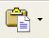 icon .
- The image is now on your document.

Insert Small Images To Be In Line With The Text
Small images can be inserted in line with the text such as this one, the Copy icon.

Add/Delete Spaces Between Image And Text
The images are saved "As Character" and can be moved up or down on your line of text. After insertion, you may delete spaces by clicking the Del key or add spaces by clicking the space bar between the image and your text.

Image Too Large Or Too Small
If the image is too large, there will be additional space between your lines of text. To correct this:
- Click on the image. (The green handles will appear.)
- Place your pointer on one of the handles.
- Hold down the Shift key and drag to make the image smaller.

The "Styles And Formatting" Window
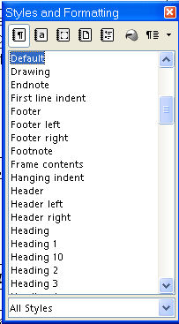

Icons In The "Styles And Formatting" Window

Character Styles
The Character Styles icon

Fill Format Mode
The Fill Format Mode icon

Frames Styles
The Frames Styles icon

List Styles
The List Styles icon

New Style From Selection
The New Style From Selection icon

Page Styles
The Page Styles icon

Paragraph Styles
The Paragraph Styles icon

New/ Modify -Small Menu
The small menu when you right-click on an entry in the "Styles and Formatting" window 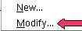

Notes

Tutorials are improved by input from users. We welcome your constructive criticism.
E-mail suggestions and comments to: contact@tutorialsforopenoffice.org
For other free tutorials go to: http://www.tutorialsforopenoffice.org

This work is licensed under a Creative Commons Attribution 3.0 License

