**Northern Virginia Community College**

**Annandale**

**CSC 110**

**Create a excel file with data as below:**

The spreadsheet is used by a new airline to calculate the fuel requirements and associated cost for its available flights. The airline has only two types of planes, Boeing-727s and DC-9s. The fuel needed for any given flight depends on the aircraft and number of flying hours. In addition, the plan must carry an additional some % of the required fuel to maintain a holding pattern and an addition some % as reserve. Your worksheet should be completely flexible and amenable to change; that is the hours fuel requirements, price per gallon, holding and reserve percentages, plane are all subject to change at a moment notice. **Thus, all formulas in the body worksheet should be based on the “fuel facts” in row 15 through 17 and column A4 through A8. Use absolute reference cell if it is needed.**

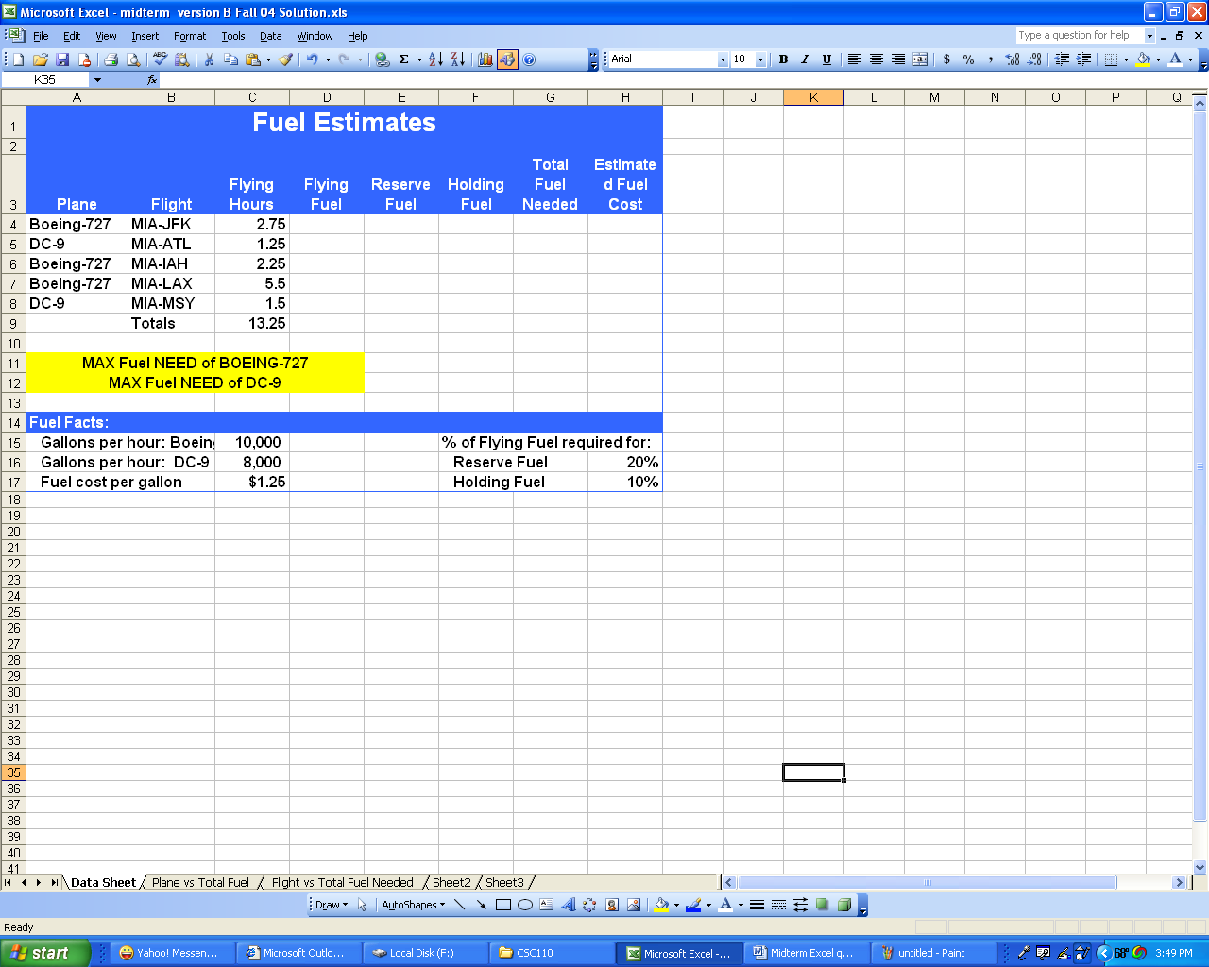

FORMULA:

* Flying Fuel=Flying Hours times Gallons per Hour
* Reserve Fuel= Flying Fuel times Reserve Fuel
* Holding Fuel= Flying Fuel times holding Fuel
* Total Fuel Needed= Sum of Flying Fuel, Reserve Fuel and Holding Fuel
* Estimate Fuel Cost= Total Fuel Needed times Fuel Cost per Gallon
* Max Fuel Need= Max(range of data)

1. Setup **formulas** to do the rest of fields, use **absolute reference wherever needed** and
2. Graph:
   1. A pie chart of Plane vs Total Fuel Needed.
   2. A column chart of Flight vs Total Fuel Needed
   3. A Line X,Y scatter (with line) chart. Scale axis and add equation.
   4. A line X, Y scatter (with points) chart. Add equation.

All charts put in **separate sheets** name Plane vs. Total Fuel Needed and Flight vs. Total Fuel Needed, Flying Hours vs. Flying Fuel, and Flying Hours vs. Total fuel respective.

**NOTE: These charts are just a sample may not be your charts with data from question.**

**Pie Chart**

Column chart

Line X, Y scatter (with smooth line and markers) chart

Set scale of the grid line.

Line X, Y scatter (with markers) chart

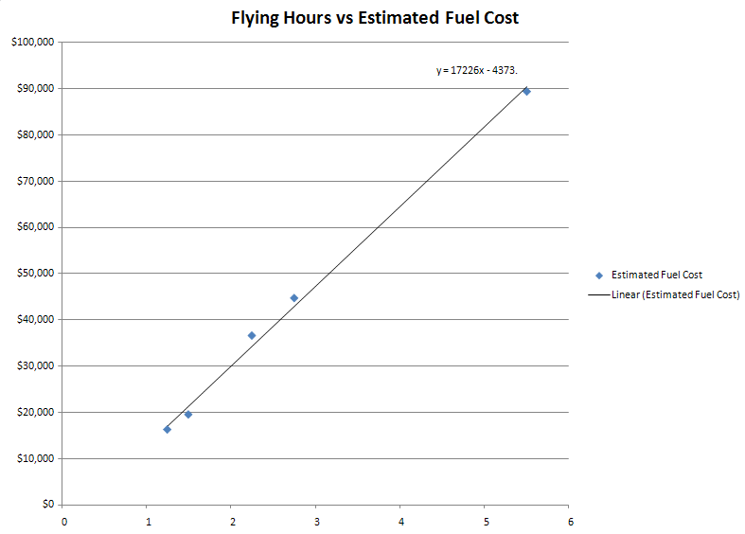

**NOTE:**

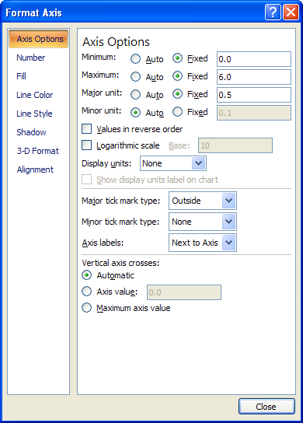To add equation just right clicks on line of graph and select add Trendline with turn on display equation option.

To scale axis just right clicks on axis and

select format axis

1. **Rename tab sheets**, format your worksheets and add charts in separate sheets as below:

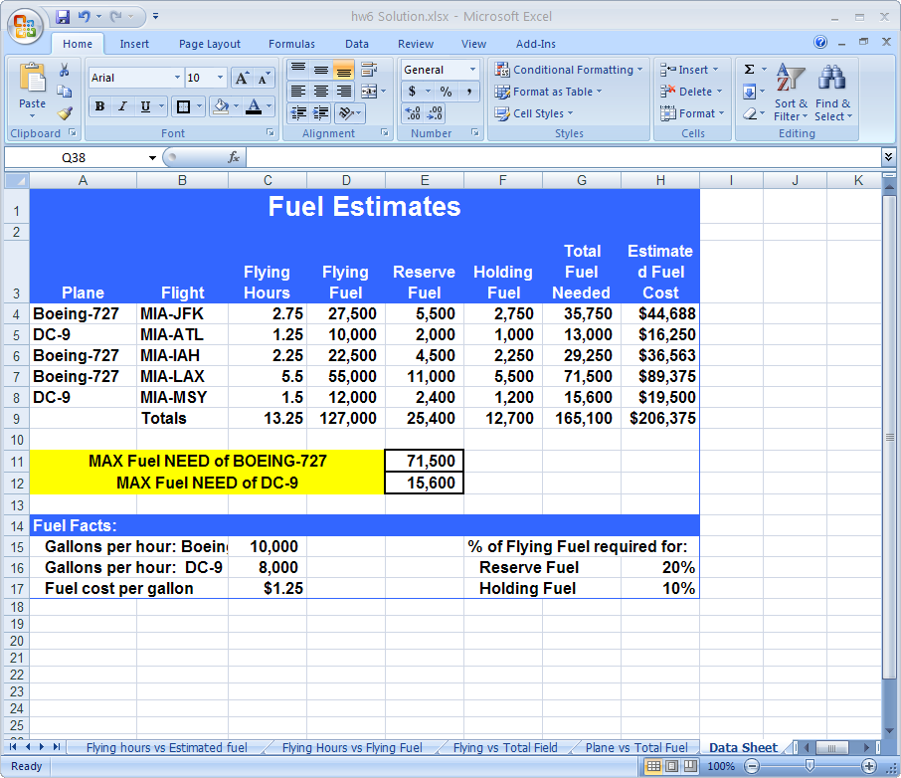

**Submit printout with both value and formula sheets included grid, row and column heading.**

**Note: put your name in cell A20**